Notice of Proposed Rule

DEPARTMENT OF AGRICULTURE AND CONSUMER SERVICES
Division of Agricultural Environmental Services
RULE NOS.: RULE TITLES:
5E-4.002 Labels
5E-4.003 Noxious Weed Seed
5E-4.004 Worthless Seed
5E-4.0041 Disposition of Seed Contaminated with Noxious Weed Seed
5E-4.006 Seed Standards
5E-4.007 Commercial Tests
5E-4.0071 Consumer Request Samples
5E-4.011 Flower Seed Germination Standards
5E-4.013 Seed Aircraft Registration, Inspection, Security, Transactions, Recordkeeping, Area-of-Application Information and Forms
5E-4.014 Seed Dealer Registration Fees
PURPOSE AND EFFECT: The proposed rules are being developed to implement recently enacted statutory changes to Chapter 578, F.S., and to update associated form references and other outdated information.
SUMMARY: Extensive changes were made to Section 578.09, F.S., Labeling Requirements. Consequently, the analysis tag templates and labeling guidance outlined in Rule 5E-4.002, F.A.C., require updating to assist seed producers and distributors in properly labeling their seed by aligning seed label content and format with recently modified seed-type classifications, labeling terminology, and germination test date requirements. Rule 5E-4.003, F.A.C., lists prohibited noxious weed seed, several of which are misspelled or need naming corrections to align with currently-recognized, scientific plant nomenclature. Rule 5E-4.004, F.A.C., requires changes to align this rule section with new verbiage adopted in Chapter 578, F.S., regarding “tree and shrub seed”, and deletes irrelevant language pertaining to worthless seed. Rule 5E-4.006, F.A.C., updates references to federal publications that establish seed standards and specifies the locations where these references can be obtained. Rule 5E-4.007, F.A.C., updates the kinds of seed for which the department offers commercial and consumer request testing services. Rule 5E-4.0071, F.A.C., lists the fees associated with the analysis of official seed samples taken by the department upon request by a consumer. Changes to Rule 5E-4.0071, F.A.C., are required to align this rule section with new verbiage adopted in Chapter 578 F.S., and certain seed kinds and groups currently listed, are being consolidated to simplify the schedule of charges. Rule 5E-4.011, F.A.C., requires a change pertaining to the germination standard for sunflower seeds, to align with the nationally-recognized standard. Rule 5E-4.013, F.A.C., pertains to aircraft registration and aerial application of seed. Many forms have new revision dates and a reference needs to be added for the aircraft registration website. Rules 5E-4.0041 and 5E-4.014, F.A.C., both need to be updated to reflect the new Bureau of Licensing and Enforcement, and Rule 5E-4.014, F.A.C., also requires an update to reflect the new department website address.
SUMMARY OF STATEMENT OF ESTIMATED REGULATORY COSTS (SERC) AND LEGISLATIVE RATIFICATION:
The Agency has determined that this rule will not have an adverse impact on small business or likely increase directly or indirectly regulatory costs in excess of $200,000 in the aggregate within one year after the implementation of the rule. A SERC has not been prepared by the Agency.
The Agency has determined that the proposed rule is not expected to require legislative ratification based on the statement of estimated regulatory costs or, if no SERC is required, the information expressly relied upon and described herein:
There are no adverse regulatory impacts associated with implementing this rule. The proposed modifications serve to align Rule Chapter 5E-4 Florida Administrative Code (F.A.C.) with changes recently made to Chapter 578 Florida Statutes (F.S.). The impact of these changes will be to help clarify labeling requirements for the industry, align Florida’s requirements more closely with Federal and neighboring state laws, improve seed related services the department offers to consumers, and better educate the industry on updates to the list of noxious weeds in Florida. These changes are intended to facilitate industry compliance and enhance consumer protections and do not require modifications to current seed labeling or marketing practices. There are no anticipated additional costs to industry or other adverse effects to seed retailers, processors, or other small businesses. The adverse impact or potential regulatory costs of the proposed rule modifications did not exceed any of the criteria established in Section 120.541(2)(a), F.S. Additionally, no interested parties have submitted information regarding the economic impact of the proposed changes.
Any person who wishes to provide information regarding a statement of estimated regulatory costs, or provide a proposal for a lower cost regulatory alternative must do so in writing within 21 days of this notice.
RULEMAKING AUTHORITY: 567.181, 570.07(23), 578.11(2), 578.11(2)(i), 580.036(2) FS.
LAW IMPLEMENTED: 487.101, 576.111, 578.08(1), 578.09, (2)(a), 578.092, 578.11, 578.11(2), (2)(h), 578.11(3), 578.12, 578.29, 580.111, FS.
IF REQUESTED WITHIN 21 DAYS OF THE DATE OF THIS NOTICE, A HEARING WILL BE SCHEDULED AND ANNOUNCED IN THE FAR.
THE PERSON TO BE CONTACTED REGARDING THE PROPOSED RULE IS: Sarah Oglesby, Chief, Bureau of Licensing and Enforcement, 3125 Conner Boulevard, Bldg. 8, Tallahassee, FL 32399; (850)617-7997; Sarah.Oglesby@FreshFromFlorida.com

THE FULL TEXT OF THE PROPOSED RULE IS:

(Substantial Rewrite of Rule 5E-4.002, F.A.C. See Florida Administrative Code for present text)

5E-4.002 Labels.
(1) Form. The analysis tag or label shall carry the information required by Section 578.09, F.S., in substantially the following form:
(a) For agricultural seed:
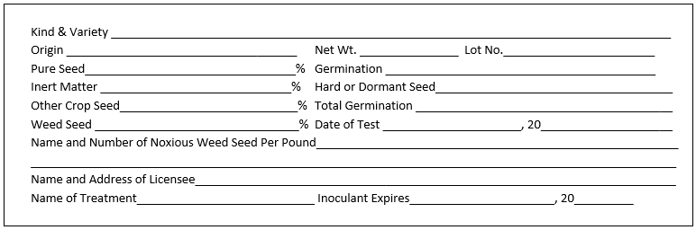
(b) For mixed agricultural seeds:
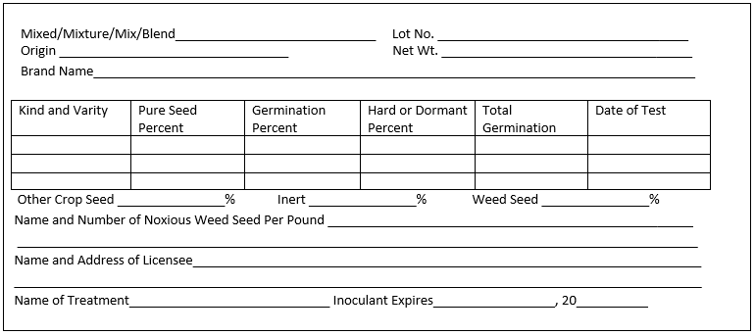

(c) For coated agricultural seed:
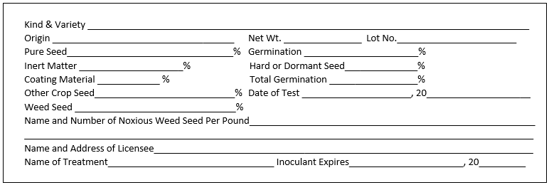

(d) For combination mulch, seed, and fertilizer products:
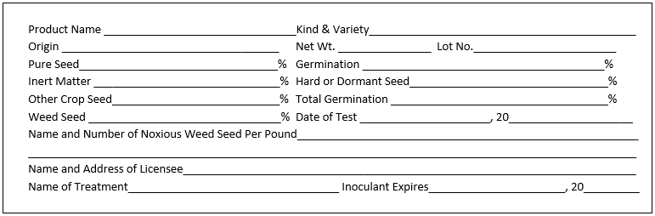

(e) Vegetable seeds in packets which germinate above standard:

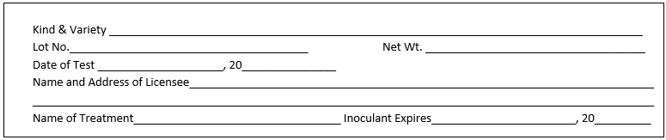

(f) Vegetable seeds other than packet seeds, or packet seeds that germinate below standard:
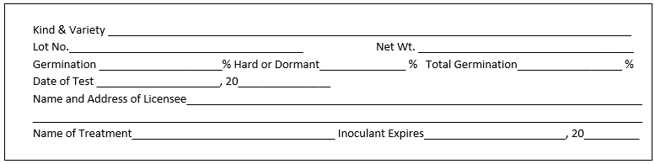

(g) Flower seeds in packets that germinate above standard:
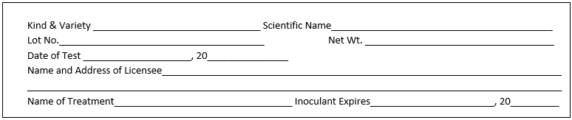

(h) Flower seeds in packets that germinate below standard:
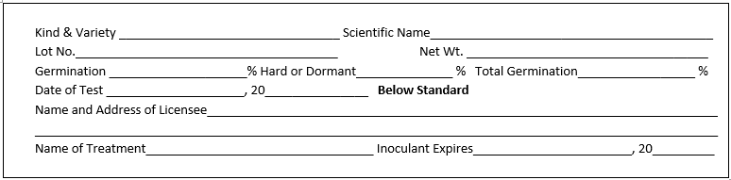

(i) Flower seeds in containers other than packets, pure seed percentage below 90%:
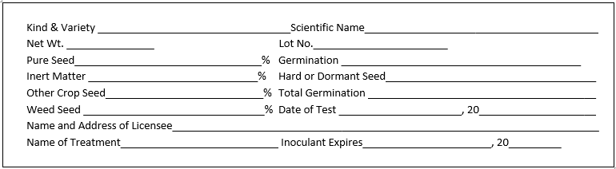

(j) Flower seeds in containers other than packets, pure seed percentage above 90%:
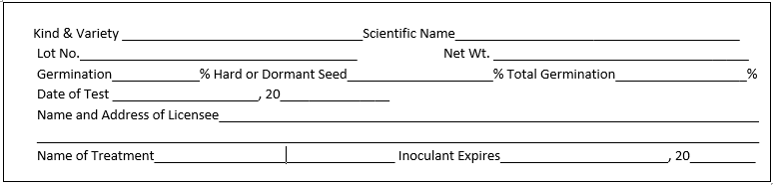

(k) For tree or shrub seed:
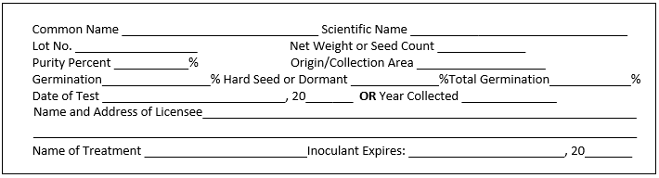

(l) The maximum percent of seed moisture for hermetically sealed containers of agricultural or vegetable seed, shall be as follows:
Family/Kind | Maximum percent Seed Moisture
1. Chenopodiaceae
a. Beet, chard | 7.5
b. Spinach | 8.0
2. Astercaeae – Lettuce | 5.5
3. Brassicaceae
a. Cabbage, broccoli, cauliflower, collard,
b. Chinese cabbage, kale, turnip, rutabaga,
c. Kohlrabi, Brussels sprouts, mustard, radish | 5.0
4. Cucurbitaceae
a. Cucumber, muskmelon, squash, pumpkin | 6.0
b. Watermelon | 6.5
5. Poaceae
a. Sweet corn | 8.0
b. Kentucky bluegrass | 6.0
c. Creeping red fescue | 8.0
d. Annual ryegrass | 8.0
e. Perennial ryegrass | 8.0
6. Fabaceae
a. Snap bean, lima bean, pea | 7.0
b. Crimson clover | 8.0
7. Amaryllidaceae – Onion, leek, chive, Welsh onion | 6.5
8. Solanaceae
a. Tomato | 5.5
b. Pepper | 4.5
c. Eggplant | 6.0
9. Apiaceae
a. Carrot, celery, celeriac | 7.0
b. Parsnip | 6.0
c. Parsley | 6.5
10. All other agricultural or vegetable seed not listed above | 6.0

(2) The term “container” includes, but is not limited to, bin, box, bag and barrel.
(3) All information required on the seed analysis tag or label shall be identified and placed on one side of the tag or label without intervening matter. No other information or matter shall be placed on this side of the tag or label unless such information is likewise identified.
(4) Analysis tag or label for agricultural seed shall show a complete analysis, and the complete purity analysis shall total one hundred percent (100%). Blank spaces on a form tag shall be deemed to imply the word “None” when such interpretation is reasonable. Either numerals or the word “None” should be used to express a percentage or numbers per pound.
(5) The name of the kind and variety of seed shall not be abbreviated, but shall be written in the words, symbols or figures as expressed by the breeder’s designation of the seed.
(6) The place of origin shall not be used in connection with the name of variety or kind of seed, unless it is a part of the generally accepted name of kind or variety. Modifying words or phrases shall not be used in connection with the variety – as for example, “for forage purposes,” etc.; nor shall brand names be used as varietal names.
(7) Upon expiration of each germination test period as prescribed by Subections 578.09(2), (5), (6), (7) & (8) and Subsection 578.092(3) F.S., a new test shall be made and the result thereof, together with the date when same was completed, shall be shown on the label or tag attached to the container of such seed (a new label or tag is recommended).
(8) Different varieties of the same kind of seed, when in quantities of less than five percent (5%), will be shown on the label or tag as other crop seed.
(9) Hybrid varieties of seed shall be labeled with the word “Hybrid” as required by Section 578.09, F.S
Examples:
 |  | (a) Hybrid Oshkosh Alfalfa | 85.00%
 | other Alfalfa |  | 14.50%
 | Inert matter |  | .25%
 | Other crop seed |  | .15%
 | Weed seed |  | .10%
 |  | (b) Hybrid Wintergreen Cabbage | 85.00%
 | other Cabbage |  | 14.00%
 | Inert matter |  | 1.00%
 | Other crop seed |  | .00%
 | Weed seed |  | .00%

(10) The following wording will comply with the requirements of Section 578.26, F.S., when printed on the analysis tag or label attached to the seed at the time of purchase by the buyer:
Notice: As a prerequisite to maintaining a legal action based upon the failure of seed to which this label is attached to produce as represented, a sworn complaint shall be made to the department within such time as to permit inspection of the crops, plants, or trees, accompanied by the required filing fee, and a copy of the complaint shall be sent to the seller by certified mail, in accordance with Section 578.26, F.S.
Rulemaking Authority 578.11(2) FS. Law Implemented 578.11(2), 578.09, 578.092 578.28, 578.28(3) FS. History–New 11-21-69, Amended 12-1-70, 9-30-72, 3-1-73, Formerly 5E-4.02, Amended 3-4-93, 6-14-95, _______.

5E-4.003 Noxious Weed Seed.
(1) Prohibited noxious weed seed shall include:
(a) Field Bindweed (Convoluolus Convolvolus arvensis) | None per pound
(b) Serrated tussock (Nassella trichotoma trichotomal) | None per pound
(c) Benghal dayflower (Commelina benghalensis) | None per pound
(2) Restricted noxious weed seed shall include:
(a) Annual bluegrass (Poa annua) | 1,000 per pound
(b) Balloonvine (Cardiospermum halicacabum) | 4 per pound
(c) Bermudagrass (Cynodon spp.) | 300 per pound
(d) Blessed thistle (Cnicus benedictus) | 9 per pound
(e) Buckhorn plantain (Plantago lanceolata) | 100 per pound
(f) Canada thistle (Cirsium arvense) | 100 per pound
(g) Cheat or Hairy chess Chess (Bromus secalinus, and/or commutatus) | 300 per pound
(h) Cocklebur (Xanthium spp.) | 4 per pound
(i) Corncockle (Agrostemma githago) | 100 per pound
(j) Crotalaria
1. Crotalaria spectabilis | 9 per pound
2. Crotalaria mucronata (Striata) | 54 per pound
(k) Darnel (Lolium temulentum) | 100 per pound
(l) Docks (Rumex crispus, obtusifolius and conglo meratus) | 100 per pound
(m) Dodders (Cuscuta spp.) | 100 per pound
(n) Horsenettle and Nightshades (Solanum carolinense and/or elaeagnifolium) | 100 per pound
(o) Johnson grass and Sorghum almum (Sorghum halepense and/or almum) | 27 per pound
(p) Nutgrass (Cyperus rotundus) | 1 per pound
(q) Quack grass (Elymus Agropyron repens) | 100 per pound
(r) Red rice (Oryza sativa) | 300 per pound
(s) Sheep sorrel (Rumex acetosella) | 200 per pound
(t) Tropical soda apple (Solanum viarum) | 1 per pound
(u) Texas millet or Buffalograss (Urochloa Panicum texanum) Buffalograss | 9 per pound
(v) Wild onion onions (Allium spp.) | 27 per pound
(w) Wild radish (Raphanus raphanistrum) | 27 per pound
(x) Wild turnip or mustard (Brassica spp.) | 27 per pound
(3) The total amount of all restricted noxious weed seed shall not exceed three hundred (300) per pound exclusive of Annual bluegrass.
Rulemaking Authority 570.07(23), 578.11(2) FS. Law Implemented 578.11(3), 578.12, 578.29 FS. History–New 5-30-63, Amended 8-22-68, 9-29-83, Formerly 5E-4.03, Amended 8-6-89, 11-14-04, 11-26-08, ________.

5E-4.004 Worthless Seed.
Agricultural, vegetable Vegetable, flower, or forest tree, or shrub seed shall be deemed worthless for planting purposes if containing in excess of two percent (2%) of total weed seed or more noxious weed seed than shown in regulation Rule 5E-4.003, F.A.C., and shall not be sold for such purposes. Exception: Carpet grass shall be considered worthless for planting purposes if containing in excess of five percent (5%) of total weed seed.
Rulemaking Authority 578.11(2) FS. Law Implemented 578.11(2) FS. History–New 11-21-69, Formerly 5E-4.04, Amended ________.

5E-4.0041 Disposition of Seed Contaminated with Noxious Weed Seed.
(1) through (3) No change.
(4) The following documents are hereby adopted and incorporated by reference. These documents may be obtained by contacting the Florida Department of Agriculture and Consumer Services, Bureau of Licensing and Enforcement Compliance Monitoring, 3125 Conner Boulevard, Building 8, Tallahassee, Florida 32399-1650 and are available online as indicated.
(a) Stop Sale, Stop Use, or Hold Order (FDACS-13233, Rev. 06/10), http://www.flrules.org/Gateway/reference.asp?No=Ref-02279.
(b) Release Notice (FDACS-13248, Rev. 08/10), http://www.flrules.org/Gateway/reference.asp?No=Ref-02280.
(c) Authorization for Movement of Goods Under Stop Sale Order (FDACS-13249, Rev. 08/10), http://www.flrules.org/Gateway/reference.asp?No=Ref-02281.
(d) University of Florida, Institute of Food and Agricultural Sciences, SS-AGR-77 “Tropical Soda Apple: Biology, Ecology and Management of a Noxious Weed in Florida” (Revised February 2010), http://www.flrules.org/Gateway/reference.asp?No=Ref-02282.
Rulemaking Authority 570.07(23), 567.181, 578.11(2), 580.036(2) FS. Law Implemented 487.101, 576.111, 578.11(3), 578.12, 580.111 FS. History–New 11-14-04, Amended 11-26-08, 3-13-13, ________.

5E-4.006 Seed Standards.
The minimum standard for agricultural seeds shall be 60% (including hard seed or dormant seed) except hybrid field corn seed which shall be 90%. The minimum standards for vegetable seeds are set forth in the documents incorporated herein. The Federal Seed Act Regulation federal seed act regulations specified in 7 CFR 201
(Revised January 2019), are hereby incorporated by reference. Copies of this document may be obtained online at http://www.flrules.org/Gateway/reference.asp?No=Ref-XXXX from the Superintendent of Documents, Attn: New Orders, P. O. Box 371954, Pittsburgh, PA 15250-7954. Charge orders may be telephoned to the Government Printing Office order desk at (202)783-3238. Also incorporated by reference are the State Noxious-Weed Seed Requirements Recognized in the Administration of the Federal Seed Act, October 2018 January 1994 publication, and the January 1995 replacement pages for the January 1994 publication. Copies of this these documents may be obtained online at http://www.flrules.org/Gateway/reference.asp?No=Ref-XXX from the United States Department of Agriculture, Agricultural Marketing Service, Seed Regulatory and Testing Branch, Livestock and Seed Division, Building 506, BARC-East, Beltsville, MD 20705-2350; telephone (301)504-9430.
Rulemaking Authority 570.07(23), 578.11(2) FS. Law Implemented 578.09(2)(a), 578.11(2) FS. History–New 5-30-63, Amended 1-1-65, 11-21-69, Formerly 5E-4.06, Amended 2-7-89, 6-14-95, 6-9-98, _________.

5E-4.007 Commercial Tests and Consumer Request Samples.
(1) The department will make commercial tests and perform analysis of consumer request samples of seed when such will not interfere with prescribed duties of the department. A schedule of charges is listed below:
(2) Definitions. As used in this rule, the following definitions shall apply:
(a) Consumer means individuals who purchase and use seed for plant production purposes.
(b) Consumer request seed samples means an official seed sample taken and analyzed by the department at the request of the consumer.
(3) Schedule of charges for the collection, packaging, shipment and analysis of consumer request seed samples and commercial tests is listed below:

 |  | Type Test and Charge
Product |  | Purity | Germination
(a) Aeschynomene |  | $10.50 | $15.75
(b) Alfalfa |  | 15.75 | 15.75
(c) Austrian Austria Winter Pea |  | 10.50 | 15.75
(d) Bahiagrass, Pensacola |  | 15.75 | 21.00
(d)(e) Bahiagrass, All Other Varieties |  | 21.00 | 21.00
(e)(f) Beggarweed |  | 10.50 | 15.75
(f)(g) Bentgrass |  | 15.75 | 15.75
(g)(h) Bermudagrass |  | 21.00 | 15.75
(h)(i) Bluegrass |  | 21.00 | 15.75
(i)(j) Buckwheat |  | 15.75 | 15.75
(j)(k) Carpetgrass |  | 21.00 | 15.75
(k)(l) Centipedegrass |  | 21.00 | 15.75
(l)(m) Chufa |  | 10.50 | 21.00
(m)(n) Clovers |  | 15.75 | 15.75
(n)(o) Corn, Field or Sweet |  | 10.50 | 21.00
(o)(p) Cowpeas |  | 10.50 | 15.75
(p)(q) Fescue |  | 21.00 | 15.75
(q)(r) Flowers |  | 15.75 | 15.75
(r)(s) Flowers, Mixed |  | 26.25 | 31.50
(s)(t) Hairy Indigo |  | 15.75 | 15.75
(t)(u) Herbs |  | 15.75 | 15.75
(u)(v) Lespedeza |  | 15.75 | 15.75
(v)(w) Lovegrass |  | 21.00 | 15.75
(w)(x) Lupine |  | 10.50 | 15.75
(x)(y) Millets |  | 15.75 | 15.75
(y)(z) Mixed Grasses |  | 36.75 | 36.75
(z)(aa) Oats |  | 15.75 | 15.75
(aa)(bb) Partridge Pea |  | 10.50 | 15.75
(bb)(cc) Peanuts, Hulled |  | 10.50 | 15.75
(cc)(dd) Rye |  | 15.75 | 15.75
(dd)(ee) Ryegrass |  | 21.00 | 15.75
(ee)(ff) Rice |  | 15.75 | 15.75
(ff)(gg) Sesame |  | 10.50 | 15.75
(gg)(hh) Sesbania |  | 10.50 | 15.75
(hh)(ii) Sorghum |  | 15.75 | 15.75
(ii)(jj) Soybeans |  | 10.50 | 15.75
(jj)(kk) Sunflower |  | 10.50 | 15.75
(kk)(ll) Timothy |  | 15.75 | 15.75
(ll)(mm) Tobacco |  | 15.75 | 15.75
(mm)(nn) Tree or Shrub Seed |  | 15.75 | 21.00
(nn)(oo) Triticale |  | 15.75 | 15.75
(oo)(pp) Vegetables (1) * |  | 10.50 | 15.75
(qq) Vegetables (2) ** |  | 10.50 | 21.00
(pp)(rr) Velvet bean Beans |  | 10.50 | 15.75
(qq)(ss) Vetch |  | 10.50 | 15.75
(rr)(tt) Wheat |  | 15.75 | 15.75
*Vegetables (1): Radish, Squash, Cucumber, Cantaloupe, Pumpkin, Collard, Turnip, Mustard, Cabbage, Bean, Lettuce, Peas
**Vegetables (2): Watermelon, Carrot, Pepper, Tomato, Eggplant, Sweet Corn
(4)(2) The Cold Test for corn is $5.00 AA Test for soybeans is $10.50.
(5)(3) Seed not listed will be charged according to other seed of similar size.
(6)(4) An additional charge of $5.00 is required for testing germination of uncleaned seed.
(7)(5) The charge for noxious weed test is equal to one-half of the charge of the purity test.
Rulemaking Authority 578.11(2) FS. Law Implemented 578.11(2), (2)(h) FS. History–New 6-29-62, Amended 9-29-83, Formerly 5E-4.07, Amended 8-17-92, ________.

5E-4.0071 Consumer Request Samples.
Rulemaking Authority 570.07(23), 578.11(2)(h) FS. Law Implemented 578.11(2), 578.11(2)(h) FS. History–New 3-4-93, Repealed .

5E-4.011 Flower Seed Germination Standards.
(1) Flower seed subject to Chapter 578, F.S., and their germination standards are as follows:
 | Standard
Kind | Germ. %
(a) African daisy – Dimorphotheca aurantiacs |  | 55
(b) Ageratum – Ageratum mexicanum |  | 60
(c) Alyssum – Alyssum compactum, A. maritimum, A. procumbens, A. saxatile |  | 60
(d) Amaranthus – Amaranthus spp. |  | 6550
(e) Anemone – Anemone coronaria, A. pulsatilla |  | 55
(f) Angels trumpet – Datura arborea |  | 60
(g) Arabis – Arabis alpina |  | 60
(h) Armeria – Armeria spp. |  | 50
(i) Aster, China – Callistephus, chinensis except Pompon, Powderpuff, and Princess types |  | 55
(j) Aster, China – Callistephus chinensis, Pompon, Powderpuff, and Princess types |  | 50
(k) Aubrietia – Aubrietia deltoidea deltoides |  | 45
(l) Balsam – Impatiens balsamina |  | 70
(m) Calendula – Calendula officinalis |  | 65
(n) California Poppy – Eschscholtzia californica |  | 60
(o) Calliposis – Coreopsis bicolor, C. drummondi, C. elegans |  | 65
(p) Campanula: Canterbury bells – Campanula medium |  | 60
Cup and Saucer bellflower – |  | 60
Campanula medium calycanthema Carpathian bellflower – Campanula carpatica |  | 50
Peach bellflower – Campanula persicifolia |  | 50
(q) Candytuft, annual – Iberis amara, I. umbellata |  | 65
(r) Candytuft, perennial – Iberis gibraltarica, I. sempervirens |  | 55
(s) Castor bean – Ricinus communis |  | 60
(t) Cathedral Bells – Cobaea scandens |  | 65
(u) Celosia – Celosia argentea |  | 65
(v) Centaurea: Basket flower – Centaurea americana, Cornflower, C. cyanus, Dusty Miller – C. candidissima, |  | 60
Royal centaurea – C. imperialis, Sweet Sultan – C. moschata, Velvet centaurea – C. gymnocarpa
(w) Chinese forget-me-not – Cynoglossum amabile |  | 55
(x) Chrysanthemum, annual – Chrysanthemum carinatum, C. coronarium, C. segetum |  | 40
(y) Clarkia – Clarkia elegans |  | 65
(z) Cleome – Cleome gigantea |  | 65
(aa) Columbine – Aquilegia spp. |  | 50
(bb) Coral bells – Heuchera sanguinea |  | 55
(cc) Coreopsis, perennial – Coreopsis lanceolata |  | 40
(dd) Cosmos: Sensation, Mammoth and Crested types – Cosmos bipinnatus; Klondyke type C. sulphureus |  | 65
(ee) Dahlia – Dahlia spp. |  | 55
(ff) Delphinium, perennial: Belladonna and Bellamosum types; Cardinal larkspur – Delphinium cardinale; |  | 55
Chinensis types; Pacific Giant, and Gold Medal and other hybrids of D. elatum
(gg) Dianthus:
Carnation – Dianthus caryophyllus |  | 60
China pinks – Dianthus chinensis, Heddewigi, Heddensis |  | 70
Grass pinks – Dianthus plurmarious plurmarious |  | 60
Maiden pinks – Dianthus deltoides |  | 60
Sweet William – Dianthus bBarabatus |  | 70
Sweet Wivelsfield – Dianthurs allwoodi |  | 60
(hh) Dracaena – Dracaena indivisa |  | 55
(ii) English daisy – Bellis perennis |  | 55
(jj) Forget-me-not – Anchusa myosatidiflora |  | 50
(kk) Foxglove-Digitalis spp. |  | 60
(ll) Gaillardia, annual – Gaillardia pulchella, Var. picta; perennial – G. grandiflora |  | 45
(mm) Geranium – Geranium spp. |  | 40
(nn) Geum – Geum spp. |  | 55
(oo) Gilia – Gilia spp. |  | 65
(pp) Godetia – Godetia amonena, G. grandiflora |  | 65
(qq) Gourds: Yellow-flowered – Cucurbita pepo; White- flowered – Langenaria sisceraria; |  | 70
Dishcloth Luffa cylindrica
(rr) Gypsophila: annual baby’s breath – Gypsophila elegans; perennial baby’s breath – G. paniculata, |  | 70
G. pacifica, G. repens
(ss) Helichrysum – Helichrysum Monstrosum |  | 60
(tt) Hollyhock – Alcthea Althea rosea |  | 65
(uu) Impatiens – Impatiens spp. |  | 55
(vv) Ipomea: Cypress vine – Ipomea quamoclit; Moonflower – I. Noctiflora; Morning glories, |  | 75
Cardinal Climber, Hearts and Honey vine – Ipomea spp.
(ww) Job’s tears – Coix lacrymajobi |  | 70
(xx) Kochia – Kochia childsi |  | 55
(yy) Larkspur, annual – Delphinium ajacis |  | 60
(zz) Lantana – Lantana camara, L. hybrida |  | 35
(aaa) Linaria – Linaria spp. |  | 65
(bbb) Lobelia, annual – Lobelia erinus |  | 65
(ccc) Lunaria, annual Lunaria annua |  | 65
(ddd) Lupine – Lupinus spp. |  | 65
(eee) Marigold – Tagetes spp. |  | 65
(fff) Marvel of Peru – Mirabilis jalapa |  | 60
(ggg) Mignonette – Reseda odorata |  | 55
(hhh) Myosotis – Myosotis alpestris, M. oblongata, M. pulastris |  | 50
(iii) Nasturtium – Tropaeolum spp. |  | 60
(jjj) Nemesia – Nemesia spp. |  | 65
(kkk) Nemophila – Nemophila insignis |  | 70
(lll) Nicotiana – Nicotiana affinis, N. Sanderae, N. sylvestris |  | 65
(mmm) Nierembergia – Nierembergia spp. |  | 55
(nnn) Nigella – Nigella damascena |  | 55
(ooo) Pansy – Viola tricolor |  | 60
(ppp) Penstemon – Penstemon barabatus, P. grandiflorus, P. Laevigatus, P. Pupescens |  | 60
(qqq) Petunia – Petunia spp. |  | 45
(rrr) Phacelia – Phacelia companularia, P. minor, P. tanacetifolia |  | 65
(sss) Phlox, annual – Phlox drummondi all types and varieties |  | 55
(ttt) Physalis – Physalis spp. |  | 60
(uuu) Poppy: Shirley poppy – Papaver rhoeas; Iceland poppy – P. nudicaule; Oriental poppy – |  | 60
P. orientale; Tulip poppy – P. glaucum
(vvv) Portulaca – Portulaca grandiflora |  | 55
(www) Salpiglossis – Salpiglossis gloxinaeflora, S. sinuata |  | 60
(xxx) Salvia – Scarlet Sage – Salvia splendens; Mealycup Sage (blue bedder) – Salvia farinacea |  | 50
(yyy) Saponaria – Saponaria ocymoides, S. vaccaria |  | 60
(zzz) Scabiosa, annual – Scabiosa atropurpurea |  | 50
(aaaa) Scabiosa, perennial – Scabiosa caucasica |  | 40
(bbbb) Schizanthus – Schizanthus spp. |  | 60
(cccc) Shasta Daisy – Chrysanthemum maximum, C. leucanthemum |  | 65
(dddd) Snapdragon – Antirrhinum spp. |  | 55
(eeee) Solanum – Solanum spp. |  | 60
(ffff) Stocks: Common – Mathiola incana; Evening scented – Mathiola bicornis |  | 65
(gggg) Sunflower – Helianthus spp. |  | 65
(hhhh) Sweet Pea, annual and perennial other than dwarf bush – Lathyrus odoratus, L. latifolius |  | 75
(iiii) Sweet Pea, dwarf bush – Lathyrus odoratus |  | 65
(jjjj) Thunbergia – Thunbergiaalata |  | 60
(kkkk) Torch flower – Tithonia speciosa |  | 70
(llll) Tritoma – Kniphofia spp. |  | 65
(mmmm) Vervain, garden Verbena, annual – Verbena hybrida |  | 35
(nnnn) Vinca – Vinca rosea |  | 60
(oooo) Viola – Viola cornuta |  | 55
(pppp) Wallflower – Cheiranthus allioni |  | 65
(qqqq) Zinnia (except linearis and creeping) – Zinnia angustifolia, Z. elegans, Z. grandiflora, Z. gracillima, |  | 65
Z. haegeana, Z. multiflora, Z. pumila
(rrrr) Zinnia, linearis and creeping – Zinnia linearis, Sanvitalia procumbens |  | 50
(2) Kinds not listed |  | 50
(3) No flower seed marked below standard may be sold which germinate less than 30%.
(4) A mixture of kinds of flower seed will be considered to be below standard if the germination of any kind or combination of kinds constituting 25 percent or more of the mixture by number is below standard for the kind or kinds involved.
Rulemaking Authority 578.11(2) FS. Law Implemented 578.11(2) FS. History–New 11-21-69, Formerly 5E-4.11, Amended 8-17-92,________.

5E-4.013 Seed Aircraft Registration, Inspection, Security, Transactions, Recordkeeping, Area-of-Application Information and Forms.
(1) Registration. Each aircraft used for aerial application of any seed must be annually registered with the department. Application for registration shall be on form Application For Aircraft Registration, FDACS-13354 Rev. 10/13 New 1/02 provided by the department or via the Aircraft Registration Transaction Reporting website located https//aerial.freshfromflorida.com. The completed registration form shall be submitted to the Pesticide Certification Office, 3125 Conner Blvd., Bldg. 8 (L-29), Tallahassee, Florida 32399-1650. The registration shall be submitted to the Department on or before June 30 of each year.
(2) through (3) No change.
(4) Transactions. Any purchase, sale, rental, leasing, or transfer of ownership of an aircraft required to be registered with the department pursuant to subsection (1) above shall be transmitted to the department on (1) Florida Department of Revenue Form DR-15AIR 42 Rev-01/16 06/99 Ownership Declaration and Sales and Use Tax Return for Report on Aircraft or (2) Aircraft Bill of Sale Form AC 8050-2 Rev. 10/18 (9/92) or (3) Report of Aircraft Transaction Form FDACS-13355 Rev. 10/13 New 1/02 within 24 hours of the transaction.
(5) through (6) No change.
(7) Forms. The following forms are hereby incorporated by reference and available at the links below. These forms may be obtained from the Florida Department of Agriculture and Consumer Services, Pesticide Certification Office, 3125 Conner Boulevard, Building 8 (L-29), Tallahassee, Florida 32399-1650, telephone (850)617-7870 488-3314.
(a) Application for Aircraft Registration (FDACS-13354), Rev. 10/13 New 01/02 http://www.flrules.org/Gateway/reference.asp?No=Ref-XXXX.
(b) Ownership Declaration and Sales and Use Tax Return for Report on Aircraft (DR-42A), Rev. 1/16 06/99 http://www.flrules.org/Gateway/reference.asp?No=Ref-XXXX.
(c) Aircraft Bill of Sale Form AC 8050-2, New 10/18 Report of Aircraft Transaction (DACS-13355), New 3/02 http://www.flrules.org/Gateway/reference.asp?No=Ref-XXXX.
(d) Report of Aircraft Transaction (FDACS-13355), (Rev. 10/13) New 3/02 http://www.flrules.org/Gateway/reference.asp?No=Ref-XXXX.
Rulemaking Authority 570.07(23), 578.11(2) FS., Chapter 2001-360, Laws of Florida. Law Implemented 578.11 FS., Chapter 2001-360, Laws of Florida. History–New 6-9-02, Amended ________.

5E-4.014 Seed Dealer Registration Fees.
(1) The Application for Registration as a Seed Dealer, FDACS-13204, Rev. 07/14 6/09, shall be submitted annually for each place of business at which seed is sold, distributed for sale, offered for sale, exposed for sale, or handled for sale, and shall be accompanied by the applicable fee established in Section 578.08, F.S.
(2) All forms and filing specifications contained in this rule are hereby adopted and incorporated by reference and may be obtained from the Florida Department of Agriculture and Consumer Services, Bureau of Compliance Monitoring, 3125 Conner Boulevard, Building 8, Tallahassee, Florida 32399-1650 or by visiting the Department’s website at http://www.doacs.state.fl.us/onestop/forms/.
Rulemaking Authority 570.07(23), 578.11(2)(i) FS. Law Implemented 578.08(1) FS. History–New 1-18-10, Amended ________.

NAME OF PERSON ORIGINATING PROPOSED RULE: Kelly Friend, Director, Division of Agricultural Environmental Services
NAME OF AGENCY HEAD WHO APPROVED THE PROPOSED RULE: Commissioner of Agriculture Nicole “Nikki” Fried
DATE PROPOSED RULE APPROVED BY AGENCY HEAD: March 27, 2019
DATE NOTICE OF PROPOSED RULE DEVELOPMENT PUBLISHED IN FAR: October 30, 2018

