Notice of Change/Withdrawal

DEPARTMENT OF AGRICULTURE AND CONSUMER SERVICES
Division of Agricultural Environmental Services
RULE NOS.: RULE TITLES:
5E-4.002 Labels
5E-4.003 Noxious Weed Seed
5E-4.006 Seed Standards
5E-4.007 Commercial Tests
5E-4.011 Flower Seed Germination Standards
5E-4.013 Seed Aircraft Registration, Inspection, Security, Transactions, Recordkeeping, Area-of-Application Information and Forms
5E-4.014 Seed Dealer Registration Fees
NOTICE OF CHANGE
Notice is hereby given that the following changes have been made to the proposed rule in accordance with subparagraph 120.54(3)(d)1., F.S., published in Vol. 45 No. 62, March 29, 2019 issue of the Florida Administrative Register.

5E-4.002 Labels.
(1) Form. The analysis tag or label shall carry the information required by Section 578.09, F.S., in substantially the following form:
(a) For agricultural seed:
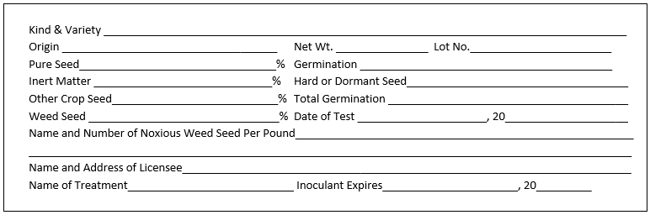
(b) For mixed agricultural seeds:
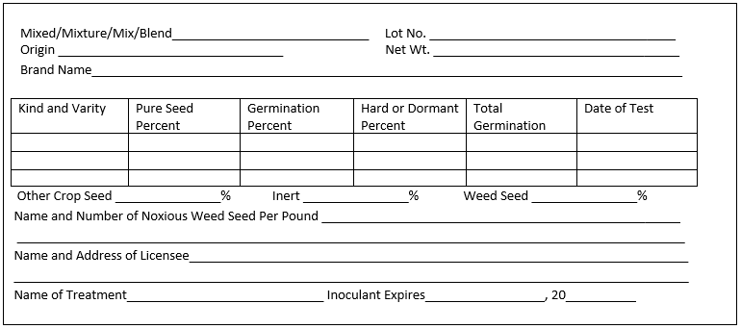

(c) For coated agricultural seed:
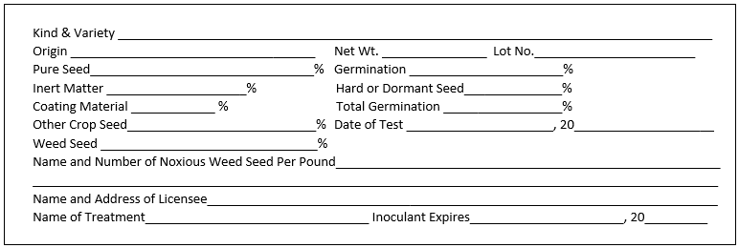

(d) For combination mulch, seed, and fertilizer products:
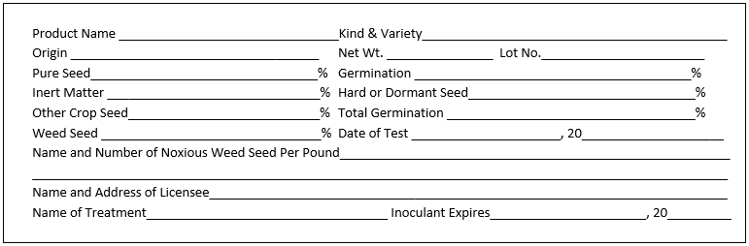

(e) Vegetable seeds in packets which germinate above standard:
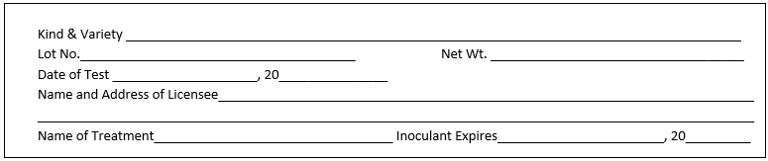
(f) Vegetable seeds in packets which germinate below standard:
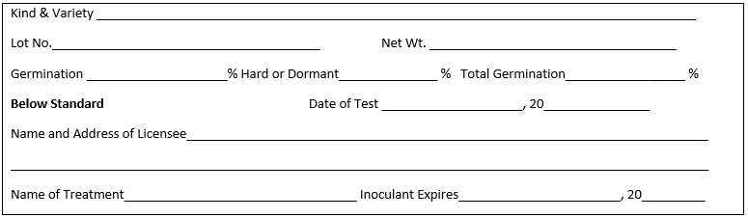
(g)(f) Vegetable seeds other than packet seeds , or packet seeds that germinate below standard:
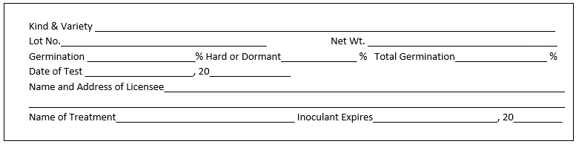

(h)(g) Flower seeds in packets that germinate above standard:
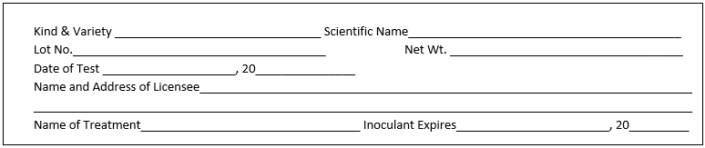

(i)(h) Flower seeds in packets that germinate below standard:
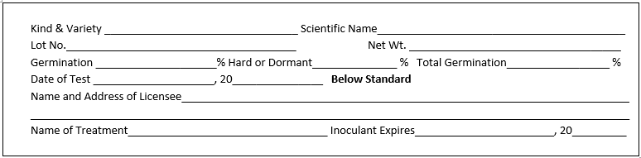

(j)(i) Flower seeds in containers other than packets, pure seed percentage below 90%:
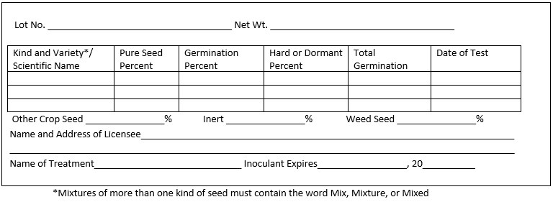

(k)(j) Flower seeds in containers other than packets, pure seed percentage above 90%:
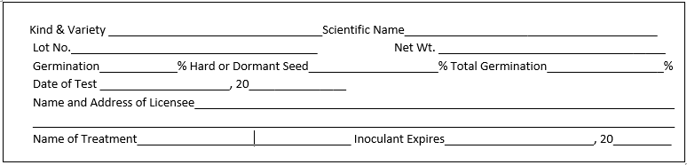

(l)(k) For tree or shrub seed:
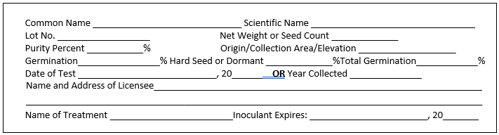

(l) renumbered (2) No change.
(3)(2) The term “container” includes, but is not limited to, bin, box, bag, and barrel or bulk receptacle.
(4)(3) All information required on the seed analysis tag or label shall be identified and placed on one side of the tag or label without intervening matter. No other information or matter shall be placed on this side of the tag or label unless such information is distinguished from the analysis labeling. likewise identified.
(4) through (9) renumbered (5) through (10) No change.
(11)(10) The following wording will comply with the requirements of Section 578.26(1)(c), F.S., when printed on the analysis tag or label attached to the seed at the time of purchase by the buyer:
Notice: As a prerequisite to maintaining a legal action based upon the failure of seed to which this label is attached to produce as represented, a sworn complaint shall be made to the department within such time as to permit inspection of the crops, plants, or trees, accompanied by the required filing fee, and a copy of the complaint shall be sent to the seller by certified mail, in accordance with Section 578.26, F.S.
Rulemaking Authority 578.11(2) FS. Law Implemented 578.11(2), 578.09, 578.092 FS. History–New 11-21-69, Amended 12-1-70, 9-30-72, 3-1-73, Formerly 5E-4.02, Amended 3-4-93, 6-14-95, _______.

5E-4.003 Noxious Weed Seed.
(1) Prohibited noxious weed seed shall include:
(a) Field Bindweed (Convolvulus Convolvolus arvensis) | None per pound
(b) Serrated tussock (Nassella trichotoma) | None per pound
(c) Benghal dayflower (Commelina benghalensis) | None per pound
(2) Restricted noxious weed seed shall include:
(a) Annual bluegrass (Poa annua) | 1,000 per pound
(b) Balloonvine (Cardiospermum halicacabum) | 4 per pound
(c) Bermudagrass (Cynodon spp.) | 300 per pound
(d) Blessed thistle (Cnicus benedictus) | 9 per pound
(e) Buckhorn plantain (Plantago lanceolata) | 100 per pound
(f) Canada thistle (Cirsium arvense) | 100 per pound
(g) Cheat or Hairy chess (Bromus secalinus, and/or commutatus) | 300 per pound
(h) Cocklebur (Xanthium spp.) | 4 per pound
(i) Corncockle (Agrostemma githago) | 100 per pound
(j) Crotalaria
1. Crotalaria spectabilis | 9 per pound
2. Crotalaria mucronata (Striata) | 54 per pound
(k) Darnel (Lolium temulentum) | 100 per pound
(l) Docks (Rumex crispus, obtusifolius and conglo meratus) | 100 per pound
(m) Dodders (Cuscuta spp.) | 100 per pound
(n) Horsenettle and Nightshades (Solanum carolinense and/or elaeagnifolium) | 100 per pound
(o) Johnson grass and Sorghum almum (Sorghum halepense and/or almum) | 27 per pound
(p) Nutgrass (Cyperus rotundus) | 1 per pound
(q) Quack grass (Elymus repens) | 100 per pound
(r) Red rice (Oryza sativa) | 300 per pound
(s) Sheep sorrel (Rumex acetosella) | 200 per pound
(t) Tropical soda apple (Solanum viarum) | 1 per pound
(u) Texas millet or Buffalograss (Urochloa texana texanum) | 9 per pound
(v) Wild onion (Allium spp.) | 27 per pound
(w) Wild radish (Raphanus raphanistrum) | 27 per pound
(x) Wild turnip or mustard (Brassica spp.) | 27 per pound
(3) No change.
Rulemaking Authority 570.07(23), 578.11(2) FS. Law Implemented 578.11(2)(d)(3), 578.12, 578.29 FS. History–New 5-30-63, Amended 8-22-68, 9-29-83, Formerly 5E-4.03, Amended 8-6-89, 11-14-04, 11-26-08, ________.

5E-4.006 Seed Standards.
The minimum standard for agricultural seeds shall be 60% (including hard seed or dormant seed) except hybrid field corn seed which shall be 90%. The minimum standards for vegetable seeds are set forth in the documents incorporated herein. The Federal Seed Act Regulation specified in 7 CFR 201
(Revised January 1, 2018 2019), are hereby incorporated by reference. Copies of this document may be obtained online at http://www.flrules.org/Gateway/reference.asp?No=Ref-XXXX. Also incorporated by reference are the State Noxious-Weed Seed Requirements Recognized in the Administration of the Federal Seed Act, October 2018 publication. Copies of this document may be obtained online at http://www.flrules.org/Gateway/reference.asp?No=Ref-XXX.
Rulemaking Authority 570.07(23), 578.11(2) FS. Law Implemented 578.09(2)(a), 578.11(2) FS. History–New 5-30-63, Amended 1-1-65, 11-21-69, Formerly 5E-4.06, Amended 2-7-89, 6-14-95, 6-9-98, _________.

5E-4.011 Flower Seed Germination Standards.
(1) Flower seed subject to Chapter 578, F.S., and their germination standards are as follows:
 | Standard
Kind | Germ. %
(a) African daisy – Dimorphotheca aurantiacs |  | 55
(b) Ageratum – Ageratum mexicanum |  | 60
(c) Alyssum – Alyssum compactum, A. maritimum, A. procumbens, A. saxatile |  | 60
(d) Amaranthus – Amaranthus spp. |  | 65
(e) Anemone – Anemone coronaria, A. pulsatilla |  | 55
(f) Angels trumpet – Datura arborea |  | 60
(g) Arabis – Arabis alpina |  | 60
(h) Armeria – Armeria spp. |  | 50
(i) Aster, China – Callistephus, chinensis except Pompon, Powderpuff, and Princess types |  | 55
(j) Aster, China – Callistephus chinensis, Pompon, Powderpuff, and Princess types |  | 50
(k) Aubrieta Aubrietia – Aubrieta Aubrietia deltoidea |  | 45
(l) Balsam – Impatiens balsamina |  | 70
(m) Calendula – Calendula officinalis |  | 65
(n) California Poppy – Eschscholtzia californica |  | 60
(o) Calliposis – Coreopsis bicolor, C. drummondi, C. elegans |  | 65
(p) Campanula: Canterbury bells – Campanula medium |  | 60
Cup and Saucer bellflower – |  | 60
Campanula medium calycanthema Carpathian bellflower – Campanula carpatica |  | 50
Peach bellflower – Campanula persicifolia |  | 50
(q) Candytuft, annual – Iberis amara, I. umbellata |  | 65
(r) Candytuft, perennial – Iberis gibraltarica, I. sempervirens |  | 55
(s) Castor bean – Ricinus communis |  | 60
(t) Cathedral Bells – Cobaea scandens |  | 65
(u) Celosia – Celosia argentea |  | 65
(v) Centaurea: Basket flower – Centaurea americana, Cornflower, C. cyanus, Dusty Miller – C. candidissima, |  | 60
Royal centaurea – C. imperialis, Sweet Sultan – C. moschata, Velvet centaurea – C. gymnocarpa
(w) Chinese forget-me-not – Cynoglossum amabile |  | 55
(x) Chrysanthemum, annual – Chrysanthemum carinatum, C. coronarium, C. segetum |  | 40
(y) Clarkia – Clarkia elegans |  | 65
(z) Cleome – Cleome gigantea |  | 65
(aa) Columbine – Aquilegia spp. |  | 50
(bb) Coral bells – Heuchera sanguinea |  | 55
(cc) Coreopsis, perennial – Coreopsis lanceolata |  | 40
(dd) Cosmos: Sensation, Mammoth and Crested types – Cosmos bipinnatus; Klondyke type C. sulphureus |  | 65
(ee) Dahlia – Dahlia spp. |  | 55
(ff) Delphinium, perennial: Belladonna and Bellamosum types; Cardinal larkspur – Delphinium cardinale; |  | 55
Chinensis types; Pacific Giant, and Gold Medal and other hybrids of D. elatum
(gg) Dianthus:
Carnation – Dianthus caryophyllus |  | 60
China pinks – Dianthus chinensis, Heddewigi, Heddensis |  | 70
Grass pinks – Dianthus plumarius plurmarious |  | 60
Maiden pinks – Dianthus deltoides |  | 60
Sweet William – Dianthus barabatus |  | 70
Sweet Wivelsfield – Dianthurs allwoodi |  | 60
(hh) Dracaena – Dracaena indivisa |  | 55
(ii) English daisy – Bellis perennis |  | 55
(jj) Forget-me-not – Anchusa myosatidiflora |  | 50
(kk) Foxglove-Digitalis spp. |  | 60
(ll) Gaillardia, annual – Gaillardia pulchella, Var. picta; perennial – G. grandiflora |  | 45
(mm) Geranium – Geranium spp. |  | 40
(nn) Geum – Geum spp. |  | 55
(oo) Gilia – Gilia spp. |  | 65
(pp) Godetia – Godetia amonena, G. grandiflora |  | 65
(qq) Gourds: Yellow-flowered – Cucurbita pepo; White- flowered – Langenaria sisceraria; |  | 70
Dishcloth Luffa cylindrica
(rr) Gypsophila: annual baby’s breath – Gypsophila elegans; perennial baby’s breath – G. paniculata, |  | 70
G. pacifica, G. repens
(ss) Helichrysum – Helichrysum Monstrosum |  | 60
(tt) Hollyhock – Alcea Alcthea rosea |  | 65
(uu) Impatiens – Impatiens spp. |  | 55
(vv) Ipomea: Cypress vine – Ipomea quamoclit; Moonflower – I. Noctiflora; Morning glories, |  | 75
Cardinal Climber, Hearts and Honey vine – Ipomea spp.
(ww) Job’s tears – Coix lacrymajobi |  | 70
(xx) Kochia – Kochia childsi |  | 55
(yy) Larkspur, annual – Delphinium ajacis |  | 60
(zz) Lantana – Lantana camara, L. hybrida |  | 35
(aaa) Linaria – Linaria spp. |  | 65
(bbb) Lobelia, annual – Lobelia erinus |  | 65
(ccc) Lunaria, annual Lunaria annua |  | 65
(ddd) Lupine – Lupinus spp. |  | 65
(eee) Marigold – Tagetes spp. |  | 65
(fff) Marvel of Peru – Mirabilis jalapa |  | 60
(ggg) Mignonette – Reseda odorata |  | 55
(hhh) Myosotis – Myosotis alpestris, M. oblongata, M. pulastris |  | 50
(iii) Nasturtium – Tropaeolum spp. |  | 60
(jjj) Nemesia – Nemesia spp. |  | 65
(kkk) Nemophila – Nemophila insignis |  | 70
(lll) Nicotiana – Nicotiana affinis, N. Sanderae, N. sylvestris |  | 65
(mmm) Nierembergia – Nierembergia spp. |  | 55
(nnn) Nigella – Nigella damascena |  | 55
(ooo) Pansy – Viola tricolor |  | 60
(ppp) Penstemon – Penstemon barabatus, P. grandiflorus, P. Laevigatus, P. Pupescens |  | 60
(qqq) Petunia – Petunia spp. |  | 45
(rrr) Phacelia – Phacelia companularia, P. minor, P. tanacetifolia |  | 65
(sss) Phlox, annual – Phlox drummondi all types and varieties |  | 55
(ttt) Physalis – Physalis spp. |  | 60
(uuu) Poppy: Shirley poppy – Papaver rhoeas; Iceland poppy – P. nudicaule; Oriental poppy – |  | 60
P. orientale; Tulip poppy – P. glaucum
(vvv) Portulaca – Portulaca grandiflora |  | 55
(www) Salpiglossis – Salpiglossis gloxinaeflora, S. sinuata |  | 60
(xxx) Salvia – Scarlet Sage – Salvia splendens; Mealycup Sage (blue bedder) – Salvia farinacea |  | 50
(yyy) Saponaria – Saponaria ocymoides, S. vaccaria |  | 60
(zzz) Scabiosa, annual – Scabiosa atropurpurea |  | 50
(aaaa) Scabiosa, perennial – Scabiosa caucasica |  | 40
(bbbb) Schizanthus – Schizanthus spp. |  | 60
(cccc) Shasta Daisy – Chrysanthemum maximum, C. leucanthemum |  | 65
(dddd) Snapdragon – Antirrhinum spp. |  | 55
(eeee) Solanum – Solanum spp. |  | 60
(ffff) Stocks: Common – Mathiola incana; Evening scented – Mathiola bicornis |  | 65
(gggg) Sunflower – Helianthus spp. |  | 65
(hhhh) Sweet Pea, annual and perennial other than dwarf bush – Lathyrus odoratus, L. latifolius |  | 75
(iiii) Sweet Pea, dwarf bush – Lathyrus odoratus |  | 65
(jjjj) Thunbergia – Thunbergiaalata |  | 60
(kkkk) Torch flower – Tithonia speciosa |  | 70
(llll) Tritoma – Kniphofia spp. |  | 65
(mmmm) Vervain, garden – Verbena hybrida |  | 35
(nnnn) Vinca – Vinca rosea |  | 60
(oooo) Viola – Viola cornuta |  | 55
(pppp) Wallflower – Cheiranthus allioni |  | 65
(qqqq) Zinnia (except linearis and creeping) – Zinnia angustifolia, Z. elegans, Z. grandiflora, Z. gracillima, |  | 65
Z. haegeana, Z. multiflora, Z. pumila
(rrrr) Zinnia, linearis and creeping – Zinnia linearis, Sanvitalia procumbens |  | 50
(2) Kinds not listed |  | 50
(3) through (4) No change.
Rulemaking Authority 578.11(2)(b) FS. Law Implemented 578.11(2)(b) FS. History–New 11-21-69, Formerly 5E-4.11, Amended 8-17-92,________.

5E-4.013 Seed Aircraft Registration, Inspection, Security, Transactions, Recordkeeping, Area-of-Application Information and Forms.
(1) Registration. Each aircraft used for aerial application of any seed must be annually registered with the department. Application for registration shall be on form Application For Aircraft Registration, FDACS-13354 Rev. 10/13 or via the Aircraft Registration Transaction Reporting website located https://aerial.freshfromflorida.com. The completed registration form shall be submitted to the Pesticide Certification Office, 3125 Conner Blvd., Bldg. 8, Tallahassee, Florida 32399-1650. The registration shall be submitted to the Department on or before June 30 of each year.
(2) through (6) No change.
(7) Forms. The following forms are hereby incorporated by reference and available at the links below. These forms may be obtained from the Florida Department of Agriculture and Consumer Services, Pesticide Certification Office, 3125 Conner Boulevard, Building 8, Tallahassee, Florida 32399-1650, telephone (850)617-7870.
(a) No change.
(b) Sales and Use Tax Return for Aircraft (DR-15AIR 42A), Rev. 1/16 http://www.flrules.org/Gateway/reference.asp?No=Ref-XXXX.
(c) through (d) No change.
Rulemaking Authority 570.07(23), 578.11(2)(j) FS., Chapter 2001-360, Laws of Florida. Law Implemented 578.11(2)(j) FS., Chapter 2001-360, Laws of Florida. History–New 6-9-02, Amended ________.

5E-4.014 Seed Dealer Registration Fees.
The Application for Registration as a Seed Dealer, FDACS-13204, Rev. 07/14, which is hereby incorporated by reference and available online at http://www.flrules.org/Gateway/reference.asp?No=Ref-XXXX, shall be submitted annually for each place of business at which seed is sold, distributed for sale, offered for sale, exposed for sale, or handled for sale, and shall be accompanied by the applicable fee established in Section 578.08, F.S. The Application for Registration as a Seed Dealer, FDACS-13204, Rev. 07/14, may be obtained from the Florida Department of Agriculture and Consumer Services, Bureau of Licensing and Enforcement, 3125 Conner Boulevard, Building 8, Tallahassee, Florida 32399-1650 or by visiting the Department’s website at www.FreshFromFlorida.com.
Rulemaking Authority 570.07(23), 578.11(2)(i) FS. Law Implemented 578.08(1) FS. History–New 1-18-10, Amended ________.

