Miscellaneous

DEPARTMENT OF AGRICULTURE AND CONSUMER SERVICES
CHILD NUTRITION PROGRAM
STATE WAIVER REQUEST TEMPLATE
Child Nutrition Programs are expected to be administered according to all statutory and regulatory requirements; waivers to the requirements are exceptions. However, Section 12(l) of the Richard B. Russell National School Lunch Act, 42 U.S.C. 1760(l), provides authority for USDA to waive requirements for State agencies or eligible service providers under certain circumstances. When requesting the waiver of statutory or regulatory requirements for the Child Nutrition Programs (CNPs), including the Child and Adult Care Food Program (CACFP), the Summer Food Service Program (SFSP), the National School Lunch Program (NSLP), the Fresh Fruit and Vegetable Program (FFVP), the Special Milk Program (SMP), and the School Breakfast Program (SBP), State agencies and eligible service providers should use this template. State agencies and eligible service providers should consult with their FNS Regional Offices when developing waiver requests to ensure a well-reasoned, thorough request is submitted. State agencies and eligible service providers are encouraged to submit complete waiver requests at least 60 calendar days prior to the anticipated implementation date. Requests submitted less than 60 calendar days prior to the anticipated implementation should be accompanied by an explanation of extenuating circumstances.

For more information on requests for waiving Program requirements, refer to SP 15-2018, CACFP 12-2018, SFSP 05-2018, Child Nutrition Program Waiver Request Guidance and Protocol- Revised, May 24, 2018.

- State agency submitting waiver request and responsible State agency staff contact information:

Florida Department of Agriculture and Consumer Services (FDACS)
Lakeisha T. Hood, Director
(850)617-7438 or 1(800)504-6609
Lakeisha.Hood@FreshFromFlorida.com

Lisa Church, Bureau Chief of Implementation and Accountability
(850)617-7413 Direct Line
Lisa.Church@FreshFromFlorida.com

- Region: Southeast

- Eligible service providers participating in waiver and affirmation that they are in good standing:

The waiver is for FDACS, who is in good standing.

- Description of the challenge the State agency is seeking to solve, the goal of the waiver to improve services under the Program, and the expected outcomes if the waiver is granted. [Section 12(l)(2)(A)(iii) and 12(l)(2)(A)(iv) of the NSLA]:

FDACS is requesting a state-wide waiver of the 3-year Administrative Review (AR) requirement and an extension of the review cycle that was proposed by the USDA Food and Nutrition Services (FNS) on February 22, 2019 through SP 12-2019 Flexibility for the Administrative Review Cycle Requirement. The impact and challenges of the 3-year review cycle on FDACS and sponsors are outlined below.

Prior to applying for the waiver, FDACS staff met to discuss the upcoming 3-year
review cycle and program workload. FDACS completed an analysis of the AR 3-year cycle for the past two cycles.

Increase in Program Sponsors and State Staffing

The number of sponsors in Florida’s National School Lunch Program (NSLP) increases consistently every year, but the SA rarely increases the number of state program accountability specialists. Sponsors have grown from 310 in school year 2013-2014 to 394 in school year 2018-2019.

The chart below includes the forecasted growth rate of NSLP sponsors in Florida.
With the new sponsors planned for 2019-2020 and planning for the upcoming 3-year cycle, Florida has determined we will not be able to effectively sustain the workload. A 4-year review cycle would greatly help FDACS to accommodate the current and foreseen workload challenges of training and supporting new sponsors, new food service directors and new state office staff.

Below is a chart illustrating how FDACS has projected the review cycle workload.
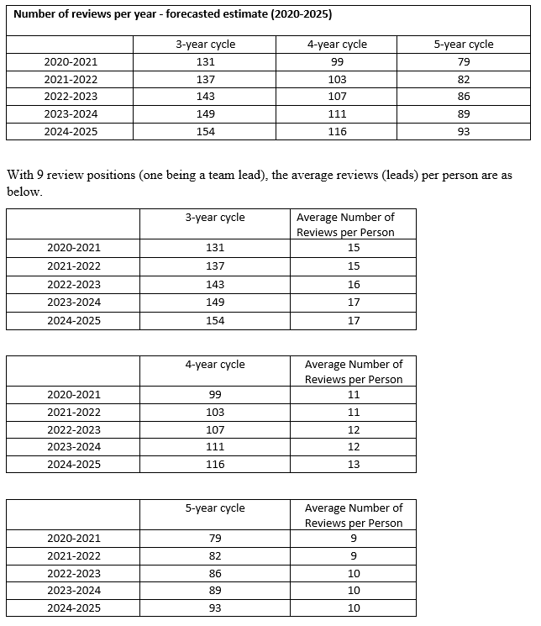
The goal of the waiver is to ensure good customer service is maintained and to align reviews to support sponsors as they strive to run exceptional school meal programs. Approval of this waiver will ensure sponsors are reviewed at least once during a 4-year review cycle while streamlining monitoring operations, allow staff to support sponsors through training and technical assistance and decrease the administrative burden on sponsors and FDACS. This will also allow FDACS and
sponsors to focus efforts on important program areas, such as financial management,
procurement, program access and participation while still ensuring program integrity in all program areas.

- Specific Program requirements to be waived (include statutory and regulatory citations). [Section 12(l)(2)(A)(i) of the NSLA]:

FDACS is requesting the use of flexibility for the Administrative Review Cycle and for the following regulatory requirement to be waived:

- Timing of reviews. State agencies must conduct administrative reviews of all school food authorities participating in the National School Lunch Program (including the Afterschool Snacks and the Seamless Summer Option) and School Breakfast Program at least once during a 3-year review cycle, provided that each school food authority is reviewed at least once every 4 years. For each State agency, the first 3-year review cycle started the school year that began on July 1, 2013 and ended on June 30, 2014. At a minimum, the on-site portion of the administrative review must be completed during the school year in which the review was begun. 7 CFR 210.18(c)

- Detailed description of alternative procedures and anticipated impact on Program operations, including technology, State systems, and monitoring:

A 4-year review cycle will allow Florida to maintain the alignment of the AR and procurement reviews and provide the opportunity to support sponsors through additional training and technical assistance. All sponsors will receive an AR and procurement review in addition to a technical assistance visit within the 4-year cycle to ensure program integrity. The procurement review is currently on a 3-year cycle with the AR and will transition to the same 4-year cycle to ensure the sponsors receive the same reviews as on the 3-year cycle. FDACS will conduct follow-up reviews (Targeted Technical Assistance Reviews) for all sponsors where significant or repeated critical or general violations exist within 2 years of their AR. If the initial violation is still in practice, the sponsor will be deemed Seriously Deficient. The sponsor will be provided 30 days to submit corrective action. FDACS will conduct a follow-up visit to ensure the corrective action has been implemented within 60 days of receipt of the corrective action. If the violations have been resolved, the Seriously Deficient status will be rescinded, and the sponsor will remain on the AR cycle. If the violations are still occurring, the sponsor will be suspended, pursuant to Rule 5P-1.004, Florida Administrative Code.

The illustration below represents the Returning Sponsor – New SMAR Process - Yellow indicates action by FDACS.

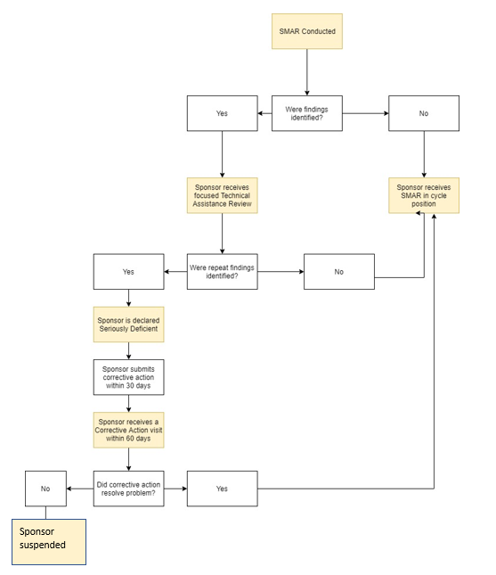

FDACS will schedule all new sponsors for their first administrative review within 12 months of program operation. Florida will also conduct Technical Assistance Visits for new sponsors within 30 days of their first claim for reimbursement. If program deficiencies are present at the Technical Assistance Visit, the sponsor will receive a Targeted Technical Assistance Review within the next 6 months. If significant or repeated critical or general violations exist, the sponsor will be deemed Seriously Deficient. The sponsor will be provided 30 days to submit corrective action. FDACS will conduct a follow-up to ensure the corrective action has been implemented within 60 days of receipt of the corrective action. If the violations have been resolved, the Seriously Deficient status will be rescinded, and the sponsor will remain on the AR cycle. If the violations are still occurring, the sponsor will be suspended, pursuant to Rule 5P-1.004, Florida Administrative Code.

The illustration below represents the New Sponsor SMAR Process - Yellow indicates action by FDACS.

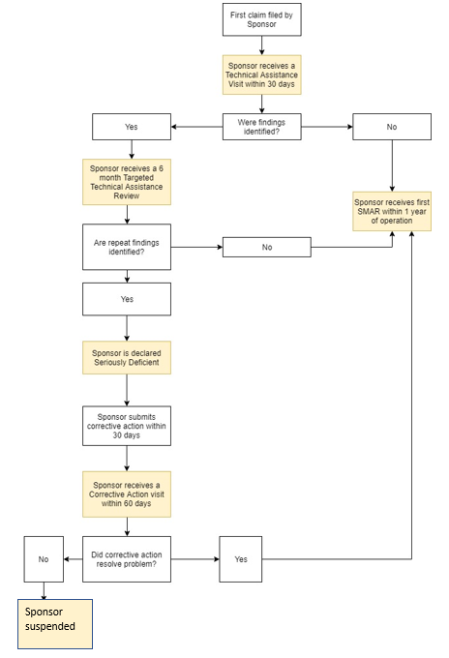

- Description of any steps the State has taken to address regulatory barriers at the State level. [Section 12(l)(2)(A)(ii) of the NSLA]:

FDACS would like to expand the current 3-year AR cycle process and tracking to a 4-year review cycle. Increasing the AR cycle by one year will continue to build program integrity by better training sponsors. Florida implemented the 3-year cycle requirement when the AR was released in 2011. Due to the burden of overloaded review schedules, technical assistance is often done in conjunction with the review, while local staff are already overwhelmed with documentation that must be completed. There is not enough time to provide thorough training during the review. Changing to a 4-year review cycle will allow our staff to provide effective and quality customer service and training for our sponsors. To address these barriers, FDACS is submitting this waiver.

- Anticipated challenges State or eligible service providers may face with the waiver implementation:

FDACS does not anticipate any challenges with waiver implementation.

- Description of how the waiver will not increase the overall cost of the Program to the Federal Government. If there are anticipated increases, confirm that the costs will be paid from non-Federal funds. [Section 12(l)(1)(A)(iii) of the NSLA]:

The waiver will not increase the overall cost of the Program to the Federal Government because it is an administrative flexibility.

- Anticipated waiver implementation date and time period:

The anticipated time period is July 1, 2019 through the end of the school year, and remaining in effect for a period of four school years until June 30, 2023.

- Proposed monitoring and review procedures:

FDACS will continue to monitor sponsors on all AR requirements outlined in 7 CFR 210.18 – Administrative Reviews, using a 4-year cycle in place of the required 3-year cycle. FDACS will continue to seek approval for 1-year extensions to the 4-year review cycle for special circumstances that may conflict with efficient FDACS management of the program, such as natural disasters. FDACS will conduct follow-up reviews (Targeted Technical Assistance Reviews) for all sponsors where significant or repeated critical or general violations exist within 2 years of their AR. If the initial violation is still in practice, the sponsor will be deemed Seriously Deficient. The sponsor will be provided 30 days to submit corrective action. FDACS will conduct a follow-up visit to ensure the corrective action has been implemented within 60 days of receipt of the corrective action. If the violations have been resolved, the Seriously Deficient status will be rescinded, and the sponsor will remain on the AR cycle. If the violations are still occurring, the sponsor will be suspended, pursuant to Rule 5P-1.004, Florida Administrative Code. FDACS will schedule all new sponsors for their first administrative review within 12 months of program operation.
FDACS will also conduct Technical Assistance Visits for new sponsors within 30 days of their first claim for reimbursement. If findings are present at the Technical Assistance Visit, the sponsor will receive a Targeted Technical Assistance Review within the next 6 months. If significant or repeated critical or general violations exist, the sponsor will be deemed Seriously Deficient. The sponsor will be provided 30 days to submit corrective action. FDACS will conduct a follow-up to ensure the corrective action has been implemented within 60 days of receipt of the corrective action. If the violations have been resolved, the Seriously Deficient status will be rescinded, and the sponsor will remain on the AR cycle. If the violations are still occurring, the sponsor will be suspended, pursuant to Rule 5P-1.004, Florida Administrative Code.

- Proposed reporting requirements (include type of data and due date(s) to FNS):

FDACS will provide FNS with required reports, including the FNS 640, program deficiencies, and recommendations provided during reviews. This information will be available annually and upon request.

