5E-4.002 Labels.
(1) Form. The analysis tag or label shall carry the information required by Section 578.09, F.S., in substantially the following form:
(a) For agricultural seed:
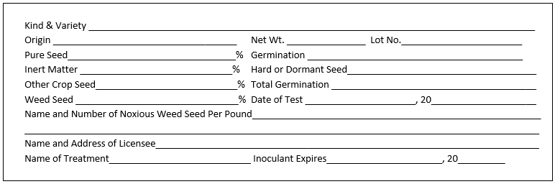
(b) For mixed agricultural seeds:
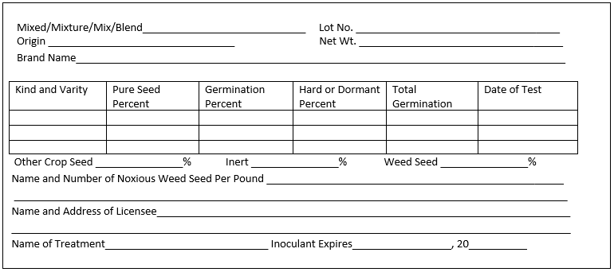
(c) For coated agricultural seed:
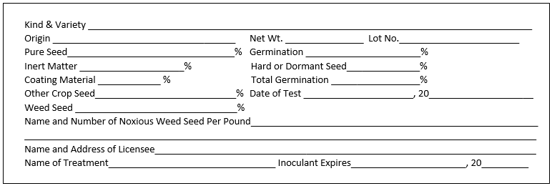
(d) For combination mulch, seed, and fertilizer products:
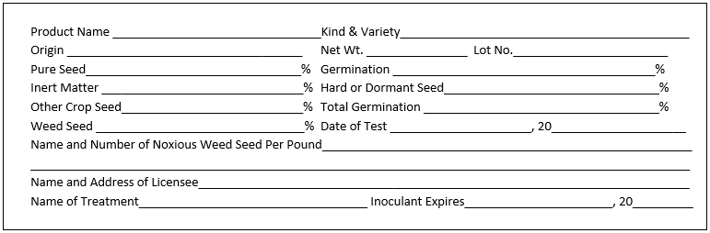
(e) Vegetable seeds in packets which germinate above standard:
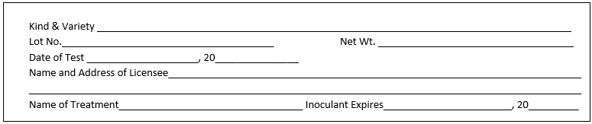
(f) Vegetable seeds in packets which germinate below standard:
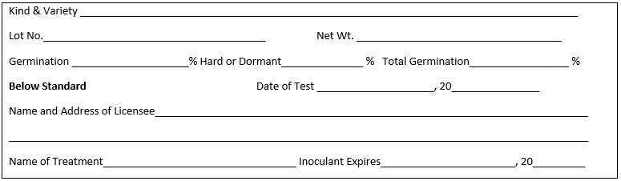
(g) Vegetable seeds other than packet seeds:
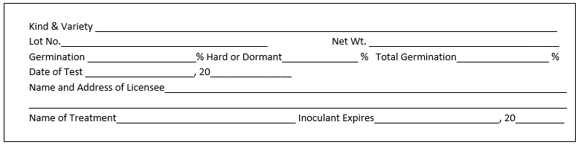
(h) Flower seeds in packets that germinate above standard:
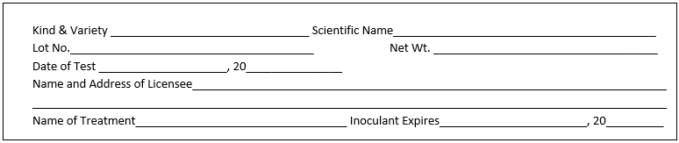
(i) Flower seeds in packets that germinate below standard:
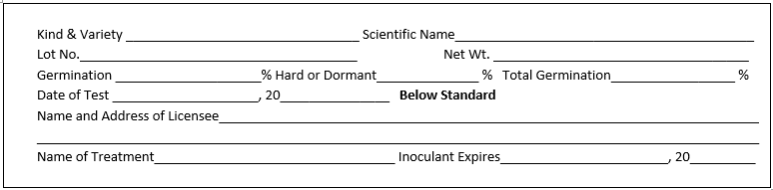
(j) Flower seeds in containers other than packets, pure seed percentage below 90%:
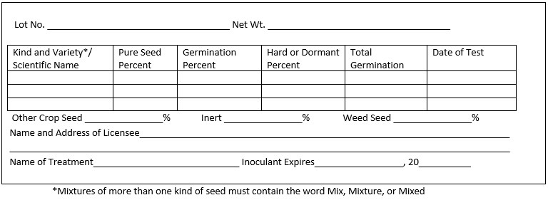
(k) Flower seeds in containers other than packets, pure seed percentage above 90%:
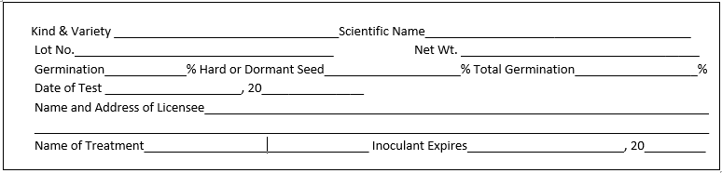
(l) For tree or shrub seed:
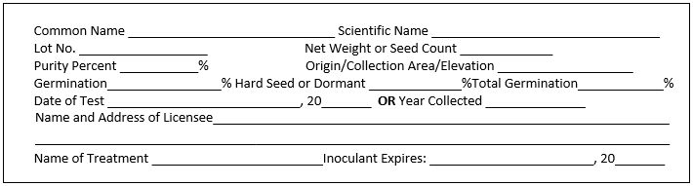
(2) The maximum percent of seed moisture for hermetically sealed containers of agricultural or vegetable seed, shall be as follows:
Family/Kind | Maximum percent Seed Moisture
1. Chenopodiaceae
a. Beet, chard | 7.5
b. Spinach | 8.0
2. Astercaeae – Lettuce | 5.5
3. Brassicaceae
a. Cabbage, broccoli, cauliflower, collard,
b. Chinese cabbage, kale, turnip, rutabaga,
c. Kohlrabi, Brussels sprouts, mustard, radish | 5.0
4. Cucurbitaceae
a. Cucumber, muskmelon, squash, pumpkin | 6.0
b. Watermelon | 6.5
5. Poaceae
a. Sweet corn | 8.0
b. Kentucky bluegrass | 6.0
c. Creeping red fescue | 8.0
d. Annual ryegrass | 8.0
e. Perennial ryegrass | 8.0
6. Fabaceae
a. Snap bean, lima bean, pea | 7.0
b. Crimson clover | 8.0
7. Amaryllidaceae – Onion, leek, chive, Welsh onion | 6.5
8. Solanaceae
a. Tomato | 5.5
b. Pepper | 4.5
c. Eggplant | 6.0
9. Apiaceae
a. Carrot, celery, celeriac | 7.0
b. Parsnip | 6.0
c. Parsley | 6.5
10. All other agricultural or vegetable seed not listed above | 6.0
(3) The term “container” includes, bin, box, bag, barrel or bulk receptacle.
(4) All information required on the seed analysis tag or label shall be identified and placed on one side of the tag or label without intervening matter. No other information or matter shall be placed on this side of the tag or label unless such information is distinguished from the analysis labeling.
(5) Analysis tag or label for agricultural seed shall show a complete analysis, and the complete purity analysis shall total one hundred percent (100%). Blank spaces on a form tag shall be deemed to imply the word “None” when such interpretation is reasonable. Either numerals or the word “None” should be used to express a percentage or numbers per pound.
(6) The name of the kind and variety of seed shall not be abbreviated, but shall be written in the words, symbols or figures as expressed by the breeder’s designation of the seed.
(7) The place of origin shall not be used in connection with the name of variety or kind of seed, unless it is a part of the generally accepted name of kind or variety. Modifying words or phrases shall not be used in connection with the variety – as for example, “for forage purposes,” etc.; nor shall brand names be used as varietal names.
(8) Upon expiration of each germination test period as prescribed by subections 578.09(2), (5), (6), (7), (8) and subsection 578.092(3) F.S., a new test shall be made and the result thereof, together with the date when same was completed, shall be shown on the label or tag attached to the container of such seed (a new label or tag is recommended).
(9) Different varieties of the same kind of seed, when in quantities of less than five percent (5%), will be shown on the label or tag as other crop seed.
(10) Hybrid varieties of seed shall be labeled with the word “Hybrid” as required by section 578.09, F.S.
Examples:
(a) Hybrid Oshkosh Alfalfa | 85.00%
other Alfalfa | 14.50%
Inert matter | .25%
Other crop seed | .15%
Weed seed | .10%
(b) Hybrid Wintergreen Cabbage | 85.00%
other Cabbage | 14.00%
Inert matter | 1.00%
Other crop seed | .00%
Weed seed | .00%
(11) The following wording will comply with the requirements of Section 578.26(1)(c), F.S., when printed on the analysis tag or label attached to the seed at the time of purchase by the buyer:
Notice: As a prerequisite to maintaining a legal action based upon the failure of seed to which this label is attached to produce as represented, a sworn complaint shall be made to the department within such time as to permit inspection of the crops, plants, or trees, accompanied by the required filing fee, and a copy of the complaint shall be sent to the seller by certified mail, in accordance with Section 578.26, F.S.
Rulemaking Authority 578.11(2) FS. Law Implemented 578.11(2), 578.09, 578.28, 578.092 FS. History–New 11-21-69, Amended 12-1-70, 9-30-72, 3-1-73, Formerly 5E-4.02, Amended 3-4-93, 6-14-95, 7-7-19.

