Notice of Bid/Request for Proposal

OTHER AGENCIES AND ORGANIZATIONS
CITY OF HIALEAH
Notice of Receipt of Unsolicited Proposal for construction of multi-family workforce housing, related parking improvements and redevelopment of an associated site for public park use
NOTICE IS HEREBY GIVEN that the City of Hialeah, Florida (the "City"), a municipal corporation of the State
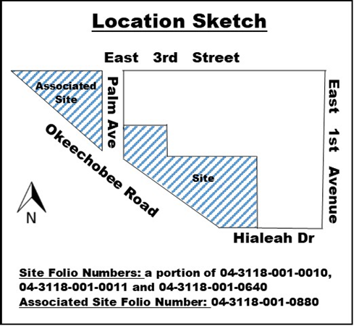
of Florida, has received an unsolicited proposal for a qualifying public-private partnership project in accordance with Section 255.065, Florida Statutes, for construction of new multi-family workforce housing to be developed and operated on real property owned by the City (the "Site"), related parking improvements to serve the new workforce housing units, and redevelopment and improvement of an associated site (the "Associated Site") for public park use (collectively, the "Project"). The Site is approximately 2.21 acres and currently serves as surface parking for the Palm Center Apartments. The Associated Site is known as Triangle Park, a public park of approximately 1.86 acres. The Site and Associated Site are shown below.

In accordance with section 255.065, Florida Statutes, the City requests and will accept alternative proposals for the Project. A more complete description of the Project, the schedule for considering proposals and related information is set forth in City Request for Proposals No. 2018-19-8500-00-002 (the "RFP"). Copies of the RFP are available at https://www.hialeahfl.gov/Bids.aspx and in the City’s Purchasing Department located at 501 Palm Avenue (4th Floor), Hialeah, Florida 33010, (305)883-5865. The deadline for submitting proposals is 3:00 p.m. on Thursday October 3, 2019. Any proposal received after that deadline will be returned unopened and will not be considered.
The City will consider entering into a comprehensive public-private partnership agreement with the successful proposer (the "P3 Partner") pursuant to which the P3 Partner will (i) lease the Site from the City for purposes of constructing and operating workforce housing facilities thereon, (ii) provide related parking improvements, and (iii) redevelop and improve the Associated Site for public park uses.
The City reserves the right to reject any or all proposals, and to negotiate a comprehensive public-private partnership agreement with the Proposer whose proposal best serves the interests of the City. Nothing contained herein shall be interpreted as an obligation or binding agreement by the City regarding the Project. All proposals received in response to this Notice will become the property of the City of Hialeah and will not be returned. Such proposals and related information shall be subject to applicable provisions of Section 255.065, Florida Statutes and Florida public records laws.

