62-342.200 Definitions.
Terms used in this chapter shall have the meanings specified below.
(1) “Banker” means an entity that creates, operates, manages, or maintains a Mitigation Bank pursuant to a Mitigation Bank Permit.
(2) “Department” means the Department of Environmental Protection.
(3) “District” means a water management district as established in Chapter 373, F.S.
(4) “Ecological Value” means the value of functions performed by uplands, wetlands and other surface waters to the abundance, diversity, and habitats of fish, wildlife, and listed species. These functions include, but are not limited to: providing cover and refuge; breeding, nesting, denning, and nursery areas; corridors for wildlife movement; food chain support; and natural water storage, natural flow attenuation, and water quality improvement, which enhance fish, wildlife and listed species utilization.
(5) “Mitigation Credit” means a standard unit of measure which represents the increase in ecological value resulting from restoration, enhancement, preservation, or creation activities.
(6) “Mitigation Service Area” means the geographic area within which Mitigation Credits from a Mitigation Bank may be used to offset adverse impacts of activities regulated under Part IV of Chapter 373, F.S.
(7) “Mitigation Bank Permit” means a permit issued to a banker to construct, operate, manage and maintain a Mitigation Bank.
(8) “Mitigation Bank” means a project permitted under Section 373.4136, F.S., undertaken to provide for the withdrawal of mitigation credits to offset adverse impacts authorized by a permit under Part IV of Chapter 373, F.S.
(9) “Regional Watershed” means a watershed as delineated in the following maps. (Figures 1, 2, 3, 4, and 5.)
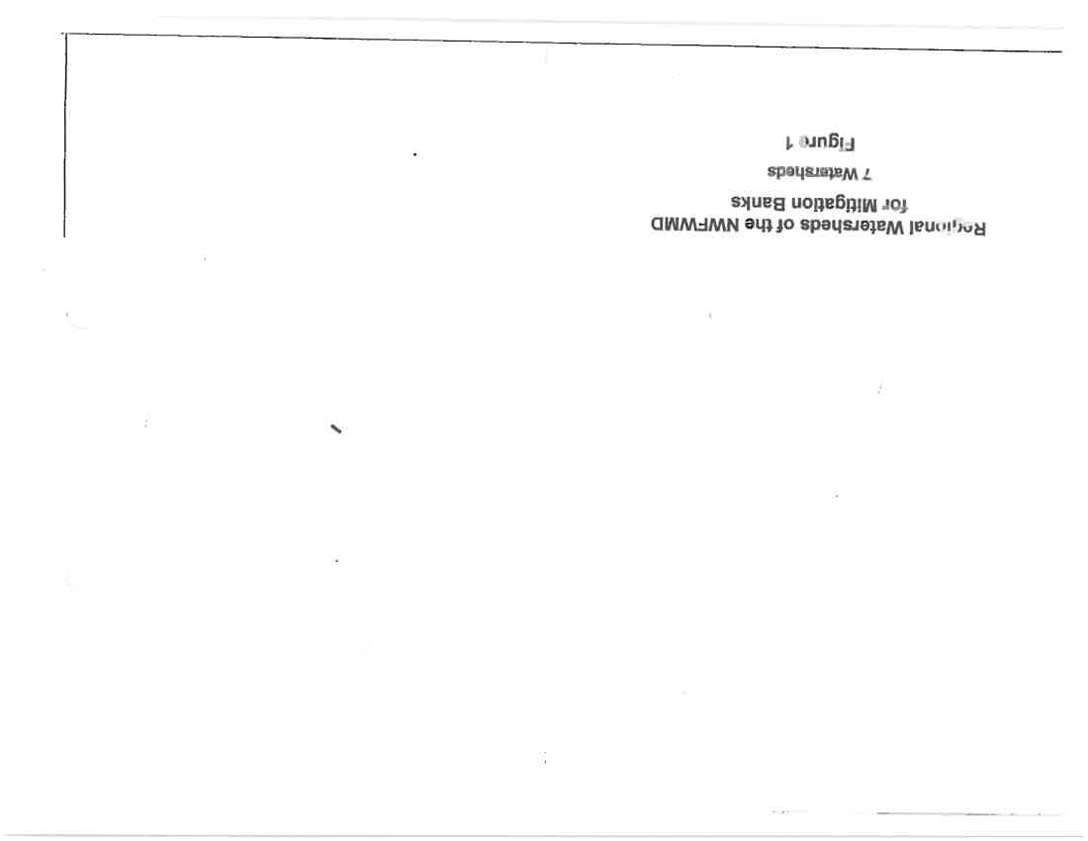

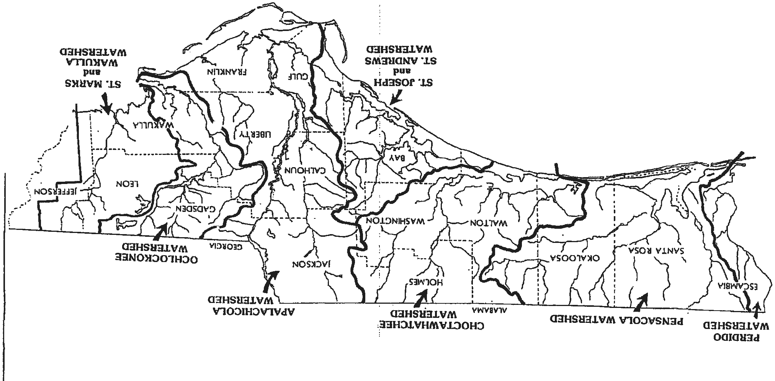



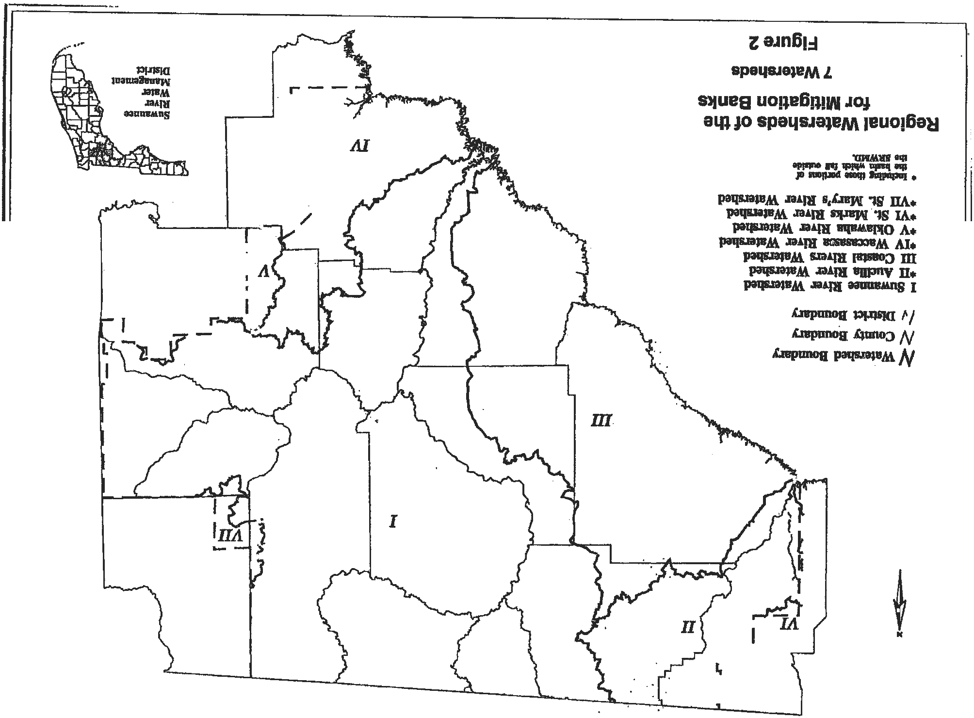



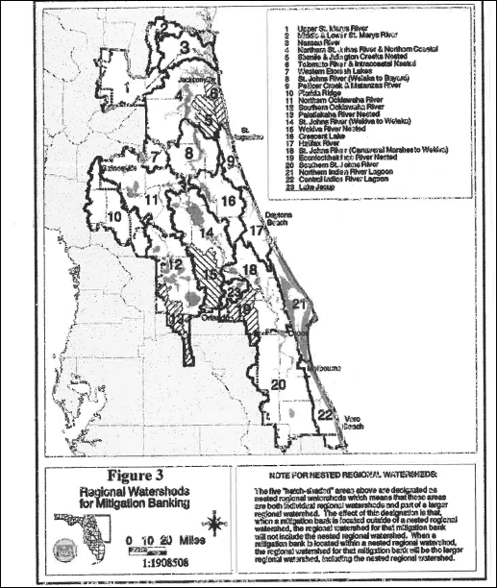


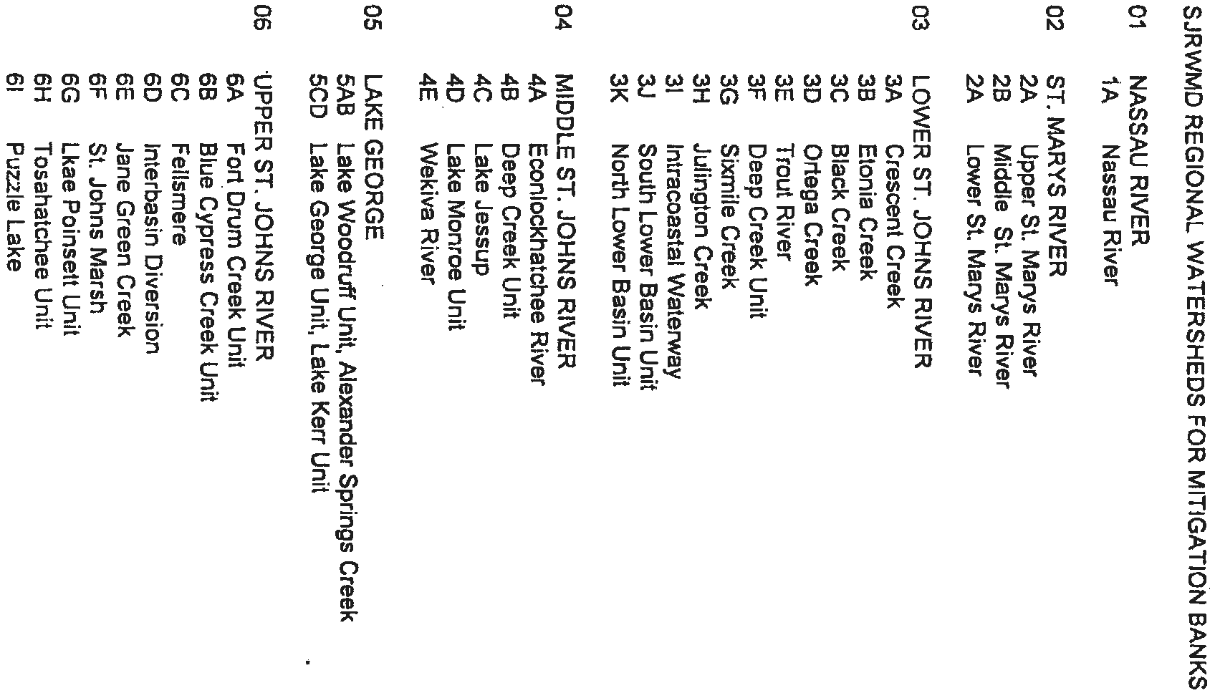


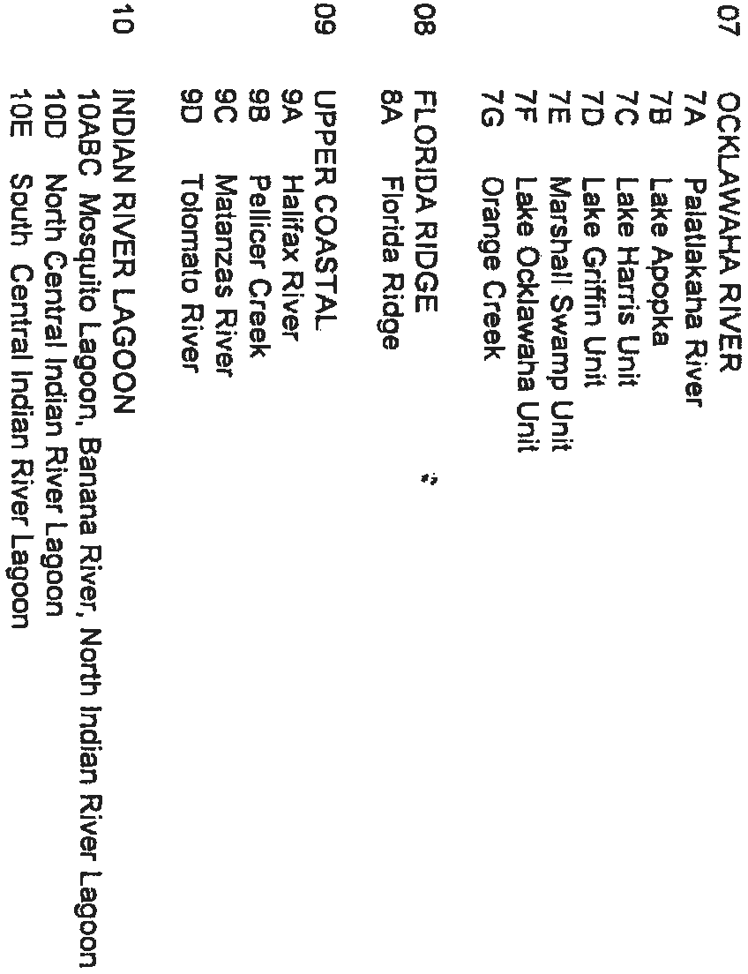

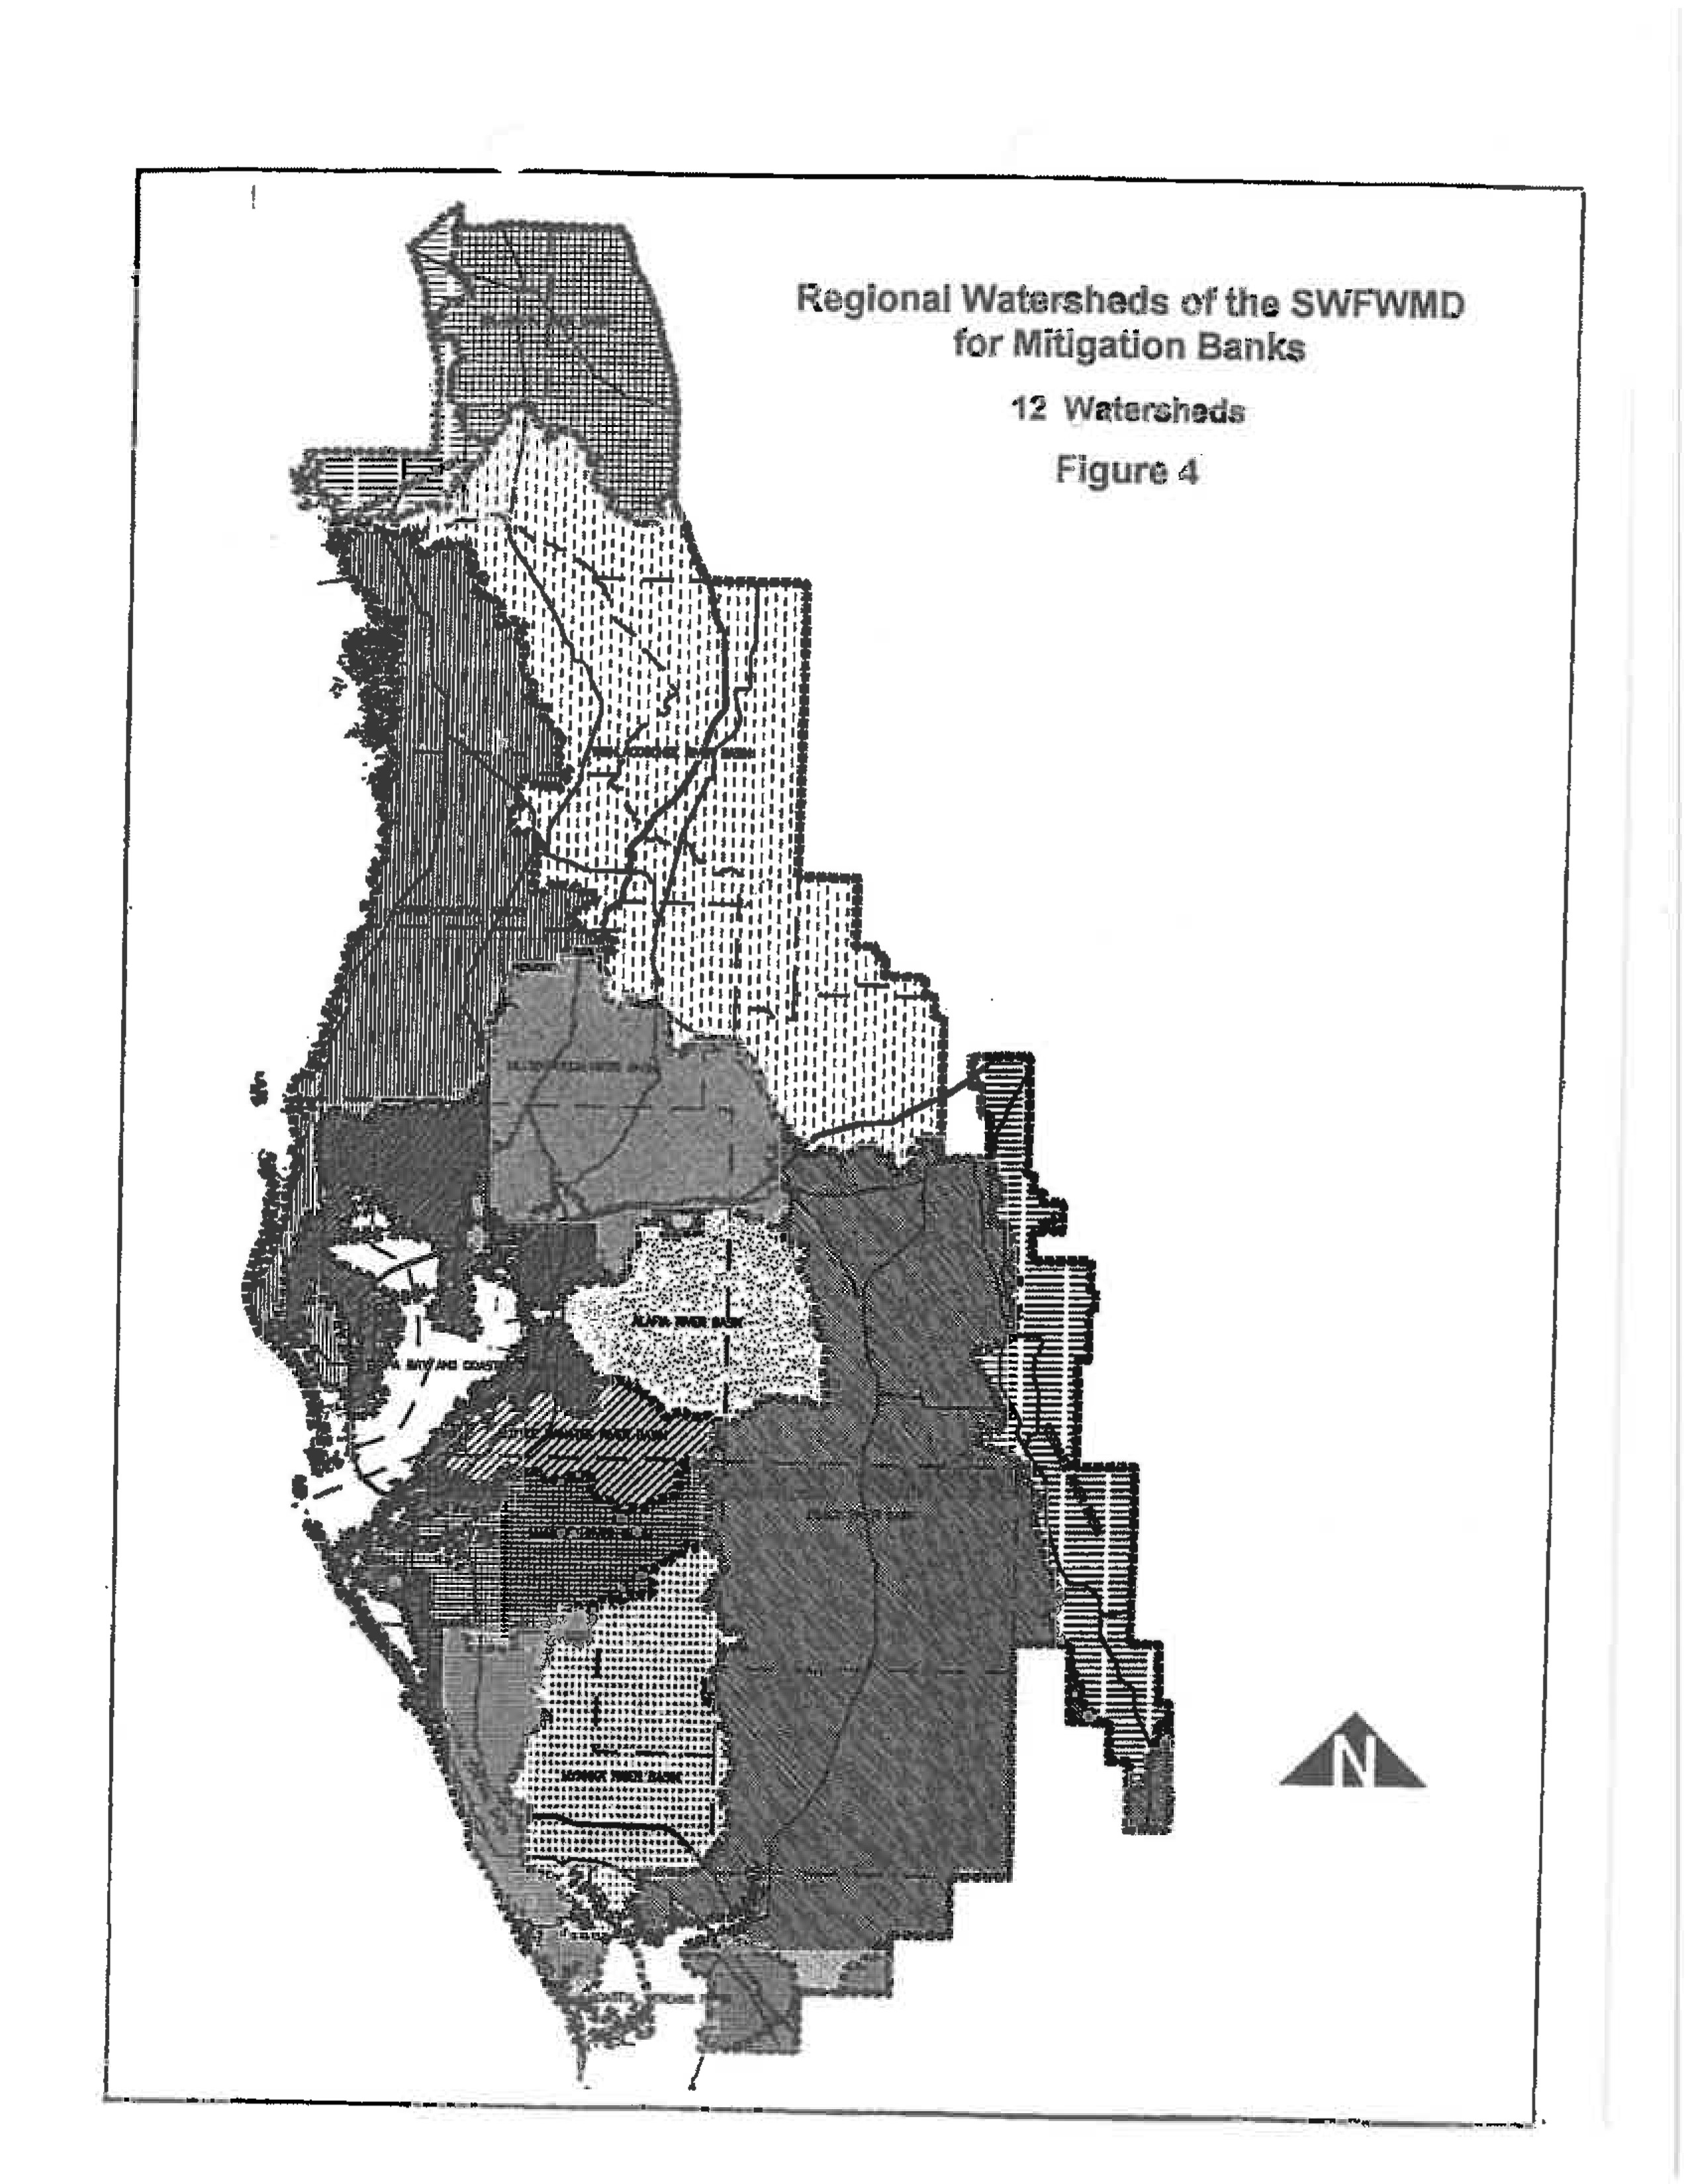
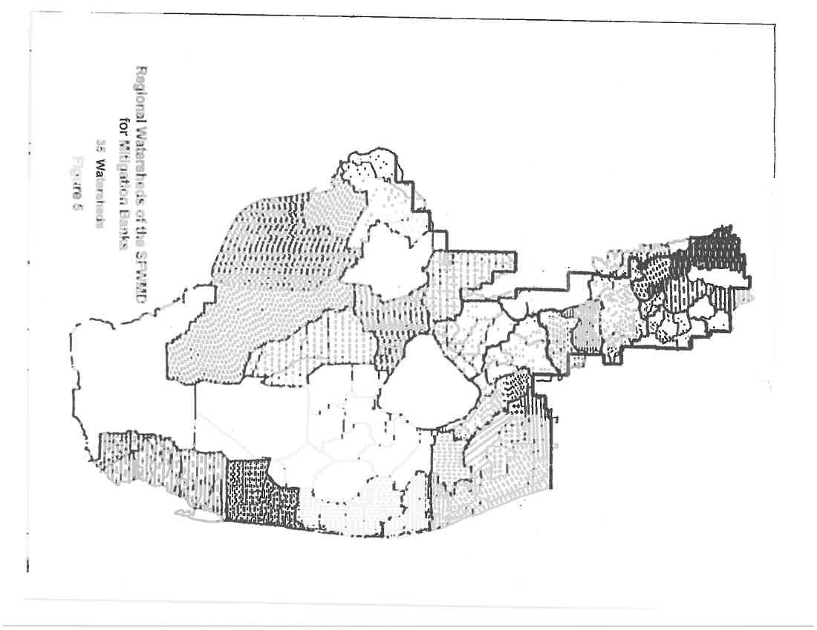


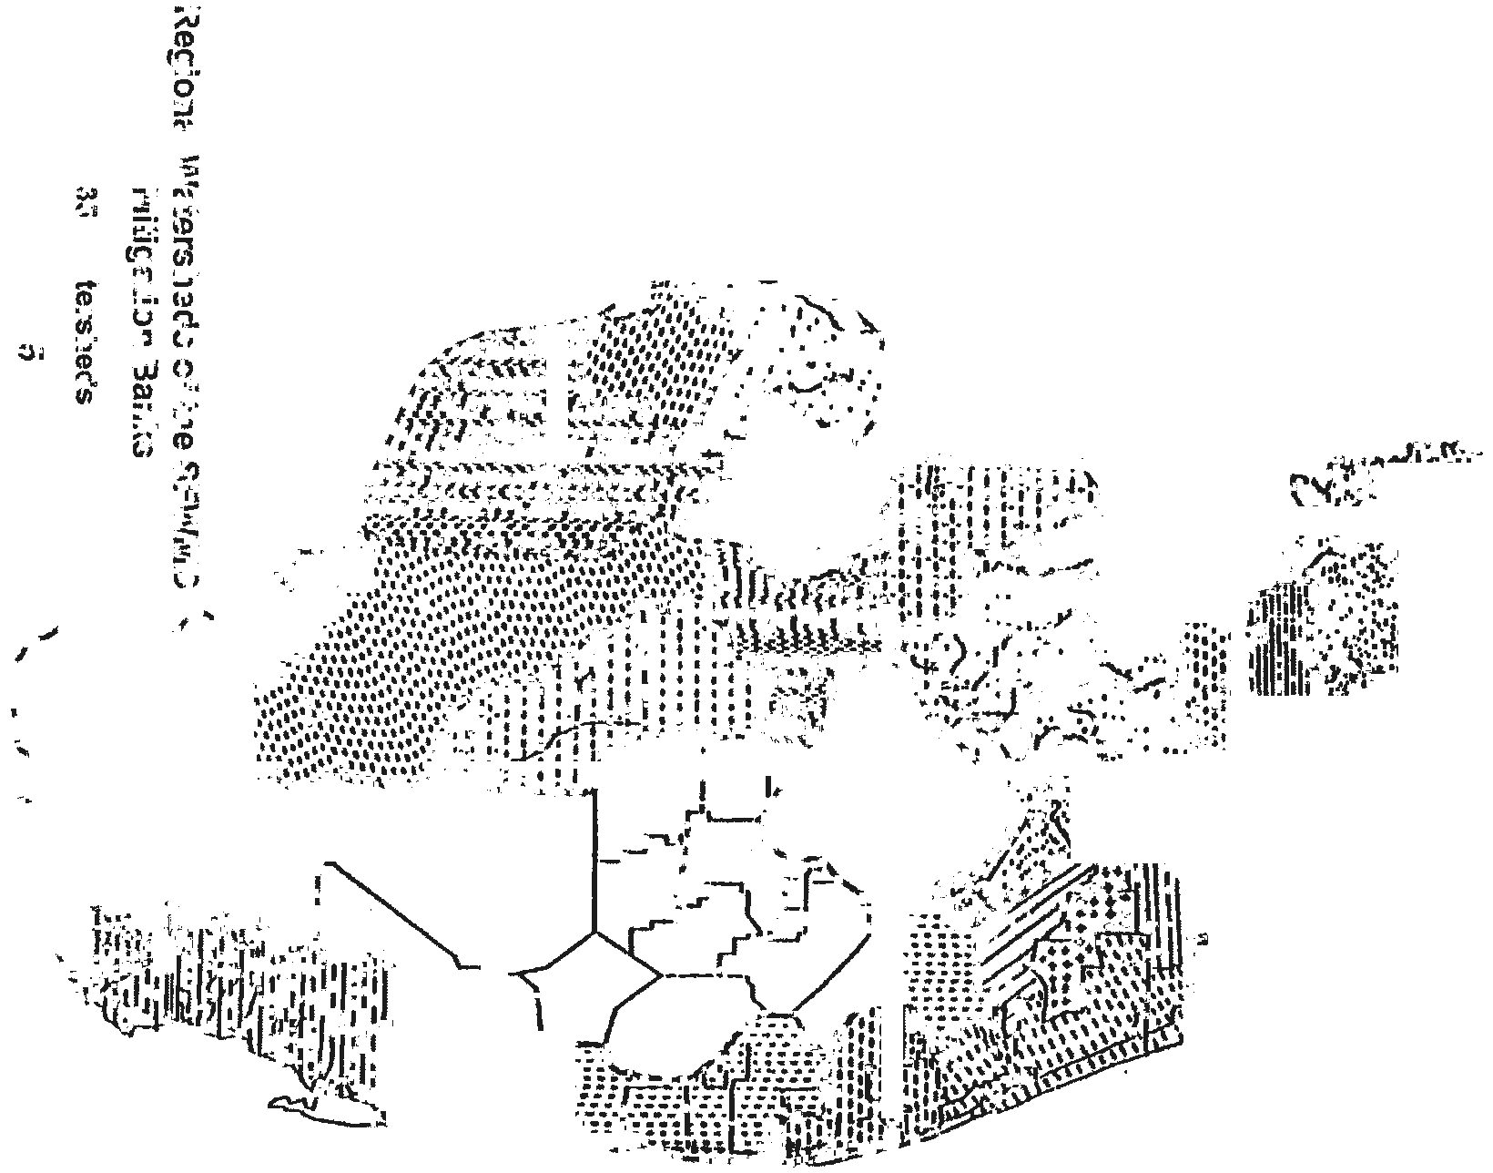
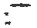




(10) “Success” means when a Mitigation Bank meets the success criteria provided in Rule 62-312.350, F.A.C., and in the Mitigation Bank Permit.
Rulemaking Authority 373.4136(11) FS. Law Implemented 373.4135, 373.4136 FS. History–New 2-2-94, Formerly 17-342.200, Amended 12-12-94, 8-21-00, 5-21-01.

