62-611.700 Monitoring Requirements.
(1) To ensure compliance with water quality standards and to establish a data base upon which to evaluate the design criteria and the performance of the treatment or receiving wetland, a monitoring program shall be required. Data to be collected shall include but not be limited to parameters, stations, and frequency as listed in Tables 1, 2, and 3. After three years of operation, the permittee may request a modification in the parameters and frequency of the monitoring program based on a demonstration that there is an adequate data base to predict future trends in the effects of the discharge of reclaimed water on the wetland. The proposed monitoring plans, using scientifically accepted methodology and appropriate quality assurance, shall be submitted to the Department. The Department shall approve or deny the plan within 45 days of receipt of all necessary information. Upon Department approval of the plan and format for data reporting, baseline monitoring may begin.
(2) Upon Department approval of the plan and format for data reporting an application to construct a domestic wastewater treatment and disposal system may be filed. Before discharge of reclaimed water to a treatment or receiving wetland begins, the applicant shall complete a baseline monitoring program to determine background conditions. The department shall utilize baseline monitoring data to evaluate whether the discharge from a treatment or receiving wetland will exceed the limits established pursuant to Rule 62-611.450, F.A.C. The Department may determine that an application to construct a domestic wastewater treatment and disposal system is complete prior to completion of the baseline monitoring program if, pursuant to subsections 62-4.070(1) and 62-302.300(5), F.A.C., reasonable assurance is provided by the applicant that the discharge from the treatment or receiving wetland will not cause or contribute to violations of water quality criteria contained in Chapter 62-302, F.A.C., in contiguous and downstream waters. If baseline monitoring data indicate the discharge from the treatment or receiving wetland may exceed the limits established in Rule 62-611.450, F.A.C., Water Quality Based Effluent Limitations (WQBEL) must be established pursuant to Rule 62-600.430, F.A.C. Any WQBEL shall be incorporated as a permit condition.
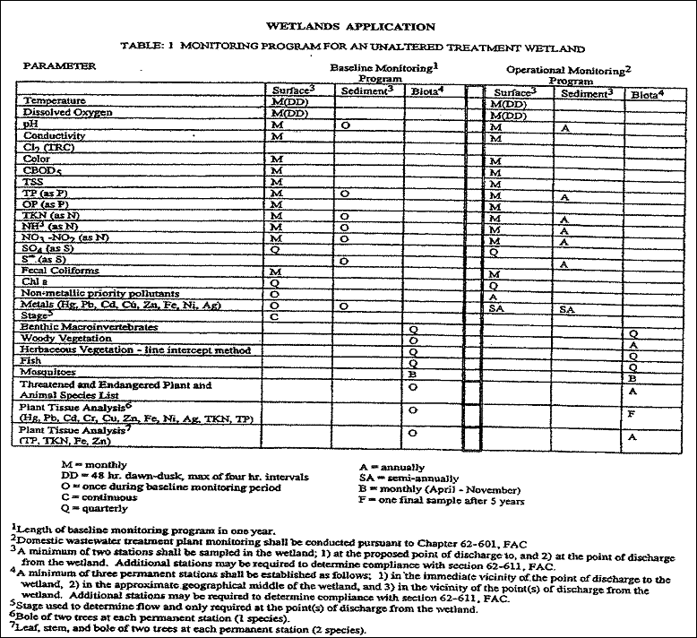
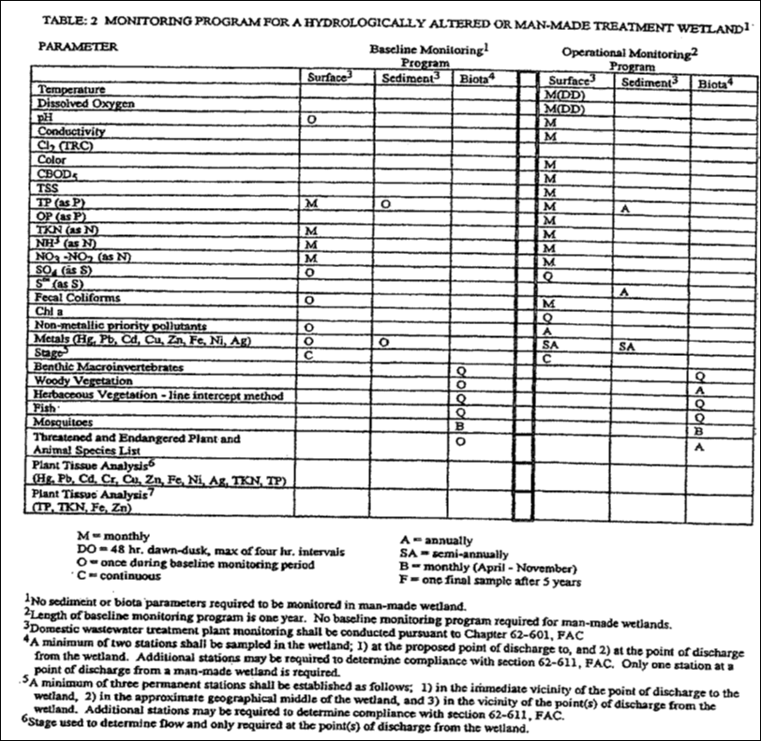

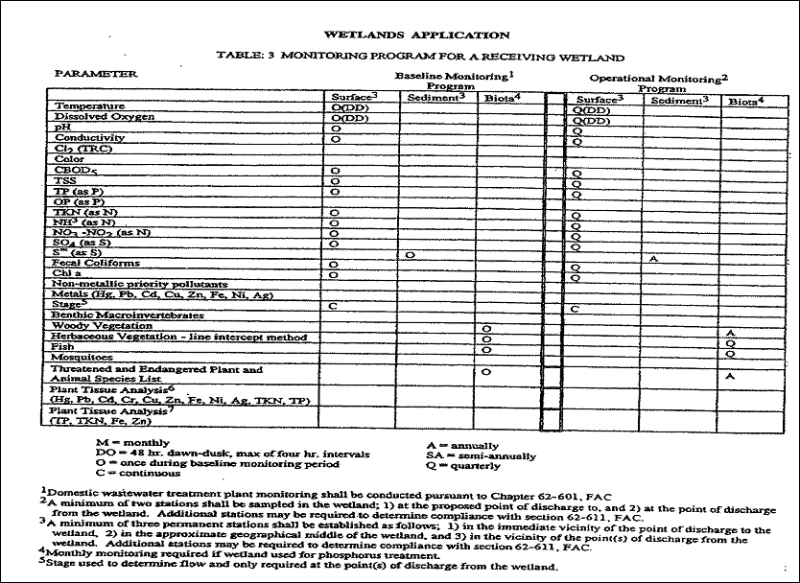
Rulemaking Authority 403.061, 373.414(4) FS. Law Implemented 403.051, 403.061, 403.085, 403.086, 403.087, 403.088, 373.414(4) FS. History–New 11-27-89, Formerly 17-611.700.

