Notice of Emergency Rule

DEPARTMENT OF THE LOTTERY
RULE NO.: RULE TITLE:
53ER20-35: Game Number 5017, MATCH 3 TRIPLER
SUMMARY: This emergency rule describes Game Number 5017, “MATCH 3 TRIPLER," for which the Department of the Lottery will start selling tickets on a date to be determined by the Secretary of the Department. The rule sets forth the specifics of the game; determination of prizewinners; estimated odds of winning, value and number of prizes in the game.
THE PERSON TO BE CONTACTED REGARDING THE EMERGENCY RULE IS: Diane D. Schmidt, Legal Analyst, Department of the Lottery, 250 Marriott Drive, Tallahassee, Florida 32399-4011.
THE FULL TEXT OF THE EMERGENCY RULE IS:
53ER20-35 Game Number 5017, MATCH 3 TRIPLER.
(1) Name of Game. Game Number 5017, MATCH 3 TRIPLER.
(2) Game Number 5017, MATCH 3 TRIPLER is a Scratch-Off lottery game (also known as an instant lottery game).
(3) Price. MATCH 3 TRIPLER lottery tickets sell for $2.00 per ticket.
(4) MATCH 3 TRIPLER lottery tickets shall have a series of numbers in machine readable code (or bar code) on the back of the ticket, along with a validation number under the latex area on the ticket. To be a valid winning MATCH 3 TRIPLER lottery ticket, the ticket must meet the applicable requirements of Rule 53ER17-54, Payment of Prizes, Florida Administrative Code.
(5) The play symbols and play symbol captions that may appear in the play area of a GAME are as follows:
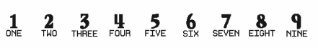
(6) The prize symbols and prize symbol captions that may appear in the YOUR NUMBERS play area are as follows:
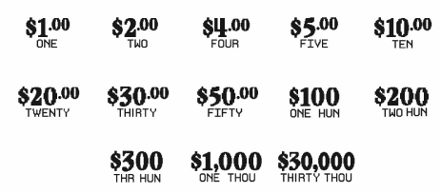
(7) The legends are as follows:
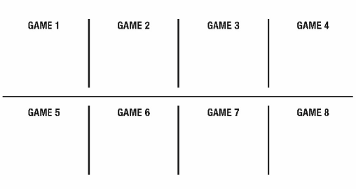
(8) Determination of Prizewinners. There are 8 GAMES on each MATCH 3 TRIPLER ticket. Each GAME is played separately.
(a) A ticket having two “3” play symbols and corresponding play symbol captions in the play area of a GAME shall entitle the prizewinner to the corresponding prize shown for that GAME.
(b) A ticket having three “3” play symbols and corresponding play symbol captions in the play area of a GAME shall entitle the prizewinner to triple the corresponding prize shown for that GAME.
(c) A player may win up to eight times on a ticket.
(9) The estimated odds of winning, value, and number of prizes in Game Number 5017 are as follows:
GAME PLAY | WIN | ESTIMATED ODDS OF 1 IN | NUMBER OF WINNERS IN 112 POOLS OF 180,000 TICKETS PER POOL
$2 | $2 | 10.00 | 2,016,000
$1 x 4 | $4 | 50.00 | 403,200
$1(333) + $1 | $4 | 50.00 | 403,200
$2 x 2 | $4 | 46.88 | 430,080
$4 | $4 | 46.88 | 430,080
$1 x 5 | $5 | 375.00 | 53,760
$1 + $4 | $5 | 375.00 | 53,760
($2 x 2) + $1 | $5 | 375.00 | 53,760
$1(333) + $2 | $5 | 375.00 | 53,760
$5 | $5 | 375.00 | 53,760
$2 x 5 | $10 | 375.00 | 53,760
$5 x 2 | $10 | 250.00 | 80,640
($4 x 2) + $2 | $10 | 250.00 | 80,640
$2(333) + ($2 x 2) | $10 | 187.50 | 107,520
$10 | $10 | 250.00 | 80,640
$2(333) + ($5 x 2) + $4 | $20 | 750.00 | 26,880
($4 x 2) + ($5 x 2) + $2 | $20 | 750.00 | 26,880
$5(333) + $5 | $20 | 750.00 | 26,880
$10 x 2 | $20 | 750.00 | 26,880
$20 | $20 | 750.00 | 26,880
($4 x 7) + $2 | $30 | 1,000.00 | 20,160
$5(333) + ($5 x 3) | $30 | 1,000.00 | 20,160
$10 x 3 | $30 | 1,000.00 | 20,160
$5(333) x 2 | $30 | 1,000.00 | 20,160
$30 | $30 | 1,000.00 | 20,160
($5 x 6) + ($10 x 2) | $50 | 2,465.75 | 8,176
$10(333) + ($10 x 2) | $50 | 2,571.43 | 7,840
$30 + $10 + ($5 x 2) | $50 | 2,571.43 | 7,840
$10(333) + $20 | $50 | 2,571.43 | 7,840
$50 | $50 | 2,571.43 | 7,840
($10 x 6) + ($20 x 2) | $100 | 3,600.00 | 5,600
$20(333) + $10(333) + $10 | $100 | 3,600.00 | 5,600
($30 x 2) + ($20 x 2) | $100 | 3,600.00 | 5,600
$50 + $20 + $10(333) | $100 | 4,500.00 | 4,480
$100 | $100 | 4,500.00 | 4,480
($30 x 7) + $30(333) | $300 | 36,000.00 | 560
($100 x 2) + $50 + ($10 x 5) | $300 | 36,000.00 | 560
$50(333) + ($50 x 3) | $300 | 36,000.00 | 560
$100(333) | $300 | 45,000.00 | 448
$300 | $300 | 45,000.00 | 448
$100(333) + ($100 x 7) | $1,000 | 90,000.00 | 224
$200(333) + ($100 x 4) | $1,000 | 90,000.00 | 224
$1,000 | $1,000 | 90,000.00 | 224
$30,000 | $30,000 | 2,520,000.00 | 8
(10) The estimated overall odds of winning some prize in Game Number 5017 are 1 in 4.33. Prizes, including the top prizes, are subject to availability at the time of ticket purchase. Prizes may be unavailable due to prior sales or other causes occurring in the normal course of business including, but not limited to, ticket damage, defect, theft, or loss.
(11) For reorders of Game Number 5017, the estimated odds of winning, value, and number of prizes shall be proportionate to the number of tickets reordered.
(12) Payment of prizes for MATCH 3 TRIPLER lottery tickets shall be made in accordance with the rule of the Florida Lottery governing payment of prizes. A copy of the current rule can be obtained from the Florida Lottery, Office of the General Counsel, 250 Marriott Drive, Tallahassee, Florida 32399-4011.
Rulemaking Authority 24.105(9)(a), (b), (c), 24.109(1), 24.115(1) FS. Law Implemented 24.105(9)(a), (b), (c), 24.115(1) FS. History- New 5-14-20.
THIS RULE TAKES EFFECT UPON BEING FILED WITH THE DEPARTMENT OF STATE UNLESS A LATER TIME AND DATE IS SPECIFIED IN THE RULE.
EFFECTIVE DATE: May 14, 2020.

