Notice of Emergency Rule

DEPARTMENT OF THE LOTTERY
RULE NO.: RULE TITLE:
53ER20-62 7-11-21®
SUMMARY: This emergency rule describes the Fast Play™ game, 7-11-21®. The rule sets forth the specifics of the game; determination of prizewinners; estimated odds of winning, value and number of prizes in the game.
THE PERSON TO BE CONTACTED REGARDING THE EMERGENCY RULE IS: Diane D. Schmidt, Legal Analyst, Department of the Lottery, 250 Marriott Drive, Tallahassee, Florida 32399-4011.

THE FULL TEXT OF THE EMERGENCY RULE IS:

53ER20-62 7-11-21®.
(1) Name of Game. 7-11-21®.
(2) Price. 7-11-21® lottery tickets sell for $5.00 per play.
(3) Game Description. 7-11-21® is a Fast Play™ instant-win game (also known as an online terminal game) printed from an authorized Florida Lottery retailer terminal at the time of purchase. Players may play the game and determine immediately if the ticket is a winner. All prizes are predetermined. The player does not have the ability to select his or her own numbers or play symbols.
(4) 7-11-21® Lottery Ticket Purchase. Players may purchase a 7-11-21® lottery ticket at an authorized retailer by telling the retailer; presenting to the retailer a barcode found on 7-11-21® supporting materials or on the Florida Lottery Mobile Convenience App; or by submitting a 7-11-21® play slip for processing through a retailer terminal. In addition, a 7-11-21® barcode may be printed from the Florida Lottery’s website at flalottery.com. Supporting materials with a 7-11-21® barcode include tear pads, game brochures or Florida Lottery emails.
(a) Players who choose to purchase a 7-11-21® lottery ticket or tickets by telling the retailer shall specify the number of plays desired. Each play will print on a separate ticket.
(b) Players who choose to present a barcode to purchase a 7-11-21® lottery ticket shall provide the barcoded material or their mobile device to the retailer to scan. One scanned barcode will produce one 7-11-21® lottery ticket.
(c) Players who choose to use a paper play slip to purchase a 7-11-21® lottery ticket or tickets may mark the appropriate box on the paper play slip for the number of plays desired and submit it to the retailer. The retailer will process the paper play slip through the retailer terminal. Each play will print on a separate ticket. Paper play slips must be Florida Lottery approved and players must use only blue or black ink or pencil for making selections.
(d) 7-11-21® lottery tickets cannot be purchased through a Florida Lottery vending machine.
(e) 7-11-21® lottery tickets cannot be canceled.
(5) The play symbols that may appear in the YOUR CARDS or WILD CARD play area are as follows:
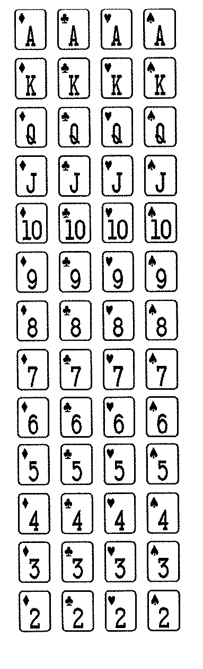
(6) How to Play and Determination of Prizewinners.
(a) There are 10 PLAYS on each ticket. Each PLAY is played separately. The K, Q, and J have a value of 10. The A has a value of 11. In each PLAY, if the total of all three cards (two YOUR CARDS and one WILD CARD) is 7, 11, or 21, using either LUCKY CARD as the WILD CARD, win that PLAY. A ticket having four or more winning PLAYS shall entitle the prizewinner to the corresponding prize shown in the PRIZE LEGEND for that number of PLAYS. Only the highest prize per winning ticket is paid. LUCKY CARDS may be used multiple times on a ticket.
(b) The prizes are $5, $10, $20, $50, $100, $500 and $50,000.
(7) The prize structure and odds of winning are as follows:

GAME PLAY | PRIZE | NUMBER OF WINNERS IN 360,000 (Per Pool) | ODDS PER POOL OF 1 IN
Win on 10 Plays | $50,000 | 1 | 360,000.00
Win on 9 Plays | $500 | 40 | 9,000.00
Win on 8 Plays | $100 | 715 | 503.50
Win on 7 Plays | $50 | 1,965 | 183.21
Win on 6 Plays | $20 | 18,500 | 19.46
Win on 5 Plays | $10 | 37,500 | 9.60
Win on 4 Plays | $5 | 55,000 | 6.55

(8) The estimated overall odds of winning some prize in the 7-11-21® game are 1:3.17. The 7-11-21® prize structure will be replenished automatically as each ticket is sold in each prize tier, including both winning and non-winning prize tiers. The odds remain the same for each ticket purchased for the life of the game.
(9) 7-11-21® Additional Provisions.
(a) By purchasing a 7-11-21® lottery ticket, a player agrees to comply with and abide by all rules and regulations of the Florida Lottery.
(b) Prizes must be claimed within 60 days after the official end of game. All 7-11-21® prizes shall be paid in a single, lump-sum payment. Ticket validation requirements for Fast Play 7-11-21® lottery tickets are set forth in the rule of the Florida Lottery governing payment of prizes. Payment of prizes for Fast Play 7-11-21® lottery tickets shall be made in accordance with the rule of the Florida Lottery governing payment of prizes. A copy of the current rule can be obtained from the Florida Lottery, Office of the General Counsel, 250 Marriott Drive, Tallahassee, Florida 32399-4011.
(c) It is the responsibility of the player to verify the readability of the information printed on the 7-11-21® lottery ticket at the time of purchase. Additionally, the player should check the date and time printed on a 7-11-21® lottery ticket to confirm that the printed date and time of purchase correspond to the actual date and time of purchase. It shall be the responsibility of the player to immediately notify the retailer of any such errors or discrepancies of a ticket prior to leaving the retailer location.
(d) Subject to a retailer’s hours of operation and gaming system availability, 7-11-21® lottery tickets are available for purchase daily between the hours of 6:00 a.m. and 12:00 midnight, Eastern Time (ET).
(10) The effective date of this emergency rule is August 3, 2020.
Rulemaking Authority 24.105(9)(a), (b), (c), (e), (h) 24.109(1), 24.115(1) FS. Law Implemented 24.105(9)(a), (b), (c), (e), (h), 24.115(1) FS. History- New 8-3-20.

THIS RULE TAKES EFFECT UPON BEING FILED WITH THE DEPARTMENT OF STATE UNLESS A LATER TIME AND DATE IS SPECIFIED IN THE RULE.
EFFECTIVE DATE: August 3, 2020.

