Notice of Emergency Rule

DEPARTMENT OF THE LOTTERY
RULE NO.: RULE TITLE:
53ER20-63 GOLD RUSH CROSSWORD
SUMMARY: This emergency rule describes the Fast Play™ game, GOLD RUSH CROSSWORD. The rule sets forth the specifics of the game; determination of prizewinners; estimated odds of winning, value and number of prizes in the game.
THE PERSON TO BE CONTACTED REGARDING THE EMERGENCY RULE IS: Diane D. Schmidt, Legal Analyst, Department of the Lottery, 250 Marriott Drive, Tallahassee, Florida 32399-4011.

THE FULL TEXT OF THE EMERGENCY RULE IS:

53ER20-63 GOLD RUSH CROSSWORD.
(1) Name of Game. GOLD RUSH CROSSWORD.
(2) Price. GOLD RUSH CROSSWORD lottery tickets sell for $2.00 per play.
(3) Game Description. GOLD RUSH CROSSWORD is a Fast Play™ instant-win game (also known as an online terminal game) printed from an authorized Florida Lottery retailer terminal at the time of purchase. Players may play the game and determine immediately if the ticket is a winner. All prizes are predetermined. The player does not have the ability to select his or her own numbers or play symbols.
(4) GOLD RUSH CROSSWORD Lottery Ticket Purchase. Players may purchase a GOLD RUSH CROSSWORD lottery ticket at an authorized retailer by telling the retailer; presenting to the retailer a barcode found on GOLD RUSH CROSSWORD supporting materials or on the Florida Lottery Mobile Convenience App; or by submitting a GOLD RUSH CROSSWORD play slip for processing through a retailer terminal. In addition, a GOLD RUSH CROSSWORD barcode may be printed from the Florida Lottery’s website at flalottery.com. Supporting materials with a GOLD RUSH CROSSWORD barcode include tear pads, game brochures or Florida Lottery emails.
(a) Players who choose to purchase a GOLD RUSH CROSSWORD lottery ticket or tickets by telling the retailer shall specify the number of plays desired. Each play will print on a separate ticket.
(b) Players who choose to present a barcode to purchase a GOLD RUSH CROSSWORD lottery ticket shall provide the barcoded material or their mobile device to the retailer to scan. One scanned barcode will produce one GOLD RUSH CROSSWORD lottery ticket.
(c) Players who choose to use a paper play slip to purchase a GOLD RUSH CROSSWORD lottery ticket or tickets may mark the appropriate box on the paper play slip for the number of plays desired and submit it to the retailer. The retailer will process the paper play slip through the retailer terminal. Each play will print on a separate ticket. Paper play slips must be Florida Lottery approved and players must use only blue or black ink or pencil for making selections.
(d) GOLD RUSH CROSSWORD lottery tickets cannot be purchased through a Florida Lottery vending machine.
(e) GOLD RUSH CROSSWORD lottery tickets cannot be canceled.
(5) The play symbols that may appear in the YOUR CALL LETTERS play area and the crossword puzzle grid play area are as follows:
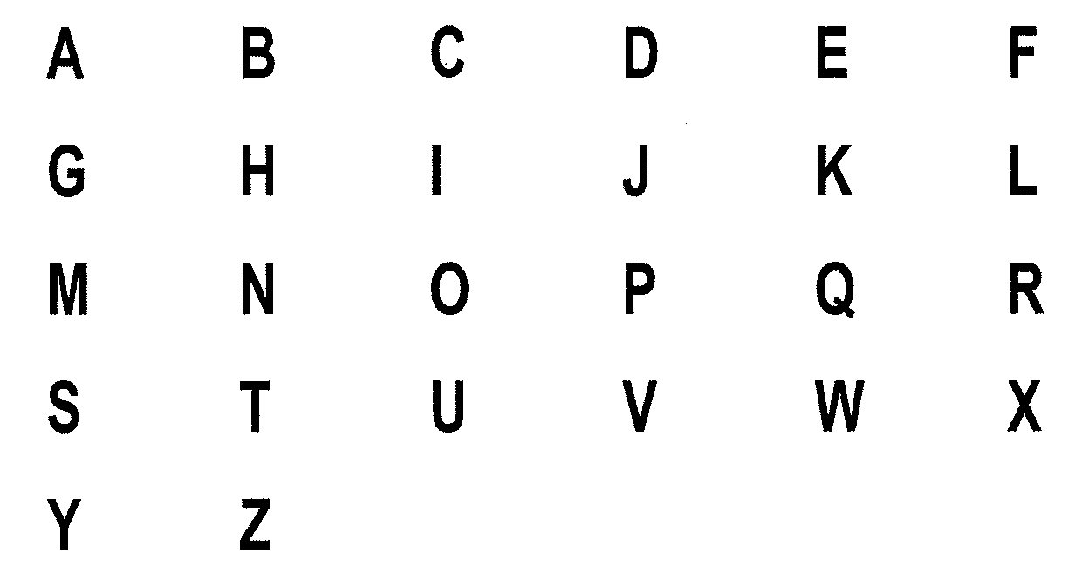
(6) How to Play and Determination of Prizewinners.
(a) A ticket having play symbols in the YOUR CALL LETTERS play area that match the play symbols in the crossword puzzle grid play area to form four or more words shall entitle the prizewinner to the corresponding prize shown in the PRIZE LEGEND for the total number of words matched. Only the highest prize won is paid per ticket. A complete word must contain at least three (3) letters. A word cannot be formed by linking letters diagonally or by reading the letters from the bottom to top or right to left. Letters combined to form a “word” must appear in an unbroken horizontal or vertical string of letters in the crossword puzzle. Every letter in the unbroken string must be revealed in YOUR CALL LETTERS and must be included to form a “word.” The possible complete words are shown in the crossword puzzle grid play area. Each possible complete word consists of three (3) or more letters and occupies an entire word space. All of the letters in a possible complete word must be matched in order to complete the word.
(b) The prizes are: $2, $5, $10, $20, $50, $500, and $10,000.
(7) The prize structure and odds of winning are as follows:

GAME PLAY | PRIZE | NUMBER OF WINNERS IN 360,000 (Per Pool) | ODDS PER POOL OF 1 IN
10 Words | $10,000 | 1 | 360,000.00
9 Words | $500 | 15 | 24,000.00
8 Words | $50 | 640 | 562.50
7 Words | $20 | 3,260 | 110.43
6 Words | $10 | 12,610 | 28.55
5 Words | $5 | 27,530 | 13.08
4 Words | $2 | 51,965 | 6.93

(8) The estimated overall odds of winning some prize in the GOLD RUSH CROSSWORD game are 1:3.75. The GOLD RUSH CROSSWORD prize structure will be replenished automatically as each ticket is sold in each prize tier, including both winning and non-winning prize tiers. The odds remain the same for each ticket purchased for the life of the game.
(9) GOLD RUSH CROSSWORD Additional Provisions.
(a) By purchasing a GOLD RUSH CROSSWORD lottery ticket, a player agrees to comply with and abide by all rules and regulations of the Florida Lottery.
(b) Prizes must be claimed within 60 days after the official end of game. All GOLD RUSH CROSSWORD prizes shall be paid in a single, lump-sum payment. Ticket validation requirements for Fast Play GOLD RUSH CROSSWORD lottery tickets are set forth in the rule of the Florida Lottery governing payment of prizes. Payment of prizes for Fast Play GOLD RUSH CROSSWORD lottery tickets shall be made in accordance with the rule of the Florida Lottery governing payment of prizes. A copy of the current rule can be obtained from the Florida Lottery, Office of the General Counsel, 250 Marriott Drive, Tallahassee, Florida 32399-4011.
(c) It is the responsibility of the player to verify the readability of the information printed on the GOLD RUSH CROSSWORD lottery ticket at the time of purchase. Additionally, the player should check the date and time printed on a GOLD RUSH CROSSWORD lottery ticket to confirm that the printed date and time of purchase correspond to the actual date and time of purchase. It shall be the responsibility of the player to immediately notify the retailer of any such errors or discrepancies of a ticket prior to leaving the retailer location.
(d) Subject to a retailer’s hours of operation and gaming system availability, GOLD RUSH CROSSWORD lottery tickets are available for purchase daily between the hours of 6:00 a.m. and 12:00 midnight, Eastern Time (ET).
(10) The effective date of this emergency rule is August 3, 2020.
Rulemaking Authority 24.105(9)(a), (b), (c), (e), (h) 24.109(1), 24.115(1) FS. Law Implemented 24.105(9)(a), (b), (c), (e), (h), 24.115(1) FS. History- New 8-3-20.

THIS RULE TAKES EFFECT UPON BEING FILED WITH THE DEPARTMENT OF STATE UNLESS A LATER TIME AND DATE IS SPECIFIED IN THE RULE.
EFFECTIVE DATE: August 3, 2020.

