53ER20-67 Game Number 5018, FULL OF $200s.
(1) Name of Game. Game Number 5018, FULL OF $200s.
(2) Game Number 5018, FULL OF $200s is a Scratch-Off lottery game (also known as an instant lottery game).
(3) Price. FULL OF $200s lottery tickets sell for $2.00 per ticket.
(4) FULL OF $200s lottery tickets shall have a series of numbers in machine readable code (or bar code) on the back of the ticket, along with a validation number under the latex area on the ticket. To be a valid winning FULL OF $200s lottery ticket, the ticket must meet the applicable requirements of Rule 53ER20-54, Payment of Prizes, Florida Administrative Code.
(5) The play symbols and play symbol captions that may appear in the YOUR NUMBERS play area are as follows:
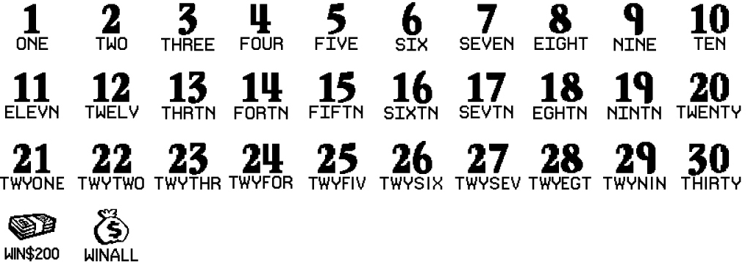
(6) The play symbols and play symbol captions that may appear in the WINNING NUMBERS play area are as follows:
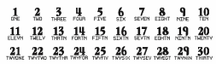
(7) The prize symbols and prize symbol captions that may appear in the YOUR NUMBERS play area are as follows:
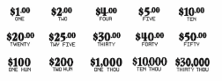
(8) The legends are as follows:

(9) Determination of Prizewinners.
(a) A ticket having a play symbol and corresponding play symbol caption in the YOUR NUMBERS play area that matches a play symbol and corresponding play symbol caption in the WINNING NUMBERS play area shall entitle the prizewinner to the corresponding prize shown for that symbol. A ticket having a  symbol in the YOUR NUMBERS play area shall entitle the prizewinner to a prize of $200. A ticket having a symbol in the YOUR NUMBERS play area shall entitle the prizewinner to all ten prizes shown on the ticket.
(b) A player may win up to ten times on a ticket.
(10) The odds of winning, value, and number of prizes in Game Number 5018 are as follows:
GAME PLAY | WIN | ODDS OF 1 IN | NUMBER OF WINNERS IN 135.15 POOLS OF 180,000 TICKETS PER POOL
$2 | $2 | 10.00 | 2,432,728
$1 x 4 | $4 | 50.01 | 486,482
($1 x 2) + $2 | $4 | 50.01 | 486,473
$2 x 2 | $4 | 49.99 | 486,589
$4 | $4 | 50.01 | 486,473
$1 x 5 | $5 | 374.55 | 64,949
($1 x 3) + $2 | $5 | 374.83 | 64,900
($2 x 2) + $1 | $5 | 375.20 | 64,836
$1 + $4 | $5 | 375.25 | 64,827
$5 | $5 | 375.17 | 64,842
$1 x 10 (MONEYBAG) | $10 | 249.91 | 97,341
$2 x 5 | $10 | 75.02 | 324,247
$10 | $10 | 375.25 | 64,827
$2 x 10 (MONEYBAG) | $20 | 750.80 | 32,401
($2 x 5) + $10 | $20 | 748.53 | 32,499
($5 x 2) + $10 | $20 | 748.53 | 32,499
$10 x 2 | $20 | 750.80 | 32,401
$20 | $20 | 750.01 | 32,435
$1 + ($2 x 7) + ($5 x 2) (MONEYBAG) | $25 | 1,196.94 | 20,324
$1 + ($2 x 7) +($5 x 2) | $25 | 1,797.97 | 13,530
($4 x 5) + ($1 x 5) (MONEYBAG) | $25 | 1,200.19 | 20,269
$5 x 5 | $25 | 1,797.71 | 13,532
$25 | $25 | 1,804.51 | 13,481
($2 x 5) + ($4 x 5) (MONEYBAG) | $30 | 1,199.47 | 20,281
($2 x 6) + ($4 x 2) + ($5 x 2)  (MONEYBAG) | $30 | 1,202.26 | 20,234
($5 x 4) + $10 | $30 | 1,799.57 | 13,518
($10 x 2) + ($5 x 2) | $30 | 1,801.83 | 13,501
$30 | $30 | 1,801.03 | 13,507
$4 x 10 (MONEYBAG) | $40 | 2,986.32 | 8,146
($5 x 4) + ($2 x 5) + $10 (MONEYBAG) | $40 | 3,004.39 | 8,097
$10 x 4 | $40 | 3,588.52 | 6,779
($10 x 2) + $20 | $40 | 3,611.96 | 6,735
$40 | $40 | 8,969.97 | 2,712
$10 x 10 (MONEYBAG) | $100 | 2,986.32 | 8,146
($5 x 8) + ($30 x 2) (MONEYBAG) | $100 | 2,989.62 | 8,137
($20 x 2) + ($10 x 4) + ($5 x 4)  (MONEYBAG) | $100 | 3,006.62 | 8,091
$25 x 4 | $100 | 8,135.97 | 2,990
$100 | $100 | 8,966.66 | 2,713
$20 x 10 (MONEYBAG) | $200 | 43,752.79 | 556
($20 x 5) + ($25 x 2) + ($5 x 2) + $40  (MONEYBAG) | $200 | 44,882.93 | 542
($30 x 5) + ($10 x 5) | $200 | 91,453.20 | 266
$100 x 2 | $200 | 91,453.20 | 266
$200 (STACK OF CASH) | $200 | 4,740.17 | 5,132
$100 x 10 (MONEYBAG) | $1,000 | 181,541.42 | 134
$200 (STACK OF CASH) x 5 | $1,000 | 90,770.71 | 268
($50 x 4) + ($200 (STACK OF CASH)  x 4) | $1,000 | 181,541.42 | 134
($100 x 4) + ($200 (STACK OF CASH)  x 3) | $1,000 | 181,541.42 | 134
$1,000 | $1,000 | 181,541.42 | 134
$1,000 x 10 (MONEYBAG) | $10,000 | 2,027,212.50 | 12
$10,000 | $10,000 | 6,081,637.50 | 4
$30,000 | $30,000 | 2,027,212.50 | 12
(11) The overall odds of winning some prize in Game Number 5018 are 1 in 4.36. Prizes, including the top prizes, are subject to availability at the time of ticket purchase. Prizes may be unavailable due to prior sales or other causes occurring in the normal course of business including, but not limited to, ticket damage, defect, theft, or loss.
(12) For reorders of Game Number 5018, the odds of winning, value, and number of prizes shall be proportionate to the number of tickets reordered.
(13) Payment of prizes for FULL OF $200s lottery tickets shall be made in accordance with the rule of the Florida Lottery governing payment of prizes. A copy of the current rule can be obtained from the Florida Lottery, Office of the General Counsel, 250 Marriott Drive, Tallahassee, Florida 32399-4011.
Rulemaking Authority 24.105(9)(a), (b), (c), 24.109(1), 24.115(1) FS. Law Implemented 24.105(9)(a), (b), (c), 24.115(1) FS. History–New 8-13-20.

