NOTICE OF PROPOSED RULE

WATER MANAGEMENT DISTRICTS
South Florida Water Management District
RULE NOS.: RULE TITLES:
40E-10.021 Definitions
40E-10.031 Water Reservations Implementation
40E-10.061 Water Reservation Areas: Lower East Coast Planning Area
PURPOSE AND EFFECT: The Everglades Agricultural Area (EAA) Reservoir is a critical component of Central Everglades Planning Project (CEPP) in the Comprehensive Everglades Restoration Plan (CERP). The project helps avoid harmful lake discharges to the St. Lucie and Caloosahatchee estuaries and sends more water south to the Central Everglades.
Section 601 of WRDA 2000 and Section 373.470, F.S., require the State to protect water made available for the natural system by CERP projects from allocation to consumptive uses. Legal protection of the water is required before the South Florida Water Management District (District) and the U.S. Army Corps of Engineers (USACE) may execute a Project Partnership Agreement (PPA) to cost-share the construction of CERP project features. The District is fulfilling these requirements by adopting rules reserving the water released from the EAA Reservoir Project to the central Everglades.
SUMMARY: The proposed water reservation rule protects all surface water released from the EAA Reservoir directed to the Lower East Coast Everglades waterbodies through the S-624, S-625, and S-626 structures (Figure 3-6 and 3-7). Model simulations of the draft operating protocol predict the EAA Reservoir, together with existing and planned infrastructure and a modified Lake Okeechobee schedule, will convey 825,000 acre-feet of surface water during an average annual water year (May-April) to the EAA Reservoir Project’s STA, STA-2, STA-3/4, or A-1 FEB, then discharge to the Lower East Coast Everglades waterbodies.
SUMMARY OF STATEMENT OF ESTIMATED REGULATORY COSTS AND LEGISLATIVE RATIFICATION:
The agency has determined that this will not have an adverse impact on small business and is not likely to increase, directly or indirectly, regulatory costs in excess of $200,000 in the aggregate within one year after the implementation of the rule. A Statement of Estimated Regulatory Costs (SERC) has not been prepared by the agency. The Agency has determined that the proposed rule is not expected to require legislative ratification based on the SERC or, if no SERC is required, the information expressly relied upon and described herein: The District completed the Governor’s Office of Fiscal Accountability and Regulatory Reform’s (OFARR) form “Is a SERC Required?” and prepared a summary of the proposed rule amendments, both of which are available upon request. Based on the completed “Is a SERC Required?” form and the District’s summary and analysis performed to prepare and complete said documents, the proposed rule amendment does not require legislative ratification pursuant to subsection 120.541(3), F.S.
Any person who wishes to provide information regarding the SERC, or to provide a proposal for a lower cost regulatory alternative must do so in writing within 21 days of this notice.
RULEMAKING AUTHORITY (formerly “Specific Authority”): 373.044, 373.113, 373.171 FS.
LAW IMPLEMENTED: 373.016, 373.026, 373.036, 373.1501, 373.1502, 373.219, 373.223, 373.4592, 373.4595, 373.470 FS.
IF REQUESTED WITHIN 21 DAYS OF THE DATE OF THIS NOTICE, A HEARING WILL BE SCHEDULED AND ANNOUNCED IN THE FAR.
Pursuant to the provisions of the Americans with Disabilities Act, any person requiring special accommodations to participate in this workshop/meeting is asked to advise the agency at least 5 days before the workshop/meeting by contacting: District Clerk @ 1(800)432-2045, ext. 6805 or (561)682-6805. If you are hearing or speech impaired, please contact the agency using the Florida Relay Service, 1(800)955-8771 (TDD) or 1(800)955-8770 (Voice).
If you are hearing or speech impaired, please contact the agency using the Florida Relay Service, 1(800)955-8771 (TDD) or 1(800)955-8770 (Voice).
THE PERSON TO BE CONTACTED REGARDING THE PROPOSED RULE IS: Don Medellin, Principal Scientist, P. O. Box 24680, West Palm Beach, FL 33416-4680, 1(800)432-2045, ext. 6340 or (561)682-6340, dmedelli@sfwmd.gov.

THE FULL TEXT OF THE PROPOSED RULE IS:

40E-10.021 Definitions.
(1) through (6) No change.
(7) Everglades Agricultural Area (EAA) Reservoir – A reservoir located in Palm Beach County, Florida, south of the City of South Bay between the Miami and North New River Canals as described in Appendix 3 and depicted in Figure 3-5.
Rulemaking Authority 373.044, 373.113, 373.171 FS. Law Implemented 373.016, 373.026, 373.036, 373.1501, 373.1502, 373.219, 373.223, 373.4592, 373.4595, 373.470 FS. History–New 7-2-09, Amended 3-18-10, 7-21-13, 7-16-14, ________.

40E-10.031 Water Reservations Implementation.

(1) through (5) No change

(6) Water reserved for the protection of fish and wildlife released via operation from the EAA Reservoir is defined in subsection 40E-10.061(3)(a), F.A.C.

Rulemaking Authority 373.044, 373.113, 373.171 FS. Law Implemented 373.016, 373.026, 373.036, 373.1501, 373.1502, 373.219, 373.223, 373.4592, 373.4595, 373.470 FS. History–New 7-2-09, Amended 3-18-10, 7-21-13, 7-14-14, 7-16-14, _______.

40E-10.061 Water Reservation Areas: Lower East Coast Planning Area.
(1) through (2) No change.
(3) EAA Reservoir:
(a) All surface water released, via operation, from the EAA Reservoir that is directed to the Lower East Coast Everglades Waterbodies through Structures S-624, S-625, and S-626 (see Figure 3-6) is reserved from allocation.
(b) The water prospectively reserved under this subsection is not available for fish and wildlife until the Governing Board makes a formal determination, pursuant to state and federal law, that the EAA Reservoir is operational.
(c) Model simulations of the draft operating protocol predict the EAA Reservoir, together with existing and planned infrastructure and a modified Lake Okeechobee schedule, will convey 825,000 acre-feet of surface water during an average annual water year (May-April) (see Figure 3-7), thereby increasing existing flows on average annually to the Central Everglades by 370,000 acre-feet over the period of simulation (1965-2005). The reservation contained in paragraph 40E-10.061(3)(a), F.A.C., above, and the criteria contained in Section 3.11.6 of the “Applicant’s Handbook for Water Use Permit Applications within the South Florida Water Management District” (Applicant’s Handbook), incorporated by reference in Rule 40E-2.091, F.A.C., will be revised in light of changed conditions or new information. The reservation and criteria in Section 3.11.6 of the Applicant’s Handbook, incorporated by reference in Rule 40E-2.091, F.A.C., will be revised before the EAA Reservoir is deemed operational, including an approved system or project operating manual, and any difference between the quantity of water actually made available and the quantity simulated will be reconciled.
(d) Water released from the EAA Reservoir through structure S-628 is not reserved. Model simulations of the draft operating protocol predict the EAA Reservoir, together with existing and planned infrastructure and a modified Lake Okeechobee schedule, will convey 82,000 acre-feet of surface water during an average annual water year through structure S-628 (see Figure 3-8).
Rulemaking Authority 373.044, 373.113, 373.171 FS. Law Implemented 373.016, 373.026, 373.036, 373.1501, 373.1502, 373.219, 373.223, 373.4592, 373.4595, 373.470 FS. History–7-21-13, Amended 3-15-17, .

APPENDIX 1 AND APPENDIX 2 – No Change.
Appendix 3: Lower East Coast Planning Area 40
Figures 3-1 through 3-4 B. – No Change.

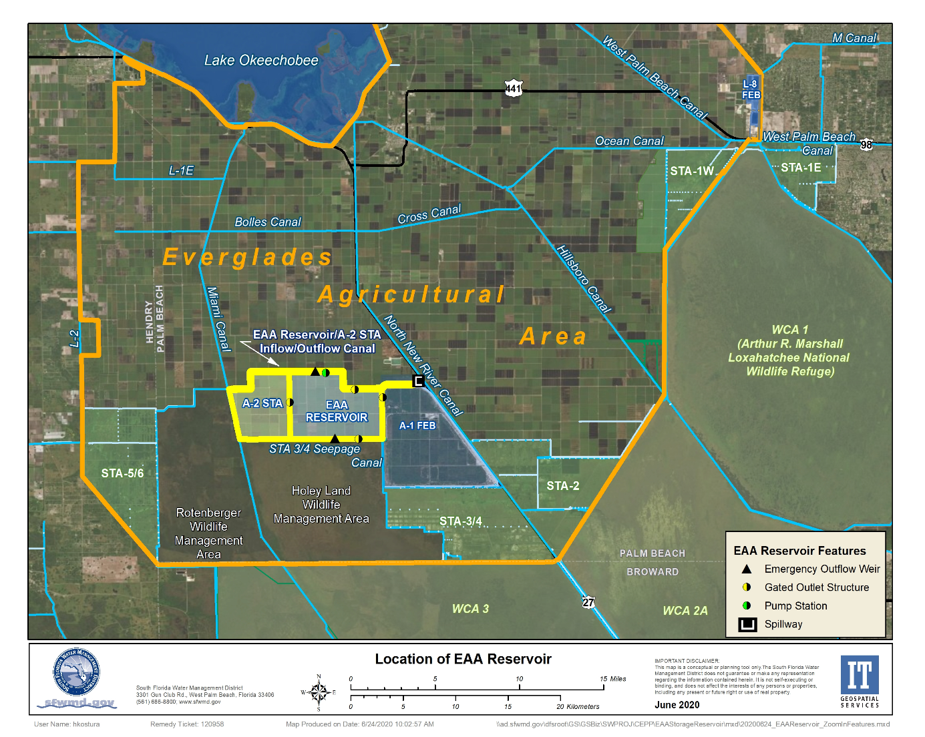

Figure 3-5. Location of the EAA Reservoir.

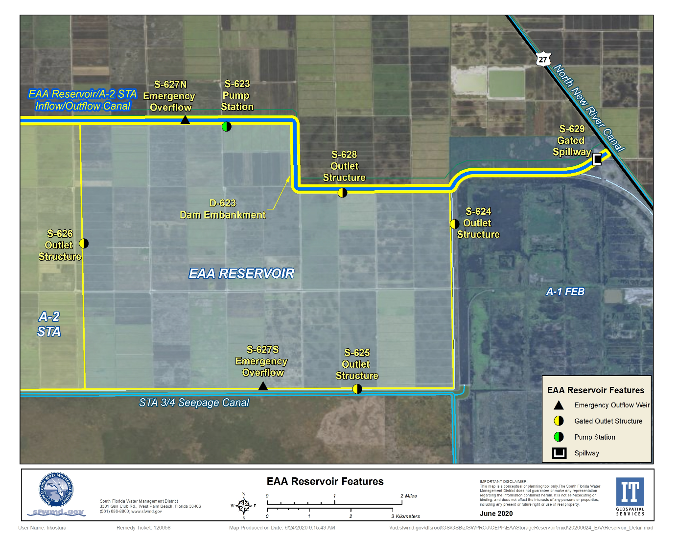

Figure 3-6. Key Features of the EAA Reservoir.

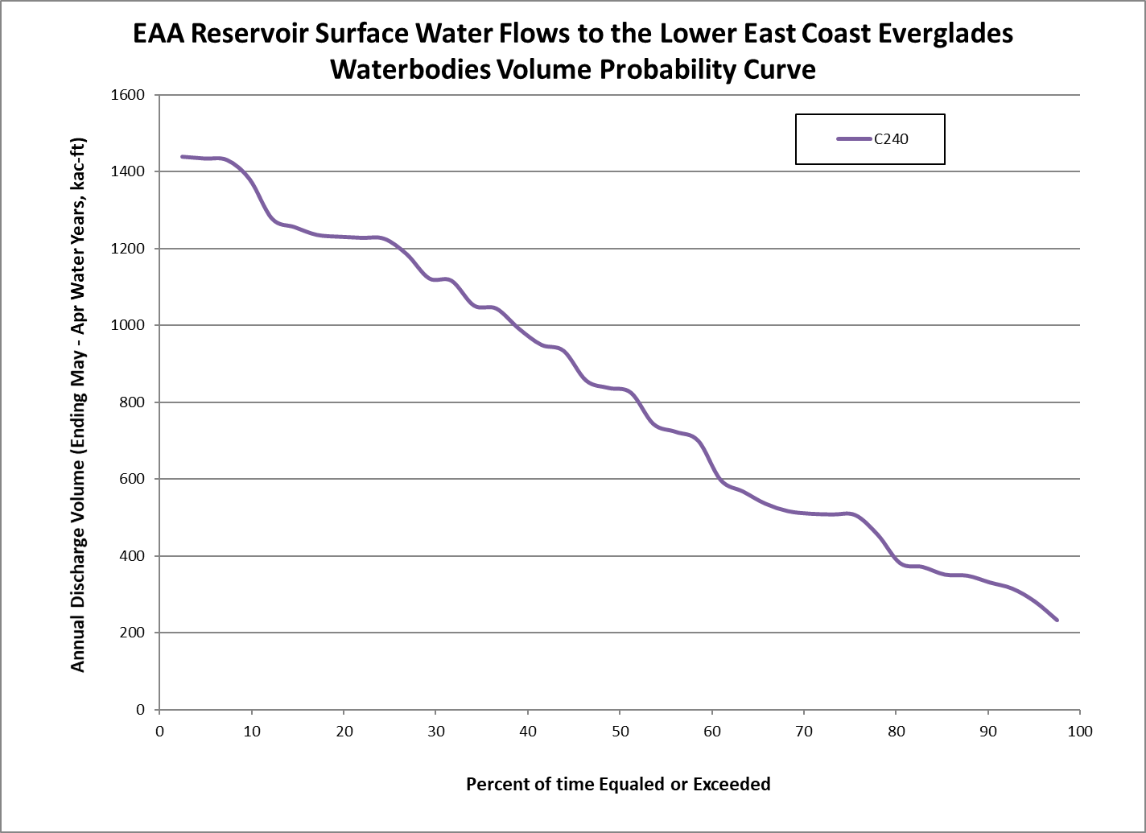

Figure 3-7. EAA Reservoir annual surface water discharges through structures S-624, S-625, and S-626 volume probability curve (May-April water year) from the Alternative C240 model simulation.

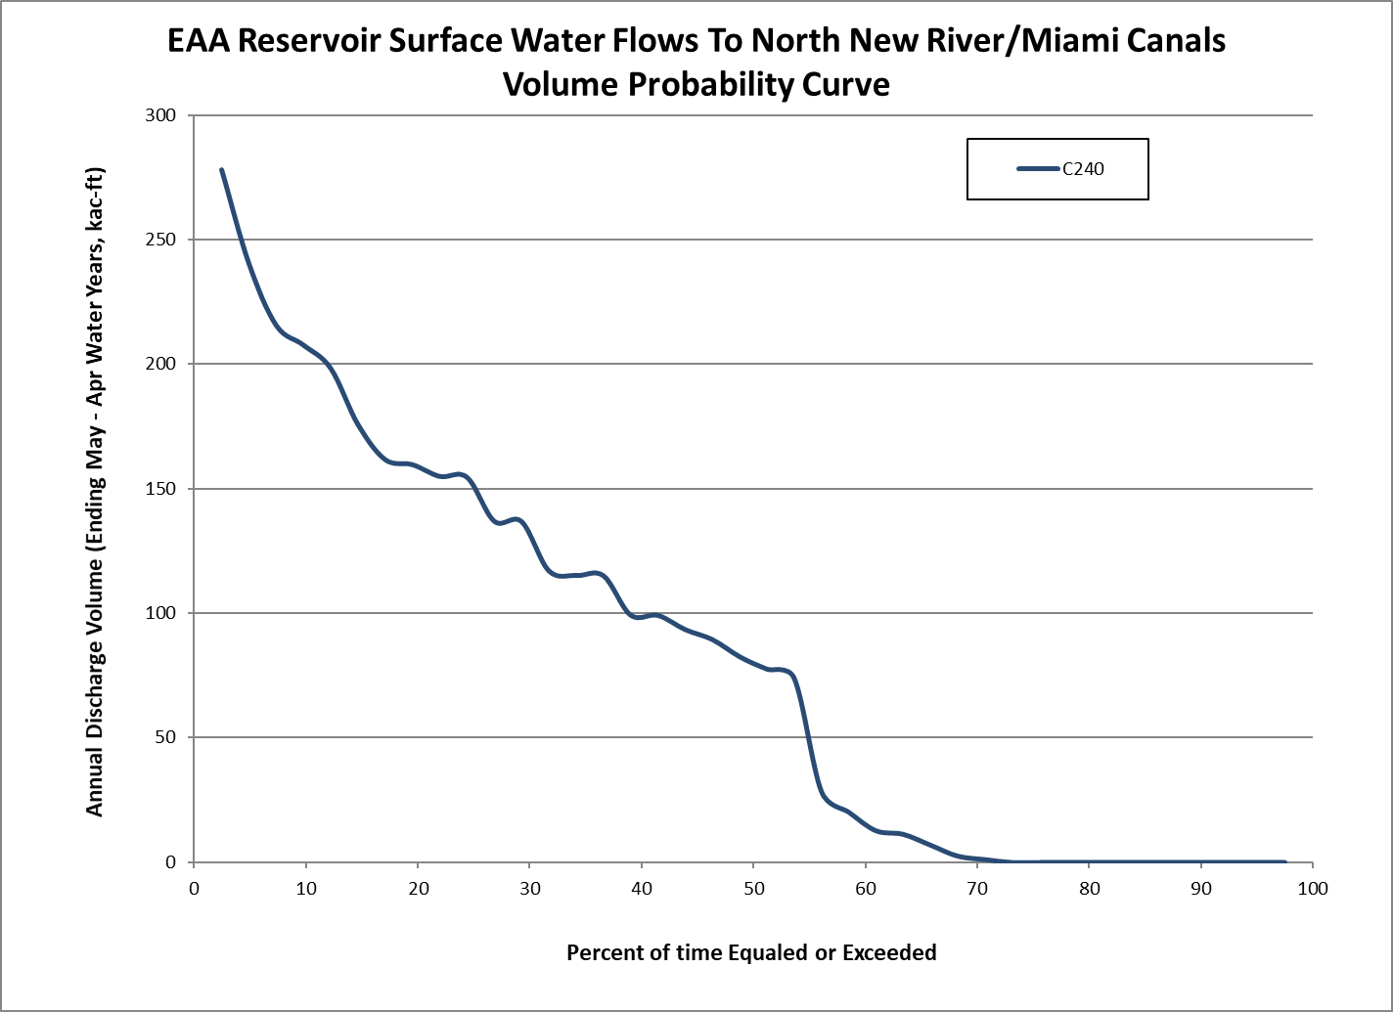

Figure 3-8. EAA Reservoir annual surface water discharges through structure S-628 volume probability curve (May-April water year) from the Alternative C240 model simulation.

NAME OF PERSON ORIGINATING PROPOSED RULE: Lawrence Glenn, Division Director, Water Resources
NAME OF AGENCY HEAD WHO APPROVED THE PROPOSED RULE: South Florida Water Management District Governing Board
DATE PROPOSED RULE APPROVED BY AGENCY HEAD: October 8, 2020
DATE NOTICE OF PROPOSED RULE DEVELOPMENT PUBLISHED IN FAR: June 30, 2020

