Notice of Emergency Rule

DEPARTMENT OF THE LOTTERY
RULE NO.: RULE TITLE:
53ER20-83 Game Number 1472, NATIONAL LAMPOON'S CHRISTMAS VACATION™
SUMMARY: This emergency rule describes Game Number 1472, “NATIONAL LAMPOON’S CHRISTMAS VACATION™," for which the Department of the Lottery will start selling tickets on a date to be determined by the Secretary of the Department. The rule sets forth the specifics of the game; determination of prizewinners; estimated odds of winning, value and number of prizes in the game.
THE PERSON TO BE CONTACTED REGARDING THE EMERGENCY RULE IS: Diane D. Schmidt, Legal Analyst, Department of the Lottery, 250 Marriott Drive, Tallahassee, Florida 32399-4011.

THE FULL TEXT OF THE EMERGENCY RULE IS:

53ER20-83 Game Number 1472, NATIONAL LAMPOON’S CHRISTMAS VACATION™.
(1) Name of Game. Game Number 1472, NATIONAL LAMPOON’S CHRISTMAS VACATION™.
(2) Game Number 1472, NATIONAL LAMPOON’S CHRISTMAS VACATION is a Scratch-Off lottery game (also known as an instant lottery game).
(3) Price. NATIONAL LAMPOON’S CHRISTMAS VACATION lottery tickets sell for $2.00 per ticket.
(4) NATIONAL LAMPOON’S CHRISTMAS VACATION lottery tickets shall have a series of numbers in machine readable code (or bar code) on the back of the ticket, along with a validation number under the latex area on the ticket. To be a valid winning NATIONAL LAMPOON’S CHRISTMAS VACATION lottery ticket, the ticket must meet the applicable requirements of Rule 53ER20-77, Payment of Prizes, F.A.C.
(5) The play symbols and play symbol captions that may appear in the YOUR NUMBERS play area are as follows:
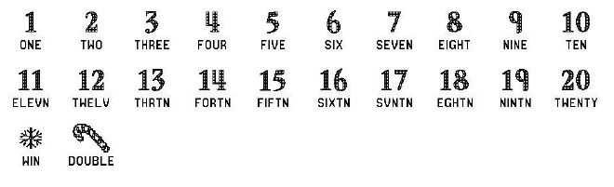
(6) The play symbols and play symbol captions that may appear in the WINNING NUMBERS play area are as follows:
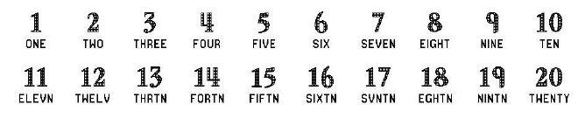
(7) The play symbols and play symbol captions that may appear in the BONUS NUMBER play area are as follows:
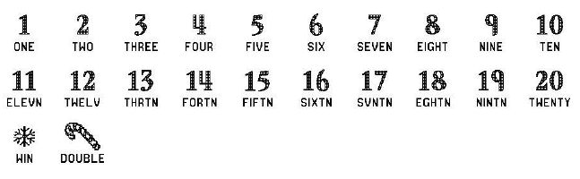
(8) The prize symbols and prize symbol captions that may appear in the YOUR NUMBERS or the BONUS NUMBER play area are as follows:
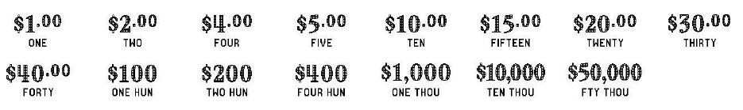
(9) The legends are as follows:
(10) Determination of Prizewinners.
(a) A ticket having a play symbol and corresponding play symbol caption in the YOUR NUMBERS or BONUS NUMBER play area that matches a play symbol and corresponding play symbol caption in the WINNING NUMBERS play area shall entitle the prizewinner to the corresponding prize shown for that symbol. A ticket having asymbol in the YOUR NUMBERS or BONUS NUMBER play area shall entitle the prizewinner to the prize shown for that symbol. A ticket having a symbol in the YOUR NUMBERS or BONUS NUMBER play area shall entitle the prizewinner to double the prize shown for that symbol.
(b) A player may win up to eleven times on a ticket.
(11) The odds of winning, value, and number of prizes in Game Number 1472 are as follows:
GAME PLAY | WIN | ODDS OF 1 IN | NUMBER OF WINNERS IN 121.15 POOLS OF 180,000 TICKETS PER POOL
$1 (CANDY CANE) | $2 | 37.50 | 581,553
$1 x 2 | $2 | 37.50 | 581,506
$2 | $2 | 21.43 | 1,017,660
$1 x 4 | $4 | 74.99 | 290,781
($1 x 2) + $2 | $4 | 75.00 | 290,746
$2 (CANDY CANE) | $4 | 37.50 | 581,542
$2 x 2 | $4 | 75.00 | 290,774
$4 | $4 | 75.00 | 290,746
$1 x 5 | $5 | 374.91 | 58,166
($1 x 3) + $2 | $5 | 375.10 | 58,137
$2 (CANDY CANE) + $1 | $5 | 374.97 | 58,156
$1 + $4 | $5 | 374.83 | 58,178
$5 | $5 | 375.19 | 58,123
$2 + $4 (CANDY CANE) | $10 | 374.91 | 58,166
$2 x 5 | $10 | 375.10 | 58,137
$5 (CANDY CANE) | $10 | 374.97 | 58,156
$5 x 2 | $10 | 374.83 | 58,178
$10 | $10 | 375.19 | 58,123
$5 + ($2 x 5) | $15 | 749.36 | 29,101
$5 + $5 (CANDY CANE) | $15 | 751.03 | 29,036
$2 + ($4 x 2) + $5 | $15 | 748.87 | 29,120
$5 + $10 | $15 | 750.46 | 29,058
$15 | $15 | 750.28 | 29,065
$2 x 10 | $20 | 749.36 | 29,101
$5 (CANDY CANE) + $10 | $20 | 751.03 | 29,036
$10 (CANDY CANE) | $20 | 748.87 | 29,120
$5 x 4 | $20 | 750.46 | 29,058
$20 | $20 | 750.28 | 29,065
($2 x 10) + $10 | $30 | 949.82 | 22,959
($2 x 5) + $10 (CANDY CANE) | $30 | 899.15 | 24,253
$10 x 3 | $30 | 950.24 | 22,949
$15 (CANDY CANE) | $30 | 900.89 | 24,206
$30 | $30 | 1,199.97 | 18,173
($5 x 2) + ($10 x 9) | $100 | 4,510.24 | 4,835
($10 x 4) + $30 (CANDY CANE) | $100 | 4,503.72 | 4,842
$20 (CANDY CANE) + ($30 x 2) | $100 | 4,518.65 | 4,826
$20 + $20 (CANDY CANE) + $40 | $100 | 4,472.31 | 4,876
$20 + ($40 x 2) | $100 | 5,995.88 | 3,637
$100 | $100 | 6,047.42 | 3,606
($5 x 4) + ($10 x 5) + $30 + $100 | $200 | 18,052.15 | 1,208
($20 x 2) + $30 (CANDY CANE) + $100 | $200 | 17,977.74 | 1,213
$40 x 5 | $200 | 18,007.43 | 1,211
$100 (CANDY CANE) | $200 | 17,992.57 | 1,212
$200 | $200 | 17,948.15 | 1,215
($5 x 2) + ($15 x 6) + ($100 x 3) | $400 | 44,778.23 | 487
$100 (CANDY CANE) + $200 | $400 | 44,870.37 | 486
$100 x 4 | $400 | 45,242.74 | 482
$200 (CANDY CANE) | $400 | 46,006.33 | 474
$400 | $400 | 45,336.80 | 481
($20 x 5) + ($100 x 5) + $400 | $1,000 | 181,725.00 | 120
$20 + ($30 x 6) + $400 (CANDY CANE) | $1,000 | 184,805.08 | 118
$200 + $200 (CANDY CANE) + $400 | $1,000 | 183,252.10 | 119
$200 + ($400 x 2) | $1,000 | 181,725.00 | 120
$1,000 | $1,000 | 180,223.14 | 121
$10,000 | $10,000 | 778,821.43 | 28
$50,000 | $50,000 | 2,725,875.00 | 8
(12) The overall odds of winning some prize in Game Number 1472 are 1 in 4.41. Prizes, including the top prizes, are subject to availability at the time of ticket purchase. Prizes may be unavailable due to prior sales or other causes occurring in the normal course of business including, but not limited to, ticket damage, defect, theft, or loss.
(13) For reorders of Game Number 1472, the odds of winning, value, and number of prizes shall be proportionate to the number of tickets reordered.
(14) Payment of prizes for NATIONAL LAMPOON’S CHRISTMAS VACATION lottery tickets shall be made in accordance with the rule of the Florida Lottery governing payment of prizes. A copy of the current rule can be obtained from the Florida Lottery, Office of the General Counsel, 250 Marriott Drive, Tallahassee, Florida 32399-4011.
Rulemaking Authority 24.105(9)(a), (b), (c), 24.109(1), 24.115(1) FS. Law Implemented 24.105(9)(a), (b), (c), 24.115(1) FS. History- New 10-22-20.
THIS RULE TAKES EFFECT UPON BEING FILED WITH THE DEPARTMENT OF STATE UNLESS A LATER TIME AND DATE IS SPECIFIED IN THE RULE.
EFFECTIVE DATE: October 22, 2020.

