Notice of Emergency Rule

DEPARTMENT OF THE LOTTERY
RULE NO.: RULE TITLE:
53ER20-89 Game Number 5019, DIAMOND MINE 9X
SUMMARY: This emergency rule describes Game Number 5019, “DIAMOND MINE 9X," for which the Department of the Lottery will start selling tickets on a date to be determined by the Secretary of the Department. The rule sets forth the specifics of the game; determination of prizewinners; estimated odds of winning, value and number of prizes in the game.
THE PERSON TO BE CONTACTED REGARDING THE EMERGENCY RULE IS: Diane D. Schmidt, Legal Analyst, Department of the Lottery, 250 Marriott Drive, Tallahassee, Florida 32399-4011.

THE FULL TEXT OF THE EMERGENCY RULE IS:

53ER20-89 Game Number 5019, DIAMOND MINE 9X.
(1) Name of Game. Game Number 5019, DIAMOND MINE 9X.
(2) Game Number 5019, DIAMOND MINE 9X is a Scratch-Off lottery game (also known as an instant lottery game).
(3) Price. DIAMOND MINE 9X lottery tickets sell for $5.00 per ticket.
(4) DIAMOND MINE 9X lottery tickets shall have a series of numbers in machine readable code (or bar code) on the back of the ticket, along with a validation number under the latex area on the ticket. To be a valid winning DIAMOND MINE 9X lottery ticket, the ticket must meet the applicable requirements of Rule 53ER20-77, Payment of Prizes, F.A.C.
(5) The play symbols and play symbol captions that may appear in a game play area are as follows:
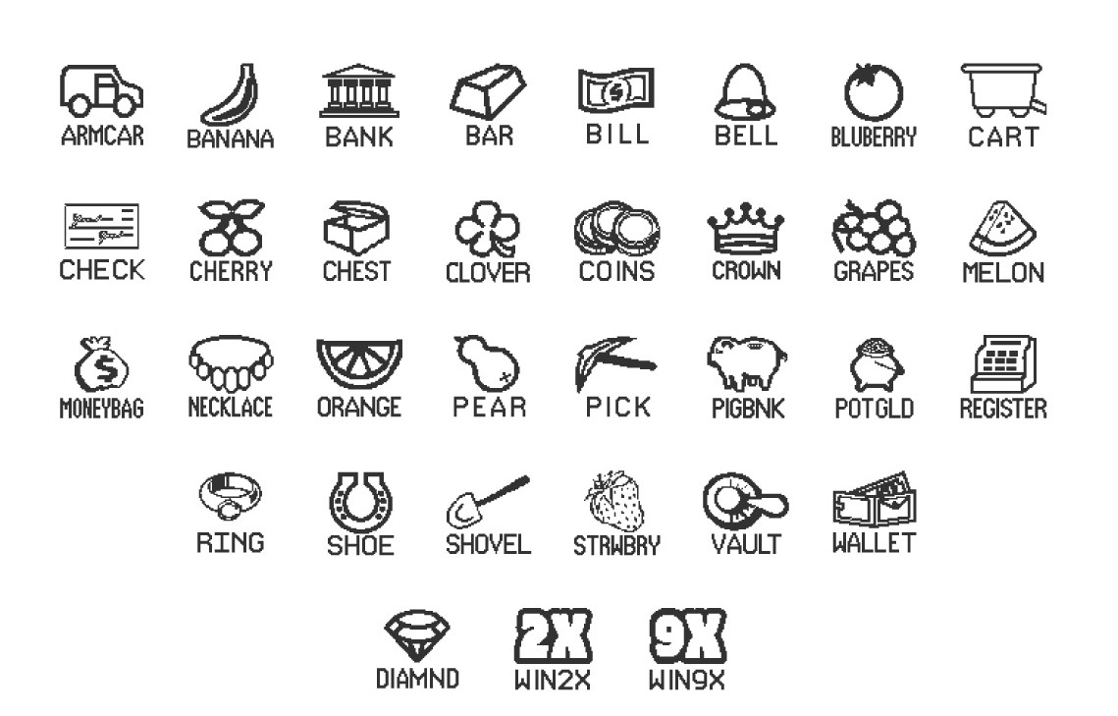

(6) The prize symbols and prize symbol captions that may appear in a game play area are as follows:
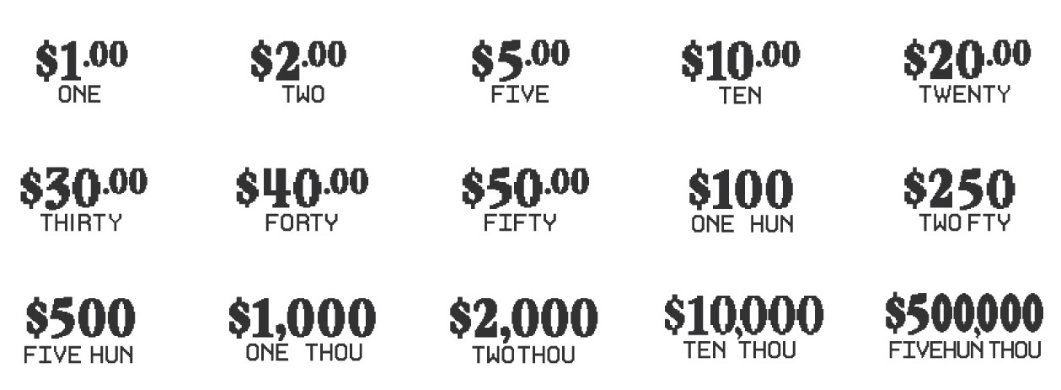

(7) The legends are as follows:
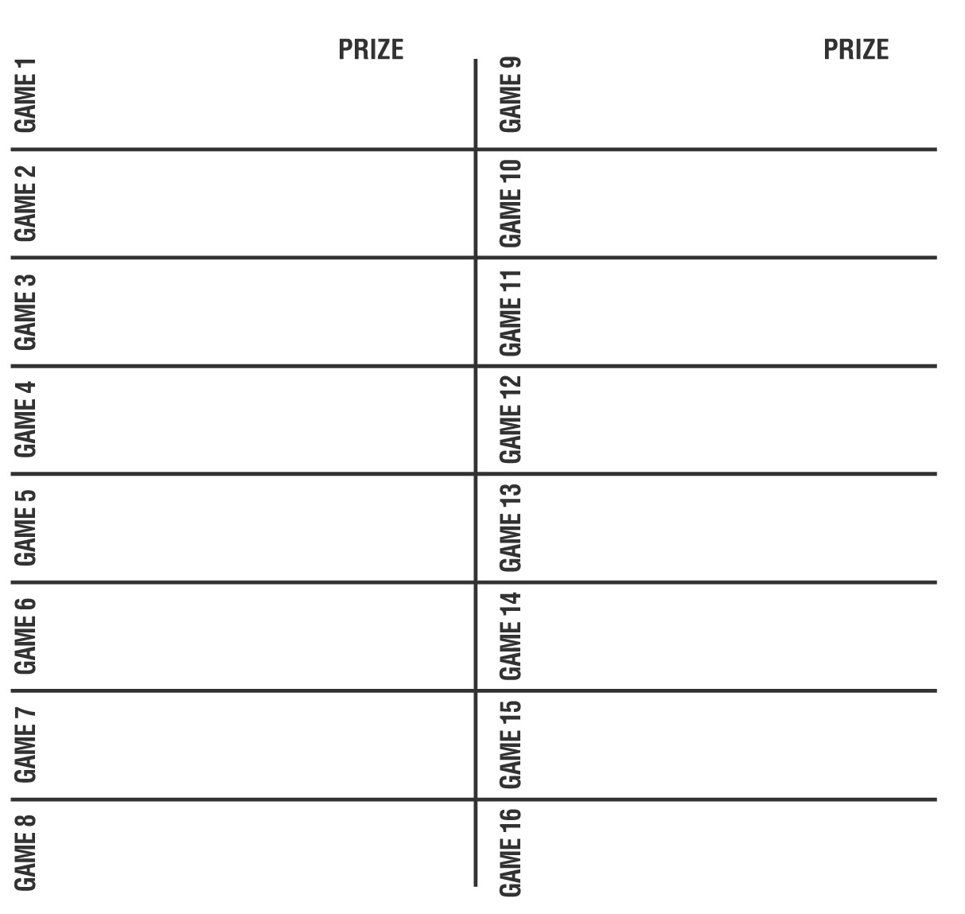
(8) Determination of Prizewinners.
(a) There are sixteen games on a ticket. Except as provided in paragraph (8)(b) below, each game is played separately. A ticket having three like play symbols and corresponding play symbol captions in the play area of one game shall entitle the prizewinner to the corresponding prize shown for that game. A ticket having a symbol in the play area of one game shall entitle the prizewinner to two times the corresponding prize shown for that game. A ticket having a  symbol in the play area of one game shall entitle the prizewinner to nine times the corresponding prize shown for that game.
(b) Diamonds. Total the number of symbols for all sixteen games. A ticket having a total of 2, 3, 4, or 5 diamonds will be entitled to the corresponding prize shown in the Diamond Prize Legend for the total number of diamonds. The prizes are $20, $50, $100, and $1,000.
(c) A player may win up to sixteen times on a ticket.
(9) The odds of winning, value, and number of prizes in Game Number 5019 are as follows:
GAME PLAY | WIN | ODDS OF 1 IN | NUMBER OF WINNERS IN 118.45 POOLS OF 120,000 TICKETS PER POOL
$5 | $5 | 10.00 | 1,421,257
$2 x 5 | $10 | 30.01 | 473,700
($2 (2X) x 2) + ($1 x 2) | $10 | 60.00 | 236,891
$5 x 2 | $10 | 29.99 | 473,902
$10 | $10 | 30.00 | 473,744
$2 x 10 | $20 | 299.97 | 47,383
$2 (9X) + $2 | $20 | 300.22 | 47,343
$5 (2X) + ($2 x 5) | $20 | 300.49 | 47,301
$20 (Gems) | $20 | 299.91 | 47,392
$20 | $20 | 299.41 | 47,472
($2 (2X) x 5) + ($5 x 2) | $30 | 1,841.12 | 7,720
$2 (9X) + ($5 x 2) + $1 (2X) | $30 | 1,853.61 | 7,668
$20 (Gems) + ($5 x 2) | $30 | 2,010.39 | 7,070
($5 (2X) x 2) + ($2 x 5) | $30 | 801.35 | 17,737
$30 | $30 | 1,998.52 | 7,112
$5 x 8 | $40 | 1,492.07 | 9,526
$2 (9X) + $2 + $20 (Gems) | $40 | 800.13 | 17,764
($2 x 12) + ($5 x 3) + $1 | $40 | 1,196.62 | 11,878
$10 (2X) + $5 (2X) + ($2 x 5) | $40 | 801.98 | 17,723
$40 | $40 | 6,002.31 | 2,368
($5 (2X) x 3) + $20 (Gems) | $50 | 1,498.20 | 9,487
$20 (Gems) + ($10 x 2) + $5 (2X) | $50 | 1,202.80 | 11,817
$5 (9X) + $5 | $50 | 1,201.88 | 11,826
$20 (2X) + ($2 x 5) | $50 | 1,195.82 | 11,886
$50 (Gems) | $50 | 1,197.73 | 11,867
$50 | $50 | 5,964.52 | 2,383
$5 (2X) x 10 | $100 | 1,989.01 | 7,146
$40 + $30 + $20 (Gems) + $10 | $100 | 2,010.39 | 7,070
$50 (Gems) + ($2 (2X) x 5) + ($5 (2X) x 3) | $100 | 1,203.31 | 11,812
($5 (2X) x 6) + ($5 x 4) + ($2 x 5) + $10 | $100 | 1,196.72 | 11,877
$20 (Gems) + $5 (9X) + $5 (2X) + ($5 x 5) | $100 | 1,200.46 | 11,840
$100 (Gems) | $100 | 1,994.87 | 7,125
$100 | $100 | 6,058.59 | 2,346
($10 (2X) x 3) + $100 (Gems) + $10 (9X) | $250 | 10,059.07 | 1,413
$20 (2X) + ($5 (9X) x 2) + $50 (Gems) + $30 (2X) + $5 (2X) | $250 | 7,516.37 | 1,891
$20 (9X) + ($5 (2X) x 5) + $20 (Gems) | $250 | 6,002.31 | 2,368
$50 (2X) + ($5 (2X) x 15) | $250 | 12,221.38 | 1,163
$250 | $250 | 60,226.53 | 236
$50 (2X) + $30 (9X) + ($10 (2X) x 4) + $50 (Gems) | $500 | 12,035.11 | 1,181
$100 (Gems) + ($20 (2X) x 5) + ($10 (2X) x 5) +($50 x 2) | $500 | 12,055.52 | 1,179
($30 x 10) + ($20 x 5) + $100 | $500 | 15,008.93 | 947
$50 (Gems) + $50 (9X) | $500 | 12,055.52 | 1,179
$500 | $500 | 58,733.31 | 242
$50 (9X) + $50 (Gems) + ($20 (2X) x 10) + $50 (2X) | $1,000 | 58,977.01 | 241
$250 (2X) + $100 (2X) + ($100 (Gems) + $50 (2X) + ($10 (2X) x 5) | $1,000 | 40,609.89 | 350
$100 (9X) + $100 (Gems) | $1,000 | 59,470.54 | 239
$1,000 (Gems) | $1,000 | 60,226.53 | 236
$1,000 | $1,000 | 124,679.47 | 114
$1,000 + $500 + ($50 (2X) x 4) + $100 (Gems) | $2,000 | 175,474.81 | 81
$2,000 | $2,000 | 710,673.00 | 20
$1,000 (Gems) + ($100 (9X) x 10) | $10,000 | 355,336.50 | 40
$10,000 | $10,000 | 1,421,346.00 | 10
$500,000 | $500,000 | 2,368,910.00 | 6
(10) The overall odds of winning some prize in Game Number 5019 are 1 in 4.00. Prizes, including the top prizes, are subject to availability at the time of ticket purchase. Prizes may be unavailable due to prior sales or other causes occurring in the normal course of business including, but not limited to, ticket damage, defect, theft, or loss.
(11) For reorders of Game Number 5019, the odds of winning, value, and number of prizes shall be proportionate to the number of tickets reordered.
(12) Payment of prizes for DIAMOND MINE 9X lottery tickets shall be made in accordance with the rule of the Florida Lottery governing payment of prizes. A copy of the current rule can be obtained from the Florida Lottery, Office of the General Counsel, 250 Marriott Drive, Tallahassee, Florida 32399-4011.
Rulemaking Authority 24.105(9)(a), (b), (c), 24.109(1), 24.115(1) FS. Law Implemented 24.105(9)(a), (b), (c), 24.115(1) FS. History- New 12-3-20.

THIS RULE TAKES EFFECT UPON BEING FILED WITH THE DEPARTMENT OF STATE UNLESS A LATER TIME AND DATE IS SPECIFIED IN THE RULE.
EFFECTIVE DATE: December 3, 2020.

