69A-3.012 Standards of the National Fire Protection Association and Other Standards Adopted.
(1) Except as specifically modified by statute or by the State Fire Marshal’s rules, the “Florida Fire Prevention Code, 7th Edition (2020),” which is comprised of the Florida specific edition of NFPA 101, the Life Safety Code® (2018 edition) and the Florida specific edition of NFPA 1, the Fire Code (2018 edition), are hereby adopted and incorporated by reference and are applicable to those buildings and structures specified in paragraphs (a) and (b), of subsection (1), of Section 633.206, F.S. In addition, the following standards, except as specifically modified in the rule chapters in rule Division 69A, are hereby adopted and incorporated by reference and shall take effect on the effective date of this rule, as a part of the uniform fire safety standards adopted by rule by the State Fire Marshal and are applicable to those buildings and structures specified in Sections 633.206(1)(a) and (b), F.S.:
(a) NFPA 2, 2016 edition, Hydrogen Technologies Code.
(b) NFPA 4, 2018 edition, Standard for Integrated Fire Protection and Life Safety System Testing.
(c) NFPA 10, 2018 edition, Standard for Portable Fire Extinguishers.
(d) NFPA 11, 2016 edition, Standard for Low-, Medium-, and High- Expansion Foam.
(e) NFPA 12, 2015 edition, Standard on Carbon Dioxide Extinguishing Systems.
(f) NFPA 12A, 2015 edition, Standard on Halon 1301 Fire Extinguishing Systems.
(g) NFPA 13, 2016 edition, Standard for the Installation of Sprinkler Systems.
(h) NFPA 13D, 2016 edition, Standard for the Installation of Sprinkler Systems in One- and Two- Family Dwellings and Manufactured Homes.
(i) NFPA 13R, 2016 edition, Standard for the Installation of Sprinkler Systems in Low-Rise Residential Occupancies.
(j) NFPA 14, 2016 edition, Standard for the Installation of Standpipe and Hose Systems.
(k) NFPA 15, 2017 edition, Standard for Water Spray Fixed Systems for Fire Protection.
(l) NFPA 16, 2015 edition, Standard for the Installation of Foam-Water Sprinkler and Foam-Water Spray Systems.
(m) NFPA 17, 2017 edition, Standard for Dry Chemical Extinguishing Systems.
(n) NFPA 17A, 2017 edition, Standard for Wet Chemical Extinguishing Systems.
(o) NFPA 20, 2016 edition, Standard for the Installation of Stationary Pumps for Fire Protection.
(p) NFPA 22, 2013 edition, Standard for Water Tanks for Private Fire Protection.
(q) NFPA 24, 2016 edition, Standards for the Installation of Private Fire Service Mains and Their Appurtenances.
(r) NFPA 25, 2017 edition, Standard for the Inspection, Testing, and Maintenance of Water-Based Fire Protection Systems.
(s) NFPA 30, 2018 edition, Flammable and Combustible Liquids Code.
(t) NFPA 30A, 2018 edition, Code for Motor Fuel Dispensing Facilities and Repair Garages.
(u) NFPA 30B, 2015 edition, Code for the Manufacture and Storage of Aerosol Products.
(v) NFPA 31, 2016 edition, Standard for the Installation of Oil-Burning Equipment.
(w) NFPA 32, 2016 edition, Standards for Drycleaning Facilities.
(x) NFPA 33, 2016 edition, Standard for Spray Application Using Flammable or Combustible Materials.
(y) NFPA 34, 2015 edition, Standard for Dipping, Coating, and Printing Processes Using Flammable or Combustible Liquids.
(z) NFPA 35, 2016 edition, Standard for the Manufacture of Organic Coatings.
(aa) NFPA 36, 2017 edition, Standard for Solvent Extraction Plants.
(bb) NFPA 37, 2018 edition, Standard for the Installation and Use of Stationary Combustion Engines and Gas Turbines.
(cc) NFPA 40, 2016 edition, Standard for the Storage and Handling of Cellulose Nitrate Film.
(dd) NFPA 45, 2015 edition, Standard on Fire Protection for Laboratories Using Chemicals.
(ee) NFPA 51, 2018 edition, Standard for the Design and Installation of Oxygen-Fuel Gas Systems for Welding, Cutting, and Allied Processes.
(ff) NFPA 51B, 2014 edition, Standard for Fire Prevention During Welding, Cutting, and Other Hot Work.
(gg) NFPA 52, 2016 edition, Vehicular Natural Gas Fuel Systems Code.
(hh) NFPA 54, 2018 edition, National Fuel Gas Code.
(ii) NFPA 55, 2016 edition, Compressed Gasses and Cryogenic Fluids Code.
(jj) NFPA 56, 2017 edition, Standard for Fire and Explosion Prevention During Cleaning and Purging of Flammable Gas Piping Systems.
(kk) NFPA 58, 2017 edition, Liquefied Petroleum Gas Code.
(ll) NFPA 59, 2018 edition, Utility LP-Gas Plant Code.
(mm) NFPA 59A, 2016 edition, Standard for the Production, Storage and Handling of Liquefied Natural Gas (LNG).
(nn) NFPA 61, 2017 edition, Standard for the Prevention of Fires and Dust Explosions in Agricultural and Food Processing Facilities.
(oo) NFPA 68, 2013 edition, Standard on Explosion Protection by Deflagration Venting.
(pp) NFPA 69, 2014 edition, Standard on Explosion Prevention Systems.
(qq) NFPA 70, 2017 edition, National Electrical Code®.
(rr) NFPA 72, 2016 edition, National Fire Alarm and Signaling Code.
(ss) NFPA 75, 2017 edition, Standard for the Fire Protection of Information Technology Equipment.
(tt) NFPA 76, 2016 edition, Standard for the Fire Protection of Telecommunications Facilities.
(uu) NFPA 80, 2016 edition, Standard for Fire Doors and Other Opening Protectives.
(vv) NFPA 82, 2014 edition, Standard on Incinerators and Waste and Linen Handling Systems and Equipment.
(ww) NFPA 85, 2015 edition, Boiler and Combustion Systems Hazards Code.
(xx) NFPA 86, 2015 edition, Standard for Ovens and Furnaces.
(yy) NFPA 88A, 2015 edition, Standard for Parking Structures.
(zz) NFPA 90A, 2018 edition, Standard for the Installation of Air-Conditioning and Ventilating Systems.
(aaa) NFPA 90B, 2018 edition, Standard for the Installation of Warm Air Heating and Air-Conditioning Systems.
(bbb) NFPA 91, 2015 edition, Standard for Exhaust Systems for Air Conveying of Vapors, Gases, Mists, and Particulate Solids.
(ccc) NFPA 92, 2015 edition, Standard for Smoke-Control Systems.
(ddd) NFPA 96, 2017 edition, Standard for Ventilation Control and Fire Protection of Commercial Cooking Operations.
(eee) NFPA 99, 2018 edition, Health Care Facilities Code.
(fff) NFPA 99B, 2018 edition, Standard for Hypobaric Facilities.
(ggg) NFPA 101, 2018 edition, Life Safety Code®.
(hhh) NFPA 101A, 2016 edition, Guide on Alternative Approaches to Life Safety.
(iii) NFPA 102, 2016 edition, Standard for Grandstands, Folding and Telescopic Seating, Tents, and Membrane Structures.
(jjj) NFPA 105, 2016 edition, Standard for Smoke Door Assemblies and Other Opening Protectives.
(kkk) NFPA 110, 2016 edition, Standard for Emergency and Standby Power Systems.
(lll) NFPA 111, 2016 edition, Standard on Stored Electrical Energy Emergency and Standby Power Systems.
(mmm) NFPA 115, 2016 edition, Standard for Laser Fire Protection.
(nnn) NFPA 120, 2015 edition, Standard for Fire Prevention and Control in Coal Mines.
(ooo) NFPA 122, 2015 edition, Standard for Fire Prevention and Control in Metal/Nonmetal Mining and Metal Mineral Processing Facilities.
(ppp) NFPA 130, 2017 edition, Standard for Fixed Guideway Transit and Passenger Rail Systems.
(qqq) NFPA 140, 2013 edition, Standard on Motion Picture and Television Production Studio Soundstages, Approved Production Facilities, and Production Locations.
(rrr) NFPA 150, 2016 edition, Standard on Fire and Life Safety in Animal Housing Facilities.
(sss) NFPA 160, 2016 edition, Standard for the Use of Flame Effects Before an Audience.
(ttt) NFPA 170, 2015 edition, Standard for Fire Safety and Emergency Symbols.
(uuu) NFPA 204, 2015 edition, Standard for Smoke and Heat Venting.
(vvv) NFPA 211, 2016 edition, Standard for Chimneys, Fireplaces, Vents, and Solid Fuel-Burning Appliances.
(www) NFPA 221, 2018 edition, Standard for High Challenge Fire Walls, Fire Walls, and Fire Barrier Walls.
(xxx) NFPA 232, 2017 edition, Standard for the Protection of Records.
(yyy) NFPA 241, 2013 edition, Standard for Safeguarding Construction, Alteration and Demolition Operations.
(zzz) NFPA 251, 2006 edition, Standard Methods of Tests of Fire Resistance of Building Construction and Materials.
(aaaa) NFPA 252, 2017 edition, Standard Methods of Fire Tests of Door Assemblies.
(bbbb) NFPA 253, 2015 edition, Standard Method of Test for Critical Radiant Flux of Floor Covering Systems Using a Radiant Heat Energy Source.
(cccc) NFPA 257, 2017 edition, Standard on Fire Test for Window and Glass Block Assemblies.
(dddd) NFPA 259, 2013 edition, Standard Test Method for Potential Heat of Building Materials.
(eeee) NFPA 260, 2013 edition, Standard Methods of Tests and Classification System for Cigarette Ignition Resistance of Components of Upholstered Furniture.
(ffff) NFPA 261, 2013 edition, Standard Method of Test for Determining Resistance of Mock-Up Upholstered Furniture Material Assemblies to Ignition by Smoldering Cigarettes.
(gggg) NFPA 265, 2015 edition, Standard Methods of Fire Tests for Evaluating Room Fire Growth Contribution of Textile or Expanded Vinyl Wall Coverings on Full Height Panels and Walls.
(hhhh) NFPA 286, 2015 edition, Standard Methods of Fire Test for Evaluating Contribution of Wall and Ceiling Interior Finish to Room Fire Growth.
(iiii) NFPA 288, 2017 edition, Standard Methods of Fire Tests of Horizontal Fire Door Assemblies Installed in Horizontal Fire Resistance-Rated Assemblies.
(jjjj) NFPA 289, 2013 edition, Standard Method of Fire Test for Individual Fuel Packages.
(kkkk) NFPA 301, 2018 edition, Code for Safety to Life from Fire on Merchant Vessels.
(llll) NFPA 302, 2015 edition, Fire Protection Standard for Pleasure and Commercial Motor Craft.
(mmmm) NFPA 303, 2016 edition, Fire Protection Standards for Marinas and Boatyards.
(nnnn) NFPA 307, 2016 edition, Standard for the Construction and Fire Protection of Marine Terminals, Piers, and Wharves.
(oooo) NFPA 312, 2016 edition, Standard for Fire Protection of Vessels During Construction, Conversion, Repair, and Lay-Up.
(pppp) NFPA 318, 2018 edition, Standard for the Protection of Semiconductor Fabrication Facilities.
(qqqq) NFPA 326, 2015 edition, Standard for the Safeguarding of Tanks and Containers for Entry, Cleaning, or Repair.
(rrrr) NFPA 385, 2017 edition, Standard for Tank Vehicles for Flammable and Combustible Liquids.
(ssss) NFPA 400, 2016 edition, Hazardous Materials Code.
(tttt) NFPA 403, 2018 edition, Standard for Aircraft Rescue and Fire-Fighting Services at Airports.
(uuuu) NFPA 407, 2017 edition, Standard for Aircraft Fuel Servicing.
(vvvv) NFPA 408, 2017 edition, Standard for Aircraft Hand Portable Fire Extinguishers.
(wwww) NFPA 409, 2016 edition, Standard on Aircraft Hangars.
(xxxx) NFPA 410, 2015 edition, Standard on Aircraft Maintenance.
(yyyy) NFPA 415, 2016 edition, Standard on Airport Terminal Buildings, Fueling Ramp Drainage, and Loading Walkways.
(zzzz) NFPA 418, 2016 edition, Standard for Heliports.
(aaaaa) NFPA 423, 2016 edition, Standard for Construction and Protection of Aircraft Engine Test Facilities.
(bbbbb) NFPA 484, 2015 edition, Standard for Combustible Metals.
(ccccc) NFPA 495, 2013 edition, Explosive Materials Code.
(ddddd) NFPA 498, 2013 edition, Standard for Safe Havens and Interchange Lots for Vehicles Transporting Explosives.
(eeeee) NFPA 501, 2017 edition, Standard on Manufactured Housing.
(fffff) NFPA 501A, 2017 edition, Standard for Fire Safety Criteria for Manufactured Home Installations, Sites, and Communities.
(ggggg) NFPA 502, 2017 edition, Standard for Road Tunnels, Bridges, and Other Limited Access Highways.
(hhhhh) NFPA 505, 2013 edition, Fire Safety Standard for Powered Industrial Trucks Including Type Designations, Areas of Use, Conversions, Maintenance, and Operations.
(iiiii) NFPA 601, 2015 edition, Standard for Security Services in Fire Loss Prevention.
(jjjjj) NFPA 652, 2016 edition, Standard on the Fundamentals of Combustible Dust.
(kkkkk) NFPA 654, 2013 edition, Standard for the Prevention of Fire and Dust Explosions from the Manufacturing, Processing, and Handling of Combustible Particulate Solids.
(lllll) NFPA 655, 2017 edition, Standard for Prevention of Sulfur Fires and Explosions.
(mmmmm) NFPA 664, 2017 edition, Standard for the Prevention of Fires and Explosions in Wood Processing and Woodworking Facilities.
(nnnnn) NFPA 701, 2015 edition, Standard Methods of Fire Tests for Flame Propagation of Textiles and Films.
(ooooo) NFPA 703, 2018 edition, Standard for Fire Retardant-Treated Wood and Fire-Retardant Coatings for Building Materials.
(ppppp) NFPA 704, 2017 edition, Standard System for the Identification of the Hazards of Materials for Emergency Response.
(qqqqq) NFPA 720, 2015 edition, Standard for the Installation of Carbon Monoxide (CO) Detection and Warning Equipment.
(rrrrr) NFPA 731, 2017 edition, Standard for the Installation of Electronic Premises Security Systems.
(sssss) NFPA 750, 2015 edition, Standard on Water Mist Fire Protection Systems.
(ttttt) NFPA 780, 2017 edition, Standard for the Installation of Lightning Protection Systems.
(uuuuu) NFPA 801, 2014 edition, Standard for Fire Protection for Facilities Handling Radioactive Materials.
(vvvvv) NFPA 804, 2015 edition, Standard for Fire Protection for Advanced Light Water Reactor Electric Generating Plants.
(wwwww) NFPA 805, 2015 edition, Performance-Based Standard for Fire Protection for Light Water Reactor Electric Generating Plants.
(xxxxx) NFPA 820, 2016 edition, Standard for Fire Protection in Wastewater Treatment and Collection Facilities.
(yyyyy) NFPA 909, 2017 edition, Code for the Protection of Cultural Resource Properties – Museums, Libraries, and Places of Worship.
(zzzzz) NFPA 914, 2015 edition, Code for Fire Protection of Historic Structures.
(aaaaaa) NFPA 1122, 2018 edition, Code for Model Rocketry.
(bbbbbb) NFPA 1123, 1995 edition, Code for Fireworks Display.
(cccccc) NFPA 1124, 2017 edition, Code for the Manufacture, Transportation, and Storage of Fireworks and Pyrotechnic Articles.
(dddddd) NFPA 1125, 2017 edition, Code for the Manufacture of Model Rocket and High-Power Rocket Motors.
(eeeeee) NFPA 1126, 2016 edition, Standard for the Use of Pyrotechnics Before a Proximate Audience.
(ffffff) NFPA 1127, 2018 edition, Code for High Power Rocketry.
(gggggg) NFPA 1141, 2017 edition, Standard for Fire Protection Infrastructure for Land Development in Wildland, Rural, and Suburban Areas.
(hhhhhh) NFPA 1142, 2017 edition, Standard on Water Supplies for Suburban and Rural Fire Fighting.
(iiiiii) NFPA 1144, 2018 edition, Standard for Reducing Structure Ignition Hazards from Wildland Fire.
(jjjjjj) NFPA 1192, 2018 edition, Standard on Recreational Vehicles.
(kkkkkk) NFPA 1194, 2018 edition, Standard for Recreational Vehicle Parks and Campgrounds.
(llllll) NFPA 1221, 2016 edition, Standard for the Installation, Maintenance, and Use of Emergency Services Communications Systems.
(mmmmmm) NFPA 1730, 2016 edition, Standard on Organization and Deployment of Fire Prevention Inspection and Code Enforcement, Plan Review, Investigation, and Public Education Operations.
(nnnnnn) NFPA 1901, 2016 edition, Standard for Automotive Fire Apparatus.
(oooooo) NFPA 1906, 2016 edition, Standard for Wildland Fire Apparatus.
(pppppp) NFPA 1925, 2013 edition, Standard on Marine Fire-Fighting Vessels.
(qqqqqq) NFPA 1963, 2014 edition, Standard for Fire Hose Connections.
(rrrrrr) NFPA 2001, 2015 edition, Standard on Clean Agent Fire Extinguishing Systems.
(ssssss) NFPA 2010, 2015 edition, Standard for Fixed Aerosol Fire-Extinguishing Systems.
(tttttt) NFPA 2113, 2015 edition, Standard on Selection, Care, Use, and Maintennce of Flame-Resistant Garments for Protection of Industrial Personnel Against Short-Duration Thermal Exposures from Fire.
(2) All buildings, structures, establishments, facilities, equipment, or vehicular equipment over which the State Fire Marshal has jurisdiction which are constructed, renovated, expanded, rehabilitated, or in any other way significantly altered on or after the effective date of the adoption of the codes and standards adopted in subsection (1), above, shall conform to the requirements of the codes, standards, recommended practices, and manuals contained therein, unless the structure, establishment, or facility has been exempted from complying because the building, structure, establishment, facility, equipment, or vehicular equipment has been granted an exemption from compliance by act of the Legislature.
(3) All buildings, structures, establishments, facilities, equipment, or vehicular equipment over which the State Fire Marshal has jurisdiction which are in existence on or after the effective date of the adoption of the codes and standards adopted in subsection (1), above, shall conform to the requirements of those codes and standards within a reasonable period of time. It is understood that the correction of some fire safety violations will necessitate the employment of design professionals while other violations can be expeditiously resolved. “Within a reasonable time” is defined as the amount of time it would normally take to correct a specific fire code violation under the assumption that the property owner would begin to correct said violations upon receipt of an official document from the enforcing agency.
(4)(a) The NFPA standards referenced in subsection (1) are copyrighted materials that cannot be copied but may be:
1. Obtained by contacting the NFPA at 1 Batterymarch Park, Quincy, Massachusetts 02169-7471; Phone 1(800)344-3555; Website www.nfpa.org.; or
2. Accessed in a read-only, non-printable, non-downloadable format at the NFPA’s website at https://www.nfpa.org/Codes-and-Standards/All-Codes-and-Standards/Free-access.
(b) The copyrighted NFPA standards referenced in subsection (1) may be viewed, during regular business hours, at the offices of:
1. The Division of State Fire Marshal, 325 John Knox Road, Third Floor, Atrium Building, Tallahassee, Florida 32303; or
2. The Florida Administrative Code and Register, R.A. Gray Building, 500 South Bronough Street, Tallahassee, Florida 32399-0250.
(c) The Florida Fire Prevention Code, the Florida specific edition of NFPA 101, the Life Safety Code®, and the Florida specific edition of NFPA 1, the Fire Code, referenced in subsection (1) are copyrighted materials that cannot be copied but may be:
1. Obtained by contacting the NFPA at 1 Batterymarch Park, Quincy, Massachusetts 02169-7471; Phone 1(800)344-3555; Website www.nfpa.org.; or
2.Accessed in a read-only, non-printable, non-downloadable format at the Division of State Fire Marshal website at: https://www.myfloridacfo.com/Division/SFM/BFP/FloridaFirePreventionCodePage.htm.; or
3. Viewed during regular business hours at the Division of State Fire Marshal, 325 John Knox Road, The Atrium, Third Floor, Tallahassee, Florida 32399-0322; or
4.Viewed during regular business hours at the Florida Administrative Code and Register, R.A. Gray Building, 500 South Bronough Street, Tallahassee, Florida 32399-0250.
(5) The Code of Federal Regulations and the Compressed Gas Association (CGA) documents incorporated by reference in this rule are available for public inspection during regular business hours at the Division currently located on the Third Floor (Room 326) of the Atrium Building, 325 John Knox Road, Tallahassee, Florida.
(6) Notice required for structures with light-frame truss-type construction.
Purpose: The purpose of this rule is to require the placement of an identifying symbol on structures constructed with a light-frame truss component in a manner sufficient to warn persons conducting fire control and other emergency operations of the existence of light-frame truss-type construction in the structure.
(a) Definitions.
1. “Light-frame truss-type construction” means a type of construction whose primary structural elements are formed by a system of repetitive wood or light gauge steel framing members.
2. “Approved symbol” means a Maltese Cross measuring 8 inches horizontally and 8 inches vertically, of a bright red reflective color, designed in accordance with Figure 1.
(b) Any commercial, industrial, or any multiunit residential structure of three units or more which uses horizontal or vertical light-frame truss-type construction in any portion shall be marked with an approved symbol. Townhouses are not multiunit residential structures and therefore not subject to this rule. Each approved symbol shall include within the center circle one of the following designations:
1. Structures with light-frame truss roofs shall be marked with the letter “R.”
2. Structures with light-frame truss floor systems shall be marked with the letter “F.”
3. Structures with light-frame truss floor and roof systems shall be marked with the letters “R/F.”
(c) The approved symbol shall be placed within 24 inches to the left of the main entry door and:
1. Be permanently attached to the face of the structure on a contrasting background, or
2. Be mounted on a contrasting base material which is then permanently attached to the face of the structure.
(d) The distance above the grade, walking surface or the finished floor to the bottom of the symbol shall be not less than 4 feet (48 inches).
(e) The distance above the grade, walking surface or the finished floor to the top of the symbol shall be not more than 6 feet (72 inches).
(7) In single tenant structures with multiple main entry doors, such as big box retail stores, department stores and grocery stores, the authority having jurisdiction is authorized to require that other main entry doors of the structure be marked with an approved symbol to carry out the purpose in subsection (6), above.
(8) In multiple tenant structures and covered malls with multiple main entry doors, the authority having jurisdiction is authorized to require that other main entry doors be marked with an approved symbol to carry out the purpose in subsection (6), above. In such structures, approved symbols shall be marked on one side only and spaced not closer than 100 feet or at each end of the structure when such structure is less than 100 feet in length.
(9) The owner of each new structure required to comply with this section shall mark the structure with the approved symbol prior to receiving a certificate of occupancy.
(10) The owner of each existing structure required to comply with this section shall mark the structure with the approved symbol within 90 days of the effective date of this rule section.
(11) Where the owner of the structure and the authority having jurisdiction disagree as to the use of light-frame truss-type construction within the structure, the owner shall be granted not more than 45 days to provide written verification from a licensed engineer or licensed architect; otherwise the owner shall comply with the rule.
Figure 1:
Approved Symbol

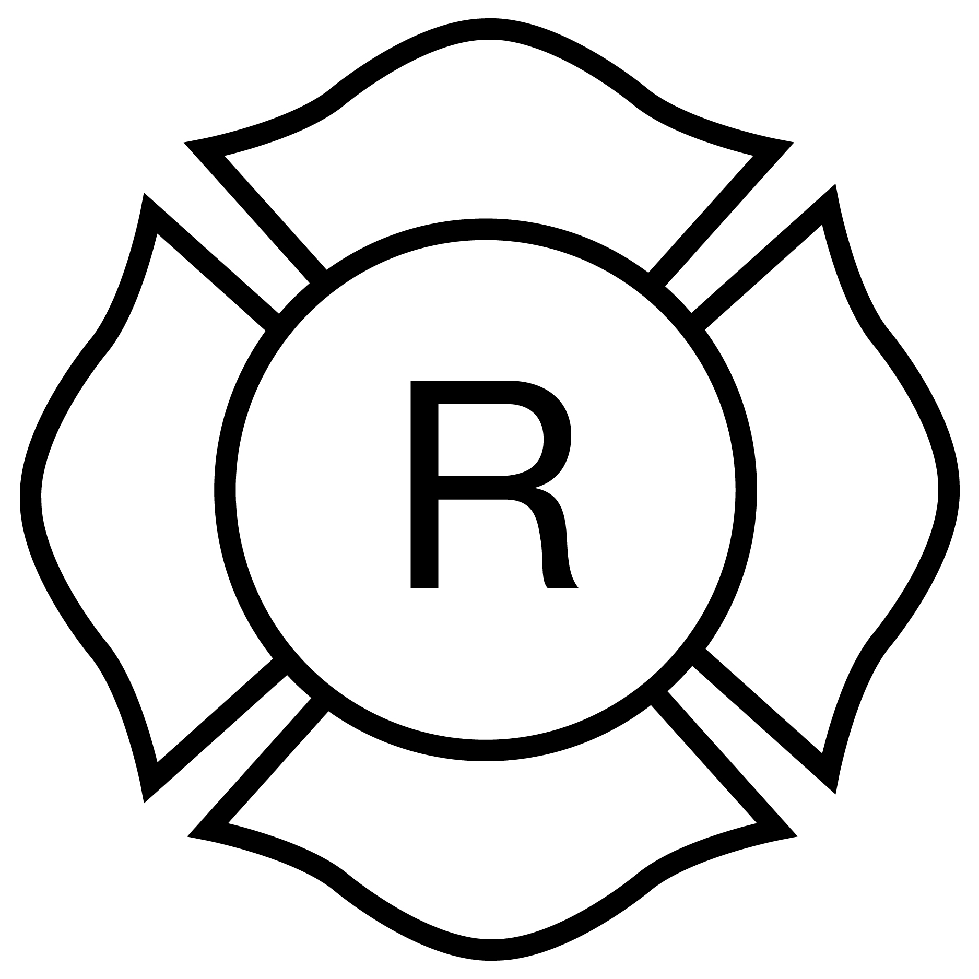
Light-frame “Roof” only

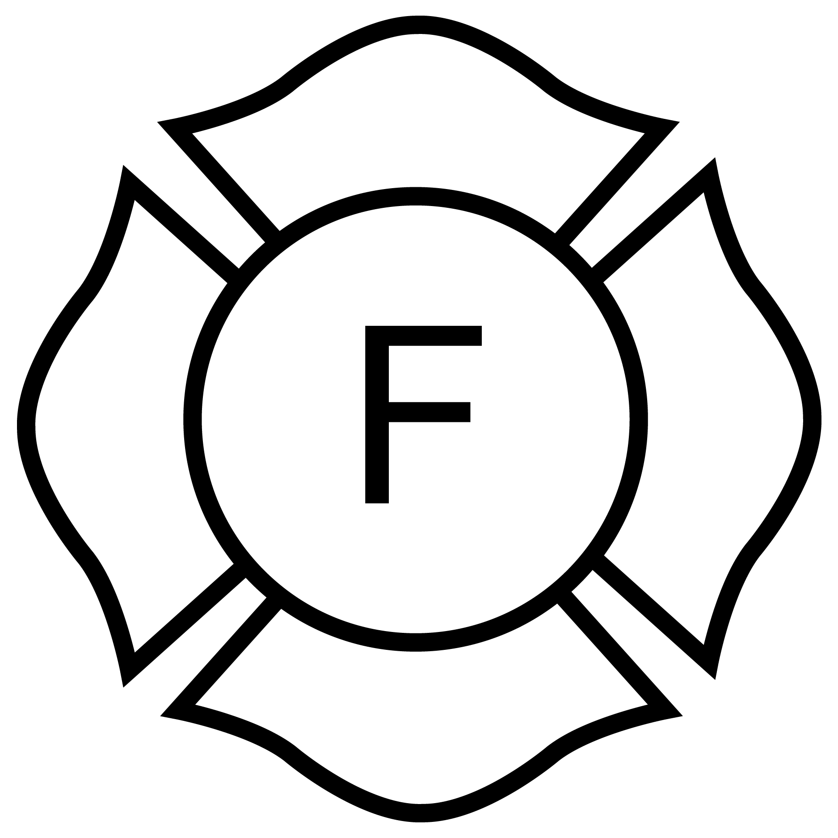
Light- frame “Floor” only

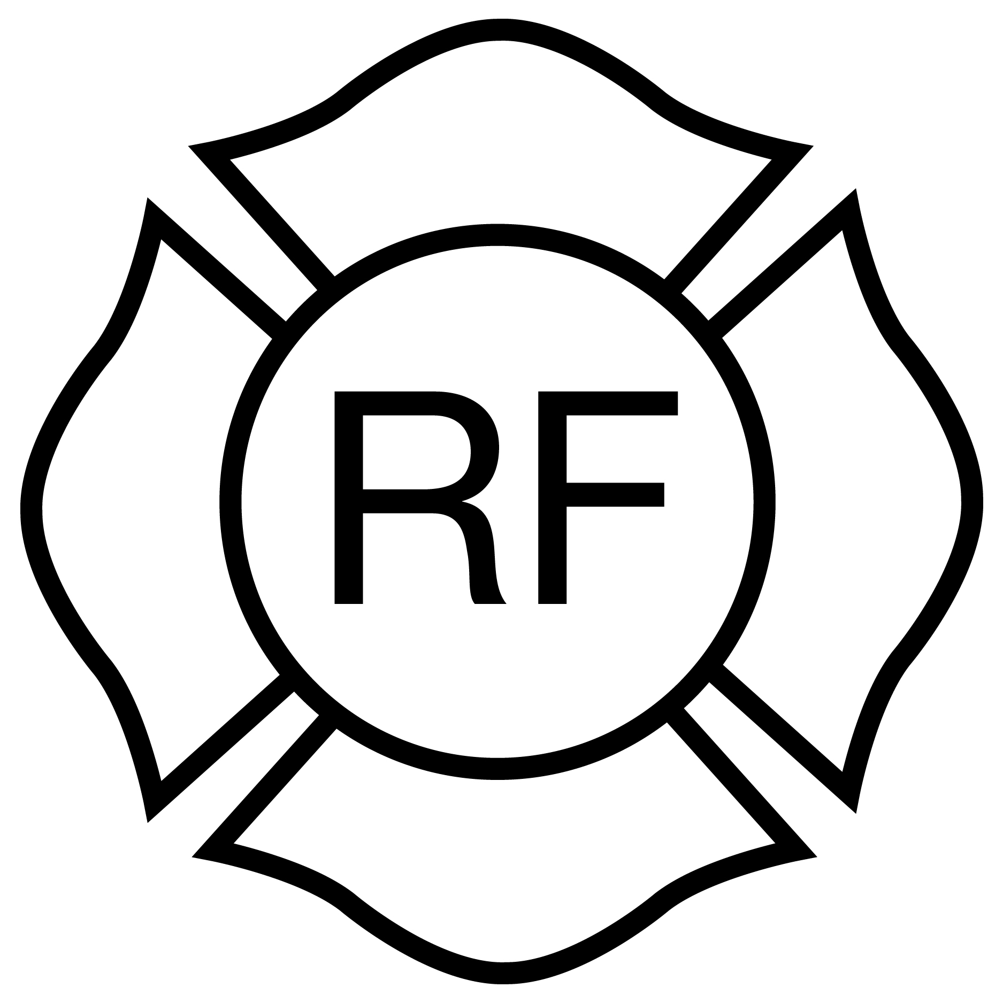
Light- frame “Floor & Roof”
Rulemaking Authority 633.104(1), 633.202, 633.206, 633.222 FS. Law Implemented 633.104(1), 633.202, 633.206, 633.222, 791.012 FS. History–New 5-14-86, Amended 2-12-87, 4-8-90, 10-30-91, 4-3-95, 11-27-01, Formerly 4A-3.012, Amended 8-7-05, 5-18-08, 12-31-08, 12-13-09, 12-31-11, 12-31-14, 12-31-17, 12-31-20.

