53ER21-31 Game Number 1489, 5X BINGO.
(1) Name of Game. Game Number 1489, “5X BINGO.”
(2) Game Number 1489, 5X BINGO is a Scratch-Off lottery game (also known as an instant lottery game).
(3) Price. 5X BINGO lottery tickets sell for $3.00 per ticket.
(4) 5X BINGO lottery tickets shall have a series of numbers in machine readable code (or bar code) on the back of the ticket, along with a validation number under the latex area on the ticket. To be a valid winning 5X BINGO lottery ticket, the ticket must meet the applicable requirements of Rule 53ER21-3, F.A.C.
(5) The “CALLER’S CARD” play symbols are as follows:
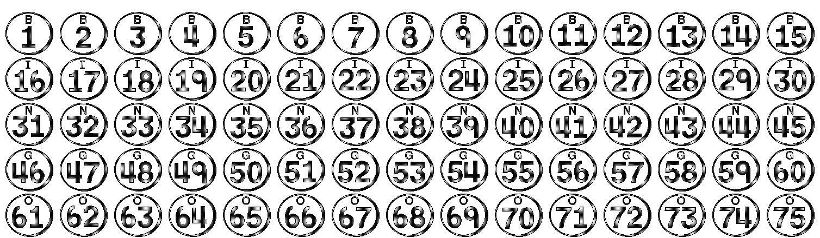
(6) The “PLAYER’S CARD” play symbols are as follows:
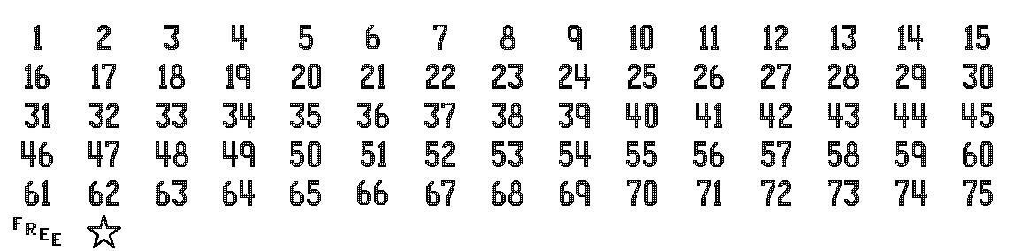
(7) The legend is as follows:

(8) Determination of Prizewinners.
(a) There are six cards on a ticket. Each card is play separately.
(b) The holder of a ticket whose play symbols in the “CALLER’S CARD” play area match the play symbols in any one card to form one of the patterns below shall entitle the prizewinner to the associated prize shown for that pattern on that card:
1. A complete horizontal, vertical, or diagonal line; or
2. All four corners; or
3. A complete “X” (consisting of eight numbers plus the “FREE” spot).
(c) A symbol constitutes a free spot and can substitute for a number in a pattern for which it is part. A card having a symbol in a winning line pattern (horizontal, vertical, or diagonal) shall entitle the prizewinner to five times the line prize shown for that card.
(d) A  appears in the center of each player’s card and can substitute as a number in a pattern of which it is part.
(e) The possible prizes are: $3, $5, $10, $25, $40, $50, $75, $100, $200, $300, $500, $1,000, $5,000, $10,000, $25,000, and $100,000.
(f) Only the highest prize won is paid per card.
(g) A player may win up to four prizes on a ticket; but cannot win more than one prize on each card.
(9) The estimated odds of winning, value, and number of prizes in Game Number 1489 are as follows:
GAME PLAY | WIN | ESTIMATED ODDS OF 1 IN | NUMBER OF WINNERS IN 124.90 POOLS OF 180,000 TICKETS PER POOL
Line ‒ Card 1 | $3 | 8.33 | 2,697,697
Line ‒ Card 2 | $5 | 16.67 | 1,348,988
Line ‒ Card 1 + Line ‒ Card 2 | $8 | 33.33 | 674,578
Line ‒ Card 3 | $10 | 99.99 | 224,839
Line ‒ Card 2 + Line ‒ Card 3 | $15 | 250.15 | 89,875
Line ‒ Card 1 (STAR) | $15 | 100.00 | 224,811
Line ‒ Card 1 (STAR) + Line ‒ Card 3 | $25 | 500.17 | 44,949
Line ‒ Card 2 (STAR) | $25 | 500.24 | 44,943
Line ‒ Card 4 | $25 | 499.43 | 45,016
Line ‒ Card 2 + Line ‒ Card 4 | $30 | 250.01 | 89,925
Line ‒ Card 1 (STAR) + Line ‒ Card 4 | $40 | 1,123.38 | 20,013
Line ‒ Card 1 (STAR) + Line ‒ Card 2 (STAR) | $40 | 1,123.89 | 20,004
Line ‒ Card 2 + Line ‒ Card 3 + Line ‒ Card 4 | $40 | 1,123.66 | 20,008
4 Corners ‒ Card 1 | $40 | 1,125.57 | 19,974
4 Corners ‒ Card 1 + Line ‒ Card 3 | $50 | 1,793.98 | 12,532
4 Corners ‒ Card 2 | $50 | 3,599.46 | 6,246
Line ‒ Card 3 (STAR) | $50 | 3,607.54 | 6,232
Line ‒ Card 2 (STAR) + Line ‒ Card 4 | $50 | 3,606.38 | 6,234
Line ‒ Card 5 | $50 | 3,607.54 | 6,232
Line ‒ Card 2 (STAR) + Line ‒ Card 5 | $75 | 6,019.33 | 3,735
Line ‒ Card 2 (STAR) + Line ‒ Card 3 (STAR) | $75 | 6,017.72 | 3,736
Line ‒ Card 3 + Line - Card 4 + 4 Corners ‒ Card 1 | $75 | 5,990.46 | 3,753
Line ‒ Card 6 | $75 | 5,987.27 | 3,755
Line ‒ Card 4 + Line ‒ Card 6 | $100 | 1,800.45 | 12,487
Line ‒ Card 1 (STAR) + Line ‒ Card 2 (STAR) + Line ‒ Card 3 + Line ‒ Card 5 | $100 | 3,605.81 | 6,235
Line ‒ Card 2 (STAR) + Line ‒ Card 4 + Line ‒ Card 3 (STAR) | $100 | 3,596.58 | 6,251
4 Corners ‒ Card 3 | $100 | 17,828.87 | 1,261
Line ‒ Card 2 (STAR) + Line ‒ Card 4 (STAR) | $150 | 18,189.48 | 1,236
Line ‒ Card 4 + Line ‒ Card 6 + 4 Corners – Card 3 | $200 | 35,914.06 | 626
X ‒ Card 1 | $200 | 36,087.00 | 623
X ‒ Card 1 + Line ‒ Card 5 | $250 | 35,686.03 | 630
Line ‒ Card 5 (STAR) | $250 | 35,573.10 | 632
Line ‒ Card 2 (STAR) + Line ‒ Card 4 + Line ‒ Card 5 (STAR) | $300 | 93,287.14 | 241
Line ‒ Card 2 (STAR) + 4 Corners ‒ Card 3 + Line ‒ Card 4 (STAR) + Line ‒ Card 5 | $300 | 90,289.96 | 249
4 Corners ‒ Card 4 | $300 | 90,654.03 | 248
Line ‒ Card 4 (STAR) + Line ‒ Card 6 (STAR) | $500 | 45,235.81 | 497
X ‒ Card 2 | $500 | 90,654.03 | 248
X ‒ Card 1 + 4 Corners ‒ Card 4 | $500 | 90,654.03 | 248
4 Corners ‒ Card 5 | $500 | 45,144.98 | 498
X ‒ Card 2 + 4 Corners ‒ Card 5 | $1,000 | 179,857.60 | 125
X ‒ Card 1 + X ‒ Card 2 + 4 Corners ‒ Card 4 | $1,000 | 178,430.16 | 126
X ‒ Card 3 | $1,000 | 182,782.11 | 123
4 Corners ‒ Card 6 | $5,000 | 90,289.96 | 249
X ‒ Card 4 | $10,000 | 936,758.33 | 24
X ‒ Card 5 | $25,000 | 1,405,137.50 | 16
X ‒ Card 6 | $100,000 | 2,810,275.00 | 8
(10) The estimated overall odds of winning some prize in Game Number 1489 are 1 in 3.98. Prizes, including the top prizes, are subject to availability at the time of ticket purchase. Prizes may be unavailable due to prior sales or other causes occurring in the normal course of business including, but not limited to, ticket damage, defect, theft, or loss.
(11) For reorders of Game Number 1489, the estimated odds of winning, value, and number of prizes shall be proportionate to the number of tickets reordered.
(12) Payment of prizes for 5X BINGO lottery tickets shall be made in accordance with the rule of the Florida Lottery governing payment of prizes. A copy of the current rule can be obtained from the Florida Lottery, Office of the General Counsel, 250 Marriott Drive, Tallahassee, Florida 32399-4011.
Rulemaking Authority 24.105(9)(a), (b), (c), 24.109(1), 24.115(1) FS. Law Implemented 24.105(9)(a), (b), (c), 24.115(1) FS. History–New 5-13-21.

