53ER21-30 Game Number 5021, JEWEL 7s DOUBLER.
(1) Name of Game. Game Number 5021, JEWEL 7s DOUBLER.
(2) Game Number 5021, JEWEL 7s DOUBLER is a Scratch-Off lottery game (also known as an instant lottery game).
(3) Price. JEWEL 7s DOUBLER lottery tickets sell for $2.00 per ticket.
(4) JEWEL 7s DOUBLER lottery tickets shall have a series of numbers in machine readable code (or bar code) on the back of the ticket, along with a validation number under the latex area on the ticket. To be a valid winning JEWEL 7s DOUBLER lottery ticket, the ticket must meet the applicable requirements of Rule 53ER21-3, Payment of Prizes, F.A.C.
(5) The play symbols and play symbol captions that may appear in the PLAY AREA are as follows:
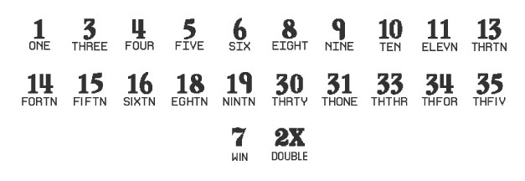
(6) The prize symbols and prize symbol captions that may appear in the PLAY AREA are as follows:
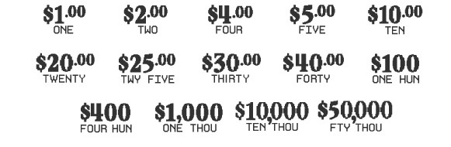
(7) The legend is as follows:

(8) Determination of Prizewinners.
(a) A ticket having aplay symbol and corresponding play symbol caption in the PLAY AREA shall entitle the prizewinner to the corresponding prize shown for that symbol. A ticket having a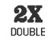play symbol and corresponding play symbol caption in the PLAY AREA shall entitle the prizewinner to double the corresponding prize shown for that symbol.
(b) A player may win up to ten times on a ticket.
(9) The odds of winning, value, and number of prizes in Game Number 5021 are as follows:
GAME PLAY | WIN | ODDS OF 1 IN | NUMBER OF WINNERS IN 132.54 POOLS OF 180,000 TICKETS PER POOL
$2 | $2 | 10.00 | 2,385,852
$1 x 4 | $4 | 74.98 | 318,181
($1 x 2) + $2 | $4 | 50.02 | 476,953
$2 (2X) | $4 | 24.99 | 954,557
$4 | $4 | 150.17 | 158,861
$1 x 5 | $5 | 374.60 | 63,687
$1 + $2 (2X) | $5 | 187.54 | 127,207
($2 x 2) + $1 | $5 | 375.58 | 63,520
$1 + $4 | $5 | 749.30 | 31,839
$5 | $5 | 749.30 | 31,839
$1 x 10 | $10 | 249.74 | 95,526
$2 x 5 | $10 | 249.78 | 95,510
$4 (2X) + $2 | $10 | 150.00 | 159,046
$5 x 2 | $10 | 250.43 | 95,263
$10 | $10 | 750.38 | 31,793
$2 x 10 | $20 | 751.94 | 31,727
$5 (2X) + ($4 x 2) + $2 | $20 | 749.30 | 31,839
$5 x 4 | $20 | 746.84 | 31,944
$10 (2X) | $20 | 751.56 | 31,743
$20 | $20 | 750.38 | 31,793
$5 + $4 + ($2 x 8) | $25 | 1,497.61 | 15,930
$5 (2X) + ($5 x 3) | $25 | 1,283.87 | 18,582
$10 (2X) + $5 | $25 | 1,502.42 | 15,879
$20 + $5 | $25 | 1,502.61 | 15,877
$25 | $25 | 1,799.16 | 13,260
($4 x 5) + ($2 x 5) | $30 | 1,800.52 | 13,250
$5 (2X) + ($5 x 4) | $30 | 898.90 | 26,540
$10 + $10 (2X) | $30 | 898.16 | 26,562
$20 + $10 | $30 | 2,998.60 | 7,956
$30 | $30 | 4,514.93 | 5,284
$4 x 10 | $40 | 4,486.91 | 5,317
($5 x 4) + $5 (2X) + $10 | $40 | 1,498.93 | 15,916
$20 (2X) | $40 | 2,248.95 | 10,608
$30 + $10 | $40 | 4,514.08 | 5,285
$40 | $40 | 8,978.89 | 2,657
$10 x 10 | $100 | 4,470.10 | 5,337
$40 + $30 + $20 + $10 | $100 | 4,476.81 | 5,329
$20 (2X) + $30 (2X) | $100 | 3,008.06 | 7,931
$25 x 4 | $100 | 4,494.52 | 5,308
$100 | $100 | 8,955.29 | 2,664
$40 x 10 | $400 | 45,528.44 | 524
($40 x 5) + ($100 x 2) | $400 | 45,702.87 | 522
$100 x 4 | $400 | 46,055.79 | 518
$100 (2X) x 2 | $400 | 45,013.02 | 530
$400 | $400 | 90,367.05 | 264
$100 x 10 | $1,000 | 89,018.28 | 268
($100 x 2) + $400 (2X) | $1,000 | 89,018.28 | 268
$1,000 | $1,000 | 89,018.28 | 268
$10,000 | $10,000 | 5,964,225.00 | 4
$1,000 (2X) x 5 | $10,000 | 1,192,845.00 | 20
$50,000 | $50,000 | 5,964,225.00 | 4
($10,000 (2X) x 2) + $10,000 | $50,000 | 2,982,112.50 | 8
(10) The overall odds of winning some prize in Game Number 5021 are 1 in 4.36. Prizes, including the top prizes, are subject to availability at the time of ticket purchase. Prizes may be unavailable due to prior sales or other causes occurring in the normal course of business including, but not limited to, ticket damage, defect, theft, or loss.
(11) For reorders of Game Number 5021, the odds of winning, value, and number of prizes shall be proportionate to the number of tickets reordered.
(12) Payment of prizes for JEWEL 7s DOUBLER lottery tickets shall be made in accordance with the rule of the Florida Lottery governing payment of prizes. A copy of the current rule can be obtained from the Florida Lottery, Office of the General Counsel, 250 Marriott Drive, Tallahassee, Florida 32399-4011.
Rulemaking Authority 24.105(9)(a), (b), (c), 24.109(1), 24.115(1) FS. Law Implemented 24.105(9)(a), (b), (c), 24.115(1) FS. History–New 5-13-21.

