Notice of Proposed Rule

FISH AND WILDLIFE CONSERVATION COMMISSION
Vessel Registration and Boating Safety
RULE NO.: RULE TITLE:
68D-24.008 Broward County Boating Restricted Areas
PURPOSE AND EFFECT: The creation of a boating restricted area is needed to provide public safety for a wide variety of users enjoying the waters of the ICW in Hallandale Beach. Operating a vessel at a slower speed improves reaction time to avoid collision with other vessels on the water. and will mitigate a public safety hazard created by a 3,700-foot 25 MPH manatee protection zone which exists between two slow speed minimum wake boating restricted areas between Broward County to the Miami-Dade County line.
SUMMARY: This rule amendment would establish a boating restricted area within a narrow section of the Intracoastal Waterway (at its widest, it is approximately 380 feet from shoreline to shoreline). The proposed boating restricted area will extend south, starting from the south end of the current boating restricted area
established for the Hallandale Beach Boulevard Bridge, and will end at the north end of the current boating restricted area for the 192nd Street Bridge at the Dade-Broward County Line. The resulting slow speed minimum wake zone will be in effect year-round.
SUMMARY OF STATEMENT OF ESTIMATED REGULATORY COSTS AND LEGISLATIVE RATIFICATION:
The Agency has determined that this will not have an adverse impact on small business or likely increase directly or indirectly regulatory costs in excess of $200,000 in the aggregate within one year after the implementation of the rule. A SERC has not been prepared by the Agency.
The Agency has determined that the proposed rule is not expected to require legislative ratification based on the statement of estimated regulatory costs or if no SERC is required, the information expressly relied upon and described herein:
Any person who wishes to provide information regarding a statement of estimated regulatory costs, or provide a proposal for a lower cost regulatory alternative must do so in writing within 21 days of this notice.
RULEMAKING AUTHORITY: 327.04, 327.46 FS.
LAW IMPLEMENTED: 327.46, FS.
IF REQUESTED WITHIN 21 DAYS OF THE DATE OF THIS NOTICE, A HEARING WILL BE SCHEDULED AND ANNOUNCED IN THE FAR.
THE PERSON TO BE CONTACTED REGARDING THE PROPOSED RULE IS: Major Rob Beaton
Boating and Waterways Section
Fish and Wildlife Conservation Commission
620 South Meridian Street
Tallahassee, Florida 32399
rob.beaton@myfwc.com

THE FULL TEXT OF THE PROPOSED RULE IS:

68D-24.008 Broward County Boating Restricted Areas
(1) For the purpose of regulating speed and operation of vessel traffic on and adjacent to the Florida Intracoastal Waterway in Broward County, Florida, the following year-round boating restricted areas are established. The boating restricted areas exclude all associated tributaries, creeks, canals, backwaters, channels, boat basins and other waterways unless otherwise designated or specifically described for inclusion:
(a) 1. through 13 No Change.
14. Hallandale Beach Boulevard Zones
a. through b. No Change
c. A Slow Speed Minimum Wake zone from shoreline to shoreline, in and adjacent to the Florida Intracoastal Waterway, bounded on the north by a line drawn perpendicular to the centerline of the Florida Intracoastal Waterway 400 feet south of the Hallandale Beach Boulevard Bridge and bounded on the south by a line drawn perpendicular to the centerline of the Florida Intracoastal Waterway at the Dade/Broward County line, as depicted in drawing K.
(b) No Change.
(2) No Change.
(3) The boating restricted areas described in Rule 68D-24.008, F.A.C., are depicted on the following drawings:
Drawings A through J No Change.
Drawing K Delete current rule drawing and replace with the following:

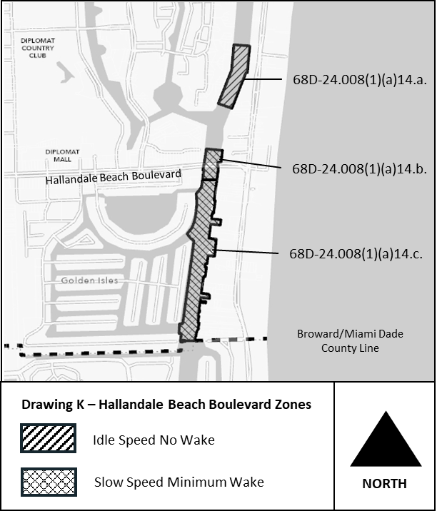
Rulemaking Authority 327.04, 327.46, 370.021 FS. Law Implemented 327.46, 327.72, 327.73(1) FS., Chapter 86-364, Ch. 89-428, Laws of Florida. History–New 11-9-86, Amended 6-14-93, Formerly 16N-24.008, Amended 12-18-94, Formerly 62N-24.008, Amended 7-21-13, __________.

NAME OF PERSON ORIGINATING PROPOSED RULE: Major Rob Beaton
Boating and Waterways Section
Fish and Wildlife Conservation Commission
620 South Meridian Street
Tallahassee, Florida 32399
rob.beaton@myfwc.com
NAME OF AGENCY HEAD WHO APPROVED THE PROPOSED RULE: Fish and Wildlife Conservation Commission
DATE PROPOSED RULE APPROVED BY AGENCY HEAD: August 4, 2021
DATE NOTICE OF PROPOSED RULE DEVELOPMENT PUBLISHED IN FAR: June 1, 2021

