Notice of Proposed Rule

FISH AND WILDLIFE CONSERVATION COMMISSION
Vessel Registration and Boating Safety
RULE NO.: RULE TITLE:
68D-24.146 Okaloosa County Boating Restricted Area
PURPOSE AND EFFECT: This proposed boating restricted area is needed to provide public safety for a wide variety of users enjoying the waters of the Intracoastal Waterway near Brooks Bridge. Operating a vessel at a slower speed improves reaction time to avoid collisions with other vessels, swimmers sharing the waterway and users launching or landing their vessel at nearby public facilities.
SUMMARY: The proposed amendments will bring all aspects of the rule into
conformity and describe the boating restricted zone accurately as approximately 3,400 feet east from the Brooks Bridge and approximately 2,000 feet west of the Brooks Bridge. Once language conformity is attained, additional uniform waterway markers will be placed on the waterway to put users on notice of the boating restricted area.
SUMMARY OF STATEMENT OF ESTIMATED REGULATORY COSTS AND LEGISLATIVE RATIFICATION:
The Agency has determined that this will not have an adverse impact on small business or likely increase directly or indirectly regulatory costs in excess of $200,000 in the aggregate within one year after the implementation of the rule. A SERC has not been prepared by the Agency.
The Agency has determined that the proposed rule is not expected to require legislative ratification based on the statement of estimated regulatory costs or if no SERC is required, the information expressly relied upon and described herein:
Any person who wishes to provide information regarding a statement of estimated regulatory costs, or provide a proposal for a lower cost regulatory alternative must do so in writing within 21 days of this notice.
RULEMAKING AUTHORITY: 327.04, 327.46 FS.
LAW IMPLEMENTED: 327.46, FS.
IF REQUESTED WITHIN 21 DAYS OF THE DATE OF THIS NOTICE, A HEARING WILL BE SCHEDULED AND ANNOUNCED IN THE FAR.
THE PERSON TO BE CONTACTED REGARDING THE PROPOSED RULE IS: Major Rob Beaton
Boating and Waterways Section, Division of Law Enforcement
620 South Meridian Street
Tallahassee, Florida 32399
rob.beaton@myfwc.com

THE FULL TEXT OF THE PROPOSED RULE IS:

68D-24.146 Okaloosa County Boating Restricted Area.
For the purpose of regulating the speed and operation of vessel traffic on the Florida Intracoastal Waterway within Okaloosa County, Florida, the following boating restricted area is established:
(1) Slow Speed Minimum Wake Zone.
(a) Brooks Bridge – A Slow Speed Minimum Wake zone, shoreline to shoreline, in and adjacent to the Florida Intracoastal Waterway approximately from 2,000’ feet west from (30° 24' 01N"/86° 36' 20W") of the centerline of the Brooks Bridge to GPS position 30° 24' 03''/86° 36' 25W", and approximately 3,400 feet east from 900’ feet east (30° 24' 14N''/86° 35' 23W") of the centerline of the Brooks Bridge to GPS position 30° 24' 06N''/86° 35' 22W" in Okaloosa County, as depicted in Drawing A.
(b) No Change.
(2) The boating restricted area is depicted in Drawing A:
Delete current rule Drawing A and insert the following:
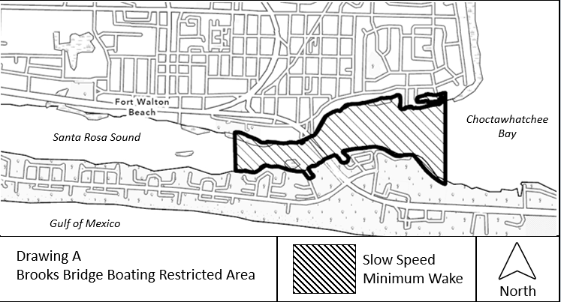
Rulemaking Authority 327.04, 327.46 FS. Law Implemented 327.46 FS. History–New 11-14-01; Amended _________.

NAME OF PERSON ORIGINATING PROPOSED RULE: Major Rob Beaton
Boating and Waterways Section, Division of Law Enforcement
620 South Meridian Street
Tallahassee, Florida 32399
rob.beaton@myfwc.com
NAME OF AGENCY HEAD WHO APPROVED THE PROPOSED RULE: Fish and Wildlife Conservation Commission
DATE PROPOSED RULE APPROVED BY AGENCY HEAD: August 4, 2021
DATE NOTICE OF PROPOSED RULE DEVELOPMENT PUBLISHED IN FAR: June 1, 2021

