Notice of Emergency Rule

DEPARTMENT OF THE LOTTERY
RULE NUMBER: RULE TITLE:
53ER21-44 Game Number 1497, TRIPLE CROSSWORD
SUMMARY OF THE RULE: This emergency rule describes Game Number 1497, “TRIPLE CROSSWORD," for which the Department of the Lottery will start selling tickets on a date to be determined by the Secretary of the Department. The rule sets forth the specifics of the game; determination of prizewinners; estimated odds of winning, value and number of prizes in the game.
THE PERSON TO BE CONTACTED REGARDING THE EMERGENCY RULE IS: Minerva Simpson, Esq., Department of the Lottery, 250 Marriott Drive, Tallahassee, Florida 32399-4011.

THE FULL TEXT OF THE EMERGENCY RULE IS:
53ER21-44 Game Number 1497, “TRIPLE CROSSWORD.”
(1) Name of Game. Game Number 1497 “TRIPLE CROSSWORD.”
(2) Game Number 1497 TRIPLE CROSSWORD, is a Scratch-Off lottery game (also known as an instant lottery game).
(3) Price. TRIPLE CROSSWORD lottery tickets sell for $3.00 per ticket.
(4) “TRIPLE CROSSWORD” lottery tickets shall have a series of numbers in Machine Readable Code (or bar code) on the back of the ticket, along with a Void If Removed Number under the latex area on the ticket. To be a valid winning TRIPLE CROSSWORD lottery ticket, the ticket must meet the applicable requirements of rule 53ER21-34, F.A.C.
(5) The play symbols in the “YOUR LETTERS” play area are as follows:
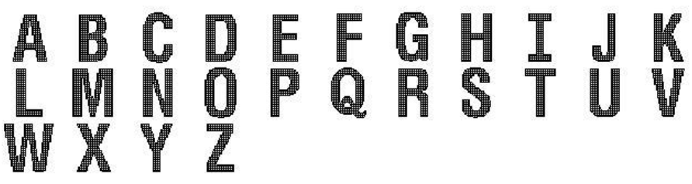
(6) The play symbols in the CROSSWORD PUZZLE play area are as follows:
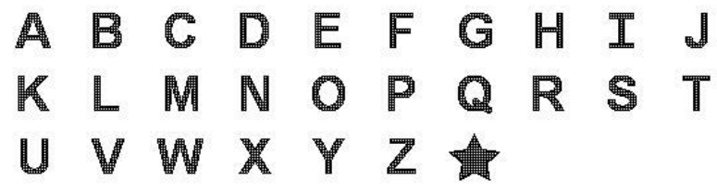
(7) The legend is as follows:
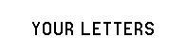
(8) Determination of Prizewinners.
(a) CROSSWORD PUZZLE. The holder of a ticket whose play symbols in the YOUR LETTERS play area that match the play symbols in the CROSSWORD PUZZLE play area to form two (2) or more words in the CROSSWORD PUZZLE play area shall be entitled to the corresponding prize in the PRIZE LEGEND for the total number of words matched. A  play symbol in the CROSSWORD PUZZLE play area is a free space and acts as a letter in a word. A “word” must contain at least three (3) letters. A “word” cannot be formed by linking letters diagonally or by reading the letters from the bottom to top or right to left. Letters combined to form a “word” must appear in an unbroken horizontal or vertical string of letters in the CROSSWORD PUZZLE play area that are not interrupted by a blank space and must contain every single letter square between two (2) blank spaces or an edge and a blank space. Every letter in the unbroken string must be revealed in “YOUR LETTERS” and must be included to form a “word.” The possible complete words are shown in the CROSSWORD PUZZLE play area. Each possible complete word consists of three (3) or more letters and occupies an entire word space. All of the letters in a possible complete word must be matched in order to complete the word.
(b) The prizes that appear in the PRIZE LEGEND are: $3, $4, $10, $20, $30, $50, $100, $200, $1,000, and $150,000.
(c) If one of the completed words contains a play symbol , the prizewinner shall be entitled to triple the corresponding prize in the PRIZE LEGEND for the total number of words matched.
(d) Only the highest prize won is paid per ticket.
(9) The estimated odds of winning, value and number of prizes in Game Number 1497 are as follows:
CROSSWORD GAME PLAY | WIN | ODDS OF 1 IN | NUMBER OF WINNERS IN 213.19 POOLS OF 180,000 TICKETS PER POOL
2 WORDS | $3 | 10.00 | 3,837,794
3 WORDS | $4 | 21.74 | 1,765,062
2 WORDS (STAR) | $9 | 29.41 | 1,304,711
4 WORDS | $10 | 33.33 | 1,151,235
3 WORDS (STAR) | $12 | 50.00 | 767,490
5 WORDS | $20 | 100.00 | 383,745
6 WORDS | $30 | 1,797.15 | 21,353
4 WORDS (STAR) | $30 | 1,028.28 | 37,319
7 WORDS | $50 | 1,791.61 | 21,419
5 WORDS (STAR) | $60 | 1,803.48 | 21,278
6 WORDS (STAR) | $90 | 1,998.15 | 19,205
8 WORDS | $100 | 2,404.12 | 15,962
7 WORDS (STAR) | $150 | 2,772.52 | 13,841
9 WORDS | $200 | 7,159.42 | 5,360
8 WORDS (STAR) | $300 | 7,262.40 | 5,284
9 WORDS (STAR) | $600 | 9,052.72 | 4,239
10 WORDS | $1,000 | 35,998.59 | 1,066
10 WORDS (STAR) | $3,000 | 45,359.93 | 846
11 WORDS | $150,000 | 1,918,725.00 | 20
(10) The estimated overall odds of winning some prize in Game Number 1497 are 1 in 4.09. Prizes, including the top prizes, are subject to availability at the time of ticket purchase. Prizes may be unavailable due to prior sale or other causes occurring in the normal course of business including, but not limited to, ticket damage, defect, theft, or loss.
(11) For reorders of Game Number 1497, the estimated odds of winning, value, and number of prizes shall be proportionate to the number of tickets reordered.
(12) Payment of prizes for TRIPLE CROSSWORD lottery tickets shall be made in accordance with the rule of the Florida Lottery governing payment of prizes. A copy of the current rule can be obtained from the Florida Lottery, Office of the General Counsel, 250 Marriott Drive, Tallahassee, Florida 32399-4011.
Rulemaking Authority 24.105(9)(a), (b), (c), 24.109(1), 24.115(1) FS. Law Implemented 24.105(9)(a), (b), (c), 24.115(1) FS. History–New 8-12-21.

THIS RULE TAKES EFFECT UPON BEING FILED WITH THE DEPARTMENT OF STATE UNLESS A LATER TIME AND DATE IS SPECIFIED IN THE RULE.
EFFECTIVE DATE: 8/12/2021.

