53ER21-42 Game Number 5022, “3 TIMES LUCKY.”
(1) Name of Game. Game Number 5022, “3 TIMES LUCKY.”
(2) Game Number 5022, 3 TIMES LUCKY is a Scratch-Off lottery game (also known as an instant lottery game).
(3) Price. 3 TIMES LUCKY lottery tickets sell for $1.00 per ticket.
(4) 3 TIMES LUCKY lottery tickets shall have a series of numbers in machine readable code (or bar code) on the back of the ticket, along with a validation number under the latex area on the ticket. To be a valid winning 3 TIMES LUCKY lottery ticket, the ticket must meet the applicable requirements of Rule 53ER21-34, Payment of Prizes, F.A.C.
(5) The play symbols and play symbol captions that may appear in the play area are as follows:
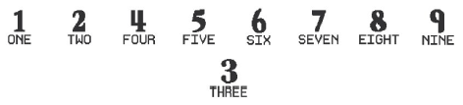
(6) The legends are as follows:
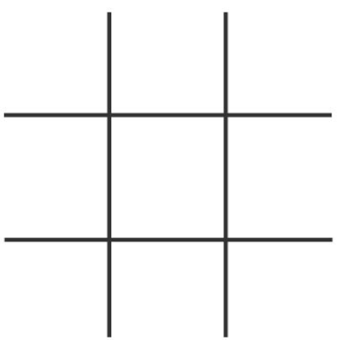
(7) The prize symbols and prize symbol captions that may appear in the PRIZE play area are as follows:
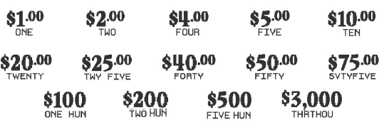
(8) Determination of Prizewinners.
(a) A ticket having three (3) “” play symbols and corresponding play symbol captions in any one horizontal row, vertical column, or diagonal line in the play area shall entitle the prizewinner to the prize shown in the PRIZE play area.
(b) A prizewinner may only win one time on a ticket.
(9) The odds of winning, value, and number of prizes in Game Number 5022 are as follows:
GAME PLAY | WIN | ODDS OF 1 IN | NUMBER OF WINNERS IN 75.84 POOLS OF 240,000 TICKETS PER POOL
$1 | $1 | 10.71 | 1,698,900
$2 | $2 | 13.64 | 1,334,664
$4 | $4 | 49.99 | 364,143
$5 | $5 | 99.91 | 182,181
$10 | $10 | 100.10 | 181,847
$20 | $20 | 299.75 | 60,725
$25 | $25 | 1,495.19 | 12,174
$40 | $40 | 2,419.58 | 7,523
$50 | $50 | 2,993.83 | 6,080
$75 | $75 | 8,057.77 | 2,259
$100 | $100 | 7,969.57 | 2,284
$200 | $200 | 26,342.26 | 691
$500 | $500 | 118,198.05 | 154
$3,000 | $3,000 | 606,750.00 | 30
(10) The overall odds of winning some prize in Game Number 5022 are 1 in 4.72. Prizes, including the top prizes, are subject to availability at the time of ticket purchase. Prizes may be unavailable due to prior sales or other causes occurring in the normal course of business including, but not limited to, ticket damage, defect, theft, or loss.
(11) For reorders of Game Number 5022, the odds of winning, value, and number of prizes shall be proportionate to the number of tickets reordered.
(12) Payment of prizes for 3 TIMES LUCKY lottery tickets shall be made in accordance with the rule of the Florida Lottery governing payment of prizes. A copy of the current rule can be obtained from the Florida Lottery, Office of the General Counsel, 250 Marriott Drive, Tallahassee, Florida 32399-4011.
Rulemaking Authority 24.105(9)(a), (b), (c), 24.109(1), 24.115(1) FS. Law Implemented 24.105(9)(a), (b), (c), 24.115(1) FS. History–New 8-12-21.

