Notice of Emergency Rule
DEPARTMENT OF THE LOTTERY
RULE NUMBER: RULE TITLE:

53ER21-50 Game Number 1498, MONEY MONEY MONEY
SUMMARY OF THE RULE: This emergency rule describes Game Number 1498, “MONEY MONEY MONEY," for which the Department of the Lottery will start selling tickets on a date to be determined by the Secretary of the Department. The rule sets forth the specifics of the game; determination of prizewinners; estimated odds of winning, value and number of prizes in the game.
THE PERSON TO BE CONTACTED REGARDING THE EMERGENCY RULE IS: Minerva Simpson, Attorney, Department of the Lottery, 250 Marriott Drive, Tallahassee, Florida 32399-4011.
THE FULL TEXT OF THE EMERGENCY RULE IS:
53ER21-50 Game Number 1498, MONEY MONEY MONEY.
(1) Name of Game. Game Number 1498, MONEY MONEY MONEY.
(2) Game Number 1498, MONEY MONEY MONEY is a Scratch-Off lottery game (also known as an instant lottery game).
(3) Price. MONEY MONEY MONEY lottery tickets sell for $2.00 per ticket.
(4) MONEY MONEY MONEY lottery tickets shall have a series of numbers in machine readable code (or bar code) on the back of the ticket, along with a validation number under the latex area on the ticket. To be a valid winning MONEY MONEY MONEY lottery ticket, the ticket must meet the applicable requirements of Rule 53ER21-34, Payment of Prizes, F.A.C.
(5) The play symbols and play symbol captions that may appear in the YOUR NUMBERS play area are as follows:
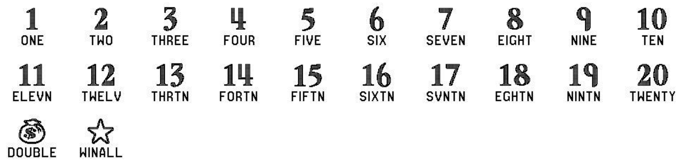

(6) The play symbols and play symbol captions that may appear in the WINNING NUMBERS play area are as follows:
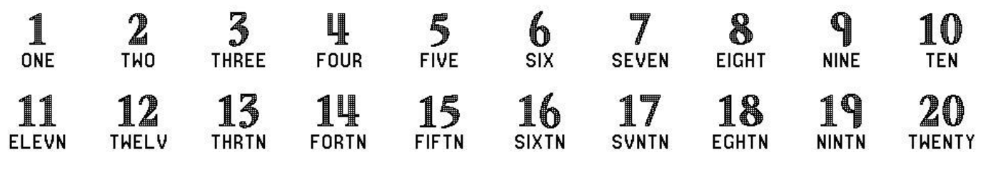
(7) The prize symbols and prize symbol captions that may appear in the YOUR NUMBERS play area are as follows:
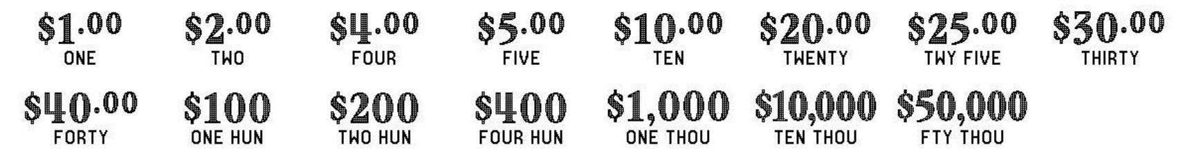
(8) The legends are as follows:
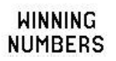
(9) Determination of Prizewinners.
(a) A ticket having a play symbol and corresponding play symbol caption in the YOUR NUMBERS play area that matches a play symbol and corresponding play symbol caption in the WINNING NUMBERS play area shall entitle the prizewinner to the corresponding prize shown for that symbol. A ticket having a 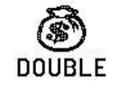 symbol in the YOUR NUMBERS play area shall entitle the prizewinner to two times the prize shown for that symbol. A ticket having a  symbol in the YOUR NUMBERS play area shall entitle the prizewinner to all ten prizes shown.
(b) A player may win up to ten times on a ticket.
(10) The odds of winning, value, and number of prizes in Game Number 1498 are as follows:
GAME PLAY | WIN | ODDS OF 1 IN | NUMBER OF WINNERS IN 100.50 POOLS OF 180,000 TICKETS PER POOL
$2 | $2 | 10.00 | 1,809,012
$1 x 4 | $4 | 50.01 | 361,748
($1 x 2) + $2 | $4 | 49.99 | 361,844
$2 (MONEYBAG) | $4 | 49.97 | 361,977
$4 | $4 | 50.03 | 361,549
$1 x 5 | $5 | 375.32 | 48,198
$1 + $2 (MONEYBAG) | $5 | 375.20 | 48,214
($2 x 2) + $1 | $5 | 375.17 | 48,217
$1 + $4 | $5 | 375.30 | 48,201
$5 | $5 | 375.32 | 48,198
$1 x 10 (STAR) | $10 | 250.26 | 72,285
$1 x 10 | $10 | 249.70 | 72,446
$2 x 5 | $10 | 250.08 | 72,335
$5 (MONEYBAG) | $10 | 249.87 | 72,397
$10 | $10 | 249.70 | 72,446
$2 x 10 (STAR) | $20 | 751.61 | 24,068
$4 x 5 | $20 | 749.68 | 24,130
$5 x 4 | $20 | 751.11 | 24,084
$10 (MONEYBAG) | $20 | 748.03 | 24,183
$20 | $20 | 749.58 | 24,133
$1 + ($2 x 7) + ($5 x 2) (STAR) | $25 | 1,204.13 | 15,023
$1 + ($2 x 7) + $5 (MONEYBAG) | $25 | 1,204.29 | 15,021
($2 x 5) + ($5 x 3) | $25 | 1,200.22 | 15,072
$5 x 5 | $25 | 1,198.23 | 15,097
$25 | $25 | 1,198.79 | 15,090
($2 x 5) + ($4 x 5) (STAR) | $30 | 1,792.66 | 10,091
$5 x 6 | $30 | 1,800.15 | 10,049
$10 x 3 | $30 | 2,573.58 | 7,029
$10 + $10 (MONEYBAG) | $30 | 1,804.64 | 10,024
$30 | $30 | 2,569.19 | 7,041
$4 x 10 (STAR) | $40 | 4,505.53 | 4,015
($4 x 5) + ($5 x 4) | $40 | 4,502.17 | 4,018
$10 x 4 | $40 | 4,485.42 | 4,033
$20 (MONEYBAG) | $40 | 4,503.29 | 4,017
$40 | $40 | 4,483.20 | 4,035
$10 x 10 (STAR) | $100 | 4,519.04 | 4,003
$10 x 10 | $100 | 4,523.56 | 3,999
$20 (MONEYBAG) + $30 (MONEYBAG) | $100 | 4,506.65 | 4,014
$25 x 4 | $100 | 4,505.53 | 4,015
$100 | $100 | 4,489.87 | 4,029
$40 x 10 (STAR) | $400 | 36,107.19 | 501
($40 x 5) + ($100 x 2) | $400 | 44,446.44 | 407
$100 x 4 | $400 | 44,555.91 | 406
$100 (MONEYBAG) x 2 | $400 | 44,776.49 | 404
$400 | $400 | 44,999.25 | 402
$100 x 10 (STAR) | $1,000 | 184,588.78 | 98
$100 x 10 | $1,000 | 179,105.94 | 101
$200 x 5 | $1,000 | 182,724.24 | 99
$200 + $400 (MONEYBAG) | $1,000 | 175,628.16 | 103
$1,000 | $1,000 | 179,105.94 | 101
$10,000 | $10,000 | 565,303.13 | 32
$50,000 | $50,000 | 1,130,606.25 | 16
(11) The overall odds of winning some prize in Game Number 1498 are 1 in 4.37. Prizes, including the top prizes, are subject to availability at the time of ticket purchase. Prizes may be unavailable due to prior sales or other causes occurring in the normal course of business including, but not limited to, ticket damage, defect, theft, or loss.
(12) For reorders of Game Number 1498, the odds of winning, value, and number of prizes shall be proportionate to the number of tickets reordered.
(13) Payment of prizes for MONEY MONEY MONEY lottery tickets shall be made in accordance with the rule of the Florida Lottery governing payment of prizes. A copy of the current rule can be obtained from the Florida Lottery, Office of the General Counsel, 250 Marriott Drive, Tallahassee, Florida 32399-4011.
Rulemaking Authority 24.105(9)(a), (b), (c), 24.109(1), 24.115(1) FS. Law Implemented 24.105(9)(a), (b), (c), 24.115(1) FS. History- New 9-16-21.
THIS RULE TAKES EFFECT UPON BEING FIED WITH THE DEPARTMENT OF STATE UNLESS A LATER TIME AND DATE IS SPECIFIED IN THE RULE.
EFFECTIVE DATE: September 16, 2021.

