68D-24.146 Okaloosa County Boating Restricted Area.
For the purpose of regulating the speed and operation of vessel traffic on the Florida Intracoastal Waterway within Okaloosa County, Florida, the following boating restricted area is established:
(1) Slow Speed Minimum Wake Zone.
(a) Brooks Bridge – A Slow Speed Minimum Wake zone, shoreline to shoreline, in and adjacent to the Florida Intracoastal Waterway approximately 2,000' feet west from of the centerline of the Brooks Bridge to GPS position 30° 24' 03''/86° 36' 25W", and approximately 3,400 feet east from the centerline of the Brooks Bridge to GPS position 30° 24' 06N''/86° 35' 22W" in Okaloosa County, as depicted in Drawing A.
(b) Okaloosa County is authorized to install and maintain appropriate regulatory markers as directed by the Division of Law Enforcement within the boating restricted area.
(2) The boating restricted area is depicted in Drawing A:
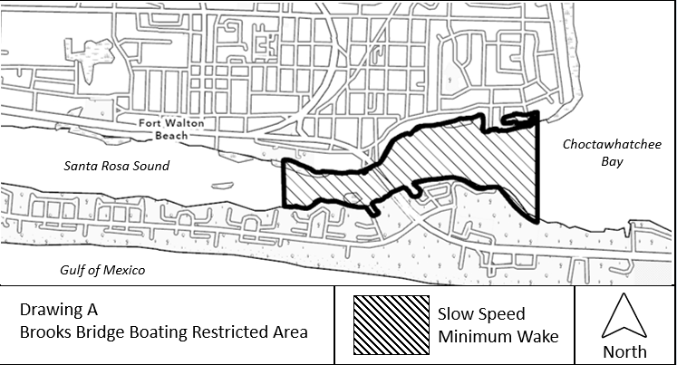
Rulemaking Authority 327.04, 327.46 FS. Law Implemented 327.46 FS. History–New 11-14-01, Amended 9-27-21.

