53ER21-52 Game Number 1501, GOLD RUSH LIMITED.
(1) Name of Game. Game Number 1501, GOLD RUSH LIMITED.
(2) Game Number 1501, GOLD RUSH LIMITED is a Scratch-Off lottery game (also known as an instant lottery game).
(3) Price. GOLD RUSH LIMITED lottery tickets sell for $20.00 per ticket.
(4) GOLD RUSH LIMITED lottery tickets shall have a series of numbers in machine readable code (or bar code) on the back of the ticket, along with a validation number under the latex area on the ticket. To be a valid winning GOLD RUSH LIMITED lottery ticket, the ticket must meet the applicable requirements of Rule 53ER21-34, Payment of Prizes, F.A.C.
(5) The play symbols and play symbol captions that may appear in the YOUR NUMBERS play area are as follows:
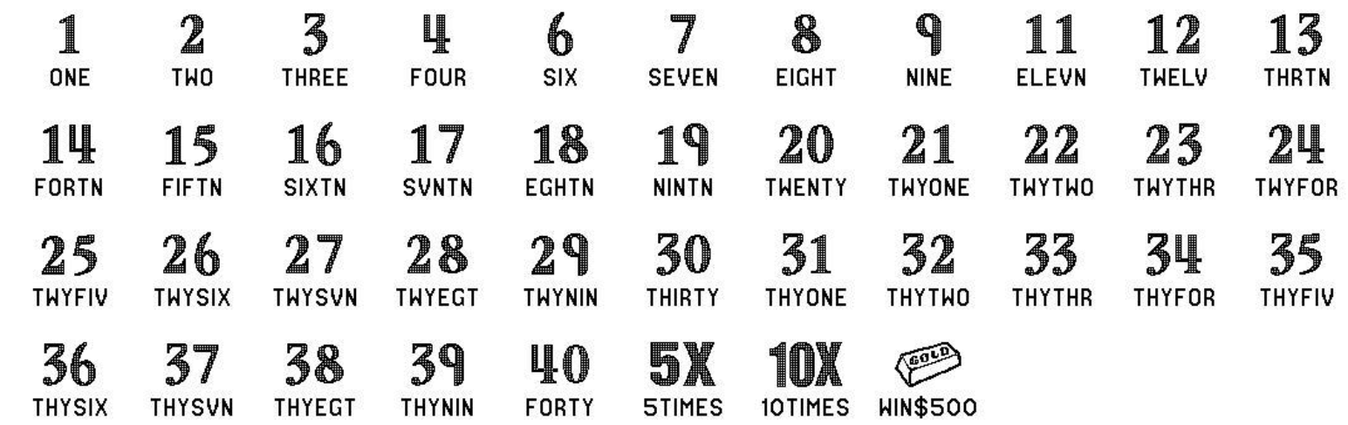
(6) The play symbols and play symbol captions that may appear in the WINNING NUMBERS play area are as follows:
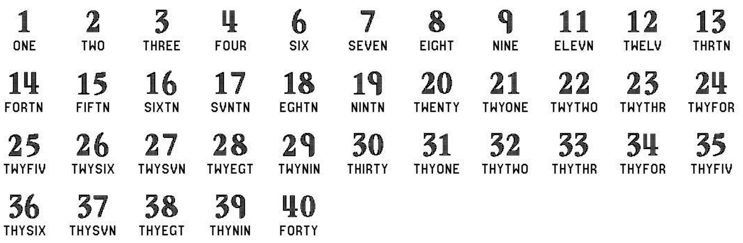
(7) The prize symbols and prize symbol captions that may appear in the YOUR NUMBERS play area are as follows:
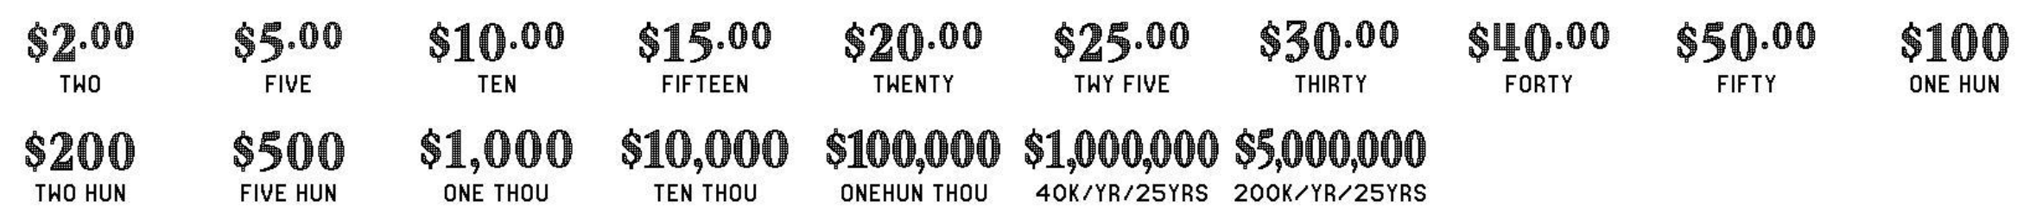
(8) The legends are as follows:
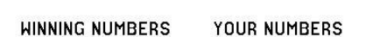
(9) The play symbols and play symbol captions that may appear in the BONUS SPOT play area are as follows:
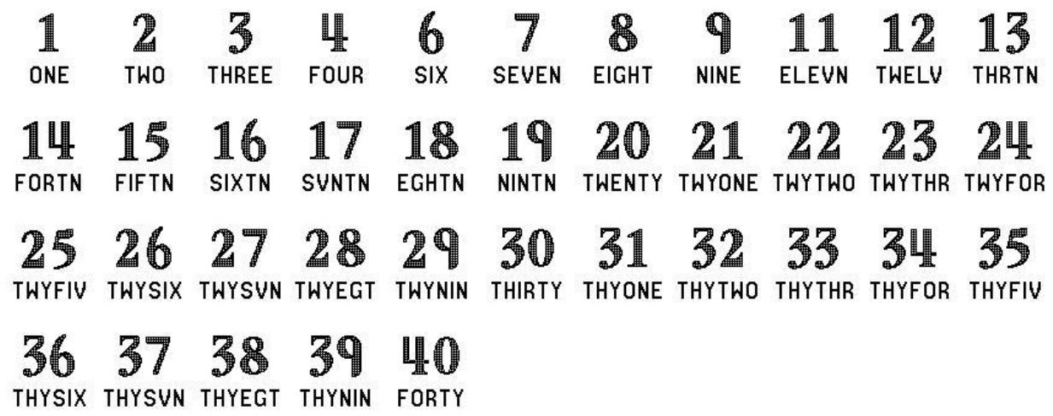
(10) The BONUS prize symbols that may appear in the BONUS SPOT play area are as follows:

(11) Determination of Prizewinners.
(a) A ticket having a play symbol and corresponding play symbol caption in the YOUR NUMBERS play area that matches a play symbol and corresponding play symbol caption in the WINNING NUMBERS play area shall entitle the prizewinner to the corresponding prize shown for that symbol. A ticket having a 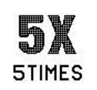 symbol in the YOUR NUMBERS play area shall entitle the prizewinner to five times the prize shown for that symbol. A ticket having a  symbol in the YOUR NUMBERS play area shall entitle the prizewinner to ten times the prize shown for that symbol. A ticket having a 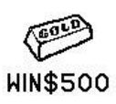 symbol in the YOUR NUMBERS play area shall entitle the prizewinner to a prize of $500.
(b) BONUS SPOT. A ticket having a play symbol and play symbol caption in the WINNING NUMBERS play area that matches a play symbol and play symbol caption in the BONUS SPOT play area shall entitle the prizewinner to the corresponding BONUS prize shown for that symbol.
(c) A player may win up to twenty-five (25) times on a ticket.
(12) $1,000,000 Prize; Payment Options.
(a) A prizewinner of a $1,000,000 prize may choose one of two payment options for receiving his or her prize. Payment options are Cash Option or Annual Payment. At the time the $1,000,000 prize is claimed, the terminal will produce a player claim instructions ticket. The prizewinner has sixty (60) days from the date the player claim instructions ticket is produced to file a claim choosing the Cash Option. If a prizewinner does not choose the Cash Option within the sixty (60) day timeframe, the Annual Payment option will be applied. Once the prizewinner files a claim and exercises the winner’s chosen option, the election of that option shall be final. The Annual Payment method of payment will also be final when it is applied due to a $1,000,000 prize winner not making his or her payment election within sixty (60) days after the player claim instructions ticket is produced.
(b) Cash Option prizes will be paid in a single cash payment. A winner of a $1,000,000 prize who elects the Cash Option shall receive a single cash payment of $795,000, less applicable federal income tax withholding.
(c) Annual Payment prizes will be paid in twenty-five (25) equal annual installments. A prizewinner of a $1,000,000 prize who elects the Annual Payment option, or has it applied, shall receive annual installments of $40,000 per year, less applicable federal tax withholding.
(13) $5,000,000 Prize; Payment Options.
(a) A prizewinner of a $5,000,000 prize may choose one of two payment options for receiving his or her prize. Payment options are Cash Option or Annual Payment. At the time the $5,000,000 prize is claimed, the terminal will produce a player claim instructions ticket. The prizewinner has sixty (60) days from the date the player claim instructions ticket is produced to file a claim choosing the Cash Option. If a prizewinner does not choose the Cash Option within the sixty (60) day timeframe, the Annual Payment option will be applied. Once the prizewinner files a claim and exercises the winner’s chosen option, the election of that option shall be final. The Annual Payment method of payment will also be final when it is applied due to a $5,000,000 prize winner not making his or her payment election within sixty (60) days after the player claim instructions ticket is produced.
(b) Cash Option prizes will be paid in a single cash payment. A winner of a $5,000,000 prize who elects the Cash Option shall receive a single cash payment of $3,960,000, less applicable federal income tax withholding.
(c) Annual Payment prizes will be paid in twenty-five (25) equal annual installments. A prizewinner of a $5,000,000 prize who elects the Annual Payment option, or has it applied, shall receive annual installments of $200,000 per year, less applicable federal tax withholding.
(14) The odds of winning, value, and number of prizes in Game Number 1501 are as follows:
GAME PLAY | WIN | ODDS OF 1 IN | NUMBER OF WINNERS IN 630 POOLS OF 120,000 TICKETS PER POOL
$2 (10X) | $20 | 15 | 5,040,000
$2 (5X) + $10 | $20 | 15 | 5,040,000
$10 x 2 | $20 | 30 | 2,520,000
$5 x 4 | $20 | 30 | 2,520,000
$20 | $20 | 30 | 2,520,000
$5 + $5 (5X) | $30 | 75 | 1,008,000
$2 (10X) + $10 | $30 | 75 | 1,008,000
$10 x 3 | $30 | 150 | 504,000
$10 + $20 | $30 | 150 | 504,000
$30 | $30 | 150 | 504,000
$5 + $5 (5X) + $10 | $40 | 75 | 1,008,000
$2 (5X) + ($10 x 3) | $40 | 75 | 1,008,000
$2 (10X) + $20 | $40 | 150 | 504,000
$20 x 2 | $40 | 150 | 504,000
$40 | $40 | 150 | 504,000
$5 x 10 | $50 | 150 | 504,000
$5 (10X) | $50 | 150 | 504,000
$10 + ($20 x 2) | $50 | 150 | 504,000
$10 (5X) | $50 | 150 | 504,000
$50 | $50 | 150 | 504,000
$10 (10X) | $100 | 342.86 | 220,500
$10 (5X) + $50 | $100 | 342.86 | 220,500
($10 x 2) + ($15 x 2) + ($25 x 2) | $100 | 600 | 126,000
$20 (5X) | $100 | 342.86 | 220,500
($20 x 2) + ($30 x 2) | $100 | 480 | 157,500
$50 x 2 | $100 | 600 | 126,000
$100 | $100 | 600 | 126,000
$10 x 20 | $200 | 12,000 | 6,300
$20 (5X) x 2 | $200 | 8,000 | 9,450
$20 (10X) | $200 | 6,000 | 12,600
$40 (5X) | $200 | 8,000 | 9,450
$100 x 2 | $200 | 12,000 | 6,300
$200 | $200 | 12,000 | 6,300
$50 x 10 | $500 | 12,000 | 6,300
$50 (10X) | $500 | 8,000 | 9,450
($50 x 4) + ($100 x 3) | $500 | 12,000 | 6,300
$100 (5X) | $500 | 8,000 | 9,450
($100 x 3) + ($50 x 2) + ($30 x 2) + ($20 x 2) | $500 | 12,000 | 6,300
$500 (GOLD BAR) | $500 | 8,000 | 9,450
($5 x 10) + ($10 x 2) + ($20 x 6) + ($30 x 2) + ($50 x 3) + $100 + $500 | $1,000 | 24,000 | 3,150
($50 x 2) + ($100 x 2) + $200 +$500 (GOLD BAR) | $1,000 | 12,000 | 6,300
$100 (10X) | $1,000 | 12,000 | 6,300
$40 (5X) x 5 | $1,000 | 12,000 | 6,300
($100 x 5) + $500 (GOLD BAR) | $1,000 | 12,000 | 6,300
$1,000 | $1,000 | 24,000 | 3,150
$1,000 (5X) x 2 | $10,000 | 120,000 | 630
$1,000 (10X) | $10,000 | 120,000 | 630
$10,000 | $10,000 | 120,000 | 630
$100,000 | $100,000 | 630,000 | 120
$1,000,000 ($40K/YR/25YRS) | $1,000,000* | 756,000 | 100
$5,000,000 ($200K/YR/25YRS) | $5,000,000* | 2,362,500 | 32
*The amount shown is the grand total for the annual payment method. If the single cash payment is chosen by the prizewinner, the actual sum paid will be as set forth in subsections (12) and (13), above, respectively.
(15) The overall odds of winning some prize in Game Number 1501 are 1 in 2.65. Prizes, including the top prizes, are subject to availability at the time of ticket purchase. Prizes may be unavailable due to prior sales or other causes occurring in the normal course of business including, but not limited to, ticket damage, defect, theft, or loss.
(16) For reorders of Game Number 1501, the odds of winning, value, and number of prizes shall be proportionate to the number of tickets reordered.
(17) Payment of prizes for GOLD RUSH LIMITED lottery tickets shall be made in accordance with the rule of the Florida Lottery governing payment of prizes. A copy of the current rule can be obtained from the Florida Lottery, Office of the General Counsel, 250 Marriott Drive, Tallahassee, Florida 32399-4011.
Rulemaking Authority 24.105(9)(a), (b), (c), 24.109(1), 24.115(1) FS. Law Implemented 24.105(9)(a), (b), (c), 24.115(1) FS. History‒New 9-16-21.

