64E-5.322 Caution Signs.
(1) Standard Radiation Symbol. Unless otherwise authorized by the department, the symbol prescribed in this section shall use the colors magenta or purple or black on yellow background. The symbol prescribed is the three-bladed design as follows:
RADIATION SYMBOL
(a) Cross-hatched area is to be magenta or purple or black, and
(b) The background is to be yellow.
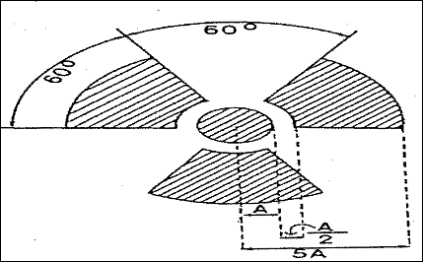
(2) Exception to Color Requirements for Standard Radiation Symbol. In spite of the requirements of subsection 64E-5.322(1), F.A.C., licensees or registrants are authorized to label sources, source holders, or device components containing sources of radiation that are subjected to high temperatures, with conspicuously etched or stamped radiation caution symbols and without a color requirement.
(3) Additional Information on Signs and Labels. In addition to contents of signs and labels prescribed in this part, the licensee or registrant shall provide on or near the required signs and labels additional information to make individuals aware of potential radiation exposures and to minimize the exposures.
Rulemaking Authority 404.051, 404.081 FS. Law Implemented 404.022, 404.051(1), (4), 404.081 FS. History–New 1-1-94, Formerly 10D-91.455.

