Notice of Proposed Rule

FISH AND WILDLIFE CONSERVATION COMMISSION
Vessel Registration and Boating Safety
RULE NO.: RULE TITLE:
68D-24.021 Ochlockonee River Boating Restricted Areas
PURPOSE AND EFFECT: This rulemaking will create a year-round vessel exclusion boating restricted area in Gadsden, Leon, and Liberty Counties, 300 feet down river from the Jackson Bluff Dam (Ochlockonee River side) and 75 feet upriver from the dam and spillway (Lake Talquin side). The resulting boating restricted area is necessary to protect public safety.
SUMMARY: This rulemaking will create a year-round vessel exclusion boating restricted area in Gadsden, Leon, and Liberty Counties, 300 feet down river from the Jackson Bluff Dam (Ochlockonee River side) and 75 feet upriver from the dam and spillway (Lake Talquin side). The resulting boating restricted area is necessary to protect public safety.
SUMMARY OF STATEMENT OF ESTIMATED REGULATORY COSTS AND LEGISLATIVE RATIFICATION:
The Agency has determined that this will not have an adverse impact on small business or likely increase directly or indirectly regulatory costs in excess of $200,000 in the aggregate within one year after the implementation of the rule. A SERC has not been prepared by the Agency.
The Agency has determined that the proposed rule is not expected to require legislative ratification based on the statement of estimated regulatory costs or if no SERC is required, the information expressly relied upon and described herein:
Any person who wishes to provide information regarding a statement of estimated regulatory costs, or provide a proposal for a lower cost regulatory alternative must do so in writing within 21 days of this notice.
RULEMAKING AUTHORITY: 327.04, 327.46 FS.
LAW IMPLEMENTED: 327.46, FS.
IF REQUESTED WITHIN 21 DAYS OF THE DATE OF THIS NOTICE, A HEARING WILL BE SCHEDULED AND ANNOUNCED IN THE FAR.
THE PERSON TO BE CONTACTED REGARDING THE PROPOSED RULE IS: Captain Gary Klein, Fish and Wildlife Conservation Commission, Division of Law Enforcement, Boating and Waterways Section, 620 South Meridian Street, Tallahassee, Florida 32399, gary.klein@myfwc.com.

THE FULL TEXT OF THE PROPOSED RULE IS:

68D-24.021 Ochlockonee River Boating Restricted Areas
For the purpose of providing for public safety, the following boating restricted areas are established:
(1) A no entry area starting from the northeast (Lake Talquin) side of the spillway of the Jackson Bluff Dam, bounded by a line running northeast approximately 75 feet to GPS position 30° 23’28.18” N 84° 38’55.98” W, then running southeast approximately 1000 feet to GPS position 30° 23’20.90” N 84° 38’48.73”W, then running northeasterly approximately 250 feet to GPS position 30° 23’21.97” N 84° 38’46.18” W, then running southeast approximately 330 feet to GPS position 30° 23’19.58” N 84° 38’43.74” W, then running southwest, following the natural contour of the shoreline, back to the southeastern base of the dam.
(2) A shoreline to shoreline no entry area from the southwest (Ochlockonee River) side of the Jackson Bluff Dam, bounded by a line running southwest approximately 300 feet, following the natural contour of the shoreline, to GPS position 30° 23’ 15.25N”/84° 38’49.31W” then running northwest approximately 550 feet to GPS position 30° 23’ 19.31N”/84° 38’53.38W” then running easterly approximately 400 feet, following the natural contour of the shoreline, to the northwest side of the dam.
(3) The boating restricted areas in subsections (1) and (2) are depicted in Drawing A.
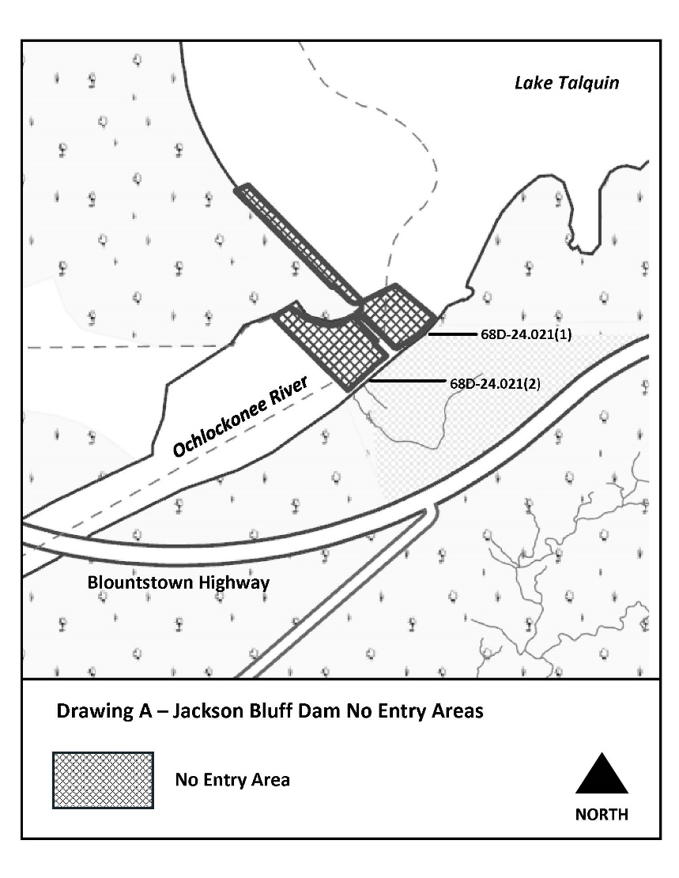
Rulemaking Authority 327.04, 327.46, FS. Law Implemented 327.46, FS.. History–New _________________.

NAME OF PERSON ORIGINATING PROPOSED RULE: Captain Gary Klein, Fish and Wildlife Conservation Commission, Division of Law Enforcement, Boating and Waterways Section, 620 South Meridian Street, Tallahassee, Florida 32399, gary.klein@myfwc.com.
NAME OF AGENCY HEAD WHO APPROVED THE PROPOSED RULE: Florida Fish and Wildlife Conservation Commission
DATE PROPOSED RULE APPROVED BY AGENCY HEAD: December 15, 2021
DATE NOTICE OF PROPOSED RULE DEVELOPMENT PUBLISHED IN FAR: October 1, 2021

