68D-24.021 Ochlockonee River Boating Restricted Areas.
For the purpose of providing for public safety, the following boating restricted areas are established:
(1) A no entry area starting from the northeast (Lake Talquin) side of the spillway of the Jackson Bluff Dam, bounded by a line running northeast approximately 75 feet to GPS position 30° 23ꞌ28.18ꞌꞌ N 84° 38ꞌ55.98ꞌꞌ W, then running southeast approximately 1000 feet to GPS position 30° 23ꞌ20.90ꞌꞌ N 84° 38ꞌ48.73ꞌꞌ W, then running northeasterly approximately 250 feet to GPS position 30° 23ꞌ21.97ꞌꞌ N 84° 38ꞌ46.18ꞌꞌ W, then running southeast approximately 330 feet to GPS position 30° 23ꞌ19.58ꞌꞌ N 84° 38ꞌ43.74ꞌꞌ W, then running southwest, following the natural contour of the shoreline, back to the southeastern base of the dam.
(2) A shoreline to shoreline no entry area from the southwest (Ochlockonee River) side of the Jackson Bluff Dam, bounded by a line running southwest approximately 300 feet, following the natural contour of the shoreline, to GPS position 30° 23ꞌ 15.25Nꞌꞌ/84° 38ꞌ49.31Wꞌꞌ then running northwest approximately 550 feet to GPS position 30° 23ꞌ 19.31Nꞌꞌ/84° 38ꞌ53.38Wꞌꞌ then running easterly approximately 400 feet, following the natural contour of the shoreline, to the northwest side of the dam.
(3) The boating restricted areas in subsections (1) and (2) are depicted in Drawing A.
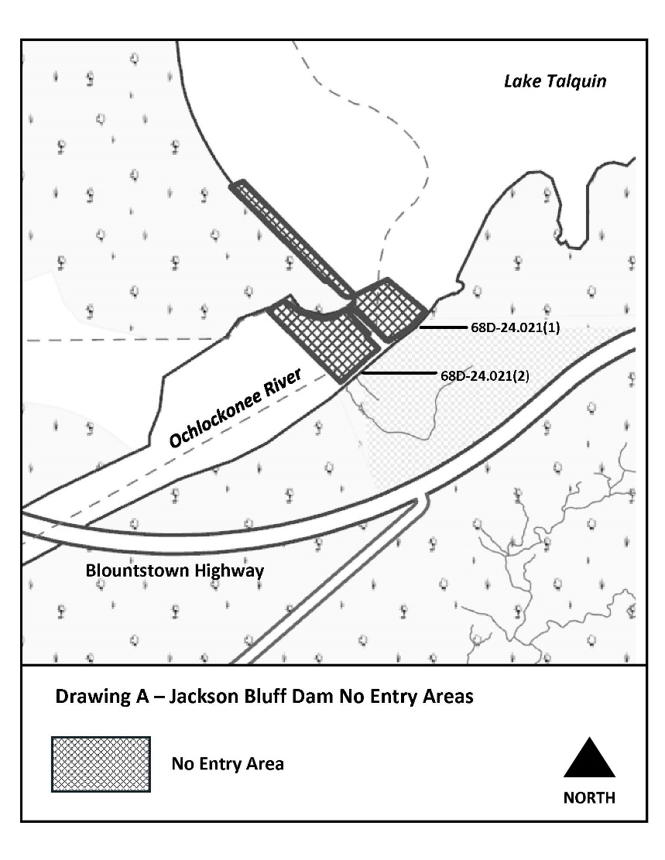
Rulemaking Authority 327.04, 327.46 FS. Law Implemented 327.46 FS. History–New 2-7-22.

