40D-2.801 Water Use Caution Areas.
(1) When the Governing Board determines that regional action is necessary to address cumulative water withdrawals that are causing or may cause adverse impacts to the water and related natural resources or the public interest, it shall declare, delineate, or modify Water Use Caution Areas (WUCAs). The Governing Board shall declare a WUCA by adopting a rule or issuing an order imposing special requirements for existing water users and permit applicants to prevent or remedy impacts to water and related natural resources or the public interest.
(2) In determining whether an area should be declared a WUCA, the Governing Board shall consider the following factors:
(a) The quantity of water available for use from groundwater sources, surface water sources, or both.
(b) The quality of water available for use from groundwater sources, surface water sources, or both, including impacts such as saline water intrusion, mineralized water upconing, or pollution.
(c) Environmental systems, such as wetlands, lakes, streams, estuaries, fish and wildlife, or other natural resources.
(d) Lake stages or surface water rates of flow.
(e) Offsite land uses.
(f) Other resources as deemed appropriate by the Governing Board.
(3) The regions described in this rule have been declared WUCAs by the District Governing Board. This rule reaffirms the declaration of WUCAs and creates conditions to be applied to water users in those areas.
(a) Northern Tampa Bay Water Use Caution Area.
To address groundwater withdrawals that have resulted in lowering of lake levels, destruction or deterioration of wetlands, reduction in streamflow and salt water intrusion, the Governing Board declared portions of northern Hillsborough County, southwestern Pasco County and all of Pinellas County a WUCA on June 28, 1989, pursuant to Resolution Number 934. The Governing Board approved expansion of the boundaries of the WUCA in June 2007.
1. The boundary for the Northern Tampa Bay Water Use Caution Area is as follows:
All of Pinellas County;
All of Pasco County; and
That portion of Hillsborough County within the following sections; (all Townships are South; all Ranges are East);
Township 27, Range 17: All Sections;
Township 27, Range 18: All Sections;
Township 27, Range 19: All Sections;
Township 27, Range 20: All Sections;
Township 27, Range 21: All Sections;
Township 27, Range 22: All Sections;
Township 28, Range 17: All Sections;
Township 28, Range 18: All Sections;
Township 28, Range 19: All Sections;
Township 28, Range 20: All Sections;
Township 28, Range 21: All Sections;
Township 28, Range 22: All Sections;
Township 29, Range 17: All Sections;
Township 29, Range 18: All Sections;
Township 30, Range 17: All Sections;
Township 30, Range 18: All Sections;
Township 30, Range 19: Section 5 West of the Hillsborough Bay Westerly Shoreline;
Township 30, Range 19: Section 6:
Township 29, Range 22: All Sections North of State Road 60;
Township 29, Range 21: All Sections North of State Road 60;
Township 29, Range 20: All Sections North of State Road 60;
Township 29, Range 19: Sections 1 through 20, 30 and 31, Section 21 West of the Hillsborough Bay Westerly Shoreline, Section 24 North of State Road 60, Section 29 West of the Hillsborough Bay Westerly Shoreline and Section 32 West of the Hillsborough Bay Westerly Shoreline.
2. Regulations specifically applicable to this WUCA are set forth in the WUP Applicant’s Handbook Part B Section 3.9.3 and are in addition to all other regulations set forth in Chapter 40D-2, F.A.C., and the WUP Applicant’s Handbook Parts B and D.
3. All WUPs within the WUCA are hereby modified to conform with this Rule, and applicable permit conditions specified in Section 7.3, of the WUP Basis of Review, incorporated by reference in Rule 40D-2.091, F.A.C., are incorporated into all WUPs within the WUCA.
4. The Northern Tampa Bay Water Use Caution Area is a water resource caution area for purposes of Chapter 403, F.S. and Chapter 62-40, F.A.C.
(b) Southern Water Use Caution Area (SWUCA). To address lowered lake levels, stream flows and ground water levels, water quality degradation and adverse impacts to water users, the Governing Board declared all or portions of Manatee, Sarasota, DeSoto, Hardee, Charlotte, Highlands, Hillsborough and Polk Counties within the District’s boundaries a WUCA on October 26, 1992, pursuant to Resolution Number 92-10.
1. As shown in Figure 2-1, the boundary for the Southern Water Use Caution Area is as follows:
All of Manatee, Sarasota, Charlotte, Hardee, DeSoto, and Highlands Counties within the boundaries of the Southwest Florida Water Management District, and that portion of Hillsborough County within the following sections (all Townships are South; all Ranges are East):
Township 29, Range 19: Section 21 East of the Hillsborough Bay Easterly Shoreline, Sections 22 and 23, Section 24 South of State Road 60, Sections 25 through 28, Section 29 East of the Hillsborough Bay Easterly Shoreline, Section 32 East of the Hillsborough Bay Easterly Shoreline and Sections 33 through 36;
Township 29, Range 20: All whole or partial Sections South of State Road 60;
Township 29, Range 21: All whole or partial Sections South of State Road 60;
Township 29, Range 22: All whole or partial Sections South of State Road 60;
Township 30, Range 19: Sections 1 through 4, Section 5 East of the Hillsborough Bay Easterly Shoreline and Section 7 through 36;
Township 30, Range 20: All Sections;
Township 30, Range 21: All Sections;
Township 30, Range 22: All Sections;
Township 31, Range 18: All Sections;
Township 31, Range 19: All Sections;
Township 31, Range 20: All Sections;
Township 31, Range 21: All Sections;
Township 31, Range 22: All Sections;
Township 32, Range 17: Section 36;
Township 32, Range 18: All Sections;
Township 32, Range 19: All Sections;
Township 32, Range 20: All Sections;
Township 32, Range 21: All Sections;
Township 32, Range 22: All Sections;
Township 33, Range 15: All Sections;
Township 33, Range 16: All Sections;
and that portion of Polk County within the Southwest Florida Water Management District and within the following sections:
Township 26, Range 25: Section 36 South of Interstate 4;
Township 26, Range 26: All whole or partial Sections 28, 29, 31 and 32 South of Interstate 4, and All of Section 33;
Township 27, Range 23: All whole or partial Sections South of Interstate 4;
Township 27, Range 24: All whole or partial Sections South of Interstate 4;
Township 27, Range 25: All whole or partial Sections South of Interstate 4;
Township 27, Range 26: Sections 4 through 9, Sections 16 through 21, Sections 28 through 36, and Partial Sections 25 through 27 South of State Road 600 (US Route 17/92);
Township 27, Range 27: Sections 25 through 28, Partial Sections 29 and 30 South of State Road 600 (US Route 17/92), and Sections 31 through 36;
Township 28, Range 23: All Sections;
Township 28, Range 24: All Sections;
Township 28, Range 25: All Sections;
Township 28, Range 26: All Sections;
Township 28, Range 27: All Sections;
Township 28, Range 28: All Sections;
Township 29, Range 23: All Sections;
Township 29, Range 24: All Sections;
Township 29, Range 25: All Sections;
Township 29, Range 26: All Sections;
Township 29, Range 27: All Sections;
Township 29, Range 28: All Sections;
Township 29, Range 29: Sections 19, 30, 31;
Township 30, Range 23: All Sections;
Township 30, Range 24: All Sections;
Township 30, Range 25: All Sections;
Township 30, Range 26: All Sections;
Township 30, Range 27: All Sections;
Township 30, Range 28: All Sections;
Township 30, Range 29: Sections 5, 6, 7, 8, 18, 19, 30, 31;
Township 31, Range 23: All Sections;
Township 31, Range 24: All Sections;
Township 31, Range 25: All Sections;
Township 31, Range 26: All Sections;
Township 31, Range 27: All Sections;
Township 31, Range 28: All Sections;
Township 31, Range 29: Section 6;
Township 32, Range 23: All Sections;
Township 32, Range 24: All Sections;
Township 32, Range 25: All Sections;
Township 32, Range 26: All Sections;
Township 32, Range 27: All Sections;
Township 32, Range 28: All Sections;
2. As shown in Figure 2-1, the area for the MIA of the Southern Water Use Caution Area is as follows:
Township 30, Range 19, Sections 2 through 36;
Township 30, Range 20, Sections 17 through 22; and 27 through 36;
Township 31, Range 18, All Sections;
Township 31, Range 19, All Sections;
Township 31, Range 20, All Sections;
Township 31, Range 21, Sections 6 through 8; 17 through 20; and 29 through 32;
Township 32, Range 17: Section 36;
Township 32, Range 18, All Sections;
Township 32, Range 19, All Sections;
Township 32, Range 20, All Sections;
Township 32, Range 21, Sections 5 through 7;
Township 33, Range 17, All Sections;
Township 33, Range 18, All Sections;
Township 33, Range 19, All Sections;
Township 33, Range 20, All Sections;
Township 33, Range 21, Sections 19, 30, 31;
Township 34, Range 15: All Sections;
Township 34, Range 16, All Sections;
Township 34, Range 17, All Sections;
Township 34, Range 18, All Sections;
Township 34, Range 19, All Sections;
Township 34, Range 20, All Sections;
Township 34, Range 21, Sections 6 through 8; 17 through 20; and 29 through 32;
Township 35, Range 16, All sections;
Township 35, Range 17, All Sections;
Township 35, Range 18, All Sections;
Township 35, Range 19, All Sections;
Township 35, Range 20, All Sections;
Township 35, Range 21, Sections 5 through 8; 17 through 20; and 30;
Township 36, Range 17, All Sections;
Township 36, Range 18, All Sections;
Township 36, Range 19, Sections 1 through 24; and 27 through 32;
Township 36, Range 20, Sections 2 through 10; and 17 and 18;
Township 37, Range 17, Sections 1 through 18;
Township 37, Range 18, Sections 1 through 10; and 17 and 18.
3. The Ridge Lakes are those lakes located anywhere within Highlands County and Polk County within the boundaries of the Southwest Florida Water Management District within the following Sections:
All of Highlands County within the boundaries of the Southwest Florida Water Management District, and that portion of Polk County within the Southwest Florida Water Management District and within the following sections (all Townships are South; all Ranges are East):
Township 26, Range 25: Partial Section 36 South of Interstate 4;
Township 26, Range 26: Partial Sections 28, 29, 31, and 32 South of Interstate 4 and whole Section 33;
Township 27, Range 25: Partial Sections 1, 2, 7, and 8 South of Interstate 4 and whole Sections 9 through 29, and 32 through 36;
Township 27, Range 26: Sections 4 through 9, 16 through 21, and 25 through 36;
Township 27, Range 27: Sections 25 through 36;
Township 27, Range 28: Section 31;
Township 28, Range 25: Sections 1 through 4, 9 through 15, 22 through 26, 35 through 36;
Township 28, Range 26: All Sections;
Township 28, Range 27: All Sections;
Township 28, Range 28: Sections 6 through 7, 17 through 22, 27 through 32, and Section 34;
Township 29, Range 25: Sections 1, 2, and 11 through 14;
Township 29, Range 26: Sections 1 through 18, and 23 through 24;
Township 29, Range 27: All Sections;
Township 29, Range 28: Sections 6 though 7, and 18 through 36;
Township 29, Range 29: Sections 19, 30, 31;
Township 30, Range 27: All Sections;
Township 30, Range 28: All Sections;
Township 30, Range 29: Sections 5 through 8, 18, 19, 30, 31;
Township 31, Range 27: All Sections;
Township 31, Range 28: All Sections;
Township 31, Range 29: Section 6;
Township 32, Range 27: All Sections;
Township 32, Range 28: All Sections.
4. Regulations applicable to this WUCA are specified in this Chapter and in the WUP Applicant’s Handbook Part B Section 3.9.2, and are in addition to all other regulations set forth in Chapter 40D-2, F.A.C., and the WUP Applicant’s Handbook Parts B and D. Those amendments and regulations relating to SWUCA effective on January 1, 2003, and January 1, 2007, are not intended to affect, and shall not be construed to affect, any WUP that does not have a withdrawal point within the SWUCA.
5. Any permit with a withdrawal point located within the boundaries of the SWUCA is deemed to be within the SWUCA. Permits with permitted withdrawals in more than one (1) WUCA shall be subject to the conservation and reporting requirements of the WUCA within which the majority of permitted quantities are withdrawn, or projected to be withdrawn, in addition to all other rule criteria, including MFL requirements, as set forth in Chapter 40D-2, F.A.C., and the WUP Applicant’s Handbook Part B.
6. All WUPs with withdrawal points within the SWUCA are hereby modified to conform with this paragraph 40D-2.801(3)(b), F.A.C., except as provided in subparagraph 5., above, and the applicable SWUCA criteria specified in the WUP Applicant’s Handbook Part B, are incorporated into all such WUPs.
7. The SWUCA is a water resource caution area for purposes of Chapter 403, F.S., and Chapter 62-40, F.A.C.
(c) Dover/Plant City Water Use Caution Area. To address adverse impacts to water users and offsite land uses due to groundwater withdrawals during frost/freeze events, the Governing Board has established portions of Hillsborough and Polk Counties as a WUCA effective as of 6-16-11.
Figure 2-1

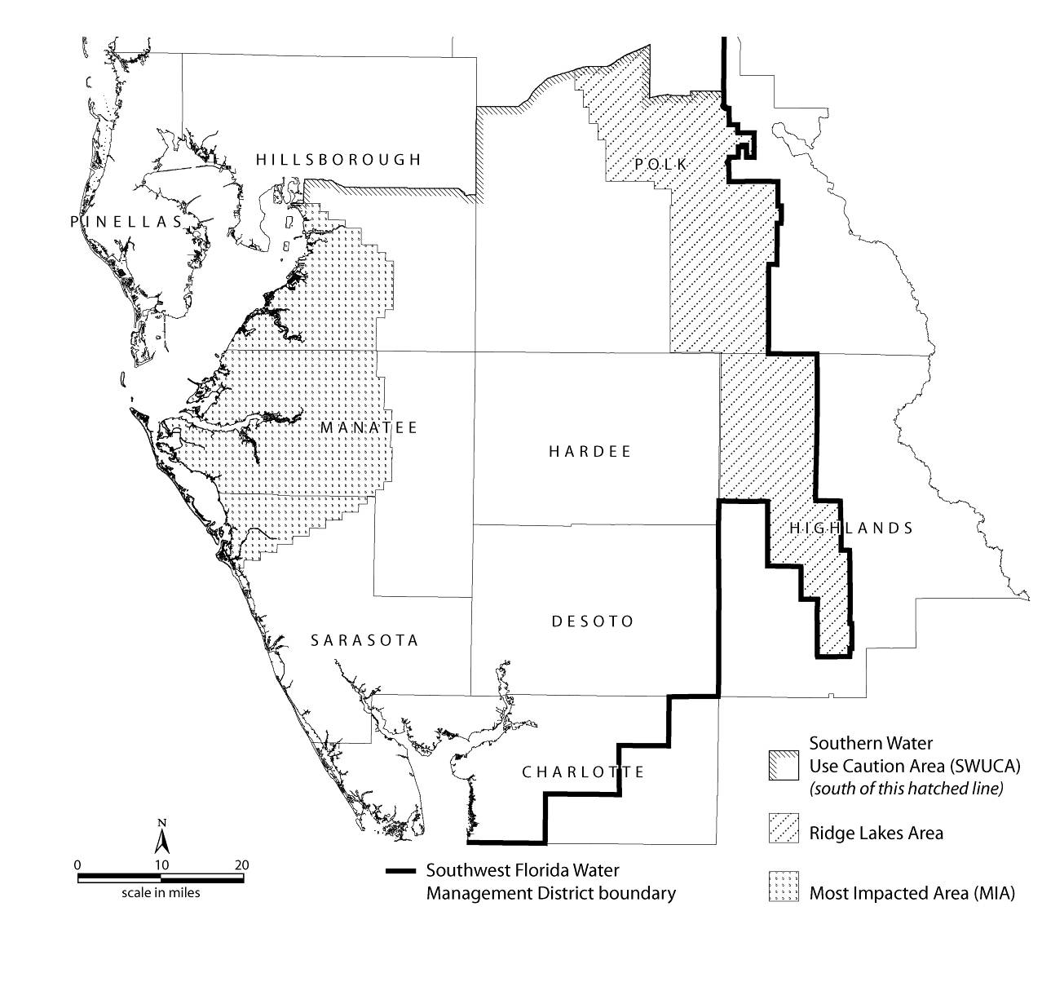

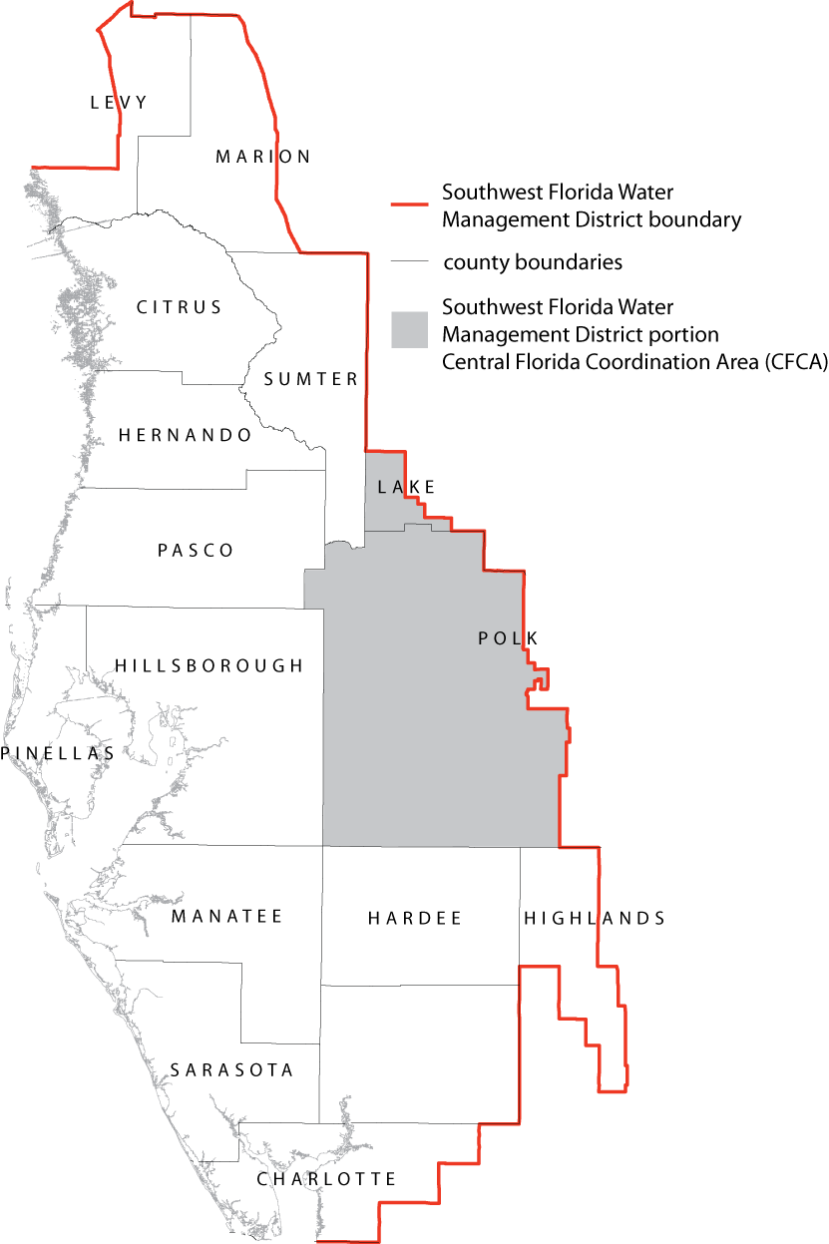
Figure 2-2
1. As shown in Figure 2-3, the boundary for the Dover/Plant City WUCA is as follows:
The portions of Hillsborough and Polk Counties within the following sections (all Townships are South; all Ranges are East):
Township 27, Range 20: Sections 25, 26, 35 and 36;
Township 27, Range 21: Sections 25 through 36;
Township 27, Range 22: Sections 25 through 36;
Township 27, Range 23: Sections 29 through 32;
Township 28, Range 20: Sections 1, 2, 11 through 14, 23 through 26, 35 and 36;
Township 28, Range 21: All Sections;
Township 28, Range 22: All Sections;
Township 28, Range 23: Sections 5 through 8, 17 through 20, and 29 through 32;
Township 29, Range 20: Sections 1, 2, 11 through 14, 23 through 26, 35 and 36;
Township 29, Range 21: All Sections;
Township 29, Range 22: All Sections;
Township 29, Range 23: Sections 5 through 8, 17 through 20, and 29 through 32;
Township 30, Range 20: Sections 1, 2, 11 and 12;
Township 30, Range 21: Sections 1 through 12;
Township 30, Range 22: Sections 1 through 12;
Township 30, Range 23: Sections 5 through 8.
2. Regulations applicable to this WUCA are specified in this chapter and in the WUP Applicant’s Handbook Part B Section 3.9.4, and are in addition to all other regulations set forth in Chapter 40D-2, F.A.C., and the WUP Applicant’s Handbook Parts B and D.
3. The permitting criteria and conditions set forth in Chapter 40D-2, F.A.C., the WUP Applicant’s Handbook Part B, and subsection 40D-8.626(3), F.A.C. shall apply, as specified therein, to the following existing, new, renewal and modification applications for:
a. Frost/freeze quantities to be withdrawn from groundwater when at least one withdrawal point is within the Dover/Plant City WUCA.
b. Quantities of 100,000 gpd annual average or greater from groundwater when at least one withdrawal point is within the Dover/Plant City WUCA.
c. A permit with at least one withdrawal point within the Dover/Plant City WUCA for groundwater quantities to provide frost/freeze quantities authorized to be used or withdrawn from any combination of sources that if withdrawn from groundwater alone would have the potential to impact the Minimum Aquifer Level Protection Zone established for the Dover/Plant City WUCA.
d. A permit with at least one withdrawal point within the Dover/Plant City WUCA for groundwater quantities to provide supplemental irrigation for a use that typically requires frost/freeze protection and where such protection could be achieved through groundwater withdrawals but alternative protection methods are proposed.
4. Any permit with a withdrawal point located within the boundaries of the Dover/Plant City WUCA is deemed to be within the Dover/Plant City WUCA. Permits with permitted withdrawals in more than one WUCA shall be subject to the conservation and reporting requirements, if any, of the WUCA within which the majority of permitted quantities are withdrawn, or projected to be withdrawn, in addition to all other rule criteria, including MFL requirements, as set forth in Chapter 40D-2, F.A.C., and the WUP Applicant’s Handbook Part B. However, the Dover/Plant City WUCA provisions shall supersede any other rule criteria that creates conflicting or more stringent requirements.
5. All water use permits with withdrawal points within the Dover/Plant City WUCA are hereby modified to conform with the provisions of paragraph 40D-2.801(3)(c), F.A.C., except as provided in subparagraph 40D-2.801(3)(c)4., F.A.C., above, and the applicable Dover/Plant City WUCA criteria specified in the WUP Applicant’s Handbook Part B, are incorporated into all such WUPs.
6. The Dover/Plant City WUCA is a water resource caution area for purposes of Chapter 403, F.S., and Chapter 62-40, F.A.C.
Figure 2-3 Dover/Plant City Water Use Caution Area
Rulemaking Authority 373.044, 373.113, 373.171 FS. Law Implemented 373.042, 373.0421, 373.171, 373.216, 373.219, 373.223 FS. History–New 10-5-74, Formerly 16J-3.30, Amended 10-1-89, 11-15-90, 3-1-91, 7-29-93, 1-1-03, 1-1-07, 10-1-07, 2-13-08, 4-7-08, 5-26-10, 6-16-11, 10-14-12, 5-19-14, 11-24-21, 2-17-22.

