Notice of Proposed Rule

FISH AND WILDLIFE CONSERVATION COMMISSION
Vessel Registration and Boating Safety
RULE NO.: RULE TITLE:
68D-24.0041 Dutchman Key Private Submerged Lands Seagrass Protection Boating Restricted Areas
PURPOSE AND EFFECT: The purpose of this rule is to establish a boating restricted area to protect seagrasses and contiguous seagrass habitat from seagrass scarring from propeller dredging over privately-owned submerged lands in accordance with section 327.46(1)(d), Fla. Stat. Certain types of vessel operations will be prohibited within the area.
SUMMARY: The owner of private submerged lands applied to FWC for this boating restricted area in accordance with section 327.46(1)(d), F.S. and rule 68D-24.004, F.A.C. for the purpose of protecting seagrass and contiguous seagrass habitat from seagrass scarring caused by propeller dredging. A portion of the area will be an external propeller limitation zone, which will encompass 59 acres of private submerged lands which qualify for seagrass protection. The external propeller limitation zone will be divided by a slow speed minimum wake zone to ensure vessels are not cut off from navigable waters of the state.
SUMMARY OF STATEMENT OF ESTIMATED REGULATORY COSTS AND LEGISLATIVE RATIFICATION:
The Agency has determined that this will not have an adverse impact on small business or likely increase directly or indirectly regulatory costs in excess of $200,000 in the aggregate within one year after the implementation of the rule. A SERC has not been prepared by the Agency.
The Agency has determined that the proposed rule is not expected to require legislative ratification based on the statement of estimated regulatory costs or if no SERC is required, the information expressly relied upon and described herein: The nature of the rule and the preliminary analysis conducted to determine whether a SERC was required.
Any person who wishes to provide information regarding a statement of estimated regulatory costs, or provide a proposal for a lower cost regulatory alternative must do so in writing within 21 days of this notice.
RULEMAKING AUTHORITY: 327.04, 327.46 FS.
LAW IMPLEMENTED: 327.46, FS.
IF REQUESTED WITHIN 21 DAYS OF THE DATE OF THIS NOTICE, A HEARING WILL BE SCHEDULED AND ANNOUNCED IN THE FAR.
THE PERSON TO BE CONTACTED REGARDING THE PROPOSED RULE IS: Kate Grimes, Fish and Wildlife Conservation Commission, Division of Law Enforcement, Boating and Waterways Section, 620 South Meridian Street, Tallahassee, Florida 32399, kate.grimes@myfwc.com.

THE FULL TEXT OF THE PROPOSED RULE IS:

68D-24.0041 Dutchman Key Private Submerged Lands Seagrass Protection Boating Restricted Areas.
For the sole purpose of protecting seagrass and contiguous seagrass habitat upon privately-owned submerged lands, the following boating restricted areas are established in the vicinity of Dutchman Key in Pasco County:
(1) North Key: an external propeller limitation zone starting from GPS position 28.206380 N, 82.843960 W, on the southwest shoreline of North Key, bounded by a line following the natural contour of the shoreline to GPS position 28.207066 N, 82.842753 W, then running northeast approximately 262 feet to GPS position 28.207587 N, 82.842192 W, then running southwest approximately 1,544 feet to GPS position 28.203437 N, 82.843217 W, then running westerly approximately 666 feet to GPS position 28.203739 N, 82.845257 W, then running northeast approximately 1,027 feet to GPS position 28.206499 N, 82.844576 W, then running east approximately 203 feet back to the southwest shoreline of North Key.
(2) North Dutchman Key: an external propeller limitation zone starting from GPS position 28.203631 N, 82.845283 W, bounded by a line running easterly approximately 666 feet to GPS position 28.203330 N, 82.843243 W, then running southwest approximately 1,810 feet to GPS position 28.198466 N, 82.844444 W, then running west approximately 64 feet to GPS position 28.198503 N, 82.844639 W, then running westerly following the natural contour of the shoreline to GPS position 28.198838 N, 82.846313 W, then running east approximately 50 feet to GPS position 28.198885 N, 82.846455 W, then running northeast approximately 1,766 feet to the starting GPS position.
(3) South Dutchman Key: an external propeller limitation zone starting from GPS position 28.188163 N, 82.844187 W, on the south shoreline of Dutchman Key, bounded by a line following the natural contour of the shoreline to GPS position 28.188817 N, 82.843475 W, then running southeast approximately 1,962 feet to GPS position 28.185271 N, 82.838884 W, then running southeasterly approximately 1,048 feet to GPS position 28.182788 N, 82.837229 W, then running northwest approximately 2,974 feet back to the south shoreline of Dutchman Key.
(4) Access channel: a slow speed minimum wake zone starting from GPS position 28.203739 N, 82.845257 W, bounded by a line running east approximately 666 feet to GPS position 28.203437 N, 82.843217 W, then running south approximately 40 feet to GPS position 28.203330 N, 82.843243 W, then running west approximately 666 feet to GPS position 28.203631 N, 82.845283 W, then running north approximately 40 feet to the starting GPS position.
(5) The boating restricted areas in subsections (1) through (4) are depicted in Drawing A.
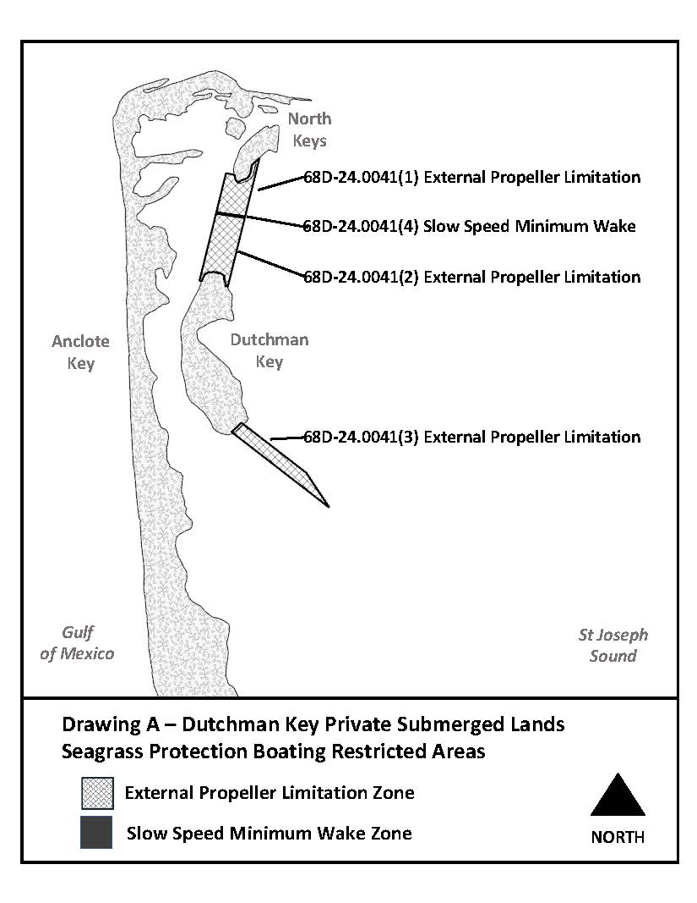
Rulemaking Authority 327.04, 327.46 FS. Law Implemented 327.46 FS. History–New ___________.

NAME OF PERSON ORIGINATING PROPOSED RULE: Kate Grimes, Fish and Wildlife Conservation Commission, Division of Law Enforcement, Boating and Waterways Section, 620 South Meridian Street, Tallahassee, Florida 32399, kate.grimes@myfwc.com.
NAME OF AGENCY HEAD WHO APPROVED THE PROPOSED RULE: Fish and Wildlife Conservation Commission
DATE PROPOSED RULE APPROVED BY AGENCY HEAD: March 02, 2022
DATE NOTICE OF PROPOSED RULE DEVELOPMENT PUBLISHED IN FAR: November 2, 2021

