68D-24.0041 Dutchman Key Private Submerged Lands Seagrass Protection Boating Restricted Areas.
For the sole purpose of protecting seagrass and contiguous seagrass habitat upon privately-owned submerged lands, the following boating restricted areas are established in the vicinity of Dutchman Key in Pasco County:
(1) North Key: an external propeller limitation zone starting from GPS position 28.206380 N, 82.843960 W, on the southwest shoreline of North Key, bounded by a line following the natural contour of the shoreline to GPS position 28.207066 N, 82.842753 W, then running northeast approximately 262 feet to GPS position 28.207587 N, 82.842192 W, then running southwest approximately 1,544 feet to GPS position 28.203437 N, 82.843217 W, then running westerly approximately 666 feet to GPS position 28.203739 N, 82.845257 W, then running northeast approximately 1,027 feet to GPS position 28.206499 N, 82.844576 W, then running east approximately 203 feet back to the southwest shoreline of North Key.
(2) North Dutchman Key: an external propeller limitation zone starting from GPS position 28.203631 N, 82.845283 W, bounded by a line running easterly approximately 666 feet to GPS position 28.203330 N, 82.843243 W, then running southwest approximately 1,810 feet to GPS position 28.198466 N, 82.844444 W, then running west approximately 64 feet to GPS position 28.198503 N, 82.844639 W, then running westerly following the natural contour of the shoreline to GPS position 28.198838 N, 82.846313 W, then running east approximately 50 feet to GPS position 28.198885 N, 82.846455 W, then running northeast approximately 1,766 feet to the starting GPS position.
(3) South Dutchman Key: an external propeller limitation zone starting from GPS position 28.188163 N, 82.844187 W, on the south shoreline of Dutchman Key, bounded by a line following the natural contour of the shoreline to GPS position 28.188817 N, 82.843475 W, then running southeast approximately 1,962 feet to GPS position 28.185271 N, 82.838884 W, then running southeasterly approximately 1,048 feet to GPS position 28.182788 N, 82.837229 W, then running northwest approximately 2,974 feet back to the south shoreline of Dutchman Key.
(4) Access channel: a slow speed minimum wake zone starting from GPS position 28.203739 N, 82.845257 W, bounded by a line running east approximately 666 feet to GPS position 28.203437 N, 82.843217 W, then running south approximately 40 feet to GPS position 28.203330 N, 82.843243 W, then running west approximately 666 feet to GPS position 28.203631 N, 82.845283 W, then running north approximately 40 feet to the starting GPS position.
(5) The boating restricted areas in subsections (1) through (4) are depicted in Drawing A.
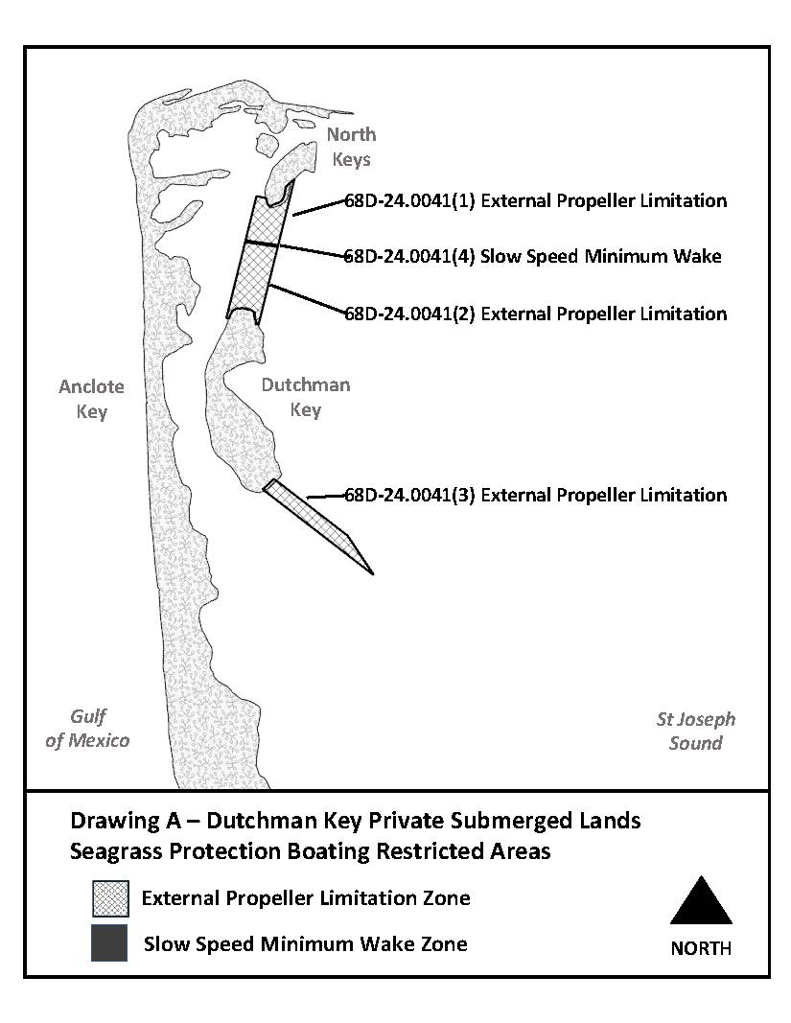
Rulemaking Authority 327.04, 327.46 FS. Law Implemented 327.46 FS. History–New 4-26-22.

