69A-21.241 Standard Service Tags, Specifications.
(1) Service Tags, Annual Maintenance.
(a) Approved standard service tags shall meet the following specifications and shall be arranged as indicated in Figure “A.” In lieu of using the standard “tie-on” type service tag, a pressure sensitive label or decal meeting the same specifications as indicated in Figure “A” may be used. Tags, pressure sensitive labels or decals may be printed or otherwise established for any number of years not in excess of five years.
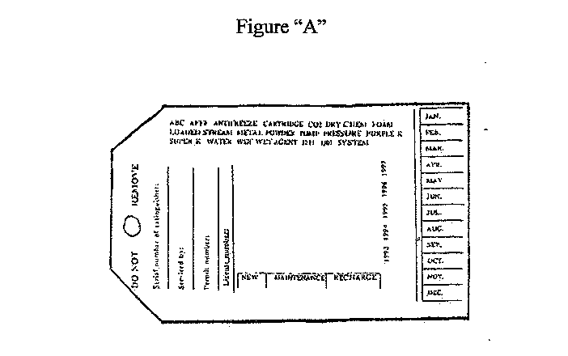

(b) Approved standard service tags, pressure sensitive labels or decals shall bear the following information:
1. “Do Not Remove.”
2. Serial Number of Extinguisher.
3. Name of person who performed the service on the extinguisher. Initials are not acceptable.
4. Permit number of the person who serviced the extinguisher.
5. Indicate the type of service performed.
6. Indicate the type of extinguisher involved.
7. Indicate the month and the year that the service was performed by means of perforation so that only the specific month is indicated.
(c) For standard service tags, pressure sensitive labels or decals, the printing may be any color.
(d) The size of the standard service tags, pressure sensitive labels or decals shall be a minimum size of no less than 2 1/2'' and no greater than 3'' by no less than 5 1/4'' and no greater than 5 3/4''.
(e) A new tag, pressure sensitive label or decal shall be attached to the portable fire extinguisher each time a service is performed.
(f) The name, street address and telephone number of the company or organization performing said service must be printed on the front center section of the service tag, pressure sensitive label or decal.
(g) The remainder of the space available on the tag shall contain no erroneous, false, or misleading statements.
(2) 6-year Maintenance, Record Tags. A verification of service collar meeting the requirements of Section 4-4.4.2, of NFPA 10, the edition as adopted in rule chapter 69A-3, F.A.C., shall be provided each time an extinguisher is opened for any type of service or for any purpose. A new verification service collar shall be provided for an extinguisher each time an extinguisher is opened for any type of internal service or for any other purpose. No advertisement or any other information shall be included on the verification service collar.
Rulemaking Authority 633.104, 633.308 FS. Law Implemented 633.104, 633.308 FS. History–New 10-18-67, Amended 12-30-70, 8-15-85, Formerly 4A-21.41, 4A-21.041, Amended 2-7-89, 10-20-93, 11-21-01, Formerly 4A-21.241.

