Notice of Emergency Rule

DEPARTMENT OF THE LOTTERY
RULE NO.: RULE TITLE:

53ER22-66 Game Number 5047, FLORIDA 100X THE CASH
SUMMARY OF THE RULE: This emergency rule describes Game Number 5047, “FLORIDA 100X THE CASH,” for which the Department of the Lottery will start selling tickets on a date to be determined by the Secretary of the Department. The rule sets forth the specifics of the game; determination of prizewinners; estimated odds of winning; value and number of prizes in the game.
THE PERSON TO BE CONTACTED REGARDING THE EMERGENCY RULE IS: Minerva Simpson, Attorney, Department of the Lottery, 250 Marriott Drive, Tallahassee, Florida 32399-4011.
THIS EMERGENCY RULE TAKES EFFECT IMMEDIATELY UPON BEING FILED WITH THE DEPARTMENT OF STATE.

THE FULL TEXT OF THIS EMERGENCY RULE IS:

53ER22-66 Game Number 5047, FLORIDA 100X THE CASH.
(1) Name of Game. Game Number 5047, FLORIDA 100X THE CASH.
(2) Game Number 5047, FLORIDA 100X THE CASH is a Scratch-Off lottery game (also known as an instant lottery game).
(3) Price. FLORIDA 100X THE CASH lottery tickets sell for $10.00 per ticket.
(4) FLORIDA 100X THE CASH lottery tickets shall have a series of numbers in machine readable code (or bar code) on the back of the ticket, along with a validation number under the latex area on the ticket. To be a valid winning FLORIDA 100X THE CASH lottery ticket, the ticket must meet the applicable requirements of Rule 53ER22-54, Payment of Prizes, F.A.C.
(5) The play symbols and play symbol captions that may appear in the YOUR NUMBERS play area are:
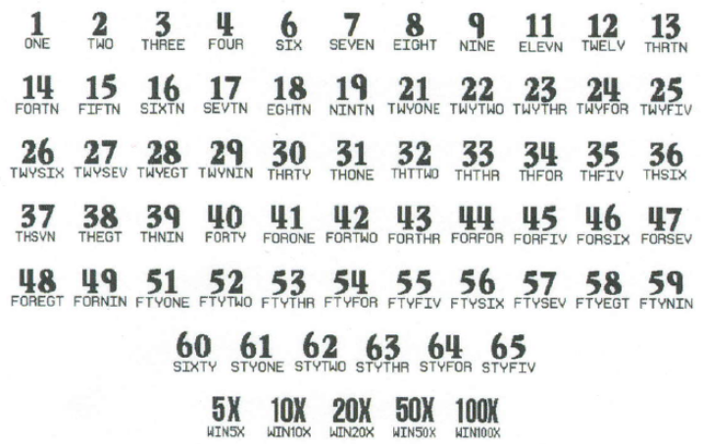
(6) The play symbols and play symbol captions that may appear in the WINNING NUMBERS play area are:

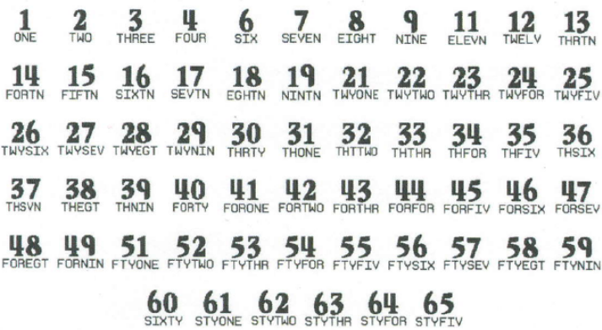
(7) The play symbols and play symbol captions that may appear in the BONUS Spot play areas are:
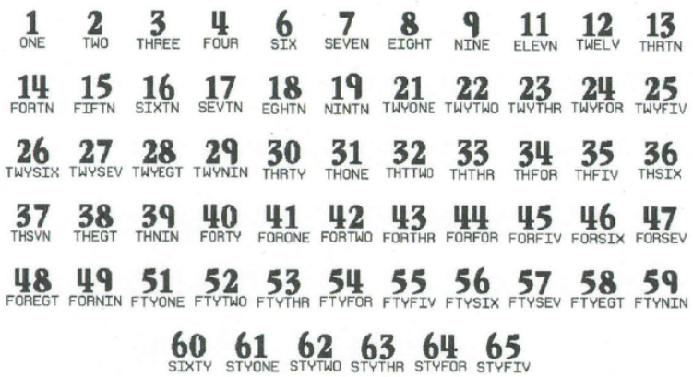

(8) The prize symbols and prize symbol captions that may appear in the YOUR NUMBERS play area are:
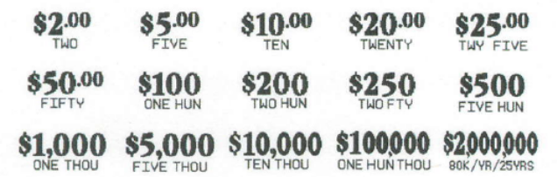
(9) The fixed symbols are:
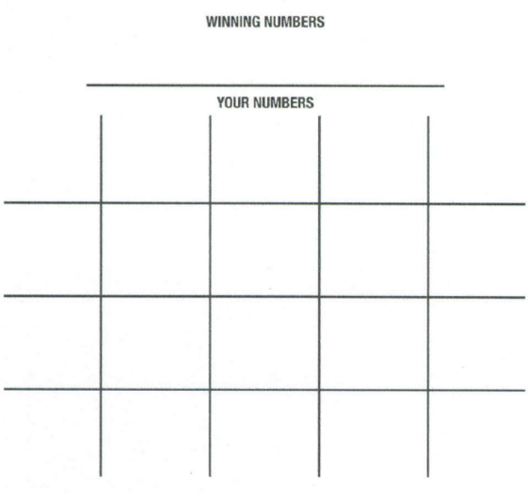

(10) Determination of Prizewinners.
(a) A ticket having a play symbol and corresponding play symbol caption in the YOUR NUMBERS play area that matches a play symbol and corresponding play symbol caption in the WINNING NUMBERS play area shall entitle the prizewinner to the corresponding prize shown for that symbol. A ticket having a 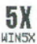 symbol in the YOUR NUMBERS play area shall entitle the prizewinner to five times the prize shown for that symbol. A ticket having a 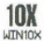 symbol in the YOUR NUMBERS play area shall entitle the prizewinner to ten times the prize shown for that symbol. A ticket having a 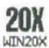 symbol in the YOUR NUMBERS play area shall entitle the prizewinner to twenty times the prize shown for that symbol. A ticket having a 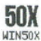 symbol in the YOUR NUMBERS play area shall entitle the prizewinner to fifty times the prize shown for that symbol. A ticket having a 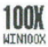 symbol in the YOUR NUMBERS play area shall entitle the prizewinner to one hundred times the prize shown for that symbol.
(b) $50, $100, and $200 BONUS Spots. There are three (3) BONUS Spots: $50, $100, and $200. A ticket having a play symbol and corresponding play symbol caption in the WINNING NUMBERS play area that matches the play symbol and corresponding play symbol caption in a BONUS Spot shall entitle the player to a $50, $100, or $200 cash prize, respectively. Each BONUS Spot is played independently and play symbols/play symbol captions in one BONUS Spot cannot be applied to another BONUS Spot.
(c) A player may win up to twenty-three (23) times on a ticket.
(11) $2,000,000 Prize; Payment Options.
(a) A prizewinner of a $2,000,000 prize may choose one of two payment options for receiving his or her prize. Payment options are One-Time Cash Payment or Annual Payments. At the time the $2,000,000 prize is claimed, the terminal will produce a player claim instructions ticket. The prizewinner has sixty (60) days from the date the player claim instructions ticket is produced to file a claim choosing the One-Time Cash Payment. If a prizewinner does not choose the One-Time Cash Payment within the sixty (60) day timeframe, the Annual Payment option will be applied. Once the prizewinner files a claim and exercises the winner’s chosen option, the election of that option shall be final. The Annual Payment method of payment will also be final when it is applied due to a $2,000,000 prize winner not making his or her payment election within sixty (60) days after the player claim instructions ticket is produced.
(b) A winner of a $2,000,000 prize who elects the One-Time Cash Payment shall receive a single cash payment of $1,390,000.00, less applicable federal income tax withholding.
(c) Annual Payments will be paid in twenty-five (25) equal annual installments. A prizewinner of a $2,000,000 prize who elects the Annual Payment option, or has it applied, shall receive annual installments of $80,000.00 per year, less applicable federal tax withholding.
(12) The odds of winning, value, and number of prizes in Game Number 5047 are as follows:
GAME PLAY | BONUS | WIN | ODDS OF 1 IN | NUMBER OF WINNERS IN 305.97 POOLS OF 120,000 TICKETS PER POOL
$5 x 2 |  | $10 | 30.00 | 1,223,879
$2 (5X) |  | $10 | 15.00 | 2,447,736
$10 |  | $10 | 60.02 | 611,681
$5 x 4 |  | $20 | 60.00 | 611,955
$2 (5X) + $10 |  | $20 | 37.50 | 978,975
$10 x 2 |  | $20 | 59.98 | 612,094
$2 (10X) |  | $20 | 30.01 | 1,223,630
$20 |  | $20 | 59.98 | 612,179
$5 x 5 |  | $25 | 199.99 | 183,588
$5 (5X) |  | $25 | 119.98 | 306,027
$5 + ($10 x 2) |  | $25 | 150.00 | 244,770
$2 (10X) + $5 |  | $25 | 79.99 | 458,985
$25 |  | $25 | 1,204.19 | 30,490
($2 x 10) + ($5 x 4) + $10 |  | $50 | 239.97 | 153,002
$5 (10X) |  | $50 | 599.31 | 61,263
$2 (5X) + ($20 x 2) |  | $50 | 239.90 | 153,045
$25 x 2 |  | $50 | 1,199.39 | 30,612
$50 (BONUS) | $50 | $50 | 200.11 | 183,476
$50 |  | $50 | 1,202.54 | 30,532
($2 x 10) + ($5 x 4) + $10 + $50 (BONUS) | $50 | $100 | 400.02 | 91,785
$5 (10X) x 2 |  | $100 | 599.83 | 61,210
$5 (20X) |  | $100 | 600.45 | 61,147
$10 (10X) |  | $100 | 1,197.36 | 30,664
$20 (5X) |  | $100 | 1,197.44 | 30,662
$2 (50X) |  | $100 | 599.56 | 61,238
($2 (5X) x 5) + $50 (BONUS) | $50 | $100 | 600.62 | 61,130
$100 (BONUS) | $100 | $100 | 599.88 | 61,205
$100 |  | $100 | 1,200.57 | 30,582
($5 x 10) + ($10 x 5) + $50 (BONUS) + $100 (BONUS) | $50 + $100 | $250 | 14,937.27 | 2,458
$5 (50X) |  | $250 | 24,075.93 | 1,525
($20 (5X) x 2) + $50 (BONUS) | $50 | $250 | 19,975.95 | 1,838
$25 (10X) |  | $250 | 24,012.95 | 1,529
($10 x 10) + ($5 x 10) + $100 (BONUS) | $100 | $250 | 20,041.38 | 1,832
$2 (100X) + $10 (5X) |  | $250 | 20,074.25 | 1,829
($10 x 5) + $200 (BONUS) | $200 | $250 | 20,107.23 | 1,826
$50 (BONUS) + $200 (BONUS) | $50 + $200 | $250 | 19,986.83 | 1,837
$250 |  | $250 | 60,387.83 | 608
($10 x 15) + ($20 x 5) + $50 (BONUS) + $200 (BONUS) | $50 + $200 | $500 | 20,318.65 | 1,807
($50 x 5) + ($20 x 5) + ($10 x 10) + $50 (BONUS) | $50 | $500 | 20,052.32 | 1,831
$25 (20X) |  | $500 | 29,777.62 | 1,233
$10 (50X) |  | $500 | 30,094.92 | 1,220
$5 (100X) |  | $500 | 29,801.79 | 1,232
($5 (5X) x 4) + ($10 x 5) + $50 (BONUS) + $100 (BONUS) + $200 (BONUS) | $50 + $100 + $200 | $500 | 14,949.43 | 2,456
($10 (5X) x 4) + $100 (BONUS) + $200 (BONUS) | $100 + $200 | $500 | 15,078.36 | 2,435
($20 x 5) + ($10 x 10) + ($5 (10X) x 3) + $50 (BONUS) + $100 (BONUS) | $50 + $100 | $500 | 15,022.83 | 2,444
$500 |  | $500 | 60,189.84 | 610
($20 x 10) + ($50 x 7) + $100 + $50 (BONUS) + $100 (BONUS) + $200 (BONUS) | $50 + $100 + $200 | $1,000 | 19,910.95 | 1,844
($50 x 10) + ($5 (5X) x 10) $50 (BONUS) + $200 (BONUS) | $50 + $200 | $1,000 | 24,075.93 | 1,525
$50 (20X) |  | $1,000 | 29,996.57 | 1,224
$100 (10X) |  | $1,000 | 29,898.86 | 1,228
$10 (100X) |  | $1,000 | 29,561.84 | 1,242
$5 (100X) + ($10 (10X) x 2) + $100 (BONUS) + $200 (BONUS) | $100 + $200 | $1,000 | 30,070.27 | 1,221
($20 x 10) + ($50 x 7) + $10 (5X) + ($25 x 2) + $50 (BONUS) + $100 (BONUS) + $200 (BONUS) | $50 + $100 + $200 | $1,000 | 29,996.57 | 1,224
$1,000 |  | $1,000 | 119,207.14 | 308
$100 (50X) |  | $5,000 | 126,171.13 | 291
$50 (100X) |  | $5,000 | 115,822.71 | 317
($100 (10X) x 4) + ($50 (5X) x 2) + ($10 (10X) x 2) + $100 (BONUS) + $200 (BONUS) | $100 + $200 | $5,000 | 117,678.85 | 312
$5,000 |  | $5,000 | 122,386.00 | 300
($250 x 10) + ($1,000 x 6) + ($500 x 2) + $20 (5X) + $10 (5X) + $50 (BONUS) + $100 (BONUS) + $200 (BONUS) | $50 + $100 + $200 | $10,000 | 895,507.32 | 41
($100 (10X) + $500 (5X) + $1,000 (5X) + $10 (100X) +$10 (50X) |  | $10,000 | 895,507.32 | 41
$10,000 |  | $10,000 | 1,835,790.00 | 20
($10,000 x 8) + ($5,000 x 2) + ($1,000 x 8) + $200 (5X) + $50 (20X) |  | $100,000 | 4,589,475.00 | 8
($100 (100X) x 5) + ($500 (20X) x 2) + ($1,000 (10X) x 2) + $500 (10X) + $50 (100X) |  | $100,000 | 4,589,475.00 | 8
$100,000 |  | $100,000 | 9,178,950.00 | 4
$2,000,000 ($80K/YR/25YRS)* |  | $2,000,000 | 4,589,475.00 | 8
*Prize amount if taken in annual payments. If a prizewinner takes a single cash payment, the amount paid will be in accordance with paragraph (11), above.
(13) The overall odds of winning some prize in Game Number 5047 are 1 in 3.43. Prizes, including the top prizes, are subject to availability at the time of ticket purchase. Prizes may be unavailable due to prior sales or other causes occurring in the normal course of business including, but not limited to, ticket damage, defect, theft, or loss.
(14) For reorders of Game Number 5047, the odds of winning, value, and number of prizes shall be proportionate to the number of tickets reordered.
(15) Payment of prizes for FLORIDA 100X THE CASH lottery tickets shall be made in accordance with the rule of the Florida Lottery governing payment of prizes. A copy of the current rule can be obtained from the Florida Lottery, Office of the General Counsel, 250 Marriott Drive, Tallahassee, Florida 32399-4011.
Rulemaking Authority 24.105(9)(a), (b), (c), 24.109(1), 24.115(1) FS. Law Implemented 24.105(9)(a), (b), (c), 24.115(1) FS. History–New 10-27-22.

THIS RULE TAKES EFFECT UPON BEING FILED WITH THE DEPARTMENT OF THE STATE UNLESS A LATER TIME AND DATE IS SPECIFIED IN THE RULE.
EFFECTIVE DATE: 10/27/2022

