Miscellaneous

OTHER AGENCIES AND ORGANIZATIONS
Babcock Ranch Community Independent Special District
BABCOCK RANCH COMMUNITY INDEPENDENT SPECIAL DISTRICT
NOTICE OF RULEMAKING FOR WATER UTILITY RATES

A public hearing will be conducted by the Babcock Ranch Community Independent Special District (“District”) on the following date, time and place:

Time & Date: January 26, 2023, at 1:00 p.m.
Location: The Hatchery – East Conference Room
42881 Lake Babcock Drive, 2nd Floor Punta Gorda, Florida 33982.

The public hearing will be a rulemaking hearing and will provide an opportunity for the public to address proposed rules that set policies, fees and charges related to the District’s water utilities. The purpose and effect of the proposed rules is to provide for efficient and effective District operations, and to provide sufficient revenues to meet expenses and provide services within the boundaries of the District. Prior notice of rule development for the rulemaking hearing was published in the Florida Administrative Record on December 22, 2022. The proposed rules adopt updates and amendments to the District’s existing water utility rates as follows:

Water Utility Rates

A. INITIAL FEES – CONNECTION FEES/AFPI, DEPOSIT FEES, TAP IN, ROAD PUSH

RESIDENTIAL PROPOSED

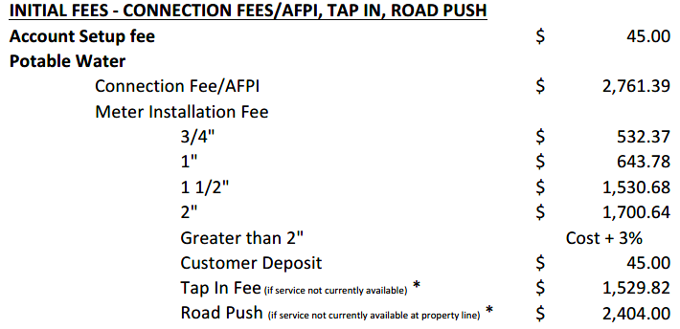
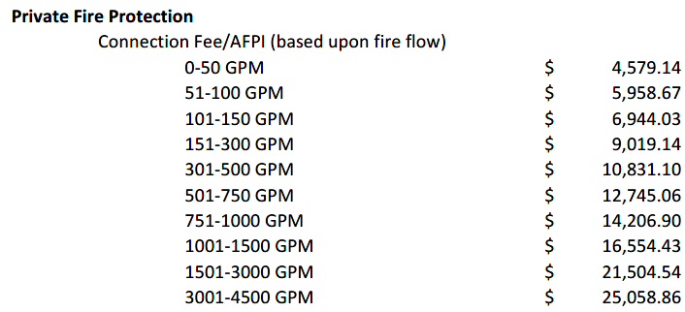

RESIDENTIAL (continued) PROPOSED

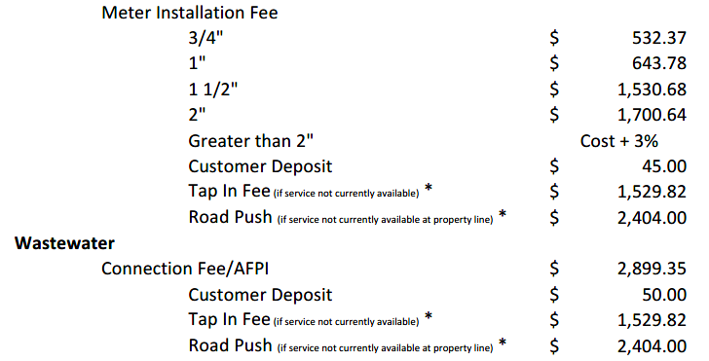
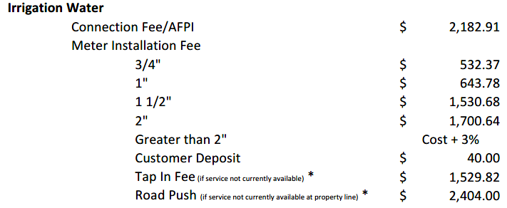

NON- RESIDENTIAL PROPOSED

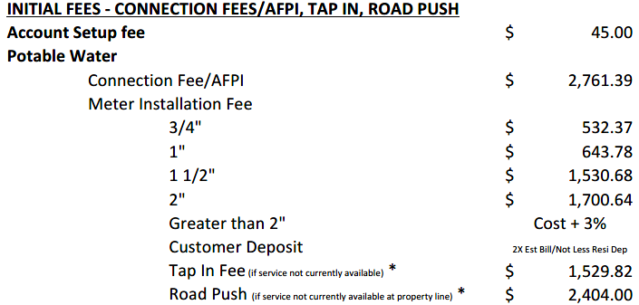

NON- RESIDENTIAL (continued) PROPOSED

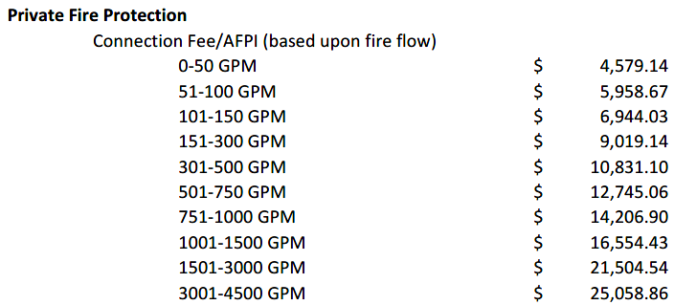
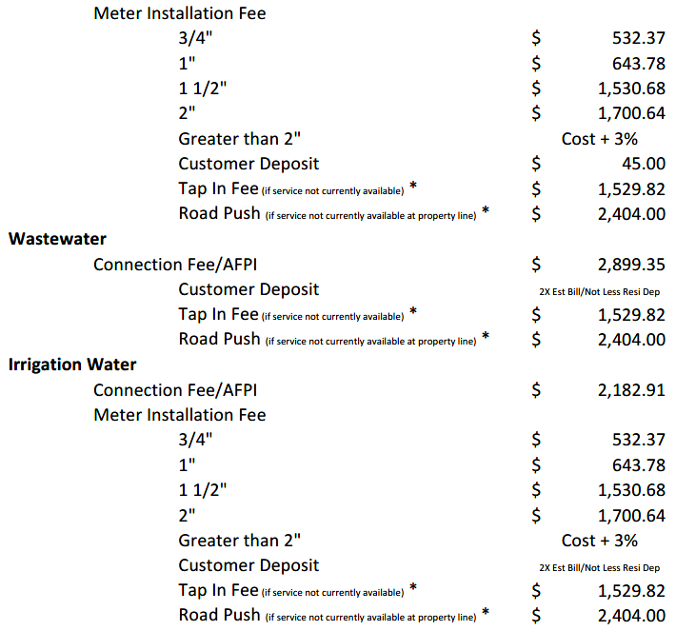

B. MONTHLY USE AND COMMODITY FEES – WATER, WASTEWATER AND IRRIGATION

RESIDENTIAL PROPOSED

Residential - Applicable to single-family Customers or mutli-family Customers which are individually metered

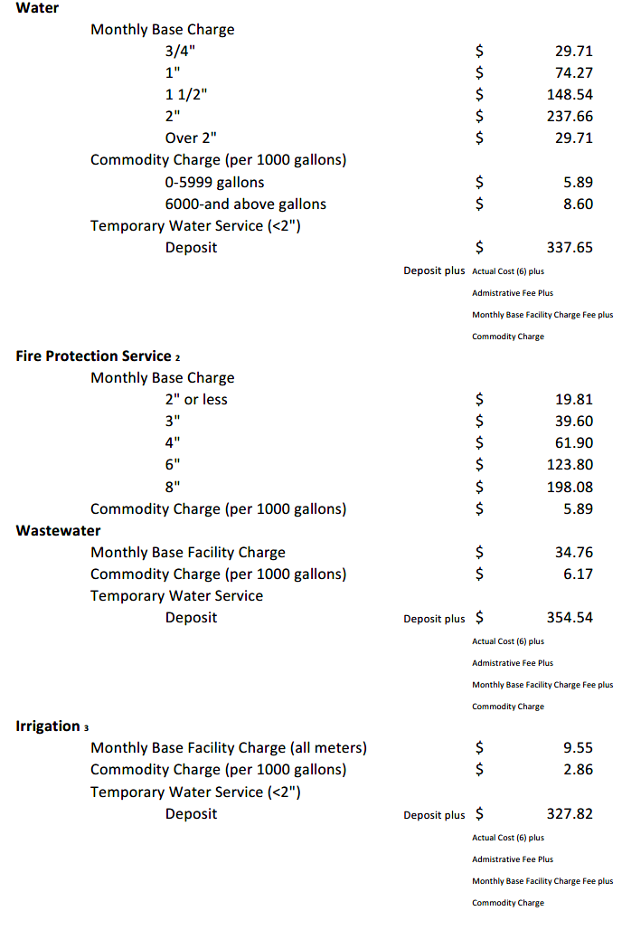

RESIDENTIAL (continued) PROPOSED

Multi-Family Residential – Applicable to multi-family Customers and mobile home park Customers which are being served by a mater meter.
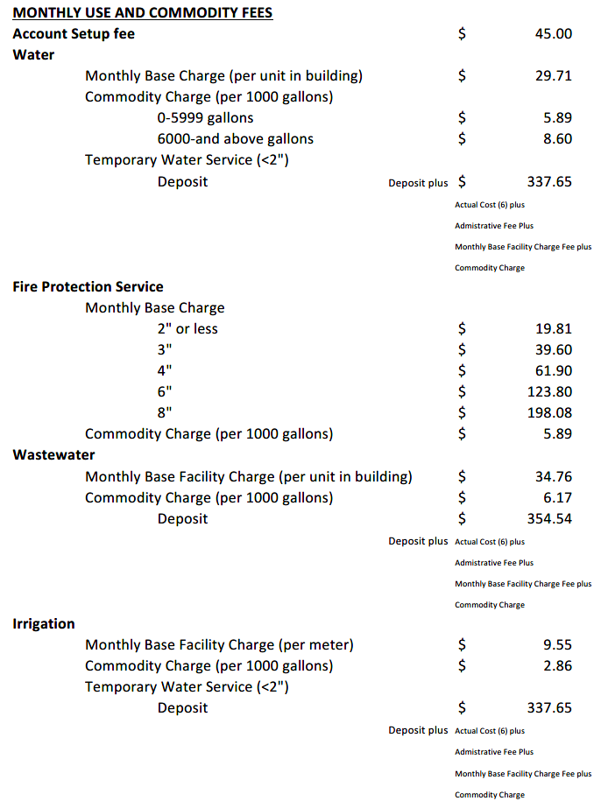

NON - RESIDENTIAL PROPOSED

Non-Residential – Applicable to non-residential commercial, industrial, office, civic, mixed use master meter or other Customers for which no other rate appplies.
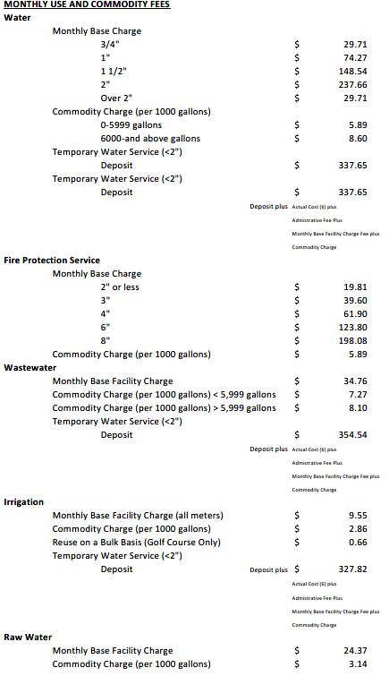

C. MISCELLANEOUS FEES

Violation of District Policies may leed to discontinuation of Utility Service, assessment of fees and fines, as well as inspection charges and fees to reconnect services once the violation has been resolved. Any work performed between 3:00 pm and 8:00 pm shall be considered after normal working hours.

MISCELLANEOUS FEE PROPOSED
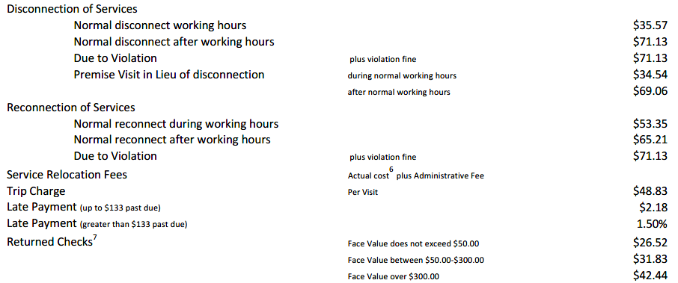
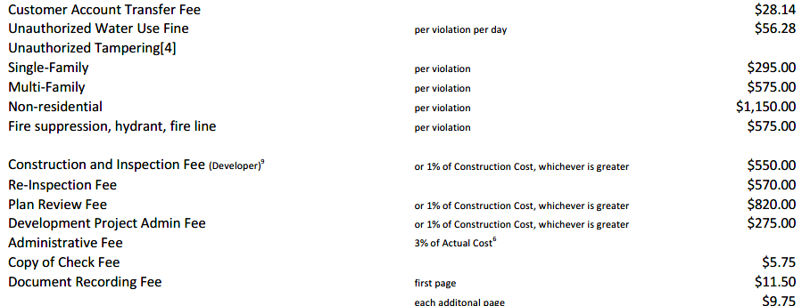
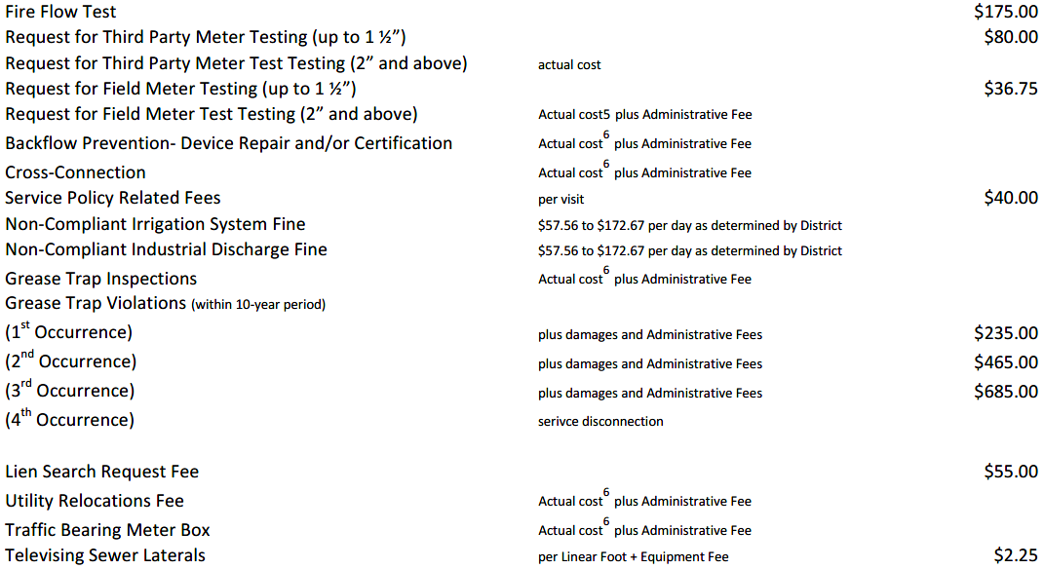

MISCELLANEOUS FEE (continued) PROPOSED

The District reserves the right to impose additional fees for the following to the extent not covered above, including cost for rental of any equipment not otherwise listed in the Tariff, plus a 10% markup.

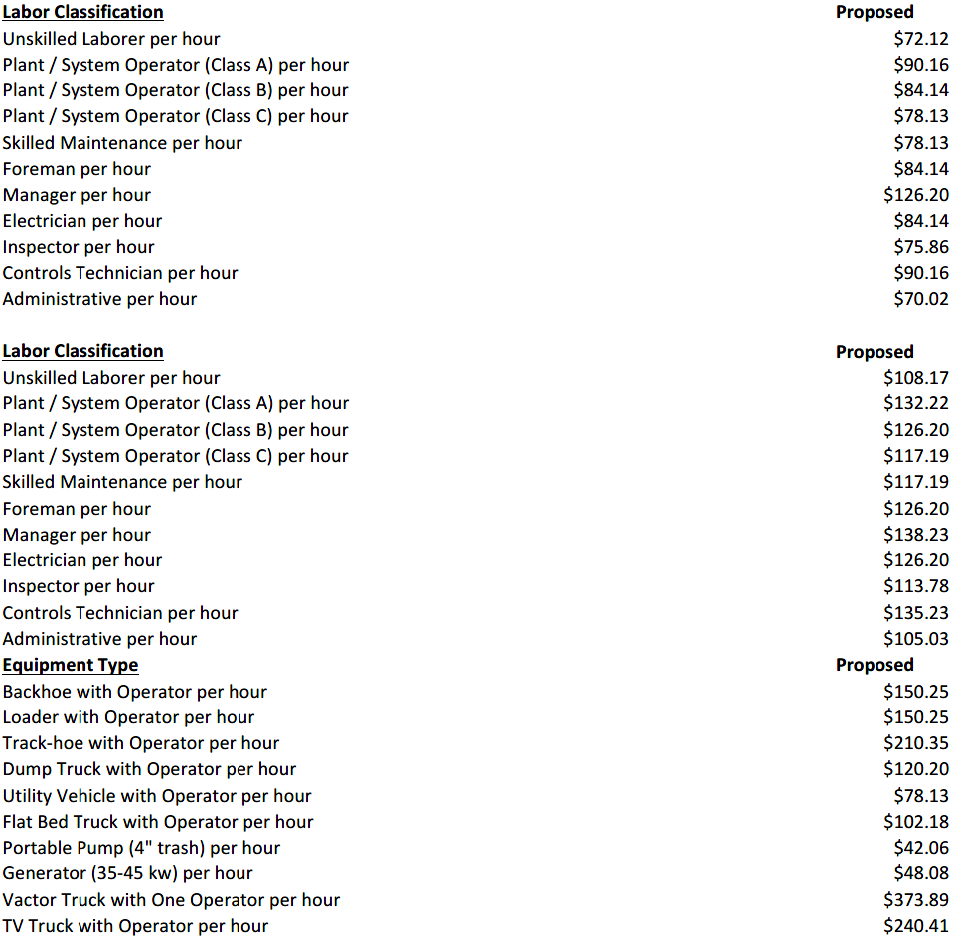

D. INDUSTRIAL DISCHARGE AND APPROVAL FEES

INDUSTRIAL DISCHAGE AND APPROVAL PROPOSED

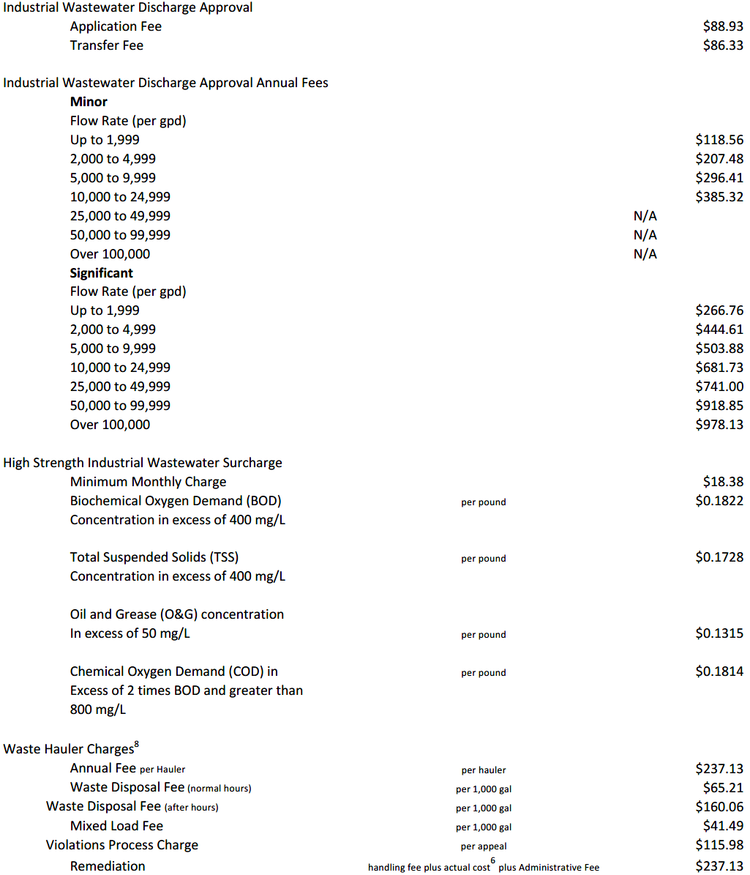

Automatic Cost Escalation. In the absence of Board action, the District’s rates, fees and charges shall be automatically increased without further action five percent (5%) per year. Upon application of this automatic cost escalation provision, the District Manager shall submit to the District Governing Board a report detailing the amount of the escalation and the new rates as revised. The Rate Schedule shall be adjusted pursuant to this section as required.

Utility Cost Pass-Through. The District’s rates, fees and charges shall be automatically increased without further action of the Board based upon the implementation of a rate increase to the District Utility System by any utility which provides service to the District, or upon implementation or increase of any taxes levied by a governmental authority against the District, or upon an increase of costs incurred for water quality, wastewater or irrigation quality water quality testing required by the Department of Environmental Protection, or other unfunded mandates imposed by a controlling governmental agency. Upon application of this cost pass-through provision, the District Manager shall submit to the Board of Supervisors a report detailing the amount of the escalation and the new rates as revised. The Rate Schedule shall be adjusted pursuant to this section as required.

Water Use Restriction Surcharge. Commodity charges may be adjusted from time to time temporarily by up to twenty five percent (25%) to reflect a water use restriction surcharge rate adjustment that may be implemented in response to and for the duration of general water use restrictions imposed by the South Florida Water Management District (SFWMD).

Prorations. Base Facility Charges will be pro-rated for any partial month of service.

Specific legal authority for the rules includes section 120.054, Florida Statutes, and Chapter 2007-306, Laws of Florida, as amended. Any person who wishes to provide the District with a proposal for a lower cost regulatory alternative as provided by section 120.541(1), Florida Statutes, must do so in writing within twenty-one (21) days after publication of this notice. The public hearing may be continued to a date, time, and place to be specified on the record at the hearing.

If anyone chooses to appeal any decision of the Board with respect to any matter considered at the public hearing, such person will need a record of the proceedings and should accordingly ensure that a verbatim record of the proceedings is made which includes the testimony and evidence upon which such appeal is to be based. At the hearing, one or more Supervisors may participate in the public hearing by telephone. Any person requiring special accommodations at the hearing because of a disability or physical impairment should contact the District Office at (561)571-0010 at least 48 hours prior to the meeting. If you are hearing or speech impaired, please contact the Florida Relay Service at 1(800)955-8770, for aid in contacting the District Office. A copy of the proposed rules may be obtained by contacting the District Manager, Craig Wrathell, at 2300 Glades Road, Suite 410W, Boca Raton, Florida 33431, (561)571-0010 or by visiting the District’s website at http://www.babcockranchliving.com/153/Independent-Special-District.

Craig Wrathell, District Manager

