68D-24.0036 Nichols Spring Protection Zone
For the purpose of protecting and preventing harm to Nichols Spring in Sumter County, the following springs protection zone is established: An area within which anchoring, mooring, beaching, and grounding are prohibited, as delineated by a line where the spring run at Nichols Spring meets the Withlacoochee River, extending from Point “A” (82 degrees 12.17974 minutes west/28 degrees 50.37195 minutes north) on the western shoreline of the spring run to Point “B” (82 degrees 12.16974 minutes west/28 degrees 50.36911 minutes north) on the eastern shoreline of the spring run, as depicted in Drawing A.
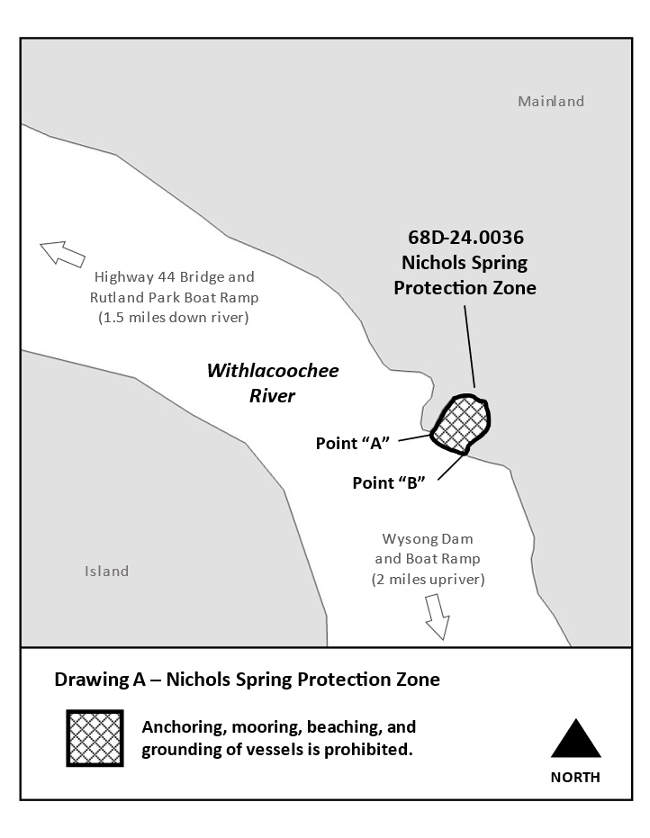
Rulemaking Authority 327.04, 327.45 FS. Law Implemented 327.45 FS. History–New 1-30-23.

