Notice of Proposed Rule

FISH AND WILDLIFE CONSERVATION COMMISSION
Vessel Registration and Boating Safety
RULE NO.: RULE TITLE:
68D-24.018 St. Johns River Boating Restricted Areas
PURPOSE AND EFFECT: The proposed rule amendments modify the boating restricted areas on the St. Johns River in Lake. Seminole, and Volusia counties and/or clarify the coordinates used in the description of zone boundaries and site location of the United States Geological Survey gauge for purposes of measuring water levels.
SUMMARY: The proposed rule amendments reference the GPS coordinates for boundaries and identify the site location for measuring water levels at the United States Geological Survey gauge. This information provides a more specific description of the boating restricted areas on the St. Johns River.
SUMMARY OF STATEMENT OF ESTIMATED REGULATORY COSTS AND LEGISLATIVE RATIFICATION:
The Agency has determined that this will not have an adverse impact on small business or likely increase directly or indirectly regulatory costs in excess of $200,000 in the aggregate within one year after the implementation of the rule. A SERC has not been prepared by the Agency.
The Agency has determined that the proposed rule is not expected to require legislative ratification based on the statement of estimated regulatory costs or if no SERC is required, the information expressly relied upon and described herein: the nature of the rule and the preliminary analysis conducted to determine whether a SERC was required,
Any person who wishes to provide information regarding a statement of estimated regulatory costs, or provide a proposal for a lower cost regulatory alternative must do so in writing within 21 days of this notice.
RULEMAKING AUTHORITY: 327.04, 327.46, FS.
LAW IMPLEMENTED: 327.33(3), 327.46 FS.
IF REQUESTED WITHIN 21 DAYS OF THE DATE OF THIS NOTICE, A HEARING WILL BE SCHEDULED AND ANNOUNCED IN THE FAR.
THE PERSON TO BE CONTACTED REGARDING THE PROPOSED RULE IS: : Kate Grimes, Fish and Wildlife Conservation Commission, 620 South Meridian Street, Tallahassee, Florida 32399-1600, kate.grimes@myfwc.com; (850)617-9493.

THE FULL TEXT OF THE PROPOSED RULE IS:

68D-24.018 St. Johns River Boating Restricted Areas.
(1) For the purpose of regulating the speed and operation of vessel traffic on the St. Johns River in Lake, Seminole and Volusia Counties, Florida the following boating restricted areas are established. Coordinates used in the description of zone boundaries are referenced to the North American Datum of 1983 (NAD83). The boating restricted areas exclude all associated tributaries, creeks, canals, backwaters, channels, boat basins and other waterways unless otherwise designated or specifically described for inclusion:
(a) No Change.
(b) Flood Zones.
1. Astor: During flooding, an Idle Speed No Wake zone from shoreline to shoreline in the St. Johns River, bounded on the northwest by a line drawn perpendicular to the centerline of the St. Johns River 50 feet north of the confluence of South Moon Canal and the St. Johns River and bounded on the south by a line drawn perpendicular to the centerline of the St. Johns River approximately 4,160 2,125 feet south of the south end of the fender of the SR 40 (Astor) Bridge to GPS position 29° 9.37267' North 81°31.38050' West, as depicted in Drawing J, when the St. Johns River water level is 2.3 feet or higher when measured at the United States Geological Survey gauge at Astor (USGS site # 02236125), as determined by the flood stage established by the National Weather Service as indicated by the St. Johns River Water Management District gauge at the SR 40 (Astor) Bridge.
2. Highbanks Boat Ramp: During flooding, an Idle Speed No Wake zone from shoreline to shoreline in the St. Johns River, bounded on the north by a line drawn perpendicular to the centerline of the St. Johns River 1,700 feet north of the centerline of Highbanks Road Boat Ramp and bounded on the southwest by a line perpendicular to the centerline of the St. Johns River 1,800 feet south of the centerline of the Highbanks Boat Ramp, as depicted in Drawing K, when the St. Johns River water level is 5.5 feet or higher when measured at the United States Geological Survey gauge at Sanford (USGS site #02234500), as determined by the flood stage established by the National Weather Service 5.6 feet or higher as indicated by the St. Johns River Water Management District gauge at the Sanford Station.
3. Mullet Lake Park: During flooding, an Idle Speed No Wake zone from shoreline to shoreline in the St. Johns River, bounded on the east by a line drawn perpendicular to the centerline of the St. Johns River at Mullet Lake Park Boat Ramp and bounded on the west by a line drawn perpendicular to the centerline of the St. Johns River 3,000 feet west of Mullet Lake Park Boat Ramp, as depicted in Drawing L, when the St. Johns River water level is 8 feet or higher when measured at the United States Geological Survey gauge at Lake Harney (USGS site #02234000), as determined by the flood stage established by the National Weather Service as indicated by the National Weather Service gauge at the Lake Harney Station.
4. Lemon Bluff: During flooding, an Idle Speed No Wake zone from shoreline to shoreline in the St. Johns River, bounded on the northeast by a line drawn perpendicular to the centerline of the St. Johns River at the northeast tip of the unnamed island (located at approximate latitude 28º 48.394' North, approximate longitude 81º 7.799' West) southeast of Lemon Bluff Boat Ramp and bounded on the southwest by a line drawn perpendicular to the centerline of the St. Johns River 3,675 feet southwest of the southern tip of said unnamed island (located at approximate latitude 28º 48.282' North, approximate longitude 81º 7.806' West), as depicted in Drawing M, when the St. Johns River water level is 8 feet or higher when measured at the United States Geological Survey gauge at Lake Harney (USGS site #02234000), as determined by the flood stage established by the National Weather Service as indicated by the National Weather Service gauge at the Lake Harney Station.
5. Lake Monroe: During flooding, an Idle Speed No Wake zone from shoreline to shoreline in the St. Johns River, bounded on the southeast by the northwesterly side of the I-4 bridge in Sanford, Florida, and bounded on the northwest by a line drawn perpendicular to the centerline of the St. Johns River at approximate latitude 28° 50.61660ꞌ North, and approximate longitude 81° 20.23200ꞌ West, including all canals associated with St. Johns River Estates, Boat Tree Marina, the intake and discharge canals at the Sanford Power Plant, and the water basin on the north side of the River between US Highway 17/92 and I-4, as depicted in Drawing N, when the St. Johns River water level is 5.5 feet or higher when measured at the United States Geological Survey gauge at Sanford (USGS site #02234500), as determined by the flood stage established by the National Weather Service as indicated by the National Weather Service gauge at the Lake Monroe Station.
(c) No Change.
(2) The boating restricted areas described in Rule 68D-24.018, F.A.C., are depicted on the following drawings:
Drawings A – I No Change.
Drawing J – Delete Current rule drawing and replace with the following:
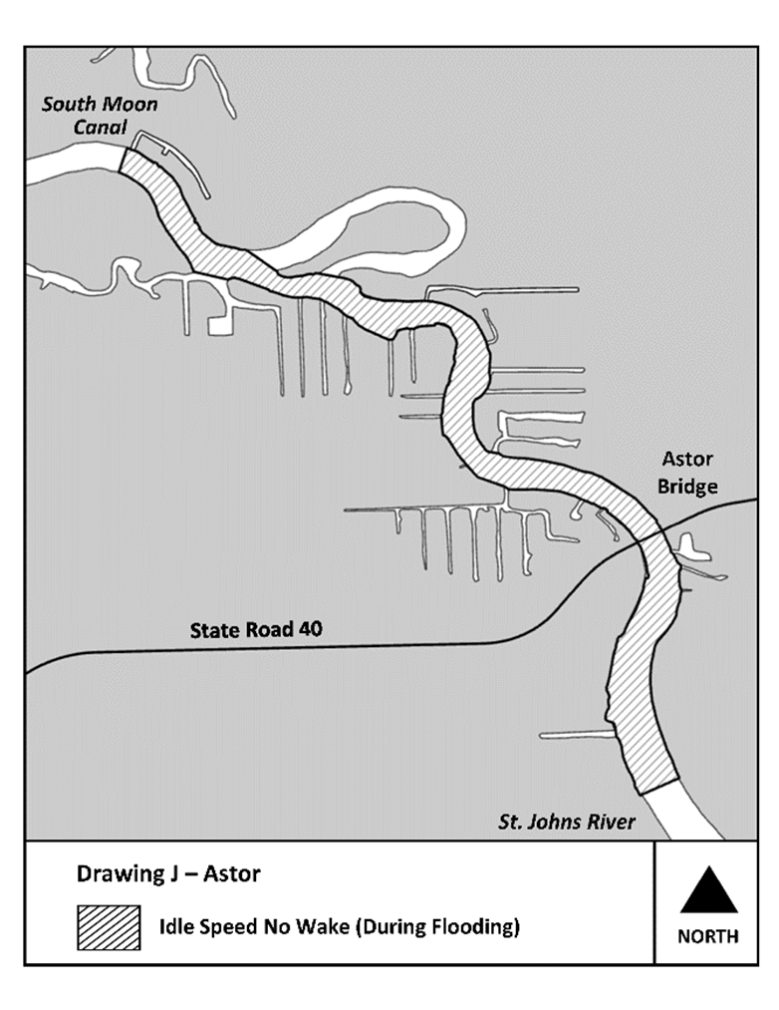
Drawings K – N No Change.
Rulemaking Authority 327.04, 327.46 FS. Law Implemented 327.33(3), 327.46 FS. History–New 6-3-92, Formerly 16N-24.018, Amended 10-3-95, 11-21-96, 2-4-98, Formerly 62N-24.018, Amended 4-22-13, 4-23-14, 2-10-20, 4-20-20, 7-6-20,______.

NAME OF PERSON ORIGINATING PROPOSED RULE: : Kate Grimes, Fish and Wildlife Conservation Commission, 620 South Meridian Street, Tallahassee, Florida 32399-1600, kate.grimes@myfwc.com; (850)617-9493.
NAME OF AGENCY HEAD WHO APPROVED THE PROPOSED RULE: Florida Fish and Wildlife Conservation Commission.
DATE PROPOSED RULE APPROVED BY AGENCY HEAD: February 21, 2023
DATE NOTICE OF PROPOSED RULE DEVELOPMENT PUBLISHED IN FAR: April 11, 2023

