Notice of Proposed Rule

FISH AND WILDLIFE CONSERVATION COMMISSION
Marine Fisheries
RULE NO.: RULE TITLE:
68B-5.007 Skyway Fishing Pier State Park: Education Course Requirement; Gear Restrictions
PURPOSE AND EFFECT: The Florida Fish and Wildlife Conservation Commission is proposing fishing regulations specific to Skyway Fishing Pier State Park (Skyway Pier). Fishing gear entanglement of birds, primarily pelicans, has been occurring at Skyway Pier for many years. Despite past non-regulatory action, rescue response coordination, and educational programs, hundreds of pelicans and other seabirds are entangled in fishing gear at Skyway Pier each year, resulting in their severe injury or death. Regulatory action is necessary to reduce severe entanglement at Skyway Pier.
The purpose of this rule change is to reduce angler-seabird interactions and the incidence of severe fishing gear entanglement of seabirds, including brown pelicans, and further seabird conservation at Skyway Pier.
The effect of this rule is to require people fishing on or from Skyway Pier to complete an annual education course and possess verification of course completion. Additionally, anglers fishing on or from Skyway Pier would be limited to use of no more than two sets of hook and line gear at any time, and they would be prohibited from using hook and line gear with more than one hook attached as well as the use of any multiple hook from November 1 through March 31 each year. Anglers would also be prohibited from using sabiki or flasher rigs on the terminal end of the South Skyway Pier. The rule would also require FWC to review the Skyway Fishing Pier State Park fishing regulations prior to October 1, 2025, to determine whether the regulations are appropriate or if they should be repealed or expanded.
SUMMARY: This rule would create an education requirement for people fishing at Skyway Pier, create a year-round limit on the number of hook and line gear than an individual could use, establish seasonal prohibitions on certain gear rigs and hooks, prohibit the use of specific rigs on a portion of the pier, and set a deadline for the Commission review of Skyway Pier fishing regulations.
SUMMARY OF STATEMENT OF ESTIMATED REGULATORY COSTS AND LEGISLATIVE RATIFICATION:
The Agency has determined that this will not have an adverse impact on small business or likely increase directly or indirectly regulatory costs in excess of $200,000 in the aggregate within one year after the implementation of the rule. A SERC has not been prepared by the Agency.
The Agency has determined that the proposed rule is not expected to require legislative ratification based on the statement of estimated regulatory costs or if no SERC is required, the information expressly relied upon and described herein: the nature of the rule and the preliminary analysis conducted to determine whether a SERC was required.
Any person who wishes to provide information regarding a statement of estimated regulatory costs, or provide a proposal for a lower cost regulatory alternative must do so in writing within 21 days of this notice.
RULEMAKING AUTHORITY: Article IV, Section 9, Florida Constitution
LAW IMPLEMENTED: Article IV, Section 9, Florida Constitution
A HEARING WILL BE HELD AT THE DATES, TIMES AND PLACE SHOWN BELOW:
DATE AND TIME: During the Commission’s regular meeting July 19 - 20, 2023, 8:30 a.m. – 5:00 p.m. each day
PLACE: Hilton St. Petersburg Bayfront, 333 1st Street SE, St. Petersburg, Florida, 33701
Pursuant to the provisions of the Americans with Disabilities Act, any person requiring special accommodations to participate in this workshop/meeting is asked to advise the agency at least 5 days before the workshop/meeting by contacting: ADA Coordinator, at (850)488-6411. If you are hearing or speech impaired, please contact the agency using the Florida Relay Service, 1(800)955-8771 (TDD) or 1(800)955-8770 (Voice).
THE PERSON TO BE CONTACTED REGARDING THE PROPOSED RULE IS: Jessica McCawley, Director, Division of Marine Fisheries Management, 620 S. Meridian St., Tallahassee, Florida 32399, and (850)487-0554.

THE FULL TEXT OF THE PROPOSED RULE IS:

68B-5.007 Skyway Fishing Pier State Park: Education Course Requirement; Gear Restrictions.
(1) A person may not participate in fishing within Skyway Fishing Pier State Park unless such person has first successfully completed within the previous 12 months a Commission-approved Pier Fishing education course, as provided herein:
(a) The Commission shall provide a Pier Fishing education course, available at: [http://www.myfwc.com/…….]. Instructions for completing the Pier Fishing education course and the minimum requirements for the course content are contained in the “Florida Pier Fishing Education Course Guide,” Form PFEC-1 (effective October 1, 2023), incorporated herein by reference and available at [http://www.flrules.org/gateway/reference…….], or from the Commission, 620 South Meridian Street, Tallahassee, Florida 32399-1600.
(b) The Commission shall issue proof of completion to a person who has successfully completed a Commission-approved Pier Fishing education course. Such proof of completion shall be valid for 12 months from the date of issuance.
(c) A person under 16 years of age who has not successfully completed a Commission-approved Pier Fishing education course may participate in fishing within Skyway Fishing Pier State Park only if such person is fishing under the supervision of, and in the presence of, a person 16 years of age or older who has successfully completed within the previous 12 months a Commission-approved Pier Fishing education course.
(2) A person may not use more than two sets of hook and line gear at any time on or from Skyway Pier State Park.
(3) A person may not use a sabiki or flasher rig on or from the portion of South Skyway Fishing Pier that extends approximately 0.23 miles (approximately 1,227 feet) in a southeasterly direction from the point where the pier terminates in Tampa Bay (the portion of the pier that lies northwest of the northernmost restroom building).
(4) The following gear restrictions apply within Skyway Fishing Pier State Park from November 1 through March 31 of the following year:
(a) A person may not use hook and line gear to which more than one hook is attached.
(b) A person may not use or possess any multiple hook.
(5) For purposes of this rule:
(a) “Fishing” means:
1. The catching, taking, or harvesting of a marine organism;
2. The attempted catching, taking, or harvesting of a marine organism;
3. Any other activity which can reasonably be expected to result in the catching, taking, or harvesting of a marine organism.
(b) “Sabiki” or “flasher rig” means hook and line gear that has a main line with several branching lines spaced at regular intervals to which small hooks are attached and is typically used to harvest baitfish.
(c) “South Skyway Fishing Pier” means the public fishing pier within the Skyway Fishing Pier State Park that begins in Manatee County and extends in a northwesterly direction, terminating in Tampa Bay.
(6) The Commission shall review the Skyway Pier fishing regulations prior to October 1, 2025, and determine whether the regulations are appropriate or if they should be repealed or expanded.
Rulemaking Authority Art. IV, Sec. 9, Fla. Const. Law Implemented Art. IV, Sec. 9, Fla. Const. History–New 10-1-23.

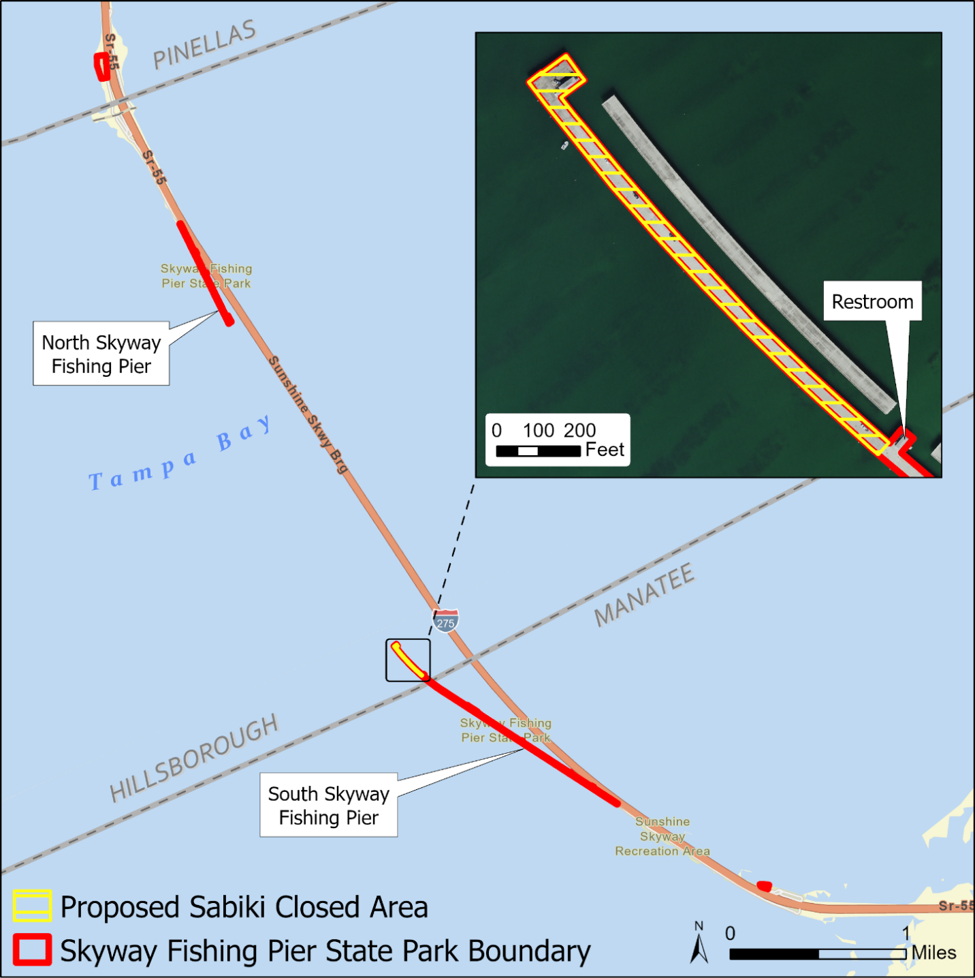
PROPOSED EFFECTIVE DATE: October 1, 2023
BE ADVISED THAT THESE PROPOSED RULES MAY BE FILED FOR ADOPTION AS SOON AS POSSIBLE FOLLOWING THE COMMISSION MEETING AT WHICH THEY ARE CONSIDERED IF THE RULES ARE NOT CHANGED. IF CHANGED, THE RULES MAY BE FILED AS SOON AS POSSIBLE AFTER PUBLICATION OF A NOTICE OF CHANGE IN THE F.A.R.

NAME OF PERSON ORIGINATING PROPOSED RULE: Jessica McCawley, Director, Division of Marine Fisheries Management, 620 S. Meridian St., Tallahassee, Florida 32399, (850)487-0554. Melissa Tucker, Director, Division of Habitat and Species Conservation, 620 S. Meridian St., Tallahassee, Florida
NAME OF AGENCY HEAD WHO APPROVED THE PROPOSED RULE: Florida Fish and Wildlife Conservation Commission.
DATE PROPOSED RULE APPROVED BY AGENCY HEAD: February 21, 2023
DATE NOTICE OF PROPOSED RULE DEVELOPMENT PUBLISHED IN FAR: February 14, 2023

