Notice of Proposed Rule

FISH AND WILDLIFE CONSERVATION COMMISSION
Vessel Registration and Boating Safety
RULE NO.: RULE TITLE:
68D-24.0037 Weeki Wachee Springs Protection Zone
PURPOSE AND EFFECT: The proposed rule establishes a spring protection zone prohibiting anchoring, mooring, beaching, or grounding of vessels in portions of Weeki Wachee Springs’ associated spring runs in Hernando County. The effect of this proposed rule is to protect and prevent harm to springs, including associated spring runs, in accordance with the Commission’s authority as set forth in section 327.45, F.S.
SUMMARY: The proposed rule will establish a spring protection zone which prohibits anchoring, mooring, beaching, or grounding of vessels in portions of the Weeki Wachee Springs’ associated spring runs in Hernando County for the purpose of protecting and preventing harm to the spring runs. The rule provides a description and map of the protected zone.
SUMMARY OF STATEMENT OF ESTIMATED REGULATORY COSTS AND LEGISLATIVE RATIFICATION:
The Agency has determined that this will not have an adverse impact on small business or likely increase directly or indirectly regulatory costs in excess of $200,000 in the aggregate within one year after the implementation of the rule. A SERC has not been prepared by the Agency.
The Agency has determined that the proposed rule is not expected to require legislative ratification based on the statement of estimated regulatory costs or if no SERC is required, the information expressly relied upon and described herein: the nature of the rule and the preliminary analysis conducted to determine whether a SERC was required.
Any person who wishes to provide information regarding a statement of estimated regulatory costs, or provide a proposal for a lower cost regulatory alternative must do so in writing within 21 days of this notice.
RULEMAKING AUTHORITY: 327.45(2), FS.
LAW IMPLEMENTED: 327.45, FS
IF REQUESTED WITHIN 21 DAYS OF THE DATE OF THIS NOTICE, A HEARING WILL BE SCHEDULED AND ANNOUNCED IN THE FAR.
THE PERSON TO BE CONTACTED REGARDING THE PROPOSED RULE IS: Major Robert Beaton, Boating and Waterways Section, Division of Law Enforcement, 620 South Meridian Street, Tallahassee, Florida 32399, rob.beaton@myfwc.com, (850)617-9544.

THE FULL TEXT OF THE PROPOSED RULE IS:

68D-24.0037 Weeki Wachee Springs Protection Zone
For the purpose of protecting and preventing harm to Weeki Wachee Springs in Hernando County, the following springs protection zone within which anchoring, mooring, beaching, and grounding of vessels are prohibited is established as follows: within an area of Weeki Wachee Springs and the associated spring run known as the Weeki Wachee River, from a point where the Hernando County Roger’s Park boat ramp canal meets the spring run, designated as “A” at Latitude 28 degrees 31 minutes 54.3 seconds North, Longitude 82 degrees 37 minutes 35.1 seconds West; thence proceed in an easterly direction, following the meander of the spring run, upstream, from shoreline to shoreline, for a distance of 5.61 miles, more or less, to a point within Weeki Wachee Springs State Park, at the farthest upstream location of the main spring boil, designated as “B” at Latitude 28 degrees 31 minutes 1.9 seconds North, Longitude 82 degrees 34 minutes 24.4 seconds West, and as depicted in Drawing A.
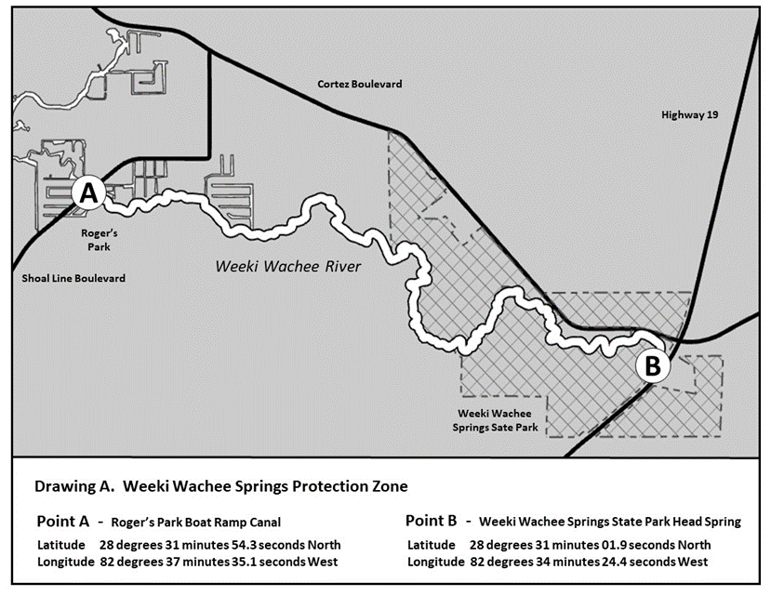
Rulemaking Authority 327.04, 327.45 FS. Law Implemented 327.45 FS. History–New _______.

NAME OF PERSON ORIGINATING PROPOSED RULE: Major Robert Beaton
NAME OF AGENCY HEAD WHO APPROVED THE PROPOSED RULE: Florida Fish and Wildlife Conservation Commission
DATE PROPOSED RULE APPROVED BY AGENCY HEAD: July 19, 2023
DATE NOTICE OF PROPOSED RULE DEVELOPMENT PUBLISHED IN FAR: June 7, 2023

