Miscellaneous

OTHER AGENCIES AND ORGANIZATIONS
Babcock Ranch Community Independent Special District
BABCOCK RANCH COMMUNITY INDEPENDENT SPECIAL DISTRICT NOTICE OF RULEMAKING FOR ADOPTION OF THE AMENDED AND SUPPLEMENTED SCHEDULE OF FEES FOR DESIGN AND SPECIFICATION MANUAL, VOLUMES 1, 2 AND 3
A rulemaking public hearing will be conducted by the Babcock Ranch Community Independent Special District (“District”) at the following date, time and place:
Date and Time: September 28, 2023, 1:00 p.m.
Place: The Hatchery, East Conference Room, Second Floor, 42881 Lake Babcock Drive, Punta Gorda, Florida 33982.
The public hearing will be a rulemaking hearing and will provide an opportunity for the public to address the proposed amended and supplemented Schedule of Fees for the Babcock Ranch Community Independent Special District Design and Specification Manual, Volumes 1, 2, and 3. The purpose and effect of the proposed changes to the rates, fees, and charges is to update such rates, fees, and charges to current industry standard and practices, and to provide for efficient and effective administrative District construction, maintenance and operations within boundaries of the District. Prior notice of rule development for the rulemaking hearing was published in the Florida Administrative Register on August 28, 2023. The proposed rates, fees and charges are as follows:

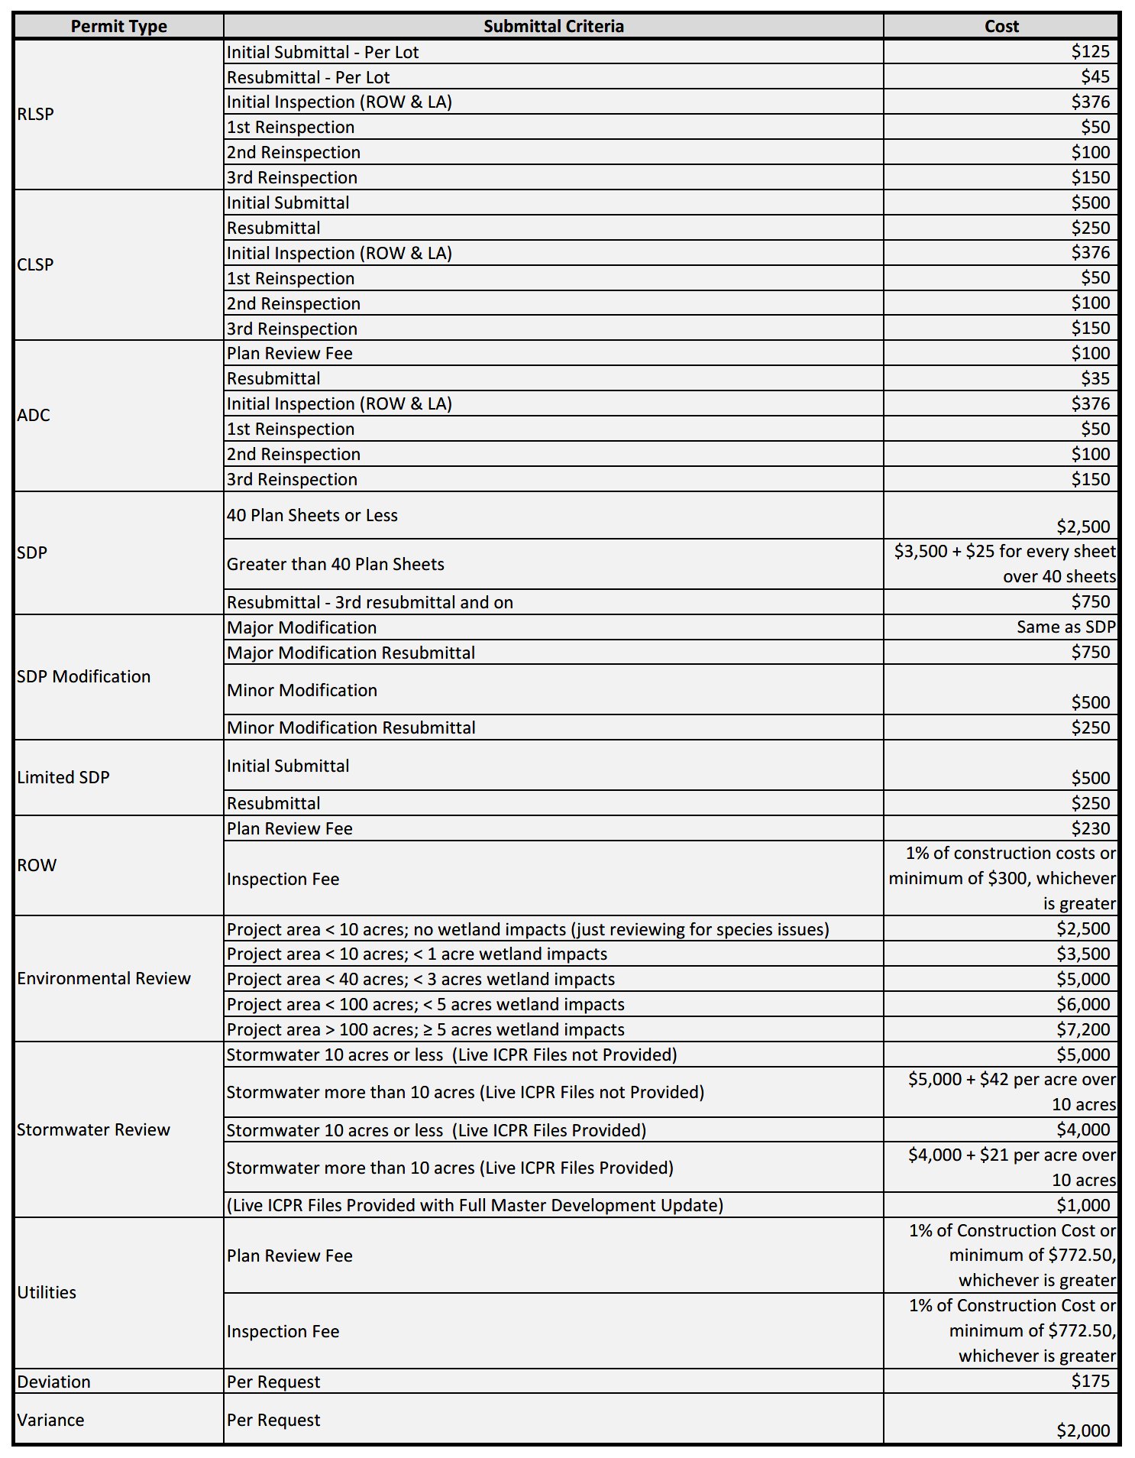

Specific legal authority for the rules includes section 120.054, Florida Statutes, and Chapter 2007-306, Laws of Florida, as amended. Any person who wishes to provide the District with a proposal for a lower cost regulatory alternative as provided by section 120.541(1), Florida Statutes, must do so in writing within twenty-one (21) days after publication of this notice.
The public hearing may be continued to a date, time, and place to be specified on the record at the hearing. If anyone chooses to appeal any decision of the Board with respect to any matter considered at the public hearing, such person will need a record of the proceedings and should accordingly ensure that a verbatim record of the proceedings is made which includes the testimony and evidence upon which such appeal is to be based. At the hearing, one or more Supervisors may participate in the public hearing by telephone. Any person requiring special accommodations at the hearing because of a disability or physical impairment should contact the District Office at (561)571-0010 at least 48 hours prior to the meeting. If you are hearing or speech impaired, please contact the Florida Relay Service at 1(800)955-8770, for aid in contacting the District Office. A copy of the proposed rules may be obtained by contacting the District Manager, Craig Wrathell, at 2300 Glades Road, Suite 410W, Boca Raton, Florida 33431, (561)571-0010, or by visiting the District’s website at the following address: http://www.babcockranchliving.com/153/Independent-Special-District.
Craig Wrathell, Manager

