Notice of Emergency Rule

DEPARTMENT OF THE LOTTERY
Departmental
RULE NO: RULE TITLE
53ER06-23: Instant Game Number 643, RUBY RED 7’s BINGO
SUMMARY: This emergency rule describes Instant Game Number 643, "RUBY RED 7’s BINGO," for which the Department of the Lottery will start selling tickets on a date to be determined by the Secretary of the Department. The rule sets forth the specifics of the game; determination of prizewinners; estimated odds of winning, value and number of prizes in the game.
THE PERSON TO BE CONTACTED REGARDING THE EMERGENCY RULE IS: Faith L. Schneider, Legal Analyst, Department of the Lottery, 250 Marriott Drive, Tallahassee, Florida 32399 4011.
THE FULL TEXT OF THE EMERGENCY RULE IS:
53ER06-23 Instant Game Number 643, RUBY RED 7’s BINGO.
(1) Name of Game. Instant Game Number 643, “RUBY RED 7’s BINGO”.
(2) Price. RUBY RED 7’s BINGO lottery tickets sell for $2.00 per ticket.
(3) RUBY RED 7’s BINGO lottery tickets shall have a series of numbers in Machine Readable Code (or bar code) on the back of the ticket, along with a Void If Removed Number under the latex area on the ticket. To be a valid winning RUBY RED 7’s BINGO lottery ticket, the ticket must meet the applicable requirements of Rule 53ER06-4, Florida Administrative Code.
(4) The “CALLER’S CARD” play symbols and play symbol captions are as follows:
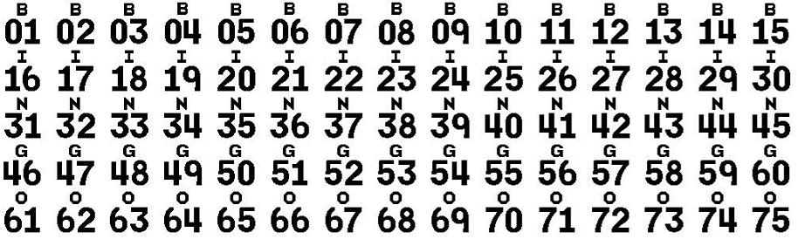

(5) The “PLAYER’S CARD” play symbols are as follows:
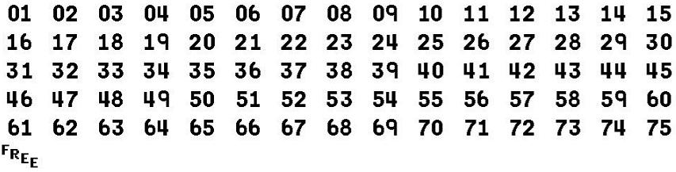
(6) Determination of Prizewinners.
(a) There are four Player’s Cards numbered 1 through 4 and one Caller's Card on each RUBY RED 7’s BINGO ticket. A “FREE” space will appear in the center of each player’s card. A “FREE” space can substitute as a number in a pattern of which it is a part.
(b) A ticket whose numbers on one of the Player’s Cards match the Caller's Card numbers in one of the following patterns shall entitle the claimant to the prize shown for that pattern on that card:
1. Horizontal line of five numbers (or four numbers and one "FREE" space).
2. Vertical line of five numbers (or four numbers and one "FREE" space).
3. Diagonal line of four numbers and one "FREE" space.
4. Four corners (consisting of four numbers).
5. "X" (consisting of eight numbers and one “FREE” space).
6. “7” (consisting of six numbers and one “FREE” space.)
Prizes that appear in the player’s cards area are: TICKET, $3, $7, $10, $17, $25, $50, $77, $100, $150, $200, $250, $500, $777 and $10,000. Prize amounts for a particular pattern are different on each player’s card.
(7) Players may win on one or more player’s cards per ticket; however, players may not win more than one prize on each player’s card.
(8) A claimant who is entitled to a prize of a “FREE TICKET” shall be entitled to a prize of a $2.00 instant ticket or combination of instant tickets with a total value of $2.00, except as follows. A person who submits by mail a RUBY RED 7’s BINGO lottery ticket that entitles the claimant to a prize of a $2.00 instant ticket and whose mailing address is outside the state of Florida will receive a check for $2.00 in lieu of an actual ticket.

(9) The estimated odds of winning, value, and number of prizes in Instant Game Number 643 are as follows:
NUMBER OF
 |  |  | WINNERS IN
 |  |  | 126 POOLS OF
 |  | ODDS OF | 120,000 TICKETS
GET BINGO WITH | WIN | 1 IN | PER POOL
LINE - CARD 1 | $2 Ticket | 12.50 | 1,209,600
LINE - CARD 2 | $3 | 8.33 | 1,814,400
LINES - CARD 1, 2 | $3 Cash + $2 Ticket | 75.00 | 201,600
7 PATTERN - CARD 1 | $7 | 75.00 | 201,600
LINE - CARD 3 | $10 | 75.00 | 201,600
LINES - CARD 1, 3 | $10 Cash + $2 Ticket | 150.00 | 100,800
7 PATTERN - CARD 2 | $17 | 150.00 | 100,800
4 CORNERS - CARD 1 | $25 | 300.00 | 50,400
LINE - CARD 4 | $25 | 300.00 | 50,400
LINES - CARD 1, 2, 4 | $28 Cash + $2 Ticket | 4,000.00 | 3,780
LINES - CARD 1, 2, 3, 4 | $38 Cash + $2 Ticket | 4,000.00 | 3,780
4 CORNERS - CARD 1 + LINE - CARD 4 | $50 | 1,200.00 | 12,600
4 CORNERS - CARD 2 | $50 | 1,200.00 | 12,600

7 PATTERN - CARD 3 | $77 | 2,400.00 | 6,300
4 CORNERS - CARD 1, 2 + LINE - CARD 4 | $100 | 3,000.00 | 5,040
4 CORNERS - CARD 3 | $100 | 6,000.00 | 2,520
"X" - CARD 1 | $150 | 20,000.00 | 756
4 CORNERS - CARDS 1, 3 + LINE-CARD 4 | $150 | 30,000.00 | 504
4 CORNERS - CARD 2 + "X"-CARD 1 | $200 | 60,000.00 | 252
4 CORNERS - CARD 4 | $200 | 60,000.00 | 252
4 CORNERS - CARDS 1, 2, 3 + LINE-CARD 4 | $200 | 60,000.00 | 252
"X" - CARD 2 | $250 | 60,000.00 | 252
"X" - CARD 1 + 4 CORNERS - CARD 2, 3, 4 | $500 | 630,000.00 | 24
"X" - CARD 1, 2 + 4 CORNERS - CARD 3 | $500 | 630,000.00 | 24
"X" - CARD 3 | $500 | 630,000.00 | 24
7 PATTERN - CARD 4 | $777 | 1,080,000.00 | 14
"X" - CARD 4 | $10,000 | 3,780,000.00 | 4

(10) The estimated overall odds of winning some prize in Instant Game Number 643 are 1 in 3.80. Prizes, including the top prizes, are subject to availability at the time of ticket purchase. Prizes may be unavailable due to prior sale or other causes occurring in the normal course of business including, but not limited to, ticket damage, defect, theft, or loss.
(11) For reorders of Instant Game Number 643, the estimated odds of winning, value, and number of prizes shall be proportionate to the number of tickets reordered.
(12) By purchasing a RUBY RED 7’s BINGO lottery ticket the player agrees to comply with and abide by all prize payment rules and regulations of the Florida Lottery.
(13) Payment of prizes for RUBY RED 7’s BINGO lottery tickets shall be made in accordance with rules of the Florida Lottery governing payment of prizes. A copy of the current rule can be obtained from the Florida Lottery, Office of the General Counsel, 250 Marriott Drive, Tallahassee, Florida 32399-4011.
Specific Authority 24.105(9)(a), (b), (c), 24.109(1), 24.115(1) FS. Law Implemented 24.105(9)(a), (b), (c), 24.115(1) FS. History--New .

THIS RULE TAKES EFFECT UPON BEING FILED WITH THE DEPARTMENT OF STATE UNLESS A LATER TIME AND DATE IS SPECIFIED IN THE RULE.
EFFECTIVE DATE: April 14, 2006

