68D-14.002 Monroe County Designated Anchoring Limitation Areas.
(1) The following anchoring limitation areas identified by boundary are designated within the waters of Monroe County: (a) Fleming Key Anchoring Limitation Area: All areas within an area of Man of War Harbor, west of Fleming Key, defined by beginning at a point designated as “A” at Latitude 24 degrees 35.1010 minutes North, Longitude 81 degrees 48.2400 minutes West; thence proceed in an easterly direction for a distance of 1,128 feet, more or less, joining the boundary of the naval restricted area around Fleming Key [as described in 33 C.F.R.§ 334.610(a)(4)] 100 yards, more or less, from the shoreline of Fleming Key at point “B” at Latitude 24 degrees 35.1050 minutes North, Longitude 81 degrees 48.0370 minutes West; thence easterly and southerly meandering along the boundary of the naval restricted area for a distance of 2,127 feet, more or less, to point “C” at Latitude 24 degrees 34.9809 minutes North, Longitude 81 degrees 47.9400 minutes West; thence southwesterly along the boundary of the naval restricted area for a distance of 1,025 feet, more or less, to point “D” at Latitude 24 degrees 34.9084 minutes North, Longitude 81 degrees 48.0945 minutes West; thence southerly along the boundary of the naval restricted area for a distance of 2,162 feet, more or less, to point “E” at Latitude 24 degrees 34.5619 minutes North, Longitude 81 degrees 48.1873 minutes West; thence southerly along the boundary of the naval restricted area for a distance of 715 feet, more or less, to point “F” at Latitude 24 degrees 34.4506 minutes North, Longitude 81 degrees, 48.1444 minutes West; thence southeasterly along the boundary of the naval restricted area for a distance of 900 feet, more or less, to point “G” at Latitude 24 degrees 34.3562 minutes North, Longitude 81 degrees 48.0192 minutes West; thence southwesterly along the boundary of the naval restricted area, for a distance of 800 feet, more or less, to point “H” at Latitude 24 degrees 34.2725 minutes North, Longitude 81 degrees 48.1304 minutes West; thence southeasterly along the boundary of the naval restricted area, for a distance of 1,210 feet, more or less, to point “I” at Latitude 24 degrees 34.1240 minutes North, Longitude 81 degrees 47.9840 minutes West; thence leaving the boundary of the naval restricted area in a northwesterly direction, for a distance of 1,327 feet, more or less, to point “J” at Latitude 24 degrees 34.2100 minutes North, Longitude 81 degrees 48.2050 minutes West; thence north for a distance of 5,407 feet, more or less, to the point of beginning at point “A”; enclosing an area of 100 acres, more or less, as depicted in Drawing a.
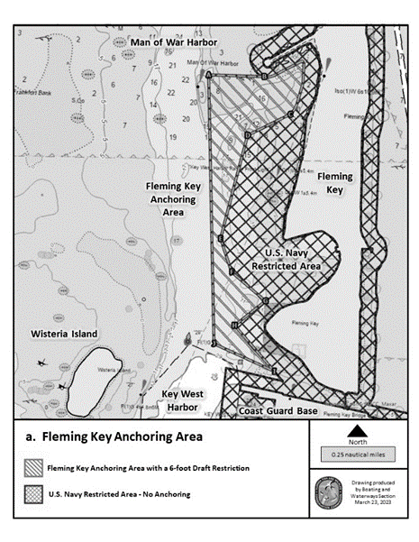
(b) Sigsbee Anchoring Limitation Area: All waters within an area of the Gulf of America, north of NAS Key West Sigsbee Park on Dredgers Key defined by beginning at a point designated as “A” at Latitude 24 degrees 35.322 minutes North, Longitude 81 degrees 46.342 minutes West; thence proceed in an easterly direction for a distance of 1,955 feet, more or less, to point “B” at Latitude 24 degrees 35.322 minutes North, Longitude 81 degrees 45.989 minutes West; thence southerly for a distance of 775 feet, more or less, to point “C” at Latitude 24 degrees 35.194 minutes North, Longitude 81 degrees 45.989 minutes West; thence westerly for a distance of 1,955 feet, more or less, to point “D” at Latitude 24 degrees 35.194 minutes North, Longitude 81 degrees 46.342 minutes West; thence northerly for a distance of 775 feet, more or less, to the point of beginning at point “A”; enclosing an area of 35 acres, more or less, as depicted in Drawing b.
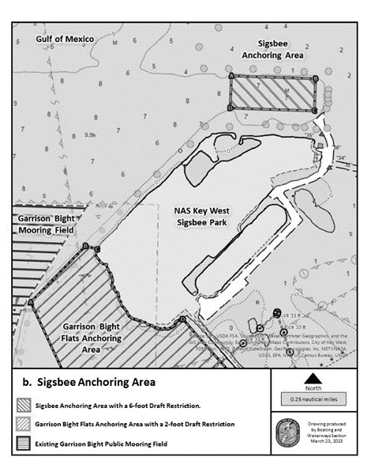
(c) Garrison Bight Flats Anchoring Limitation Area: All waters within an area of Garrison Bight, southwest of NAS Key West Sigsbee Park on Dredgers Key defined by beginning at a point designated as “A” at Latitude 24 degrees 34.447 feet North, Longitude 81 degrees 47.167 feet West; thence proceed in a northeasterly direction for a distance of 1,815 feet, more or less, to point “B” at Latitude 24 degrees 34.665 feet North, Longitude 81 degrees 46.939 feet West; thence proceed in a southeasterly direction for a distance of 281 feet, more or less, to the shoreline of Dredgers Key, at point “C” at Latitude 24 degrees 34.653 feet North, Longitude 81 degrees 46.889 feet West; thence proceed in a southeasterly direction along the meanderings of the shoreline of Dredgers Key for 3,260 feet, more or less to point “D” at Latitude 24 degrees 34.392 feet North, Longitude 81degrees 46.527 feet West; thence southeasterly along the submerged property boundary of the U.S. Navy Sigsbee Causeway for 1,065 feet, more or less, to point “E” at Latitude 24 degrees 34.262 feet North, Longitude 81degrees 46.397 feet West; thence southwesterly, maintaining clearance offshore of submerged property extending from subdivisions north of Roosevelt Boulevard, for a distance of 3,456 feet, more or less to point “F” at Latitude 24 degrees 34.163 feet North, Longitude 81degrees 47.012 feet West; thence northwesterly for a distance of 1,915 feet, more or less, to the point of beginning at point “A”; enclosing an area of 135 acres, more or less, as depicted in Drawing c.
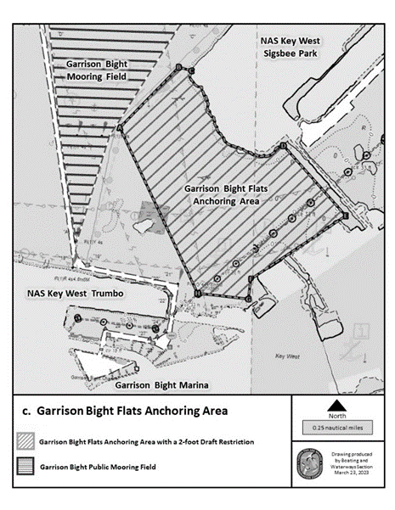
(d) Cow Key Channel Anchoring Limitation Areas (West and East): West -All waters within an area of Cow Key Channel, east of Key West and west of the Cow Key navigation channel defined by beginning at a point designated as “W-A” along the shoreline of South Roosevelt Boulevard, south of the private island identified by the Monroe County property appraiser’s office as parcel number 124000, at Latitude 24 degrees 33.751 minutes North, Longitude 81 degrees 44.970 minutes West; thence northeasterly in a straight line along the southern boundary of aforementioned private island, for a distance of 273 feet, more or less, stopping at the boundary of a submerged privately owned parcel identified as parcel number 124010 by the Monroe County property appraiser’s office, at point “WB” at Latitude 24 degrees 33.767 minutes North, Longitude 81degrees 44.924 minutes West; thence southeasterly along the western boundary of submerged parcel number 124010 for a distance of 793 feet more or less, to point “W-C” at Latitude 24 degrees 33.644 minutes North, Longitude 81 degrees 44.876 minutes West; thence easterly along the southern boundary submerged parcel number 124010, for a distance of 695 feet, more or less, to point “W-D” at Latitude 24 degrees 33.682 minutes North, Longitude 81 degrees 44.758 minutes West; thence southerly along a straight line west of the Cow Key navigation channel, for a distance of 1,960 feet, more or less, to point “W-E” at Latitude 24 degrees 33.364 minutes North, Longitude 81 degrees 44.695 minutes West; thence westerly for a distance of 1,028 feet, more or less, to point “W-F” at Latitude 24 degrees 33.320 minutes North, Longitude 81 degrees 44.874 minutes West; thence northerly meandering along the shoreline east of South Roosevelt Boulevard for a distance of 3,586 feet, more or less, to the point of beginning at point “W-A”; enclosing an area of 42 acres, more or less. Does not include the Cow Key Navigation Channel. East - All waters within an area of Cow Key Channel and the Atlantic Ocean, south of Cow Key and east of the Cow Key navigation channel defined by beginning at a point designated as “E-A” approximately 60 feet northeast of Cow Key navigation channel marker “6”, at Latitude 24 degrees 33.479 minutes North, Longitude 81 degrees 44.684 minutes West; thence northeasterly for a distance of 118 feet, more or less, to point “E-B” along the mangrove shoreline south of parcel number 123900 at Latitude 24 degrees 33.498 minutes North, Longitude 81 degrees 44.678 minutes West; thence easterly meandering along the southern shoreline of Cow Key, staying within state sovereign submerged lands, for a distance of 2,735 feet, more or less, to point “E-C” at Latitude 24 degrees 33.601 minutes North, Longitude 81 degrees 44.231 minutes West; thence leaving the shoreline and heading southerly for a distance of 697 feet more or less, maintaining clearance offshore and west of parcel number 123660, to point “E-D” at Latitude 24 degrees 33.486 minutes North, Longitude 81degrees 44.239 minutes West; thence westerly for a distance of 2,425 feet, more or less, to point “E-E” at Latitude 24 degrees 33.371 minutes North, Longitude 81 degrees 44.659 minutes West; thence northerly for a distance of 667 feet, more or less, along a straight line east of the Cow Key navigation channel to the point of beginning at point “E-A”; enclosing an area of 48 acres, more or less, as depicted in Drawing d.
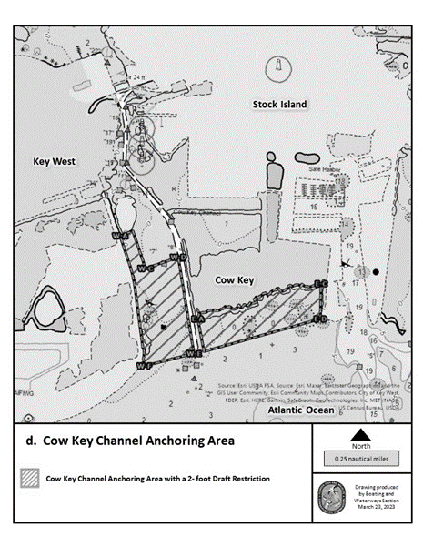
(e) Niles Channel Anchoring Limitation Area: All waters within an area of Niles Channel, east of Summerland Key and south of the Overseas Highway defined by beginning at a point designated as “A” at Latitude 24 degrees 39.433 minutes North, Longitude 81 degrees 26.064 minutes West; thence proceed in an easterly direction, for a distance of 980 feet, more or less, to point “B” at Latitude 24 degrees 39.431 minutes North, Longitude 81 degrees 25.887 minutes West; thence proceed in a southerly direction for a distance of 1,600 feet, more or less, to point “C” at Latitude 24 degrees 39.163 minutes North, Longitude 81 degrees 25.893 minutes West; thence proceed in a westerly direction for a distance of 575 feet, more or less, to point “D” at Latitude 24 degrees 39.165 minutes North, Longitude 81 degrees 25.997 minutes West; thence proceed in a northerly direction for a distance of 1,670 feet, more or less, to the point of beginning at point “A”; enclosing an area of 29 acres, more or less, as depicted in Drawing e.
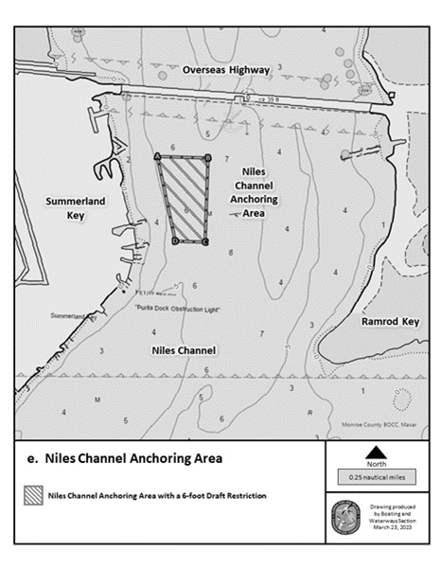
(f) Bahia Honda Channel Anchoring Limitation Area: All waters within an area of Bahia Honda Channel, a minimum of 500 feet west of Bahia Honda State Park and south of the Overseas Highway right of way defined by beginning at a point designated as “A” at Latitude 24 degrees 39.486 minutes North, Longitude 81 degrees 16.932 minutes West; thence proceed in an easterly direction for a distance of 710 feet, more or less, to point “B” at Latitude 24 degrees 39.506 minutes North, Longitude 81 degrees 16.806 minutes West; thence proceed in a southwesterly direction for a distance of 780 feet, more or less, to point “C” at Latitude 24 degrees 39.392 minutes North, Longitude 81 degrees 16.873 minutes West; thence proceed in a westerly direction for a distance of 340 feet, more or less, to point “D” at Latitude 24 degrees 39.393 minutes North, Longitude 81 degrees 16.935 minutes West; thence proceed in a northerly direction for a distance of 560 feet, more or less, to the point of beginning at point “A”; enclosing an area of 7 acres, more or less, as depicted in Drawing f.
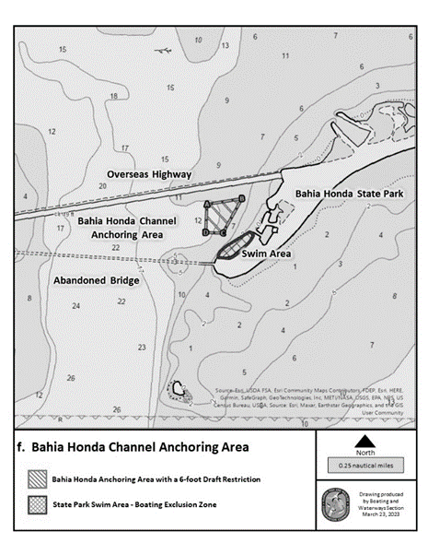
(g) Boot Key Anchoring Limitation Area: All waters within an area of the Atlantic Ocean, west of Boot Key and south of the entrance to the Boot Key Harbor navigation channel and north of the entrance to the Boot Key navigation channel, defined by beginning at a point designated as “A” at Latitude 24 degrees 41.764 minutes North, Longitude 81 degrees 7.374 minutes West; thence proceed in a northeasterly direction for a distance of 1,300 feet, more or less, to point “B” at Latitude 24 degrees 41.859 minutes North, Longitude 81 degrees 7.162 minutes West; thence proceed in a southeasterly direction for a distance of 2,600 feet, more or less, to point “C” at Latitude 24 degrees 41.475 minutes North, Longitude 81 degrees 6.937 minutes West; thence proceed in a southwesterly direction for a distance of 1,300 feet, more or less, to point “D” at Latitude 24 degrees 41.379 minutes North, Longitude 81 degrees 7.149 minutes West; thence proceed in a northwesterly direction, for a distance of 2,600 feet, more or less, to the point of beginning at point “A”; enclosing an area of 80 aces, more or less, as depicted in Drawing g.
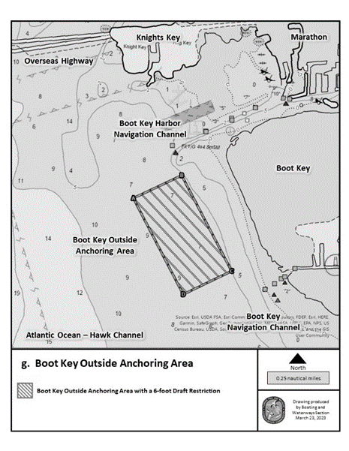
Rulemaking Authority 327.04, 327.4108(3)(b) FS. Law Implemented 327.4108, FS. History–New 10-3-23.

