68D-24.0037 Weeki Wachee Springs Protection Zone
For the purpose of protecting and preventing harm to Weeki Wachee Springs in Hernando County, the following springs protection zone within which anchoring, mooring, beaching, and grounding of vessels are prohibited is established as follows: within an area of Weeki Wachee Springs and the associated spring run known as the Weeki Wachee River, from a point where the Hernando County Roger’s Park boat ramp canal meets the spring run, designated as “A” at Latitude 28 degrees 31 minutes 54.3 seconds North, Longitude 82 degrees 37 minutes 35.1 seconds West; thence proceed in an easterly direction, following the meander of the spring run, upstream, from shoreline to shoreline, for a distance of 5.61 miles, more or less, to a point within Weeki Wachee Springs State Park, at the farthest upstream location of the main spring boil, designated as “B” at Latitude 28 degrees 31 minutes 1.9 seconds North, Longitude 82 degrees 34 minutes 24.4 seconds West, and as depicted in Drawing A.
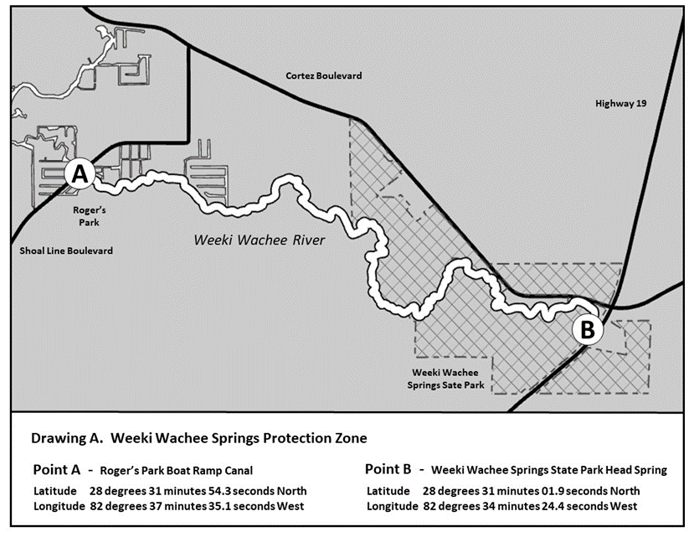
Rulemaking Authority 327.04, 327.45 FS. Law Implemented 327.45 FS. History–New 10-10-23.

