53ER23-54 Game Number 1546, $1,000,000 TRIPLE MATCH.
(1) Name of Game. Game Number 1546, $1,000,000 TRIPLE MATCH.
(2) Game Number 1546, $1,000,000 TRIPLE MATCH is a Scratch-Off lottery game (also known as an instant lottery game).
(3) Price. $1,000,000 TRIPLE MATCH lottery tickets sell for $5.00 per ticket.
(4) $1,000,000 TRIPLE MATCH lottery tickets shall have a series of numbers in machine readable code (or bar code) on the back of the ticket, along with a validation number under the latex area on the ticket. To be a valid winning $1,000,000 TRIPLE MATCH lottery ticket, the ticket must meet the applicable requirements of Rule 53ER23-20, Payment of Prizes, F.A.C.
(5) The play symbols and play symbol captions that may appear in the YOUR NUMBERS play area are:
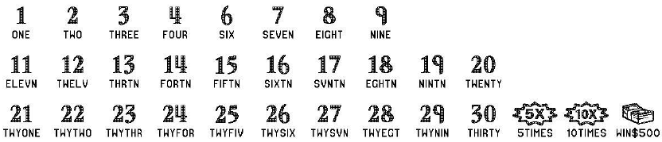

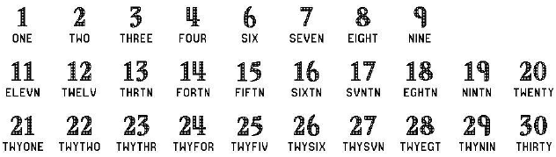
(6) The play symbols and play symbol captions that may appear in the WINNING NUMBERS and/or BONUS NUMBER play areas are:

(7) The prize symbols and prize symbol captions that may appear in the YOUR NUMBERS play area are:
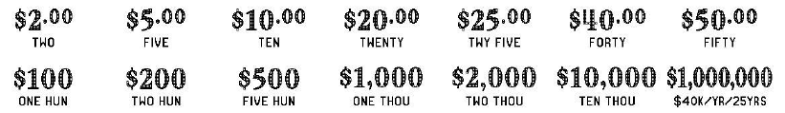

(8) The prize symbols and prize symbol captions that may appear in the BONUS NUMBER play area are:
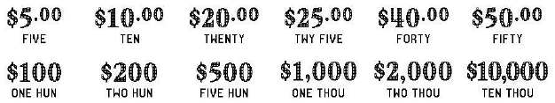

(9) The legends are:

(10) Determination of Prizewinners.
(a) A ticket having a play symbol and corresponding play symbol caption in the YOUR NUMBERS play area that matches a play symbol and corresponding play symbol caption in the WINNING NUMBERS play area shall entitle the prizewinner to the corresponding prize shown for that symbol. A ticket having a symbol and symbol caption shall entitle the player to five (5) times the corresponding prize shown. A ticket having a symbol and symbol caption shall entitle the player to ten (10) times the corresponding prize shown. A ticket having a symbol and symbol caption shall entitle the player to a $500 prize.
If a player matches three (3) identical prize amounts (prize symbols and prize symbol captions) in the YOUR NUMBERS play area, he/she is entitled to that amount (a single amount, not the amount times three). The prize amount shown in the BONUS NUMBER play area cannot be included in the count.
(b) BONUS NUMBER. A ticket having the play symbol and play symbol caption in the BONUS NUMBER play area that matches a play symbol and play symbol caption in the WINNING NUMBERS play area shall entitle the player to the BONUS NUMBER prize shown. The BONUS NUMBER play area is played independently from the YOUR NUMBERS play area. The prize symbol and prize symbol caption in the BONUS NUMBER play area cannot be counted as one of the three (3) prize amounts, described above.
(c) A player may win up to six (6) times on a ticket.
(11) $1,000,000 Prize; Payment Options.
(a) A prizewinner of a $1,000,000 prize may choose one of two payment options for receiving his/her prize. Payment options are One-Time Cash Payment or Annual Payments. At the time the $1,000,000 prize is claimed, the terminal will produce a player claim instructions ticket. The prizewinner has sixty (60) days from the date the player claim instructions ticket is produced to file a claim choosing the One-Time Cash Payment. If a prizewinner does not choose the One-Time Cash Payment within the sixty (60) day timeframe, the Annual Payment option will be applied. Once the prizewinner files a claim and exercises the winner’s chosen option, the election of that option shall be final. The Annual Payment method of payment will also be final when it is applied due to a $1,000,000 prizewinner not making his/her payment election within sixty (60) days after the player claim instructions ticket is produced.
(b) A winner of a $1,000,000 prize who elects the One-Time Cash Payment shall receive a single cash payment of $635,000.00, less applicable federal income tax withholding.
(c) Annual Payments will be paid in twenty-five (25) equal annual installments of $40,000.00 for a grand total of $1,000,000.00. Each payment is subject to federal tax withholding.
(12) The odds of winning, value, and number of prizes in Game Number 1546 are:
GAME PLAY | GAME PLAY – MATCH 3 | WIN | ODDS OF 1 IN | NUMBER OF WINNERS IN 151.14 POOLS OF 120,000 TICKETS PER POOL
 | $5 | $5 | 15.00 | 1,209,214
$5 |  | $5 | 20.00 | 906,849
 | $10 | $10 | 30.01 | 604,351
$5 x 2 |  | $10 | 60.00 | 302,283
$2 (5X) |  | $10 | 30.00 | 604,633
$10 |  | $10 | 60.00 | 302,283
$2 (10X) |  | $20 | 299.47 | 60,564
$2 (5X) + ($5 x 2) |  | $20 | 300.08 | 60,441
 | $20 | $20 | 300.14 | 60,428
$10 x 2 |  | $20 | 300.14 | 60,428
$20 |  | $20 | 300.05 | 60,447
 | $25 | $25 | 799.69 | 22,680
$5 (5X) |  | $25 | 798.53 | 22,713
$2 (5X) + $5 + $10 |  | $25 | 799.73 | 22,679
$5 + $20 |  | $25 | 798.77 | 22,706
$25 |  | $25 | 799.94 | 22,673
 | $40 | $40 | 687.97 | 26,363
($10 x 2) + $20 |  | $40 | 687.50 | 26,381
$5 + $5 (5X) + $10 |  | $40 | 685.37 | 26,463
$20 x 2 |  | $40 | 685.63 | 26,453
$40 |  | $40 | 686.77 | 26,409
 | $50 | $50 | 1,996.15 | 9,086
$5 (5X) + $5 + ($10 x 2) |  | $50 | 2,404.80 | 7,542
$10 (5X) |  | $50 | 2,007.19 | 9,036
$5 (10X) |  | $50 | 1,992.20 | 9,104
$10 + $40 |  | $50 | 6,023.57 | 3,011
$50 |  | $50 | 6,051.71 | 2,997
 | $100 | $100 | 2,396.85 | 7,567
($25 x 2) + ($20 x 2) + ($5 x 2) |  | $100 | 2,400.66 | 7,555
$10 (5X) + $5 (10X) |  | $100 | 2,397.17 | 7,566
$20 (5X) |  | $100 | 2,393.37 | 7,578
$10 (10X) |  | $100 | 2,388.96 | 7,592
$20 + ($40 x 2) |  | $100 | 1,499.54 | 12,095
$50 x 2 |  | $100 | 3,333.39 | 5,441
$100 |  | $100 | 3,991.41 | 4,544
 | $200 | $200 | 12,075.22 | 1,502
($10 x 2) + ($40 x 2) + ($50 x 2) |  | $200 | 24,086.29 | 753
$10 (10X) x 2 |  | $200 | 12,019.20 | 1,509
$20 (10X) |  | $200 | 11,916.54 | 1,522
$40 (5X) |  | $200 | 12,115.55 | 1,497
$100 x 2 |  | $200 | 23,990.71 | 756
$200 |  | $200 | 29,635.59 | 612
 | $500 | $500 | 24,086.29 | 753
($200 x 2) + ($50 x 2) |  | $500 | 40,304.40 | 450
($25 x 2) + $50 (5X) + ($100 x 2) |  | $500 | 39,949.30 | 454
$50 (10X) |  | $500 | 24,279.76 | 747
$100 (5X) |  | $500 | 23,990.71 | 756
$100 + ($200 x 2) |  | $500 | 58,695.73 | 309
$500 (CASH) |  | $500 | 23,739.50 | 764
 | $1,000 | $1,000 | 40,215.03 | 451
$100 (5X) + $500 |  | $1,000 | 59,465.51 | 305
$100 (5X) + ($200 x 2) + ($50 x 2) |  | $1,000 | 61,273.58 | 296
$100 (5X) x 2 |  | $1,000 | 58,506.39 | 310
$100 (10X) |  | $1,000 | 60,456.60 | 300
$100 (5X) + $500 (CASH) |  | $1,000 | 60,255.75 | 301
$1,000 |  | $1,000 | 123,380.82 | 147
 | $2,000 | $2,000 | 60,056.23 | 302
$200 (10X) |  | $2,000 | 120,112.45 | 151
$1,000 x 2 |  | $2,000 | 121,724.70 | 149
$1,000 + $50 (10X) + $500 (CASH) |  | $2,000 | 120,913.20 | 150
$2,000 |  | $2,000 | 120,112.45 | 151
$10,000 |  | $10,000 | 117,772.60 | 154
$1,000,000 ($40K/YR/25YRS)* |  | $1,000,000* | 3,022,830.00 | 6
*Prize amount if the Annual Payment method is chosen or has it applied. If the One-Time Cash Payment is chosen, the amount paid is in accordance with subsection (11), above.
(13) The overall odds of winning some prize in Game Number 1546 are 1 in 3.95. Prizes, including the top prizes, are subject to availability at the time of ticket purchase. Prizes may be unavailable due to prior sales or other causes occurring in the normal course of business including, but not limited to, ticket damage, defect, theft, or loss.
(14) For reorders of Game Number 1546, the odds of winning, value, and number of prizes shall be proportionate to the number of tickets reordered.
(15) Payment of prizes for $1,000,000 TRIPLE MATCH lottery tickets shall be made in accordance with the rule of the Florida Lottery governing payment of prizes. A copy of the current rule can be obtained from the Florida Lottery, Office of the General Counsel, 250 Marriott Drive, Tallahassee, Florida 32399-4011.
Rulemaking Authority 24.105(9)(a), (b), (c), 24.109(1), 24.115(1) FS. Law Implemented 24.105(9)(a), (b), (c), 24.115(1) FS. History–New 10-30-23.

