69O-154.105 Standards for Policy Provisions.
(1) Terms of renewability – Each individual or family policy of accident and health insurance shall include a renewal, continuation or nonrenewal provision. The language or specifications of such provision must be consistent with the type of contract to be issued (e.g., noncancellable and guaranteed renewable, guaranteed renewable, renewable at the option of the insurer, single term nonrenewable, etc.). Such provision must be appropriately captioned and commence or be referenced on the first page of the policy and must clearly state the duration, where limited, of renewability and the duration of the term of coverage for which the policy is issued and for which it may be renewed.
(a) Noncancellable and Guaranteed Renewable Policy – A renewal provision of a policy characterized as “noncancellable and guaranteed renewable” must be consistent with the minimum requirements as adopted and set forth in Rule 69O-154.004, F.A.C. In a family policy covering both husband and wife the age of the younger spouse must be used as the basis for fulfilling the age (at least to age 50) or durational (for at least 5 years if issued after age 44) requirements of the definitions of “noncancellable” and “guaranteed renewable” policies for the purpose of defining the period of guaranteed renewability of the policy. This requirement shall not prevent termination of coverage of the older spouse upon attainment of the state age limit (e.g., age 65) so long as the policy may be continued in force as to the younger spouse to the age or for the durational period as specified in said definition.
(b) Guaranteed Renewable Policy – The renewal provision used in a policy which is characterized as a “guaranteed renewable policy” must be consistent with the minimum requirements of Rule 69O-154.004, F.A.C. The renewal provision of a “guaranteed renewable policy” will be the same as that contained in a “noncancellable and guaranteed renewable policy” except for the reservation of the right to the insurer to change premium on a class basis. Such right shall be clearly expressed within the renewal provision and referenced in the caption of such provision.
(c) Renewable Subject to Consent of Company and Variants Thereof.
1. The renewal provision of a policy characterized as “renewable subject to the consent of the company” shall be appropriately captioned as:
a. Renewable Subject to Consent of Company; or
b. Renewable Subject to Company Consent; or
c. Renewable at Option of Company.
The designated captions are without prejudice to the right of the insurer to submit another caption, subject to the approval of the Director, which it believes is equally clear or more definitive as to the subject matter of said provision. The provision shall clearly declare that renewal of the policy is subject to the consent of the insurer and that the premium rate applicable to such policy shall be that currently in use on each renewal date of the policy. If the insurer reserves the right of cancellation, notice of the existence of the provision shall be cross-referenced in the renewal provision.
2. Conditional or limited continuance – A policy which provides a qualified right of continuance after expiration of the period during which such policy is “noncancellable and guaranteed renewable” or “guaranteed renewable” must clearly specify the conditions, such as continued gainful employment, which must be fulfilled to permit continuance of the policy. If premiums are to be based on an attained age or on a step-rate basis, such must be declared in the renewal provision. The age limit, if any, to which any policy is renewed shall be declared in the renewal provision.
3. Qualified right of renewal – A renewal provision, other than enumerated above, may grant to the insured the right of renewal by timely payment of premium up to a stated age, if any, subject to the reserved right of the insurer to terminate all such policies on a specified basis upon the giving of a specified period of notice, which shall be set forth in the appropriate provision of the policy. The right of the insured to renew the policy may be conditioned upon the continuation of a specified status (e.g., an employee or a named employer, member of a named organization, while engaged in a specific occupation associated with such employment or such organization, residence in a given state or geographic area, insured under a given form of insurance having like form number identification). The rights of the insured and of the insurer shall be clearly set forth in the renewal provision. Such shall include the specified age limit, if any, requirements as to the professional or occupational status, if any, and requirements as to the continuing relationship, if any, of the employee or member. Continuance of insurance after the insured ceases to be eligible for coverage under the plan may be at the option of the insurer. In the event a different table of premium rates is to be applicable with respect to renewals occurring thereafter, such fact shall be declared in the renewal provision.
4. Single term nonrenewable policy – A policy characterized as a “single term nonrenewable policy” shall include a provision appropriately captioned (e.g., “this policy is not renewable” or words of similar import). Such provision must identify or reference the proper part of the contract within which the term (duration) of the coverage is specified.
(d) Renewable at the option of the insured – A policy which may not be characterized as “noncancellable and guaranteed renewable” or “guaranteed renewable” under existing definitional requirements solely because such policy may not be continuable to age 50 or for a minimum period of five years, may use a renewal provision caption, subject to the approval of the Director, which states that the right of the renewal is vested in the insured (e.g., policies issued to afford coverage for family income protection mortgage payments or temporary debt obligations) for a stated period of years, to a stated age, to the occurrence of a stated event or during the continuance of a given status (e.g., employment, membership).
(2) Initial and Subsequent Conditions of Eligibility – A family policy providing hospital, surgical, medical expense, hospital confinement indemnity, or accident only insurance (which includes accidental death, dismemberment, loss of sight, indemnity for fractures or dislocations, blanket medical expense, etc.) shall include provisions which specify the identity and qualifications applicable to those family members who may become insured under the policy initially or by subsequent addition.
(a) Eligible family members may include:
1. The insured;
2. The insured’s spouse;
3. Children of the insured or of the insured’s spouse who are over a specified age and under a specified age not to exceed 21, unless a dependency test is specified; and,
4. Any other person dependent upon the insured.
(b) The provisions concerning eligibility shall, for persons who may become insured subsequent to policy issuance, state the conditions under which such coverage may become effective. Such conditions include:
1. Qualifications for automatic coverage and the duration thereof;
2. Required evidence of insurability;
3. The necessity of application or notice from the insured;
4. Any requirements as to the payment of premiums as to such addition; and,
5. The time within which action is to be taken by the insured.
(c) In family policies providing for the addition of newly eligible family members, the Time Limit on Certain Defenses provision may be modified to provide for a new contestable period for each new member so added other than newborn children of the insured, but shall not provide for a new contestable period for the policy.
(d) A family policy providing benefits for accidental injury (e.g., accidental death, dismemberment, loss of sight, indemnity for fractures or dislocations, blanket medical expense, etc.) shall include provisions which specify the identity and qualifications applicable to such family members who may become insured under the policy initially or by subsequent addition. Provisions describing eligibility of family members or the adding of family members will generally follow the pattern specified in subsections 69O-154.105(2) and (3), F.A.C. Generally, causes of termination of coverage of individual family members will be predicated on age, cessation of dependency, legal separation, termination of marriage, and similar causes.
(3) Termination of Insurance – A family policy providing hospital, surgical, medical expense, hospital confinement indemnity or accident only insurance shall include termination provisions which shall specify:
(a) As to the insured: the age or event, if any, upon which coverage under the policy will terminate (e.g., age 65, eligibility for Medicare).
(b) As to the spouse: the age or event, if any, upon which coverage under the policy will terminate (e.g., age 65, eligibility for Medicare, legal separation, termination of marriage by divorce or annulment or similar actions).
(c) As to a child: the age or event upon which coverage under the policy will terminate (e.g., age 21, marriage of the child, cessation of dependency).
(d) Other family members: the age or event, if any, or such other reasons as are appropriate for termination of coverage as to persons not coming within paragraphs (a), (b), or (c) above.
(e) A noncancellable and guaranteed renewable or guaranteed renewable policy may not provide for termination of coverage of the spouse solely because of the occurrence of an event specified for termination of coverage of the insured, other than nonpayment of premium. The provision shall provide that in the event of the insured’s death the spouse of the insured, if covered under the policy, shall become the insured.
(f) The provision shall provide that if the insurer accepts premium for coverage extending beyond the date, age or event specified for termination as to an insured family member, then coverage as to such person shall continue during the period for which an identifiable premium was accepted, except where such acceptance was predicated on a misstatement of age as outlined in Sections 627.620 and 627.634, F.S.
(g) The provision shall provide that, in the event of cancellation by the insurer, pursuant to Section 627.626, F.S., or refusal to renew by the insurer of a policy providing pregnancy benefits, such policy shall provide for an extension of benefits as to pregnancy commencing while the policy is in force and for which benefits would have been payable had the policy continued in force.
(h) The provision shall provide that termination of the policy by the insurer shall be without prejudice to any continuous loss which commenced while the policy was in force, but the extension of benefits beyond the period the policy was in force may be predicated upon the continuous total disability of the insured person, limited to the duration of the policy benefit period, payment of the maximum benefits or for a time period of not less than 3 months.
(i) The provision may provide for the termination or suspension of the family members who become eligible for coverage provided by the federal government (CHAMPUS or similar legislation).
(4) Nonduplication of Coverage Provisions:
(a) In addition to any other provisions not prohibited by law or rules, an insurer may avoid duplication of benefits with respect to losses for which benefits are payable under any workers’ compensation, occupational disease, employers’ liability or similar laws or payable pursuant to the Florida Automobile Reparations Reform Act (motor vehicle no-fault plan or similar law), and any national, state or other governmental plan not limited to civilian governmental employees or their families. An insurer may, alternatively, afford excess insurance to benefits afforded under any workers’ compensation, occupational disease, employers’ liability or similar laws or any national, state or other governmental plan or Florida Automobile Reparations Reform Act (motor vehicle no-fault plan or similar law), as well as other insurance or employer-employee or union welfare plans.
(b) Nonduplication may involve an interrelation, as related above and as appropriate to the coverage afforded, with other benefit programs including but not limited to individual or family insurance, group insurance, hospital service, medical service, group practice, individual practice and other prepayment plans, employee or employer benefit organizations, union or association welfare plans, Medicare, Florida Automobile Reparations Reform Act (motor vehicle no-fault plan or similar law), and similar benefit programs.
(5) Pre-existing Conditions – The policy must clearly disclose the intent of the insurer as to the applicability or nonapplicability or coverage to pre-existing conditions. If coverage of the policy is not to be applicable to pre-existing conditions, the policy shall specify, in substance, that coverage pertains solely to accidental bodily injuries resulting from accidents occurring after the effective date of coverage and that sicknesses are limited to these which first manifest themselves subsequent to the effective date of coverage or expiration of the probationary period, if any.
(6) Probationary or Waiting Periods – A probationary or waiting period shall relate to that period of time which may be specified in the policy and which must follow the date a person is initially insured under the policy before the coverage or coverages of the policy shall become effective as to such person.
(a) A probationary or waiting period shall not be used with respect to any loss resulting from accidental injuries as defined in the policy; however, as to loss resulting from sickness a policy may specify a probationary or waiting period which shall not exceed 30 days except as follows:
1. For pregnancy, childbirth, complications of pregnancy, 30 days where the probationary or waiting period is expressed in terms of the inception of the pregnancy;
2. Six months for losses resulting from hernia, disorder or reproduction organs, varicose veins, hemorrhoids, appendix, tonsils, adenoids and gall bladder;
3. 120 days for coverages under specified disease insurance.
(b) This subsection does not apply to benefits for dental or vision care.
(7) Limitations – The limitations on the risk undertaken, whether applicable to amounts, duration of benefits, age, or other matters, must be specified with clarity and certainty in the appropriate provision of the contract.
(8) Exceptions, Exclusions and Reductions.
(a) An exception or exclusion is any provision in a policy whereby coverage for a specified hazard is entirely eliminated. It is a statement of a risk not assumed under the terms and provisions of the contract.
(b) A reduction is a provision which takes away some portion, but not all of the coverage of the policy under certain specific conditions. Such relates to a risk assumed by the insurer but benefit upon the occurrence of such loss is limited to some amount or period less than would be otherwise payable had such reduction clause not been used.
(c) Exceptions, exclusions and reductions must be clearly expressed as a part of the benefit provision to which such applies, or if applicable to more than one benefit provision, shall be set forth as a separate provision and appropriately captioned. The use of general policy exclusions and the scope thereof will, of necessity, vary with the type of benefits afforded in a given policy. Such may generally be classified as “result” or “status” types. Policies containing the specified exclusionary subjects appearing in Exhibit A will be acceptable; however, this shall not preclude the consideration or approval of other exceptions or exclusions where such are deemed reasonable and appropriate to the risk undertaken and are approved by the Director.
(d) The listing of specified exclusionary subjects set forth in Exhibit A shall not impair or limit the use of waivers to exclude, limit or reduce coverage or benefits for specifically named or described pre-existing diseases, physical condition or extra hazardous activity. Where waivers are required as a condition of issuance, renewal or reinstatement, signed acceptance by the insured is required unless on initial issuance the full text of the waiver is contained either on the first page or specification page of the policy or unless notice of the waiver appears on the first page or specification page. Any waiver required as a condition precedent of renewal or reinstatement shall include a signed acceptance by the policyholder.

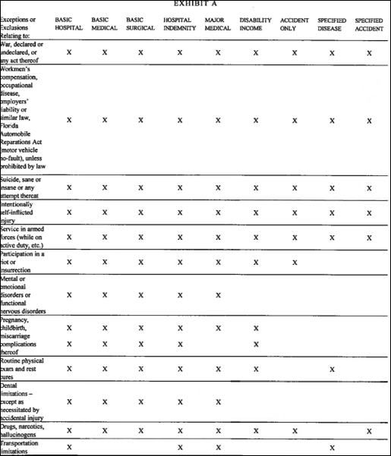
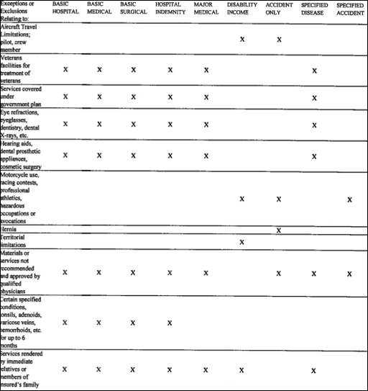
(e) If a policy contains a military service exclusion or a provision suspending coverage during military service, and if the premiums are either reduced or refunded for the period of such military service, the policy shall clearly so state.
1. As to policies other than noncancellable and guaranteed renewable, guaranteed renewable and renewable at option of the insured:
a. If the policy contains a “status” type of exclusion which excludes all coverages applicable to an insured person while in military service on full-time active duty, the policy shall provide, upon receipt of written request, for refund of premiums as applicable to such person on a pro rata basis.
b. If the policy contains a “causation” type exclusion (loss resulting from military service) while an insured person is on full-time active duty, refund of premium is not required since the policy would be operative as to any other loss not resulting from military service causes.
c. A provision for voluntary suspension of coverage as to an insured person during military service may be used, and if an identifiable premium is charged as to such person, then upon written request for suspension, a pro rata premium must be refunded.
2. As to noncancellable and guaranteed renewable, guaranteed renewable and renewable at the option of the insured:
a. The policy may provide for refund of the entire premium for the period of military service or for a partial refund of the premium from the date the insurer receives notice and it may adjust any such refund for any change in reserves during the period of suspension.
b. The policy may contain a military service exclusion or may provide for suspension of coverage upon entry into military service with the right of reinstatement upon termination of such service without evidence of insurability, if applied for within a specified period of not less than 60 days.
c. The insurer may charge a partial premium during the period of suspension which will anticipate accumulation of reserves required by law or regulation and related cost factors.
(9) Elimination Period – Elimination period shall relate to the initial period of time, during the continuance of a condition insured against and specified in respect to a particular benefit, for which such benefit will not be paid. Such periods must be clearly expressed in the policy schedule or benefits page and clearly expressed or referenced in the benefit provision to which such elimination period applies.
(10) Recurrent Conditions – A policy may contain provisions relating to recurrent confinements or recurrent disability; provided, however, a recurrent confinement or recurrent disability provision may not specify that such confinement or such disabilities be separated by a period greater than six months.
(11) Conversion Privileges – If a policy contains a conversion privilege, it shall comply, in substance, with the following:
(a) The caption of the provision shall be “Conversion Privilege”, or words of similar import. The provision shall indicate the persons eligible for conversion. The circumstances applicable to the conversion privilege, including any limitations on the conversion, and the person by whom the conversion privilege may be exercised, shall be described in the provision. The provision may indicate that the privilege is subject to the underwriting standards of the insurer relating to overinsurance.
(b) A business overhead expense policy issued on either a guaranteed renewable basis, or on a noncancellable basis, or renewable at the option of the company basis may contain a conversion privilege exercisable upon termination of the business interest, or it may provide for its continuation as a loss of time policy.
(c) A policy issued pursuant to the exercise of a conversion privilege contained in a group, individual family or another individual policy, the converted policy or a rider attached thereto shall reflect the relative rights of each person covered under the converted policy.
Rulemaking Authority 627.643, 624.308 FS. Law Implemented 624.307(1), 627.642, 627.643 FS. History–New 1-1-75, Formerly 4-37.05, 4-37.005, 4-154.105.

