53ER23-59 Game Number 1548, “2024.”
(1) Name of Game. Game Number 1548, “2024.”
(2) Game Number 1548, “2024” is a Scratch-Off lottery game (also known as an instant lottery game).
(3) Price. “2024” lottery tickets sell for $2.00 per ticket.
(4) “2024” lottery tickets shall have a series of numbers in machine readable code (or bar code) on the back of the ticket, along with a validation number under the latex area on the ticket. To be a valid winning “2024” lottery ticket, the ticket must meet the applicable requirements of Rule 53ER23-20, Payment of Prizes, F.A.C.
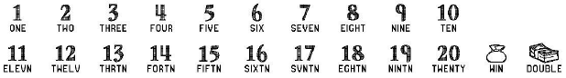
(5) The play symbols and play symbol captions that may appear in the YOUR NUMBERS play area are:

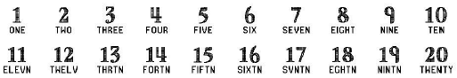
(6) The play symbols and play symbol captions that may appear in the WINNING NUMBERS play area are:

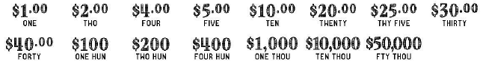
(7) The prize symbols and prize symbol captions that may appear in the YOUR NUMBERS play area are:

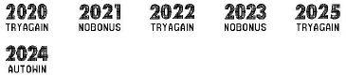
(8) The play symbols and play symbol captions that may appear in the BONUS BOX play area are:

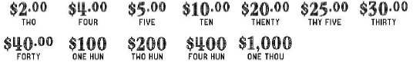
(9) The prize symbols and prize symbol captions that may appear in the BONUS BOX play area are:

(10) The legends are:
(11) Determination of Prizewinners.
(a) A ticket having a play symbol and corresponding play symbol caption in the YOUR NUMBERS play area that matches a play symbol and corresponding play symbol caption in the WINNING NUMBERS play area shall entitle the prizewinner to the corresponding prize shown for that symbol. A ticket having a symbol and symbol caption shall entitle the player to the corresponding prize shown. A ticket having a symbol and symbol caption shall entitle the player to two (2) times the corresponding prize shown.
(b) BONUS BOX. A ticket having a play symbol and play symbol caption in the BONUS BOX play area shall entitle the player to the BONUS BOX prize shown.
(c) A player may win up to eleven (11) times on a ticket.
(12) The odds of winning, value, and number of prizes in Game Number 1548 are:
GAME PLAY | WIN | ODDS OF 1 IN | NUMBER OF WINNERS IN 67.46 POOLS OF 180,000 TICKETS PER POOL
$2 | $2 | 10.00 | 1,214,257
$1 x 4 | $4 | 50.00 | 242,836
($1 x 2) + $2 | $4 | 49.99 | 242,888
$2 (CASH) | $4 | 50.01 | 242,818
$4 | $4 | 49.99 | 242,882
$1 x 5 | $5 | 374.99 | 32,381
$1 + $2 (CASH) | $5 | 375.00 | 32,380
($2 x 2) + $1 | $5 | 375.15 | 32,367
$1 + $4 | $5 | 375.08 | 32,373
$5 | $5 | 374.78 | 32,399
$1 + $4 + $5 | $10 | 249.93 | 48,583
$5 x 2 | $10 | 249.96 | 48,577
$2 x 5 | $10 | 250.10 | 48,551
$5 (CASH) | $10 | 250.01 | 48,569
$10 | $10 | 250.00 | 48,570
($1 x 10) + $10 | $20 | 750.28 | 16,184
$4 x 5 | $20 | 749.72 | 16,196
$5 x 4 | $20 | 750.88 | 16,171
$10 (CASH) | $20 | 749.44 | 16,202
$20 | $20 | 749.68 | 16,197
($2 x 10) + $5 | $25 | 2,996.67 | 4,052
$5 x 5 | $25 | 3,004.83 | 4,041
($2 x 5) + ($5 x 3) | $25 | 2,987.08 | 4,065
$5 + $5 (CASH) + $10 | $25 | 3,000.37 | 4,047
$25 | $25 | 3,026.55 | 4,012
($2 x 10) + $10 | $30 | 1,198.31 | 10,133
$5 x 6 | $30 | 1,196.66 | 10,147
$10 x 3 | $30 | 1,199.97 | 10,119
$10 + $10 (CASH) | $30 | 1,202.11 | 10,101
$30 | $30 | 1,198.79 | 10,129
($2 x 10) + $20 | $40 | 3,620.30 | 3,354
($4 x 5) + ($5 x 4) | $40 | 3,583.97 | 3,388
$10 x 4 | $40 | 3,606.33 | 3,367
$20 (CASH) | $40 | 3,617.07 | 3,357
$40 | $40 | 4,283.07 | 2,835
($5 x 8) + ($20 x 3) | $100 | 3,594.58 | 3,378
($10 x 2) + $40 (CASH) | $100 | 3,583.97 | 3,388
$20 (CASH) + $30 (CASH) | $100 | 3,603.12 | 3,370
$25 x 4 | $100 | 4,529.09 | 2,681
$100 | $100 | 4,493.89 | 2,702
$40 x 10 | $400 | 46,169.20 | 263
($40 x 5) + $100 (CASH) | $400 | 45,139.41 | 269
$100 x 4 | $400 | 45,820.75 | 265
$100 (CASH) x 2 | $400 | 45,139.41 | 269
$400 | $400 | 61,017.59 | 199
$100 x 10 | $1,000 | 181,231.34 | 67
($40 x 5) + $400 (CASH) | $1,000 | 92,690.84 | 131
$200 x 5 | $1,000 | 171,021.13 | 71
$200 + $400 (CASH) | $1,000 | 181,231.34 | 67
$1,000 | $1,000 | 186,807.69 | 65
$10,000 | $10,000 | 758,906.25 | 16
$50,000 | $50,000 | 1,517,812.50 | 8
(13) The overall odds of winning some prize in Game Number 1548 are 1 in 4.37. Prizes, including top prizes, are subject to availability at the time of ticket purchase. Prizes may be unavailable due to prior sales or other causes occurring in the normal course of business including, but not limited to, ticket damage, defect, theft, or loss.
(14) For reorders of Game Number 1548, the odds of winning, value, and number of prizes shall be proportionate to the number of tickets reordered.
(15) Payment of prizes for “2024” lottery tickets shall be made in accordance with the rule of the Florida Lottery governing payment of prizes. A copy of the current rule can be obtained from the Florida Lottery, Office of the General Counsel, 250 Marriott Drive, Tallahassee, Florida 32399-4011.
Rulemaking Authority 24.105(9)(a), (b), (c), 24.109(1), 24.115(1) FS. Law Implemented 24.105(9)(a), (b), (c), 24.115(1) FS. History–New 12-4-23.

