53ER23-60 Game Number 1549, BINGO NIGHT.
(1) Name of Game. Game Number 1549, BINGO NIGHT.
(2) Game Number 1549, BINGO NIGHT is a Scratch-Off lottery game (also known as an instant lottery game).
(3) Price. BINGO NIGHT lottery tickets sell for $3.00 per ticket.
(4) BINGO NIGHT lottery tickets shall have a series of numbers in machine readable code (or bar code) on the back of the ticket, along with a validation number under the latex area on the ticket. To be a valid winning BINGO NIGHT lottery ticket, the ticket must meet the applicable requirements of Rule 53ER23-20, Payment of Prizes, F.A.C.
(5) The play symbols that may appear in the CALLER’S CARD play area are:
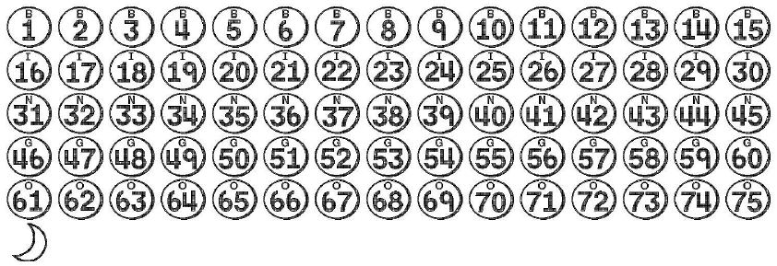
(6) The play symbols that may appear in the Player’s CARD play areas are:
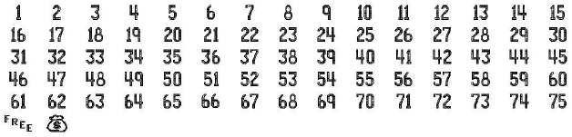
(7) The legend is:
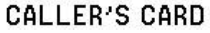
(8) Determination of Prizewinners.
(a) A ticket having a symbol in the CALLER’S CARD play area shall entitle the player to a $20 cash prize.
(b) There are six (6) Player’s CARDS (CARD 1 through CARD 6). Each CARD is played separately.
(c) Each Player CARD has a space in the center. The space can substitute for a number in a pattern of which it is a part.
(d) A ticket having play symbols in the CALLER’S CARD play area that match all play symbols in a Player’s CARD to form one of the below patterns shall entitle the player to the prize shown for that Player CARD for the pattern completed:
1. a completed horizontal, vertical, or diagonal line, or
2. all four (4) corners, or
3. a completed “X” pattern (consisting of eight numbers and ).
(e) If a symbol appears in a Player CARD, it can substitute as a number. If the symbol completes a winning “line” pattern (horizontal, vertical, or diagonal), a player is entitled to triple the “line” prize for that CARD.
(f) Play symbols from one Player’s CARD cannot be used in any other Player’s CARD.
(g) A player may win up to five (5) times on a ticket but cannot win more than one time per Player CARD. Only the highest prize is paid per Player CARD.
(9) The odds of winning, value, and number of prizes in Game Number 1549 are as follows:
GAME PLAY | WIN | ODDS OF 1 IN | NUMBER OF WINNERS IN 145.29 POOLS OF 180,000 TICKETS PER POOL
Line - Card 1 | $3 | 8.33 | 3,138,535
Line - Card 2 | $5 | 25.00 | 1,046,161
Line - Card 1 + Line - Card 2 | $8 | 33.33 | 784,551
Line - Card 1 (MONEYBAG) | $9 | 100.00 | 261,517
Line - Card 3 | $10 | 499.80 | 52,324
Line - Card 2 + Line - Card 3 | $15 | 249.92 | 104,640
Line - Card 2 (MONEYBAG) | $15 | 166.67 | 156,909
MOON | $20 | 499.80 | 52,324
Line - Card 2 (MONEYBAG) + Line - Card 3 | $25 | 250.00 | 104,608
Line - Card 2 + MOON | $25 | 250.13 | 104,553
Line - Card 4 | $25 | 500.25 | 52,277
Line - Card 3 (MONEYBAG) | $30 | 499.96 | 52,308
Line - Card 3 + MOON | $30 | 250.09 | 104,569
Line - Card 2 + Line - Card 4 | $30 | 500.25 | 52,277
Line - Card 2 + Line - Card 3 + Line - Card 4 | $40 | 996.33 | 26,248
4 Corners - Card 1 | $40 | 900.57 | 29,039
4 Corners - Card 1 + Line - Card 3 | $50 | 4,508.91 | 5,800
4 Corners - Card 2 | $50 | 4,511.25 | 5,797
Line - Card 3 (MONEYBAG) + MOON | $50 | 3,628.65 | 7,207
Line - Card 2 + Line - Card 4 + MOON | $50 | 3,603.16 | 7,258
Line - Card 5 | $50 | 4,504.25 | 5,806
Line - Card 4 (MONEYBAG) | $75 | 5,987.11 | 4,368
Line - Card 4 + Line - Card 5 | $75 | 9,074.15 | 2,882
Line - Card 3 + Line - Card 4 + 4 Corners - Card 1 | $75 | 9,080.45 | 2,880
Line - Card 2 + Line - Card 5 + MOON | $75 | 3,601.17 | 7,262
4 Corners - Card 2 + Line - Card 4 | $75 | 3,607.63 | 7,249
Line - Card 6 | $75 | 8,934.64 | 2,927
Line - Card 4 + Line - Card 6 | $100 | 7,232.22 | 3,616
4 Corners - Card 1 + Line - Card 2 + Line - Card 3 + Line - Card 4 + MOON | $100 | 3,592.27 | 7,280
Line - Card 2 + Line - Card 4 (MONEYBAG) + MOON | $100 | 3,589.80 | 7,285
4 Corners - Card 3 | $100 | 8,993.02 | 2,908
Line - Card 5 (MONEYBAG) | $150 | 8,974.50 | 2,914
Line - Card 4 + Line - Card 6 + 4 Corners - Card 3 | $200 | 35,292.44 | 741
X - Card 1 | $200 | 30,128.69 | 868
X - Card 1 + Line - Card 5 | $250 | 59,300.91 | 441
Line - Card 4 + Line - Card 6 + X - Card 1 | $300 | 89,868.38 | 291
Line - Card 6 (MONEYBAG) + Line - Card 5 + Line - Card 4 | $300 | 90,804.51 | 288
4 Corners - Card 4 | $300 | 91,120.91 | 287
X - Card 2 | $500 | 88,052.86 | 297
X - Card 1 + 4 Corners - Card 4 | $500 | 91,120.91 | 287
4 Corners - Card 5 | $500 | 91,760.35 | 285
X - Card 2 + 4 Corners - Card 5 | $1,000 | 181,609.03 | 144
X - Card 1 + X - Card 2 + 4 Corners - Card 4 | $1,000 | 173,190.07 | 151
X - Card 3 | $1,000 | 182,879.02 | 143
4 Corners - Card 6 | $5,000 | 88,951.36 | 294
X - Card 4 | $10,000 | 1,089,654.17 | 24
X - Card 5 | $25,000 | 1,634,481.25 | 16
X - Card 6 | $150,000 | 4,358,616.67 | 6
(10) The overall odds of winning some prize in Game Number 1549 are 1 in 4.21. Prizes, including top prizes, are subject to availability at the time of ticket purchase. Prizes may be unavailable due to prior sales or other causes occurring in the normal course of business including, but not limited to, ticket damage, defect, theft, or loss.
(11) For reorders of Game Number 1549, the odds of winning, value, and number of prizes shall be proportionate to the number of tickets reordered.
(12) Payment of prizes for BINGO NIGHT lottery tickets shall be made in accordance with the rule of the Florida Lottery governing payment of prizes. A copy of the current rule can be obtained from the Florida Lottery, Office of the General Counsel, 250 Marriott Drive, Tallahassee, Florida 32399-4011.
Rulemaking Authority 24.105(9)(a), (b), (c), 24.109(1), 24.115(1) FS. Law Implemented 24.105(9)(a), (b), (c), 24.115(1) FS. History- New 12-4-23.

