53ER24-2 Game Number 1551, 10X® THE CASH.
(1) Name of Game. Game Number 1551, 10X THE CASH.
(2) Game Number 1551, 10X THE CASH is a Scratch-Off lottery game (also known as an instant lottery game).
(3) Price. 10X THE CASH lottery tickets sell for $1.00 per ticket.
(4) 10X THE CASH lottery tickets shall have a series of numbers in machine readable code (or bar code) on the back of the ticket, along with a validation number under the latex area on the ticket. To be a valid winning 10X THE CASH lottery ticket, the ticket must meet the applicable requirements of Rule 53ER23-20, Payment of Prizes, F.A.C.
(5) Play symbols and play symbol captions that may appear in the YOUR NUMBERS play area:
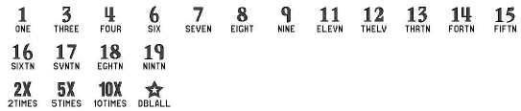
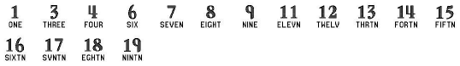
(6) Play symbols and play symbol captions that may appear in the WINNING NUMBER play area:

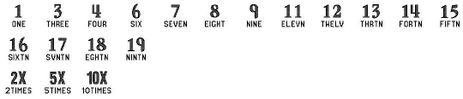
(7) Play symbols and play symbol captions that may appear in the BONUS NUMBER play area:

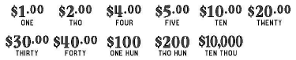
(8) Prize symbols and prize symbol captions that may appear in the YOUR NUMBERS play area:

(9) The legends are:
(10) Determination of Winners.
(a) A ticket having a play symbol and corresponding play symbol caption in either the YOUR NUMBERS play area or BONUS NUMBER play area that matches the play symbol and corresponding play symbol caption in the WINNING NUMBER play area shall entitle the winner to the corresponding prize shown for that symbol. A ticket having a 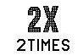symbol and symbol caption in either the YOUR NUMBERS or BONUS NUMBER play area shall entitle the winner to two times the prize shown for that symbol. A ticket having a symbol and symbol caption in either the YOUR NUMBERS or BONUS NUMBER play area shall entitle the winner to five times the prize shown for that symbol. A ticket having a 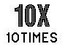 symbol and symbol caption in either the YOUR NUMBERS or BONUS NUMBER play area shall entitle the winner to ten times the prize shown for that symbol. A ticket having a symbol and symbol caption in the YOUR NUMBERS play area shall entitle the winner to two times (i. e. “double”) all six prizes shown.
(b) A player may win up to six times on a ticket.
(11) The odds of winning, value, and number of prizes in Game Number 1551 are as follows:

GAME PLAY | WIN | ODDS OF 1 IN | NUMBER OF WINNERS IN 114.28 POOLS OF 240,000 TICKETS PER POOL
$1 | $1 | 10.71 | 2,560,032
$1 (2X) | $2 | 25.00 | 1,096,924
$2 | $2 | 33.33 | 822,798
$1 x 4 | $4 | 300.30 | 91,330
$1 (2X) + $2 | $4 | 149.99 | 182,858
$2 x 2 | $4 | 149.92 | 182,936
$4 | $4 | 300.00 | 91,422
$1 x 5 | $5 | 749.22 | 36,607
$1 (5X) | $5 | 750.34 | 36,552
$1 + $2 (2X) | $5 | 751.41 | 36,500
$1 + $4 | $5 | 750.57 | 36,541
$5 | $5 | 748.46 | 36,644
$2 x 5 | $10 | 499.37 | 54,922
$2 (5X) | $10 | 499.75 | 54,881
$1 + $2 (2X) + $5 | $10 | 500.69 | 54,778
$1 (10X) | $10 | 500.35 | 54,815
$10 | $10 | 499.85 | 54,870
($1 x 5) + $5 (STAR) | $20 | 1,500.53 | 18,278
$2 (10X) | $20 | 1,500.85 | 18,274
$2 (5X) + $5 (2X) | $20 | 1,504.81 | 18,226
$4 (5X) | $20 | 1,497.49 | 18,315
$20 | $20 | 1,496.35 | 18,329
($2 x 5) + $5 (STAR) | $30 | 8,017.13 | 3,421
$1 + $4 + $5 (5X) | $30 | 9,275.14 | 2,957
$5 (2X) + $10 (2X) | $30 | 9,275.14 | 2,957
$2 (5X) + $4 (5X) | $30 | 8,483.33 | 3,233
$2 (10X) + $10 | $30 | 8,012.45 | 3,423
$30 | $30 | 10,849.13 | 2,528
($2 x 5) + $10 (STAR) | $40 | 6,669.89 | 4,112
$5 (2X) + ($10 x 3) | $40 | 7,972.85 | 3,440
$5 + $5 (5X) + $10 | $40 | 7,977.49 | 3,438
($5 x 4) + $2 (10X) | $40 | 7,390.62 | 3,711
$4 (10X) | $40 | 7,991.43 | 3,432
$40 | $40 | 9,559.64 | 2,869
($5 x 4) + $20 + $10 (STAR) | $100 | 16,315.65 | 1,681
$10 (5X) + $20 + $30 | $100 | 23,953.36 | 1,145
$20 + $40 (2X) | $100 | 23,787.16 | 1,153
$10 (5X) x 2 | $100 | 24,292.83 | 1,129
$10 (10X) | $100 | 19,874.35 | 1,380
$100 | $100 | 29,682.47 | 924
($10 x 4) + $40 + $20 (STAR) | $200 | 60,014.44 | 457
$10 + $20 (5X) + ($30 x 3) | $200 | 79,960.93 | 343
$10 (2X) + $20 (5X) + $40 (2X) | $200 | 80,666.47 | 340
$10 + $20 (2X) + $30 (5X) | $200 | 78,586.25 | 349
$20 (10X) | $200 | 78,361.71 | 350
$200 | $200 | 117,710.73 | 233
$10,000 | $10,000 | 527,434.62 | 52

(12) The overall odds of winning some prize in Game Number 1551 are 1 in 4.88. All prizes are subject to availability at the time of ticket purchase. Prizes may be unavailable due to prior sales or other causes occurring in the normal course of business including, but not limited to, ticket damage, defect, theft, or loss.
(13) For reorders of Game Number 1551, the odds of winning, value, and number of prizes shall be proportionate to the number of tickets reordered.
(14) Payment of prizes for 10X THE CASH lottery tickets shall be made in accordance with the rule of the Florida Lottery governing payment of prizes. A copy of the current rule can be obtained from the Florida Lottery, Office of the General Counsel, 250 Marriott Drive, Tallahassee, Florida 32399-4011 or at flrules.org.
(15) Third party trademarks are the property of their respective owners, not the Florida Lottery.
Rulemaking Authority 24.105(9)(a), (b), (c), 24.109(1), 24.115(1) FS. Law Implemented 24.105(9)(a), (b), (c), 24.115(1) FS. History–New 1-15-24.

