53ER24-3 Game Number 1552, 20X THE CASH.
(1) Name of Game. Game Number 1552, 20X THE CASH.
(2) Game Number 1552, 20X THE CASH is a Scratch-Off lottery game (also known as an instant lottery game).
(3) Price. 20X THE CASH lottery tickets sell for $2.00 per ticket.
(4) 20X THE CASH lottery tickets shall have a series of numbers in machine readable code (or bar code) on the back of the ticket, along with a validation number under the latex area on the ticket. To be a valid winning 20X THE CASH lottery ticket, the ticket must meet the applicable requirements of Rule 53ER23-20, Payment of Prizes, F.A.C.
(5) Play symbols and play symbol captions that may appear in the YOUR NUMBERS play area:
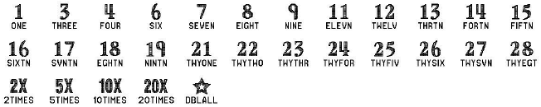
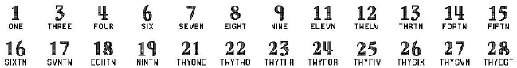
(6) Play symbols and play symbol captions that may appear in the WINNING NUMBERS play area:

(7) Play symbols and play symbol captions that may appear in the BONUS NUMBERS play area:
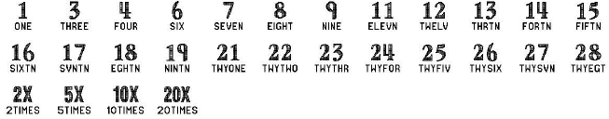
(8) Prize symbols and prize symbol captions that may appear in the YOUR NUMBERS play area:
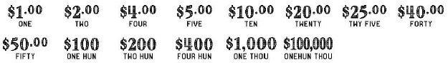
(9) The legends are:
(10) Determination of Winners.
(a) A ticket having a play symbol and corresponding play symbol caption in either the YOUR NUMBERS play area or the BONUS NUMBERS play area that matches a play symbol and corresponding play symbol caption in the WINNING NUMBERS play area shall entitle the winner to the corresponding prize shown for that symbol. A ticket having a symbol and symbol caption in either the YOUR NUMBERS or BONUS NUMBERS play area shall entitle the winner to two times the prize shown for that symbol. A ticket having a symbol and symbol caption in either the YOUR NUMBERS or BONUS NUMBERS play area shall entitle the winner to five times the prize shown for that symbol. A ticket having a symbol and symbol caption in either the YOUR NUMBERS or BONUS NUMBERS play area shall entitle the winner to ten times the prize shown for that symbol. A ticket having a symbol and symbol caption in either the YOUR NUMBERS or BONUS NUMBERS play area shall entitle the winner to twenty times the prize shown for that symbol. A ticket having a symbol and symbol caption in the YOUR NUMBERS play area shall entitle the winner to two times (i. e. “double”) all twelve prizes shown.
(b) A player may win up to twelve times on a ticket.
(11) The odds of winning, value, and number of prizes in Game Number 1552 are as follows:

GAME PLAY | WIN | ODDS OF 1 IN | NUMBER OF WINNERS IN 179.65 POOLS OF 180,000 TICKETS PER POOL
$2 | $2 | 10.71 | 3,018,159
$1 x 4 | $4 | 50.00 | 646,785
($1 x 2) + $2 | $4 | 74.99 | 431,216
$2 (2X) | $4 | 50.00 | 646,731
$4 | $4 | 50.00 | 646,798
$1 x 5 | $5 | 375.18 | 86,192
($1 x 3) + $2 | $5 | 375.18 | 86,192
($2 x 2) + $1 | $5 | 374.90 | 86,255
$1 + $4 | $5 | 374.85 | 86,268
$5 | $5 | 374.95 | 86,244
$1 x 10 | $10 | 250.04 | 129,327
$2 (5X) | $10 | 250.07 | 129,314
$5 (2X) | $10 | 250.02 | 129,338
$5 x 2 | $10 | 249.95 | 129,377
$10 | $10 | 249.92 | 129,390
($1 x 10) + ($5 x 2) | $20 | 750.58 | 43,083
$2 (10X) | $20 | 750.13 | 43,109
$5 (2X) + $10 | $20 | 749.49 | 43,146
$2 (5X) + $10 | $20 | 749.90 | 43,122
$20 | $20 | 749.90 | 43,122
($1 x 10) + $5 + $10 (STAR) | $50 | 671.18 | 48,180
($1 x 10) + ($20 x 2) | $50 | 1,804.34 | 17,922
$5 (10X) | $50 | 1,797.72 | 17,988
$4 (10X) + ($5 x 2) | $50 | 1,803.53 | 17,930
$10 (5X) | $50 | 1,795.32 | 18,012
$10 + $10 (2X) + $20 | $50 | 1,798.62 | 17,979
$2 (20X) + $5 (2X) | $50 | 1,800.02 | 17,965
$50 | $50 | 1,799.22 | 17,973
($2 x 10) + $10 + $20 (STAR) | $100 | 2,161.44 | 14,961
($5 x 10) + $10 + $40 | $100 | 5,997.27 | 5,392
$10 (10X) | $100 | 5,991.72 | 5,397
$4 (10X) + $5 (10X) + $5 (2X) | $100 | 5,979.53 | 5,408
$20 (5X) | $100 | 6,005.07 | 5,385
$5 (20X) | $100 | 5,979.53 | 5,408
$100 | $100 | 6,005.07 | 5,385
($10 x 10) + ($50 x 2) (STAR) | $400 | 183,734.66 | 176
$20 (10X) + $50 (2X) + $100 | $400 | 178,659.12 | 181
($50 (2X) x 2) + $20 (10X) | $400 | 179,651.67 | 180
$20 (5X) + $50 (5X) + $50 | $400 | 181,670.22 | 178
$20 (20X) | $400 | 182,696.61 | 177
$400 | $400 | 178,659.12 | 181
($25 x 10) + $50 + $200 (STAR) | $1,000 | 181,670.22 | 178
$100 (2X) + $400 (2X) | $1,000 | 181,670.22 | 178
$100 (10X) | $1,000 | 184,784.57 | 175
$100 (5X) x 2 | $1,000 | 181,670.22 | 178
$50 (10X) x 2 | $1,000 | 180,655.31 | 179
$50 (20X) | $1,000 | 179,651.67 | 180
$1,000 | $1,000 | 183,734.66 | 176
$100,000 | $100,000 | 2,309,807.14 | 14

(12) The overall odds of winning some prize in Game Number 1552 are 1 in 4.68. All prizes are subject to availability at the time of ticket purchase. Prizes may be unavailable due to prior sales or other causes occurring in the normal course of business including, but not limited to, ticket damage, defect, theft, or loss.
(13) For reorders of Game Number 1552, the odds of winning, value, and number of prizes shall be proportionate to the number of tickets reordered.
(14) Payment of prizes for 20X THE CASH lottery tickets shall be made in accordance with the rule of the Florida Lottery governing payment of prizes. A copy of the current rule can be obtained from the Florida Lottery, Office of the General Counsel, 250 Marriott Drive, Tallahassee, Florida 32399-4011 or at flrules.org.
Rulemaking Authority 24.105(9)(a), (b), (c), 24.109(1), 24.115(1) FS. Law Implemented 24.105(9)(a), (b), (c), 24.115(1) FS. History–New 1-15-24.

