53ER24-5 Game Number 1554, 100X THE CASH.
(1) Name of Game. Game Number 1554, 100X THE CASH.
(2) Game Number 1554, 100X THE CASH is a Scratch-Off lottery game (also known as an instant lottery game).
(3) Price. 100X THE CASH lottery tickets sell for $10.00 per ticket.
(4) 100X THE CASH lottery tickets shall have a series of numbers in machine readable code (or bar code) on the back of the ticket, along with a validation number under the latex area on the ticket. To be a valid winning 100X THE CASH lottery ticket, the ticket must meet the applicable requirements of Rule 53ER23-20, Payment of Prizes, F.A.C.
(5) Play symbols and play symbol captions that may appear in the YOUR NUMBERS play area:
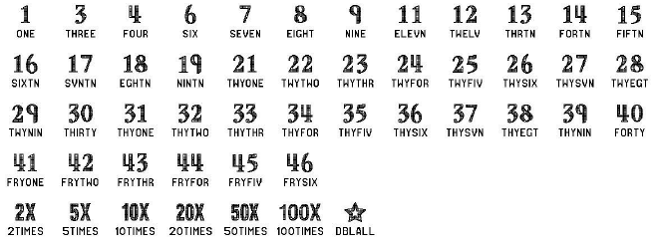
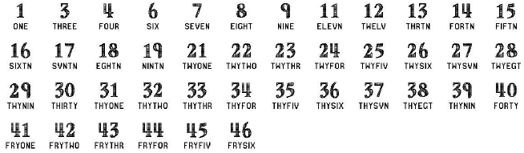
(6) Play symbols and play symbol captions that may appear in the WINNING NUMBERS play area:

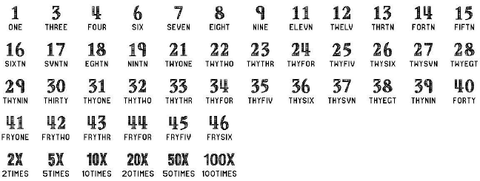
(7) Play symbols and play symbol captions that may appear in the BONUS NUMBERS play area:

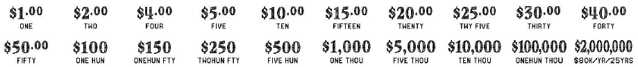
(8) Prize symbols and prize symbol captions that may appear in the YOUR NUMBERS play area:

(9) The legends are:
(10) Determination of Winners.
(a) A ticket having a play symbol and corresponding play symbol caption in the YOUR NUMBERS play area or the BONUS NUMBERS play area that matches a play symbol and corresponding play symbol caption in the WINNING NUMBERS play area shall entitle the winner to the corresponding prize shown for that symbol. A ticket having a symbol and symbol caption in either the YOUR NUMBERS or BONUS NUMBERS play area shall entitle the winner to two times the prize shown for that symbol. A ticket having a symbol and symbol caption in either the YOUR NUMBERS or BONUS NUMBERS play area shall entitle the winner to five times the prize shown for that symbol. A ticket having a symbol and symbol caption in either the YOUR NUMBERS or BONUS NUMBERS play area shall entitle the winner to ten times the prize shown for that symbol. A ticket having a symbol and symbol caption in either the YOUR NUMBERS or BONUS NUMBERS play area shall entitle the winner to twenty times the prize shown for that symbol. A ticket having a symbol and symbol caption in either the YOUR NUMBERS or BONUS NUMBERS play area shall entitle the winner to fifty times the prize shown for that symbol. A ticket having a symbol and symbol caption in either the YOUR NUMBERS or BONUS NUMBERS play area shall entitle the winner to one hundred times the prize shown for that symbol. A ticket having a symbol and symbol caption in the YOUR NUMBERS play area shall entitle the winner to two times (i. e. “double”) all twenty prizes shown.
(b) A player may win up to twenty times on a ticket.
(11) $2,000,000 Prize; Payment Options.
(a) A winner of a $2,000,000 prize may choose one of two payment options for receiving his/her prize. Payment options are One-Time Cash Payment or Annual Payments. At the time the $2,000,000 prize is claimed, the terminal will produce a player claim instructions ticket. The winner has sixty (60) days from the date the player claim instructions ticket is produced to file a claim choosing the One-Time Cash Payment. If a winner does not choose the One-Time Cash Payment within the sixty (60) day timeframe, the Annual Payment option will be applied. Once the winner files a claim and exercises the winner’s chosen option, the election of that option shall be final. The Annual Payment method of payment will also be final when it is applied due to a $2,000,000 prize winner not making his/her payment election within sixty (60) days after the player claim instructions ticket is produced.
(b) A winner of a $2,000,000 prize who elects the One-Time Cash Payment shall receive a single cash payment of $1,280,000.00, less applicable federal income tax withholding.
(c) Annual Payments will be paid in twenty-five (25) equal annual installments. A winner of a $2,000,000 prize who elects the Annual Payment option, or has it applied, shall receive annual installments of $80,000.00 per year, less applicable federal tax withholding.
(12) The odds of winning, value, and number of prizes in Game Number 1554 are as follows:

GAME PLAY | WIN | ODDS OF 1 IN | NUMBER OF WINNERS IN 276.11 POOLS OF 120,000 TICKETS PER POOL
$5 x 2 | $10 | 60.00 | 552,219
$2 (5X) | $10 | 30.00 | 1,104,372
$10 | $10 | 30.00 | 1,104,455
$5 x 3 | $15 | 60.00 | 552,236
$5 + $10 | $15 | 60.00 | 552,202
$2 (5X) + $5 | $15 | 30.00 | 1,104,354
$15 | $15 | 60.00 | 552,202
$5 x 4 | $20 | 60.00 | 552,219
$2 (5X) + $10 | $20 | 99.98 | 331,408
$10 (2X) | $20 | 150.05 | 220,811
$2 (10X) | $20 | 60.00 | 552,236
$20 | $20 | 60.00 | 552,202
$5 x 5 | $25 | 400.47 | 82,735
$5 (5X) | $25 | 399.86 | 82,861
$5 + ($10 x 2) | $25 | 400.17 | 82,797
$2 (10X) + $5 | $25 | 400.34 | 82,763
$25 | $25 | 399.96 | 82,841
$5 x 6 | $30 | 399.83 | 82,868
$2 (5X) + $10 (2X) | $30 | 399.93 | 82,847
$2 (10X) + $10 | $30 | 399.92 | 82,849
$10 x 3 | $30 | 363.34 | 91,190
$30 | $30 | 400.30 | 82,770
$5 x 8 | $40 | 922.21 | 35,928
$2 (5X) + ($10 x 3) | $40 | 799.29 | 41,453
$2 (10X) + $20 | $40 | 799.20 | 41,458
$20 (2X) | $40 | 800.01 | 41,416
$40 | $40 | 998.32 | 33,189
$5 x 10 | $50 | 799.56 | 41,439
$5 (10X) | $50 | 801.71 | 41,328
$2 (5X) + ($20 x 2) | $50 | 797.06 | 41,569
$15 (2X) + $20 | $50 | 801.05 | 41,362
$50 | $50 | 798.31 | 41,504
($2 x 15) + ($4 x 5) (STAR) | $100 | 240.07 | 138,016
$5 x 20 | $100 | 600.99 | 55,131
$5 (20X) | $100 | 600.29 | 55,195
$10 (10X) | $100 | 599.66 | 55,253
$20 (5X) | $100 | 600.06 | 55,216
$1 (100X) | $100 | 566.72 | 58,465
$100 | $100 | 684.77 | 48,386
($2 x 15) + ($5 x 4) + $25 (STAR) | $150 | 5,992.61 | 5,529
($5 x 16) + $10 + ($20 x 3) | $150 | 23,957.44 | 1,383
$10 (10X) + ($10 x 5) | $150 | 23,974.78 | 1,382
$30 (5X) | $150 | 23,615.92 | 1,403
$2 (50X) + $50 | $150 | 24,026.93 | 1,379
$1 (100X) + $50 | $150 | 7,936.08 | 4,175
$150 | $150 | 23,836.79 | 1,390
($5 x 15) + ($10 x 5) (STAR) | $250 | 7,968.53 | 4,158
$5 (50X) | $250 | 39,967.60 | 829
($20 (5X) x 2) + $25 (2X) | $250 | 40,112.76 | 826
$25 (10X) | $250 | 39,632.94 | 836
$10 (20X) + $50 | $250 | 40,654.16 | 815
$2 (100X) + $10 (5X) | $250 | 23,871.14 | 1,388
$250 | $250 | 39,967.60 | 829
($5 x 5) + ($15 x 15) (STAR) | $500 | 5,724.45 | 5,788
($20 x 15) + ($25 x 4) + $100 | $500 | 40,161.38 | 825
$50 (10X) | $500 | 39,680.41 | 835
$10 (50X) | $500 | 39,871.41 | 831
$5 (100X) | $500 | 19,923.72 | 1,663
$500 | $500 | 39,823.49 | 832
($20 x 15) + ($25 x 4) + $100 (STAR) | $1,000 | 12,009.11 | 2,759
$10 (50X) + $25 (20X) | $1,000 | 20,032.13 | 1,654
$50 (20X) | $1,000 | 19,959.72 | 1,660
$100 (5X) + $250 (2X) | $1,000 | 19,769.18 | 1,676
$10 (100X) | $1,000 | 13,221.52 | 2,506
$1,000 | $1,000 | 19,828.33 | 1,671
$100 (50X) | $5,000 | 115,446.48 | 287
$50 (100X) | $5,000 | 122,715.33 | 270
$5,000 | $5,000 | 117,493.40 | 282
$10,000 | $10,000 | 59,484.99 | 557
$100,000 | $100,000 | 1,104,438.00 | 30
$2,000,000 ($80K/YR/25YRS)* | $2,000,000* | 3,313,314.00 | 10

*Prize amount if taken in annual payments. If a winner takes a single cash payment, the amount will be in accordance with subsection (11), above.
(13) The overall odds of winning some prize in Game Number 1554 are 1 in 3.49. All prizes are subject to availability at the time of ticket purchase. Prizes may be unavailable due to prior sales or other causes occurring in the normal course of business including, but not limited to, ticket damage, defect, theft, or loss.
(14) For reorders of Game Number 1554, the odds of winning, value, and number of prizes shall be proportionate to the number of tickets reordered.
(15) Payment of prizes for 100X THE CASH lottery tickets shall be made in accordance with the rule of the Florida Lottery governing payment of prizes. A copy of the current rule can be obtained from the Florida Lottery, Office of the General Counsel, 250 Marriott Drive, Tallahassee, Florida 32399-4011 or flrules.org.
Rulemaking Authority 24.105(9)(a), (b), (c), 24.109(1), 24.115(1) FS. Law Implemented 24.105(9)(a), (b), (c), 24.115(1) FS. History–New 1-15-24.

