Notice of Proposed Rule

FISH AND WILDLIFE CONSERVATION COMMISSION
Vessel Registration and Boating Safety
RULE NO.: RULE TITLE:
68D-24.165 Collier County Boating Restricted Areas.
PURPOSE AND EFFECT: The proposed rule will create boating restricted areas in Little Hickory Bay in Collier County which regulate the speed and operations of vessels. The effect of the rule will be to ensure public safety as provided for in section 327.46, F.S. and Rule 68D-24.003, F.A.C. This rule will include a map and set forth the geographic locations of slow speed, minimum wake zones located in Little Hickory Bay.
SUMMARY: The proposed rule will create boating restricted areas which regulate speed of vessel operation in specific areas of Little Hickory Bay located in Collier County.
SUMMARY OF STATEMENT OF ESTIMATED REGULATORY COSTS AND LEGISLATIVE RATIFICATION:
The Agency has determined that this will not have an adverse impact on small business or likely increase directly or indirectly regulatory costs in excess of $200,000 in the aggregate within one year after the implementation of the rule. A SERC has not been prepared by the Agency.
The Agency has determined that the proposed rule is not expected to require legislative ratification based on the statement of estimated regulatory costs or if no SERC is required, the information expressly relied upon and described herein: The nature of the rule and the preliminary analysis conducted to determine whether a SERC was required.
Any person who wishes to provide information regarding a statement of estimated regulatory costs, or provide a proposal for a lower cost regulatory alternative must do so in writing within 21 days of this notice.
RULEMAKING AUTHORITY: 327.04, 327.46 FS.
LAW IMPLEMENTED: 327.46, FS.
IF REQUESTED WITHIN 21 DAYS OF THE DATE OF THIS NOTICE, A HEARING WILL BE SCHEDULED AND ANNOUNCED IN THE FAR.
THE PERSON TO BE CONTACTED REGARDING THE PROPOSED RULE IS: Kate Grimes, Boating and Waterways Section, Division of Law Enforcement, 620 South Meridian Street, Tallahassee, Florida 32399, kate.grimes@myfwc.com; (850)567-4264.

THE FULL TEXT OF THE PROPOSED RULE IS:

68D-24.165 Collier County Boating Restricted Areas.

For the purpose of regulating the speed and operation of vessel traffic in Little Hickory Bay in Collier County, Florida, the following boating restricted area is created:

1) Slow Speed, Minimum Wake Zone, from shoreline to shoreline within the mangrove islands, which lie approximately 2 miles north of Wiggins Pass inlet, beginning at point “A” at Latitude 26 degrees 18 minutes 52.10 seconds North, Longitude 81 degrees 50 minutes 9.57 seconds West; thence proceed in a northerly direction for a distance of 1,500 feet, more or less, to a point designated as “B” at Latitude 26 degrees 19 minutes 06.45 seconds North, Longitude 81 degrees 50 minutes 03.18 seconds West; including the waterway intersection originating near channel marker number 15, thence proceeding easterly and northeasterly for a distance of 1,100 feet, more or less, to a point designated as “C” at Latitude 26 degrees 19 minutes 01.08 seconds North, Longitude 81 degrees 49 minutes 53.73 seconds West, as depicted in drawing A.

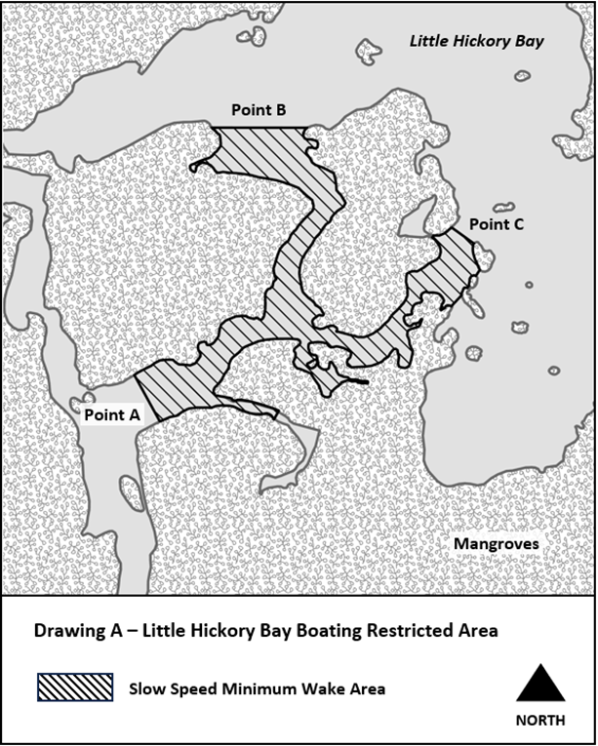

Rulemaking Authority 327.04, 327.46 FS. Law Implemented 327.46 FS. History-New____

NAME OF PERSON ORIGINATING PROPOSED RULE: Kate Grimes, Boating and Waterways Section, Division of Law Enforcement, 620 South Meridian Street, Tallahassee, Florida 32399, kate.grimes@myfwc.com; (850)617-9493.
NAME OF AGENCY HEAD WHO APPROVED THE PROPOSED RULE: Florida Fish and Wildlife Conservation Commission
DATE PROPOSED RULE APPROVED BY AGENCY HEAD: May 01, 2024
DATE NOTICE OF PROPOSED RULE DEVELOPMENT PUBLISHED IN FAR: May 8, 2024

