68D-24.165 Collier County Boating Restricted Areas.
For the purpose of regulating the speed and operation of vessel traffic in Little Hickory Bay in Collier County, Florida, the following boating restricted area is created:
(1) Slow Speed, Minimum Wake Zone, from shoreline to shoreline within the mangrove islands, which lie approximately 2 miles north of Wiggins Pass inlet, beginning at point “A” at Latitude 26 degrees 18 minutes 52.10 seconds North, Longitude 81 degrees 50 minutes 9.57 seconds West; thence proceed in a northerly direction for a distance of 1,500 feet, more or less, to a point designated as “B” at Latitude 26 degrees 19 minutes 06.45 seconds North, Longitude 81 degrees 50 minutes 03.18 seconds West; including the waterway intersection originating near channel marker number 15, thence proceeding easterly and northeasterly for a distance of 1,100 feet, more or less, to a point designated as “C” at Latitude 26 degrees 19 minutes 01.08 seconds North, Longitude 81 degrees 49 minutes 53.73 seconds West, as depicted in drawing A.
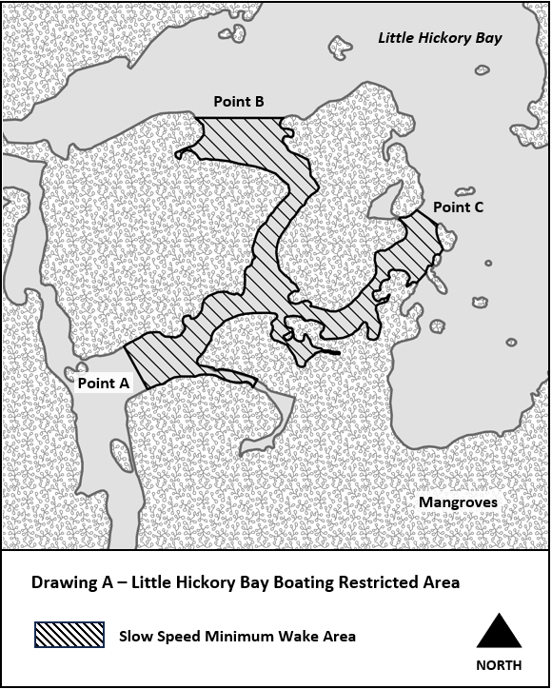
Rulemaking Authority 327.04, 327.46 FS. Law Implemented 327.46 FS. History-New 7-17-24.

